Talend Job: PatientInfo_Text_Load

Overview
This job loads hospital/patient billing information (patient demographics, admission/discharge details, facility and doctor details, diagnosis and procedure codes) into Snowflake. It follows the standard truncate → load → merge → archive/delete pattern, encrypts the mapped rows before loading (like Insurance_Text_Load), and — like cmi_Hermes_Recommendations_Load — explicitly checks whether the Snowflake merge step succeeded, failing the job or logging a row count depending on the outcome.

Detail table
Field | Value
Job name | PatientInfo_Text_Load
Version | 0.1
Project | LATITUDE
Author | jmach@harriscollect.com
Created | 2026-01-21T09:33:39.210-0800
Last Modified | 2026-02-16T10:26:57.323-0800

Step-by-step data flow
- Set up. tPrejob_1 starts the job; tJava_3 sets the dated archive path and opens the log; tSetKeystore_1 configures the SSL keystore; tDBConnection_1 opens the Snowflake connection.
- Empty the staging table. tDBRow_1 runs TRUNCATE TABLE LIQUID_STAGING.PATIENTINFO;.
- Find the file. tFileList_1 lists files in context.sourceDir (skipping .txt), sorted by last-modified date. The match becomes context.filePath (tJava_1).
- Read, map, and encrypt. tFileInputDelimited_1 reads the file as pipe-delimited (|~|/|$|), US-ASCII encoded, with DIE_ON_ERROR set to true (a parse error fails the job outright). tMap_1 maps the file's columns onto the PATIENTINFO schema; the mapped rows then pass through tDataEncrypt_1 (AES encryption) before reaching tDBOutput_1.
- Load staging. tDBOutput_1 inserts the (encrypted) rows into the staging table.
- Merge, check the result, and clean up — in parallel. tParallelize_1 splits into two branches:
- Merge branch: tDBRow_2 calls CALL MERGE_TXT_INTO_PATIENTINFO();, which returns a value captured by tJavaRow_1 into context.retValue. Depending on that value, the job runs either tDie_3 (fails the job with "MERGE failed - result is " + context.retValue, exit code 4) or tWarn_1 (logs "MERGE succeeded - result is " + context.retValue, severity 42) — the same result-checking pattern documented in cmi_Hermes_Recommendations_Load. As with that job, the exact condition that routes to one branch vs. the other isn't captured in this metadata — only that both RUN_IF branches exist off tJavaRow_1.
- Cleanup branch: the file is listed again, archived into context.archiveDir as a .zip (tFileArchive_1), and deleted (tFileDelete_1).
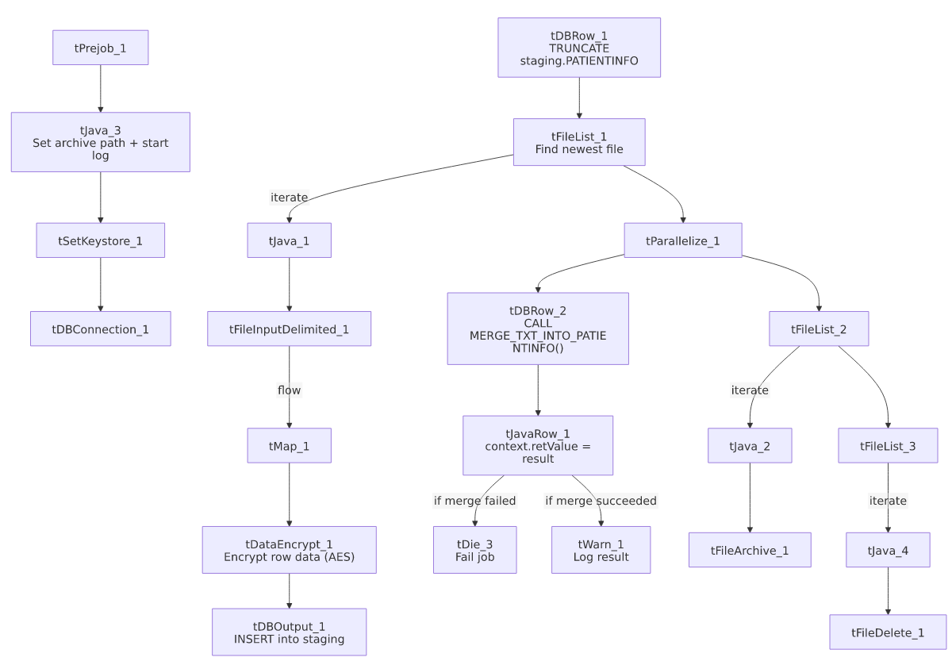

Settings tables

Source: `tFileInputDelimited_1`
Setting | Value | What it means
FILENAME | context.filePath | Reads whichever file tFileList_1 just found.
FIELDSEPARATOR / ROWSEPARATOR | `\ | ~\
ENCODING | US-ASCII | Matches Carrier_Text_Load/Insurance_Text_Load.
DIE_ON_ERROR | true | A file-parsing error fails the job.
SCHEMA_REJECT | repository schema "patient" | Correctly points at a patient-specific reject schema (unlike the "customer" mismatch seen in some other jobs).

Encryption step: `tDataEncrypt_1`
Setting | Value | What it means
CRYPTO_METHOD | AES | Rows encrypted with AES, same as Insurance_Text_Load.
ALGO_VERSION | 2 | Version 2 of Talend's encryption algorithm.
CRYPTO_FILE_PATH | context.cryptoPath | Parameterized via context.

Target: `tDBOutput_1`
Setting | Value | What it means
Table | PATIENTINFO | Loads into the staging copy of this table.
Output action | INSERT | Adds rows only.
Table action | NONE | No table create/drop/truncate here.

Merge & result check: `tDBRow_2` → `tJavaRow_1` → `tDie_3` / `tWarn_1`
Setting | Value | What it means
Query (tDBRow_2) | CALL MERGE_TXT_INTO_PATIENTINFO(); | Runs the Snowflake merge procedure; its RETVALUE output column is captured.
context.retValue assignment | context.retValue = row2.RETVALUE; | Copies the procedure's returned value into a context variable for the tDie/tWarn branches to read.
tDie_3 message | "MERGE failed - result is " + context.retValue.toPlainString() (exit code 4, priority 5) | Fails the job if the merge reports failure.
tWarn_1 message | "MERGE succeeded - result is " + context.retValue.toPlainString() (code 42, priority 4) | Logs the result and continues if the merge succeeded.

Dependencies & configuration
- Triggers/depends on other jobs: none found — no tRunJob links.
- Context variables used: context.sourceDir, context.archiveDir, context.filePath, context.fileName, context.logDir, context.keystorePath, context.cryptoPath, plus the job-local context.retValue (all Directories_0.1 except cryptoPath/retValue, which are job-specific additions). Uses the shared Snowflake connection object, not LEGACY_DW_0.1 directly.
- Hardcoded values found: tFileInputDelimited_1.TEMP_DIR, tFileArchive_1.SOURCE_FILE, tFileDelete_1.DIRECTORY/PATH, and tSetKeystore_1.SSL_TRUSTSERVER_TRUSTSTORE — the same fixed Windows paths seen project-wide.

Glossary
Component type | Plain-English meaning
tPrejob / tParallelize | Job-flow control (see job_Address_Text_Load.md).
tFileList | Lists files to loop over (see job_Address_Text_Load.md).
tFileInputDelimited | Reads a delimited text file (see job_Address_Text_Load.md).
tMap | Maps/transforms columns (see job_Address_Text_Load.md).
tDataEncrypt | Encrypts row data (AES here) before it moves further down the flow — see job_Insurance_Text_Load.md for the fuller explanation (not covered in the original three reference docs).
tDBOutput / tSnowflakeOutput | Writes rows to Snowflake (see job_Address_Text_Load.md).
tDBRow / tSnowflakeRow | Runs a single SQL statement (see job_Address_Text_Load.md).
tJavaRow | Custom code capturing the merge procedure's return value (see job_cmi_Hermes_Recommendations_Load.md).
tDie | Fails the job immediately with a specific message and exit code (see job_cmi_Hermes_Recommendations_Load.md).
tWarn | Logs a warning without failing the job (see job_cmi_Hermes_Recommendations_Load.md).
tJava | Custom Java code blocks (see job_Address_Text_Load.md).
tFileArchive | Zips a file into an archive location (see job_Address_Text_Load.md).
tFileDelete | Deletes a file from disk (see job_Address_Text_Load.md).
tSetKeystore | Configures the SSL keystore for Snowflake (see job_Address_Text_Load.md).

Issues observed
- The pass/fail condition on the merge-result check isn't in the metadata, same caveat as cmi_Hermes_Recommendations_Load — only that both RUN_IF branches exist off tJavaRow_1.
- Encryption key/password are redacted, so it's not possible to independently verify from Talend alone what's encrypted before the merge — worth checking given the sensitive nature of patient billing data (SSN-adjacent fields like PatientRecNumber/GuarantorRecNumber are present in the schema).
- Hardcoded, machine-specific paths exist alongside the parameterized ones — the same project-wide pattern.

