Talend Job: PayHistory_Table_Text_Load

Overview
This job loads payment-history transaction records (a large schema covering batches, invoices, fees, balances, and various payment-processor identifiers) from a shared folder into Snowflake. It follows the project's standard load pattern: truncate the staging table, read the source file, load into staging, merge into the permanent table via a stored procedure, then archive and delete the source file. Notably, the staging table (PAYHIST_TXT) and the merge procedure name (MERGE_TXT_INTO_PAYHISTORY) don't follow the same naming stem as every other job in this batch — see Issues observed.

Detail table
Field | Value
Job name | PayHistory_Table_Text_Load
Version | 0.1
Project | LATITUDE
Author | jmach@harriscollect.com
Created | 2024-10-24T10:27:16.865-0700
Last Modified | 2026-07-12T14:16:06.767-0700

Step-by-step data flow
- Set up. tPrejob_1 starts the job; tJava_2 appends today's date to context.archiveDir and opens a log file; tSetKeystore_1 configures the SSL client keystore; tDBConnection_1 opens the Snowflake connection.
- Empty the staging table. tDBRow_1 runs TRUNCATE TABLE PAYHIST_TXT;, then triggers the file-processing chain.
- Find the file. tFileList_1 lists files in context.sourceDir (skipping .txt files); the match becomes context.filePath (tJava_1).
- Read and reshape. tFileInputDelimited_1 reads the file using the repository schema "payhist" — pipe-delimited (|~|/|$|), quote-enclosed fields ("), US-ASCII encoding, header row, DIE_ON_ERROR true. tMap_1 maps its roughly 80 columns (payment batch details, fee/balance breakdowns 1–10, invoice info, AIM agency fields, etc.) onto the equivalent target schema, adding LOAD_DT.
- Load staging. The mapped rows flow directly into tDBOutput_1, which inserts them into PAYHIST_TXT (no row counter on this path).
- Merge and clean up — in parallel. tParallelize_1 splits into:
- Merge branch: tDBRow_2 runs CALL MERGE_TXT_INTO_PAYHISTORY();. No tDie/tWarn check follows it.
- Cleanup branch: the source file is listed again, archived (tFileArchive_1), then separately listed and deleted (tFileDelete_1, FAILON false).
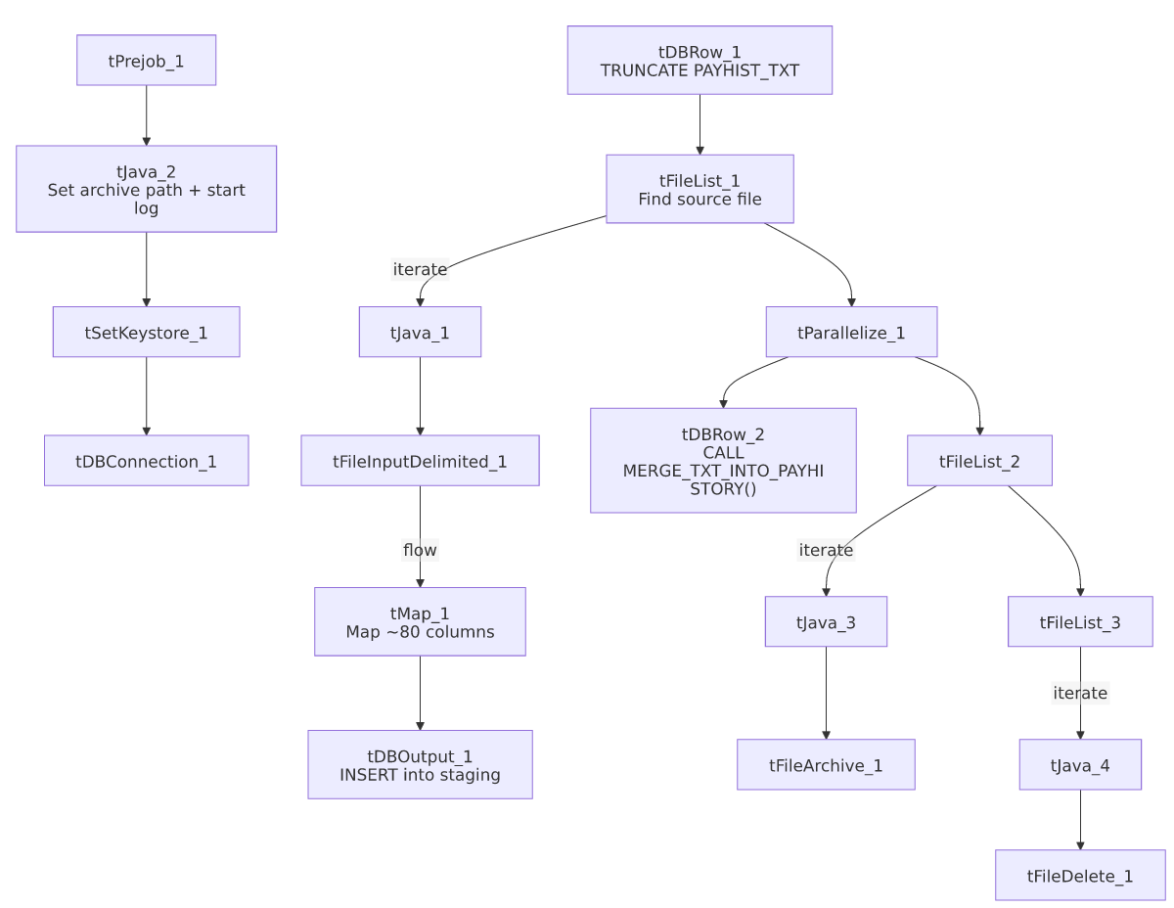

Settings tables

Source: `tFileInputDelimited_1`
Setting | Value | What it means
FILENAME | context.filePath | Reads whichever file tFileList_1 found.
Schema | Repository schema "payhist" | Uses a shared, pre-defined column layout matching this large payment-history record.
FIELDSEPARATOR / ROWSEPARATOR | `\ | ~\
ESCAPE_CHAR / TEXT_ENCLOSURE | " | Fields can be quoted with ".
ENCODING | US-ASCII | Plain ASCII.
DIE_ON_ERROR | true | A malformed row fails the whole job.

Target: `tDBOutput_1`
Setting | Value | What it means
Table | PAYHIST_TXT | Staging table written to.
Output action | INSERT | Adds rows only.
Table action | NONE | Structure untouched — truncation is the separate tDBRow_1 step.

Merge step: `tDBRow_2`
Setting | Value | What it means
Query | CALL MERGE_TXT_INTO_PAYHISTORY(); | Snowflake stored procedure folding staged rows into the permanent table. Body not visible in this metadata. Note the name doesn't match the staging table's stem (PAYHIST vs. PAYHISTORY) — see Issues observed.

Dependencies & configuration
- Triggers/depends on other jobs: none — no tRunJob links found.
- Context variables used: context.sourceDir, context.archiveDir, context.filePath, context.fileName, context.logDir, context.keystorePath (all Directories_0.1).
- Snowflake connection: uses the shared connection object, not LEGACY_DW_* context variables directly.

Glossary
Component type | Plain-English meaning
tPrejob / tParallelize | Setup-before-main-flow, and concurrent branches (see job_Address_Text_Load.md).
tFileList | Lists files in a folder to loop over (see job_Address_Text_Load.md).
tFileInputDelimited | Reads a delimited text file row by row (see job_Address_Text_Load.md).
tMap | Maps/transforms columns (see job_Address_Text_Load.md).
tSnowflakeOutput (tDBOutput) | Writes rows into Snowflake (see job_Address_Text_Load.md).
tSnowflakeRow (tDBRow) | Runs a single SQL statement — TRUNCATE and CALL <procedure> here (see job_Address_Text_Load.md).
tJava | Custom Java code for small tasks (see job_Address_Text_Load.md).
tFileArchive | Zips a file into an archive location (see job_Address_Text_Load.md).
tFileDelete | Deletes a file from disk (see job_Address_Text_Load.md).
tSetKeystore | Configures the SSL keystore for the Snowflake connection (see job_Address_Text_Load.md).

Issues observed
- Naming mismatch between staging table and merge procedure. Every other job in this batch either keeps the same stem (e.g. DESK → MERGE_TXT_INTO_DESK) or simply drops the staging table's _TXT suffix (e.g. LETTER_TXT → MERGE_TXT_INTO_LETTER, CMI_DIALER_SBT_HISTORY_TXT → MERGE_TXT_INTO_CMI_DIALER_SBT_HISTORY). Here, the staging table is PAYHIST_TXT but the procedure is MERGE_TXT_INTO_PAYHISTORY — a full stem change from "PAYHIST" to "PAYHISTORY", not just a suffix drop. Worth confirming with the Snowflake procedure owner that this is intentional and that the procedure is in fact merging from PAYHIST_TXT (and not from some other, differently-named staging table).
- Hardcoded machine-specific paths: tFileInputDelimited_1.TEMP_DIR, tFileArchive_1.SOURCE_FILE, tFileDelete_1.DIRECTORY/PATH, and tSetKeystore_1.SSL_TRUSTSERVER_TRUSTSTORE are all fixed C:/Talend-Studio-20211109_1610-V8.0.1/... or C:/clientTrustStore.trustStore paths rather than context variables — the same pattern flagged project-wide.
- No row counter (`tFlowMeter`) on the load path.
- No explicit error handling on the merge step — no tDie/tWarn reacting to whether the merge succeeded.

