Talend Job: Result_Table_Text_Load

Overview
This job loads "result code" reference data (contact-attempt outcome codes like whether a call was worked/contacted, with descriptions and compliance-attempt flags) into Snowflake. It follows the standard truncate → load → merge → archive/delete pattern, with a couple of naming inconsistencies worth flagging (see Issues observed).

Detail table
Field | Value
Job name | Result_Table_Text_Load
Version | 0.1
Project | LATITUDE
Author | jmach@harriscollect.com
Created | 2024-10-25T09:48:07.359-0700
Last Modified | 2025-10-02T10:44:45.581-0700

Step-by-step data flow
- Set up. tPrejob_1 starts the job; tJava_2 sets the dated archive path and opens the log; tSetKeystore_1 configures the SSL keystore; tDBConnection_1 opens the Snowflake connection.
- Empty the staging table. tDBRow_1 runs TRUNCATE TABLE RESULT_TXT; — note there is no schema qualifier here (see Issues observed).
- Find the file. tFileList_1 lists files in context.sourceDir (skipping .txt) with no explicit sort order applied (ORDER_BY_NOTHING=true — unlike most peer jobs, which sort by last-modified date). The match becomes context.filePath (tJava_1).
- Read and reshape. tFileInputDelimited_1 reads the file as pipe-delimited (|~|/|$|), US-ASCII encoded, with a header row. tMap_1 maps the file's columns (code, ctl, Description, worked, contacted, note, ComplianceAttempt) plus LOAD_DT onto the RESULT_TXT schema.
- Load staging. The mapped rows flow directly into tDBOutput_1 (no row-counter component here, unlike several peer jobs), which inserts them into the staging table.
- Merge and cleanup — in parallel. tParallelize_1 splits into:
- Merge branch: tDBRow_2 runs CALL MERGE_TXT_INTO_RESULT(); — note the procedure name refers to "RESULT", not "RESULT_TXT" as the table itself is named (see Issues observed). No tDie/tWarn reacts to the result.
- Cleanup branch: the file is listed again, archived as a .zip into context.archiveDir (tFileArchive_1), and deleted (tFileDelete_1).
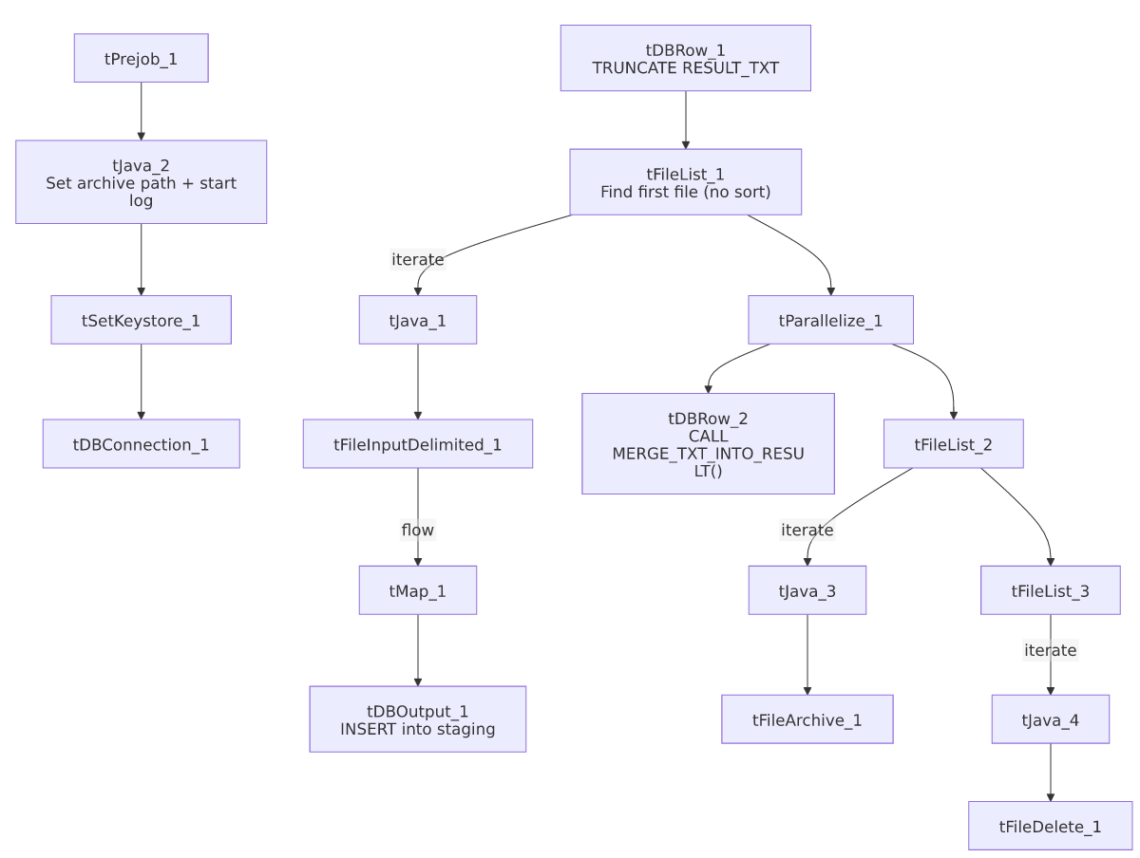

Settings tables

Source: `tFileInputDelimited_1`
Setting | Value | What it means
FILENAME | context.filePath | Reads whichever file tFileList_1 just found.
FIELDSEPARATOR / ROWSEPARATOR | `\ | ~\
CSVROWSEPARATOR | \n | Fallback row separator (inert since CSV_OPTION is false).
ENCODING | US-ASCII | Matches Carrier_Text_Load/Insurance_Text_Load.
SCHEMA_REJECT | repository schema "customer" | Mismatched — same copy-paste artifact seen in Carrier_Text_Load, cmi_Dialer_Plan_History_Table_Text_Load, and cmi_renkim_ReturnHistory_Text_Load.
ORDER_BY_NOTHING (on tFileList_1) | true | No sort order is applied when picking the file to process — whichever file the filesystem returns first is used, unlike jobs that explicitly sort by last-modified date.
EXCLUDEFILEMASK (on tFileList_1) | *.txt | .txt files skipped.

Target: `tDBOutput_1`
Setting | Value | What it means
Table | RESULT_TXT | Loads into the staging copy of this table.
Output action | INSERT | Adds rows only.
Table action | NONE | No table create/drop/truncate here.

Truncate & merge: `tDBRow_1` / `tDBRow_2`
Setting | Value | What it means
Query (tDBRow_1) | TRUNCATE TABLE RESULT_TXT; | Empties staging — no schema prefix, unlike TRUNCATE TABLE LIQUID_STAGING.<table>; used in most peer jobs (relies on whatever schema is the connection's default).
Query (tDBRow_2) | CALL MERGE_TXT_INTO_RESULT(); | Runs the merge procedure — named after "RESULT", not "RESULT_TXT".

Dependencies & configuration
- Triggers/depends on other jobs: none found — no tRunJob links.
- Context variables used: context.sourceDir, context.archiveDir, context.filePath, context.fileName, context.logDir, context.keystorePath (all Directories_0.1). Uses the shared Snowflake connection object, not LEGACY_DW_0.1 directly.
- Hardcoded values found: tFileInputDelimited_1.TEMP_DIR, tFileArchive_1.SOURCE_FILE, tFileDelete_1.DIRECTORY/PATH, and tSetKeystore_1.SSL_TRUSTSERVER_TRUSTSTORE — the same fixed Windows paths seen project-wide.

Glossary
Component type | Plain-English meaning
tPrejob / tParallelize | Job-flow control (see job_Address_Text_Load.md).
tFileList | Lists files to loop over (see job_Address_Text_Load.md).
tFileInputDelimited | Reads a delimited text file (see job_Address_Text_Load.md).
tMap | Maps/transforms columns (see job_Address_Text_Load.md).
tDBOutput / tSnowflakeOutput | Writes rows to Snowflake (see job_Address_Text_Load.md).
tDBRow / tSnowflakeRow | Runs a single SQL statement (see job_Address_Text_Load.md).
tJava | Custom Java code blocks (see job_Address_Text_Load.md).
tFileArchive | Zips a file into an archive location (see job_Address_Text_Load.md).
tFileDelete | Deletes a file from disk (see job_Address_Text_Load.md).
tSetKeystore | Configures the SSL keystore for Snowflake (see job_Address_Text_Load.md).

Issues observed
- Naming mismatch between the table and its merge procedure. The staging/permanent table is RESULT_TXT, but the merge procedure is MERGE_TXT_INTO_RESULT() — dropping the _TXT suffix. This breaks the otherwise-consistent MERGE_TXT_INTO_<TABLE>() naming convention seen elsewhere (e.g. MERGE_TXT_INTO_CARRIER() for table CARRIER) and is worth double-checking with whoever owns the Snowflake procedures to confirm it's pointed at the right table.
- The truncate statement has no schema qualifier (TRUNCATE TABLE RESULT_TXT;), unlike most peer jobs which explicitly truncate LIQUID_STAGING.<table>. This likely still works via the connection's default schema, but is inconsistent with the more explicit style used elsewhere.
- No row-counter (`tFlowMeter`) between the map and the load, unlike DeskChangeHistory_Text_Load/Users_Text_Load/Insurance_Text_Load — a minor observability gap (no per-run row count logged at that point).
- File is picked with no sort order (ORDER_BY_NOTHING=true) rather than by last-modified date — if more than one matching file is ever present in the source folder at once, which one gets processed is effectively arbitrary/filesystem-dependent.
- Reject-schema mismatch ("customer" reject schema) — same copy-paste artifact flagged in Carrier_Text_Load.
- Hardcoded, machine-specific paths exist alongside the parameterized ones — the same project-wide pattern.

