Talend Job: Voapps_Response_Load

Overview
This job loads response records from VoApps (a ringless-voicemail/message-drop vendor) — target date, caller number, message ID, delivery result and code, and the linked Hermes recommendation request — into Snowflake. It follows the overall truncate → load → merge → archive/delete pattern, but the source file format is a notable deviation from most other LATITUDE text-load jobs: it's a comma-delimited file, not the project's usual |~|/|$| pipe-delimited format.

Detail table
Field | Value
Job name | Voapps_Response_Load
Version | 0.1
Project | LATITUDE
Author | jmach@harriscollect.com
Created | 2026-02-18T14:28:47.819-0800
Last Modified | 2026-02-23T08:36:13.831-0800

Step-by-step data flow
- Set up. tPrejob_1 triggers tJava_1, which appends today's date to context.archiveDir and opens a log file; this chains into tSetKeystore_1 and tDBConnection_1.
- Empty the staging table. tDBRow_1 runs TRUNCATE TABLE LIQUID_STAGING.VOAPPS; (schema-qualified, and note the staging table name is simply VOAPPS, not VOAPPS_TXT like most peer jobs' <NAME>_TXT staging tables — see Issues observed).
- Find the file. tFileList_1 lists files in context.sourceDir (skipping *.txt), explicitly sorted by modified date, ascending — processes the oldest file first, same pattern as Dialer_CallTracking_Load and ScheduledPayment_Text_Load.
- Read the file. tFileInputDelimited_1 reads it with FIELDSEPARATOR: "," and ROWSEPARATOR: "\n" — a plain comma-separated, newline-delimited file, not the project's usual pipe format — US-ASCII encoded, with DIE_ON_ERROR: true (a malformed row stops the job, stricter than most peers). Columns cover phone number, VoApps target date, caller number, message ID, zip code, voice-append flag, the linked Hermes request ID, file number, and the delivery result/code/timestamp.
- Transform. tMap_1 maps these onto the VOAPPS schema, adding FILE_NAME and LOAD_DTTM columns (note the column is LOAD_DTTM, not the LOAD_DT used by most peer jobs — see Issues observed).
- Load staging. Mapped rows pass through a row counter (tFlowMeter_1) into tDBOutput_1, inserting into VOAPPS.
- Merge and clean up — in parallel. Once the file-list subjob completes, tParallelize_1 splits into: tDBRow_2 calling CALL MERGE_TXT_INTO_VOAPPS();, and a file-listing chain (tFileList_2 → archive via tFileArchive_1; then tFileList_3 → delete via tFileDelete_1).
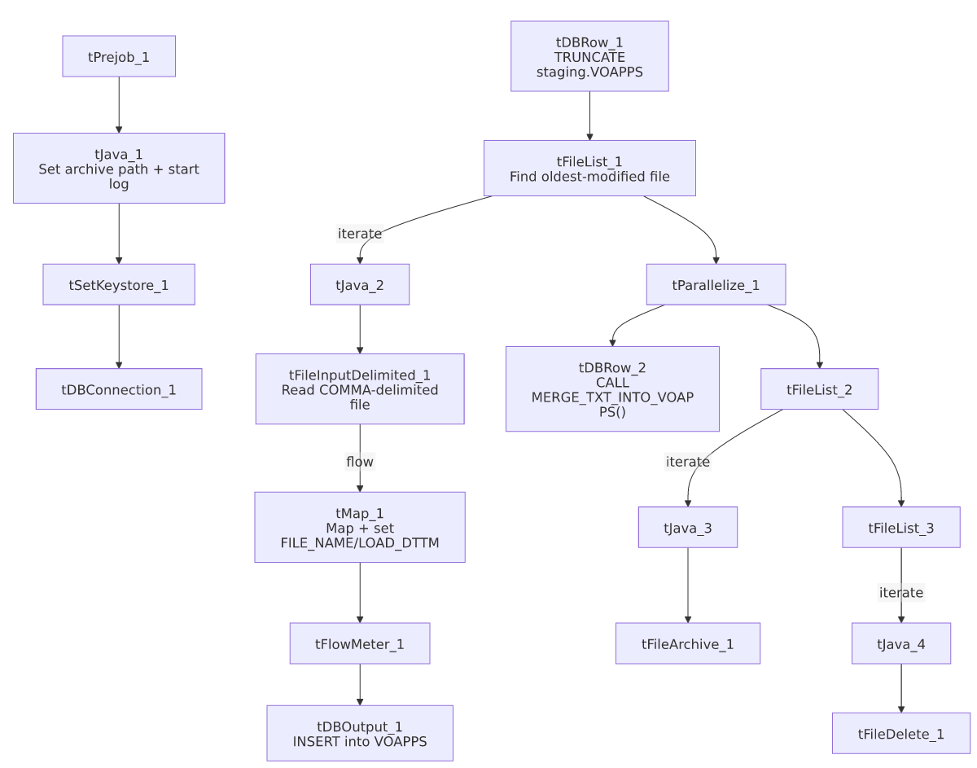

Settings tables

Source: `tFileInputDelimited_1`
Setting | Value | What it means
FILENAME | context.filePath | Reads whichever file tFileList_1 just found.
FIELDSEPARATOR | , | Comma-separated — not the project's usual `\
ROWSEPARATOR | \n | Plain newline-delimited rows — not the project's usual `\
HEADER | 1 | First line is a header.
ENCODING | US-ASCII | Plain ASCII text.
DIE_ON_ERROR | true | A malformed row fails the job immediately.
DIRECTORY ordering (tFileList_1) | ORDER_BY_MODIFIEDDATE=true, ascending | Explicitly processes the oldest untouched file first.

Target: `tDBOutput_1`
Setting | Value | What it means
Table | VOAPPS | Staging table for VoApps response records — note the name has no _TXT suffix, unlike most peer staging tables.
Output action | INSERT | Adds rows only.

Merge step: `tDBRow_2`
Setting | Value | What it means
Query | CALL MERGE_TXT_INTO_VOAPPS(); | Snowflake procedure that folds staged rows into the permanent VOAPPS table.

Dependencies & configuration
- Triggers/depends on other jobs: none found — no tRunJob links.
- Context variables used: context.sourceDir, context.archiveDir, context.filePath, context.fileName, context.logDir, context.keystorePath (all Directories_0.1). Uses the shared Snowflake connection object, not LEGACY_DW_* variables directly.
- Related jobs: the loaded hermes_request_id column suggests this job's output is consumed alongside cmi_Hermes_Recommendations_Load / Hermes_Latitude_Recommendations data, though no direct tRunJob link exists between them in this metadata.
- Hardcoded values found: tSetKeystore_1.SSL_TRUSTSERVER_TRUSTSTORE, tFileInputDelimited_1.TEMP_DIR, tFileArchive_1.SOURCE_FILE, and tFileDelete_1.DIRECTORY/PATH are fixed paths rather than context variables.

Glossary
Component type | Plain-English meaning
tPrejob / tParallelize | Setup-before-main-start, concurrent branches (see job_Address_Text_Load.md).
tFileList | Lists files for the job to loop over (see job_Address_Text_Load.md).
tFileInputDelimited | Reads a delimited text file (see job_Address_Text_Load.md).
tMap | Maps/transforms columns (see job_Address_Text_Load.md).
tFlowMeter | Counts rows passing a point, for logging (see job_Address_Text_Load.md).
tDBOutput / tSnowflakeOutput | Writes rows into Snowflake (see job_Address_Text_Load.md).
tDBRow / tSnowflakeRow | Runs a single SQL statement (see job_Address_Text_Load.md).
tJava | Custom Java code block (see job_Address_Text_Load.md).
tFileArchive | Zips a file into an archive location (see job_Address_Text_Load.md).
tFileDelete | Deletes a file from disk (see job_Address_Text_Load.md).
tSetKeystore | Configures the SSL keystore for the Snowflake connection (see job_Address_Text_Load.md).

Issues observed
- Source file format deviates from the project standard. This job reads a comma-separated, newline-delimited file, while nearly every other LATITUDE text-load job uses the custom \|~\|/\|$\| pipe format. This is presumably because VoApps (an external vendor) delivers its response file in its own native CSV export format rather than the internal Latitude export format — worth confirming with the team, since it means this job's input file cannot be treated interchangeably with other "Text_Load" source files.
- Staging table name lacks the usual `_TXT` suffix (VOAPPS rather than VOAPPS_TXT) — a minor naming inconsistency versus peer jobs.
- Timestamp column is named `LOAD_DTTM`, not `LOAD_DT` like every other job in this batch — worth confirming this isn't simply a typo/inconsistency in the target schema design, since downstream reporting that expects a consistent LOAD_DT column name across staging tables would need to special-case this table.
- `DIE_ON_ERROR` is `true` on the file reader, stricter than most peer jobs.
- File pickup order deviates from the norm — explicitly oldest-first rather than default unordered listing.
- The merge procedure's own logic is outside Talend and not visible in this metadata.

