Talend Job: cmi_Hermes_Recommendations_Load

Overview
This job loads Hermes contact-channel recommendations (which channel — e.g. phone number — to try next for a given account) into Snowflake. It follows the same overall pattern as Address_Text_Load — truncate a staging table, load the current file, merge into the permanent table, archive/delete the source file — but it's one of only 8 jobs in the project that explicitly checks whether that Snowflake merge succeeded and reacts differently depending on the outcome (fail the job vs. just log a count), which makes it a good example of the project's error-handling pattern.

Detail table
Field | Value
Job name | cmi_Hermes_Recommendations_Load
Version | 0.1
Project | LATITUDE
Author | jmach@harriscollect.com
Created | 2026-03-04T10:25:20.254-0800
Last Modified | 2026-03-04T16:11:38.780-0800

Step-by-step data flow
- Set up. tJava_1 prepares logging; tSetKeystore_1 configures the SSL keystore; tDBConnection_1 opens the Snowflake connection.
- Empty the staging table. tDBRow_1 runs TRUNCATE TABLE LIQUID_STAGING.CMI_HERMES_RECOMMENDATIONS;.
- Find and read the file. tFileList_1 finds the newest matching file in context.sourceDir (skipping .txt files); tFileInputDelimited_1 reads it as a pipe-delimited, US-ASCII-encoded file with a header row.
- Transform. tMap_1 maps the file's columns onto the recommendation schema (ID, NUMBER, PROPOSED_CHANNEL, PHONENUMBER, HERMES_REQUEST_ID, CREATEDWHEN_UTC, UPDATEDWHEN_UTC, PROCESS_OUTCOME, COMMENTS, plus LOAD_DT).
- Load staging. Mapped rows pass through a row counter (tFlowMeter_2) into tDBOutput_1, which inserts them into the staging table. (Its schema also carries Snowflake's built-in reject-row columns — columnName, rowNumber, errorMessage, sqlState, etc. — for rows that fail to load; see Glossary.)
- Merge and check the result — in parallel with archiving. tParallelize_1 splits into two branches that run at the same time:
- Merge branch: tDBRow_2 calls CALL MERGE_TXT_INTO_CMI_HERMES_RECOMMENDATIONS(); — a Snowflake stored procedure that folds the staged rows into the permanent table and returns a value. tJavaRow_1 copies that return value into context.retValue. Depending on that value, the job either runs tDie_1 (fails the job with the message "MERGE failed - error code " + context.retValue, exit code 4) or tWarn_1 (logs "<count> rows inserted or updated", severity code 42, without failing the job). Which specific value routes to which branch is not captured in this metadata — only that both are wired as RUN_IF branches off the same code (see Issues observed).
- Cleanup branch: the source file is listed again, deleted (tFileDelete_1), and separately listed and archived (tFileArchive_1) into context.archiveDir.
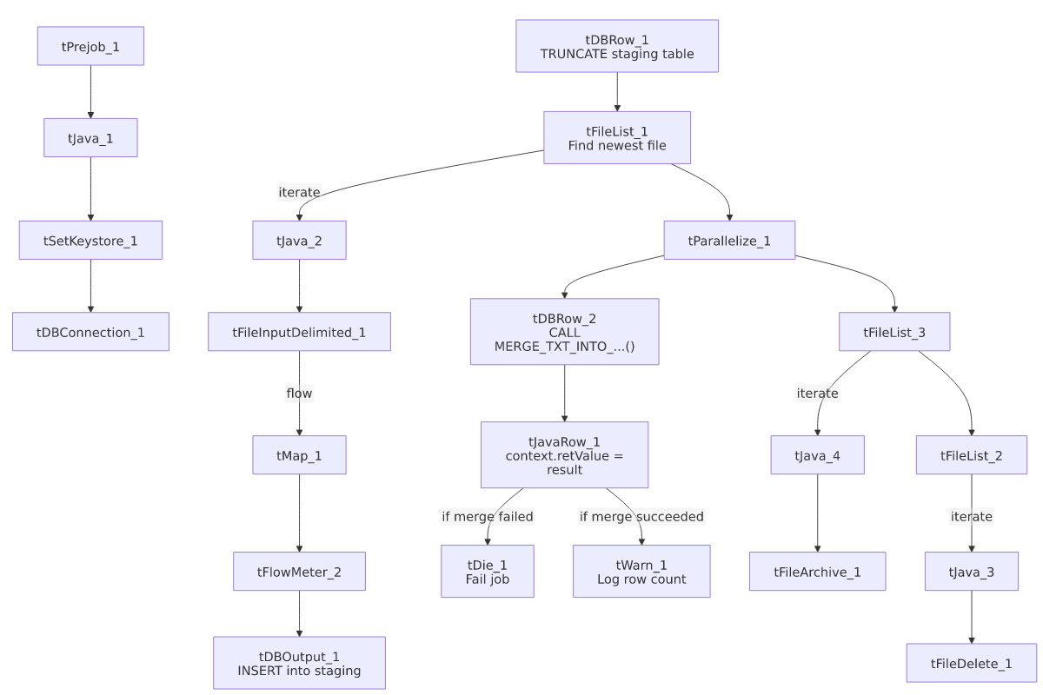

Settings tables

Source: `tFileInputDelimited_1`
Setting | Value | What it means
FILENAME | context.filePath | Reads whichever file tFileList_1 just found.
FIELDSEPARATOR / ROWSEPARATOR | `\ | ~\
ENCODING | US-ASCII | Notably plain ASCII here, not ISO-8859-15 like Address_Text_Load — worth confirming this is intentional if the file can ever contain non-ASCII characters (e.g., accented names).

Target: `tDBOutput_1`
Setting | Value | What it means
Table | CMI_HERMES_RECOMMENDATIONS | Loads into the staging copy of this table (schema LIQUID_STAGING, per the preceding TRUNCATE).
Output action | INSERT | Adds rows only — no update/delete at this step.

Merge & result check: `tDBRow_2` → `tJavaRow_1` → `tDie_1` / `tWarn_1`
Setting | Value | What it means
Query (tDBRow_2) | CALL MERGE_TXT_INTO_CMI_HERMES_RECOMMENDATIONS(); | Runs the Snowflake procedure that merges staged rows into the permanent table.
tDie_1 message | "MERGE failed - error code " + context.retValue (exit code 4) | Fails the job outright if the merge reports an error.
tWarn_1 message | context.retValue + " rows inserted or updated" (severity 42) | Logs a row count and continues if the merge succeeded — this job does not hard-fail on a successful merge.

Dependencies & configuration
- Triggers/depends on other jobs: none — no tRunJob links found.
- Context variables used: context.sourceDir, context.archiveDir, context.filePath, context.fileName, context.logDir, context.keystorePath (all Directories_0.1). Like Address_Text_Load, it uses the shared Snowflake connection object rather than referencing LEGACY_DW_0.1 variables by name.
- Related jobs: cmi_VoApp_Results_Load, Dialer_CallTracking_Load, master_prediction_proposal_Load, and PatientInfo_Text_Load follow the same truncate → load → merge → die/warn pattern (see 05_operational_runbook.md).

Glossary
Component type | Plain-English meaning
tDie | Fails the job immediately with a specific message and exit code — used here when the merge procedure reports failure.
tWarn | Logs a warning message without failing the job — used here to record how many rows the merge affected when it succeeds.
tJavaRow | A small custom-code step that runs once per row (or, as used here, once to capture a single returned value) — here it copies the merge procedure's return value into a context variable so tDie/tWarn can react to it.
Snowflake reject columns (columnName, rowNumber, errorMessage, sqlState, code, etc.) | Extra schema columns Snowflake's output component adds automatically to capture details about any row that fails to load — not part of the actual CMI_HERMES_RECOMMENDATIONS business data.
(See job_Address_Text_Load.md for the shared components — tFileList, tFileInputDelimited, tMap, tFlowMeter, tFileArchive, tFileDelete, tSetKeystore — which behave the same way here.)

Issues observed
- The pass/fail condition itself isn't in the metadata. The job clearly branches on context.retValue (one path to tDie_1, one to tWarn_1, both wired as RUN_IF links), but the actual condition expression on each link isn't captured by the extractor — only that both branches exist. Confirm the exact success/failure threshold with the job's author or in Talend Studio directly before relying on this write-up for incident response.
- File encoding differs from other jobs in the project (US-ASCII here vs. ISO-8859-15 in Address_Text_Load and most peers) — flagging in case this is accidental rather than intentional, since a non-ASCII character in a Hermes file would fail to load without an obvious explanation.
- The merge procedure's own logic is outside Talend, same caveat as every other job that calls a MERGE_TXT_INTO_* procedure (see 04_data_lineage_map.md).

