Talend Job: cmi_Score_Text_Load

Overview
This job loads collectability/propensity scores per account (an original score, an adjusted score, and a dollar-value score, plus the date the score was added) into Snowflake. It follows the standard truncate → load → merge → archive/delete pattern, with a small formatting quirk in the file reader's escape/enclosure settings.

Detail table
Field | Value
Job name | cmi_Score_Text_Load
Version | 0.1
Project | LATITUDE
Author | jmach@harriscollect.com
Created | 2024-11-20T08:30:38.291-0800
Last Modified | 2025-09-29T21:45:27.299-0700

Step-by-step data flow
- Set up. tPrejob_1 triggers tJava_4, which appends today's date to context.archiveDir and opens a log file; this chains into tSetKeystore_1 and tDBConnection_1.
- Empty the staging table. tDBRow_1 runs TRUNCATE TABLE CMI_SCORE_TXT; (no explicit schema prefix — see Issues observed).
- Find the file. tFileList_1 lists files in context.sourceDir (skipping *.txt), with no explicit sort order.
- Read and reshape the file. tFileInputDelimited_1 reads the file as pipe-delimited (|~| fields, |$| rows), US-ASCII encoded, with a header row, covering account ID, original score, adjusted score, dollar score, and date added. Its ESCAPE_CHAR and TEXT_ENCLOSURE settings are both configured as empty strings, unlike most peer jobs which set both to a double quote (") — see Issues observed. tMap_1 maps these onto the CMI_SCORE_TXT schema, adding LOAD_DT.
- Load staging. Mapped rows flow directly into tDBOutput_1 (no row counter), inserting into CMI_SCORE_TXT.
- Merge and clean up — in parallel. Once the file-list subjob completes, tParallelize_1 splits into: tDBRow_2 calling CALL MERGE_TXT_INTO_CMI_SCORE();, and a file-listing chain (tFileList_2 → archive via tFileArchive_1; then tFileList_3 → delete via tFileDelete_1, with FAILON: true — a failed delete here does fail the job, unlike most peer jobs).
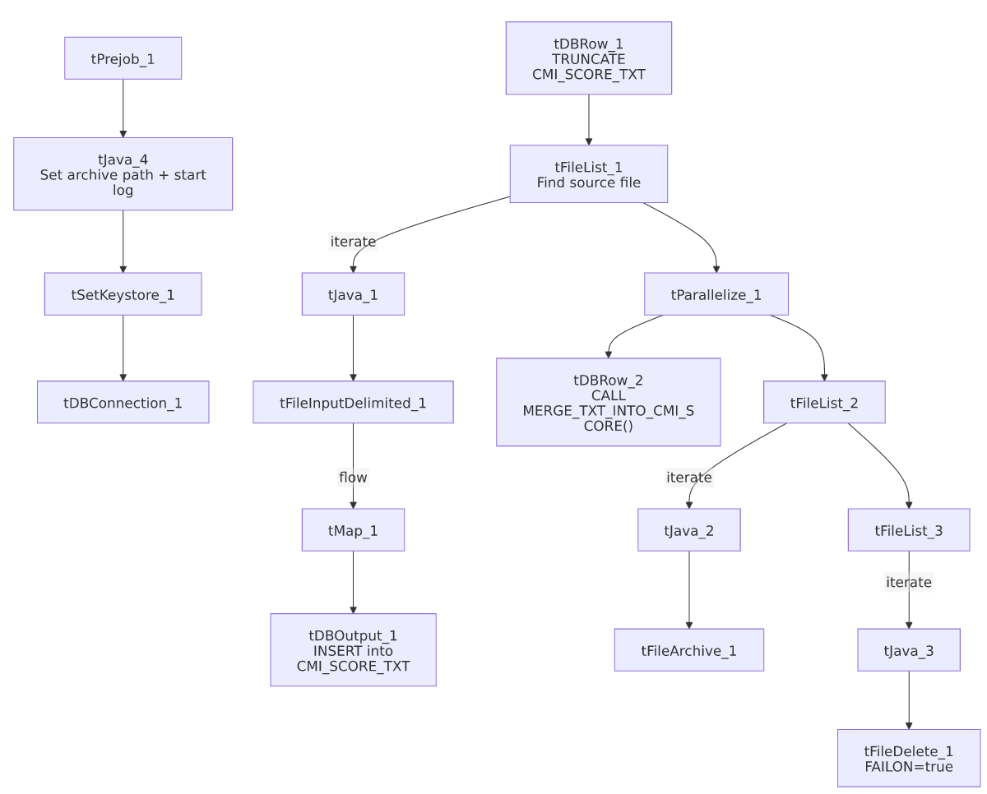

Settings tables

Source: `tFileInputDelimited_1`
Setting | Value | What it means
FILENAME | context.filePath | Reads whichever file tFileList_1 just found.
FIELDSEPARATOR / ROWSEPARATOR | `\ | ~\
ESCAPE_CHAR / TEXT_ENCLOSURE | "" / "" (empty) | No escape or text-enclosure character is configured — unlike most peer jobs, which use " for both.
ENCODING | US-ASCII | Plain ASCII text.

Target: `tDBOutput_1`
Setting | Value | What it means
Table | CMI_SCORE_TXT | Staging table for score records.
Output action | INSERT | Adds rows only.

Merge step: `tDBRow_2`
Setting | Value | What it means
Query | CALL MERGE_TXT_INTO_CMI_SCORE(); | Snowflake procedure that folds staged rows into the permanent CMI_SCORE table.

Delete step: `tFileDelete_1`
Setting | Value | What it means
FAILON | true | Unlike most peer jobs, a failed delete of the source file does fail this job.

Dependencies & configuration
- Triggers/depends on other jobs: none found — no tRunJob links.
- Context variables used: context.sourceDir, context.archiveDir, context.filePath, context.fileName, context.logDir, context.keystorePath (all Directories_0.1). Uses the shared Snowflake connection object, not LEGACY_DW_* variables directly.
- Hardcoded values found: tFileInputDelimited_1.TEMP_DIR, tFileArchive_1.SOURCE_FILE, tFileDelete_1.DIRECTORY/PATH, and tSetKeystore_1.SSL_TRUSTSERVER_TRUSTSTORE are fixed paths rather than context variables.

Glossary
Component type | Plain-English meaning
tPrejob / tParallelize | Setup-before-main-start, concurrent branches (see job_Address_Text_Load.md).
tFileList | Lists files for the job to loop over (see job_Address_Text_Load.md).
tFileInputDelimited | Reads a delimited text file (see job_Address_Text_Load.md).
tMap | Maps/transforms columns (see job_Address_Text_Load.md).
tDBOutput / tSnowflakeOutput | Writes rows into Snowflake (see job_Address_Text_Load.md).
tDBRow / tSnowflakeRow | Runs a single SQL statement (see job_Address_Text_Load.md).
tJava | Custom Java code block (see job_Address_Text_Load.md).
tFileArchive | Zips a file into an archive location (see job_Address_Text_Load.md).
tFileDelete | Deletes a file from disk (see job_Address_Text_Load.md).
tSetKeystore | Configures the SSL keystore for the Snowflake connection (see job_Address_Text_Load.md).

Issues observed
- `ESCAPE_CHAR`/`TEXT_ENCLOSURE` are both empty on the file reader, unlike most peer jobs which use " for both — meaning a value in this file that happens to contain a literal |~| or |$| sequence (or an embedded quote) has no defined escaping. Worth confirming with the team that score data can never legitimately contain those sequences.
- The staging truncate doesn't qualify its schema (TRUNCATE TABLE CMI_SCORE_TXT;, no LIQUID_STAGING. prefix) — same pattern as several other jobs in this batch.
- `tFileDelete_1.FAILON` is `true` here, unlike most peer jobs (false) — a failed file delete will fail this job outright, a stricter posture worth being aware of operationally.
- No row-count logging — no tFlowMeter component between tMap_1 and tDBOutput_1.
- The merge procedure's own logic is outside Talend and not visible in this metadata.

