Talend Job: cmi_dialer_SubscriberStatusHistory_Text_Load

Overview
This job loads a history of dialer subscriber SMS/text opt-in and opt-out status changes (CMI_DIALER_SUBSCRIBERSTATUSHISTORY — company code, phone number, event timestamp, and various opt-in/opt-out flags) into Snowflake. It follows the project's standard truncate → load → merge → archive/delete pattern, with one small gap compared to peers: it has no row-count (tFlowMeter) component in its load path.

Detail table
Field | Value
Job name | cmi_dialer_SubscriberStatusHistory_Text_Load
Version | 0.1
Project | LATITUDE
Author | jmach@harriscollect.com
Created | 2025-10-07T08:30:13.203-0700
Last Modified | 2026-07-12T14:09:46.200-0700

Step-by-step data flow
- Set up. tPrejob_1 → tJava_4 (appends today's date to context.archiveDir, opens a log file) → tSetKeystore_1 → tDBConnection_1.
- Empty the staging table. tDBRow_1 runs TRUNCATE TABLE CMI_DIALER_SUBSCRIBERSTATUSHISTORY_TXT; (no LIQUID_STAGING. schema prefix).
- Find and read the file. tFileList_1 lists files in context.sourceDir (excluding *.txt, no particular sort order); tJava_1 captures the path; tFileInputDelimited_1 reads it (|~|/|$|, header row, US-ASCII encoding, DIE_ON_ERROR=true).
- Transform and load staging. tMap_1 maps SUBSCRIBERSTATUSHISTORYID, COMPANYCODE, PHONENUMBER, EVENTOCCURREDAT, STATUSCHANGEDFROM, and the opt-in/opt-out flags (OPTEDIN, OPTINPENDING, OPTINDELIVERED, OPTOUTOVERRIDE, CANOPTIN) onto the staging schema, adding LOAD_DT. Rows flow directly into tDBOutput_1 — there is no tFlowMeter row-count step in this job's load path, unlike most peers.
- Merge and clean up — in parallel. tParallelize_1 splits into:
- Merge branch: tDBRow_2 runs CALL MERGE_TXT_INTO_CMI_DIALER_SUBSCRIBERSTATUSHISTORY();.
- Cleanup branch: tFileList_2 → tJava_2 (captures path + name) → tFileArchive_1 (zips into context.archiveDir); and tFileList_3 → tJava_3 (captures path only, no fileName — but this branch only feeds tFileDelete_1, which doesn't need fileName, so this isn't a functional gap) → tFileDelete_1 (deletes the source file; FAILON=true, like HH_Violation_Text_Load).
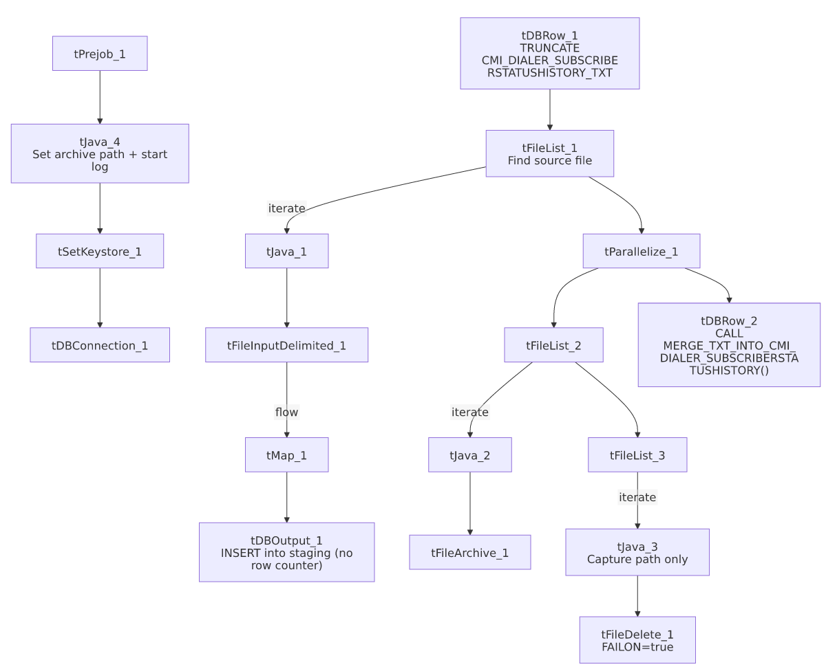

Settings tables

Source: `tFileInputDelimited_1`
Setting | Value | What it means
FILENAME | context.filePath | Reads whichever file tFileList_1 just found.
FIELDSEPARATOR / ROWSEPARATOR | `\ | ~\
ENCODING | US-ASCII | Plain ASCII.
DIE_ON_ERROR | true | A malformed row fails the job immediately.
TEMP_DIR | "C:/Talend-Studio-.../workspace" | Hardcoded Windows path.

Target: `tDBOutput_1`
Setting | Value | What it means
Table | CMI_DIALER_SUBSCRIBERSTATUSHISTORY_TXT | Loads into the staging copy of the table.
Output action | INSERT | Adds rows only.
Table action | NONE | Table structure untouched.

Merge step: `tDBRow_2`
Setting | Value | What it means
Query | CALL MERGE_TXT_INTO_CMI_DIALER_SUBSCRIBERSTATUSHISTORY(); | Runs the Snowflake merge procedure, unqualified — the project's more common style.

Delete: `tFileDelete_1`
Setting | Value | What it means
FAILON | true | If deleting the source file fails, the job fails outright — stricter than the project default of false (seen in Bankruptcy_Text_Load, Debtor_Table_Text_Load, MiscExtra_Text_Load, etc.), but consistent with HH_Violation_Text_Load.

Dependencies & configuration
- Triggers/depends on other jobs: none found — no tRunJob links.
- Context variables used: context.sourceDir, context.archiveDir, context.filePath, context.fileName, context.logDir, context.keystorePath (all Directories_0.1). Uses the shared Snowflake connection object, not LEGACY_DW_0.1 variables directly.

Glossary
Component type | Plain-English meaning
tPrejob / tParallelize | Job-flow control (see job_Address_Text_Load.md).
tSnowflakeConnection (tDBConnection) | Opens the shared Snowflake connection (see job_Bankruptcy_Text_Load.md).
tFileList | Lists files for iteration (see job_Address_Text_Load.md).
tFileInputDelimited | Reads a delimited text file (see job_Address_Text_Load.md).
tMap | Maps/transforms columns (see job_Address_Text_Load.md).
tDBOutput / tSnowflakeOutput | Writes rows to Snowflake (see job_Address_Text_Load.md).
tDBRow / tSnowflakeRow | Runs a single SQL statement (see job_Address_Text_Load.md).
tJava | Custom Java code block (see job_Address_Text_Load.md).
tFileArchive | Zips a file into an archive location (see job_Address_Text_Load.md).
tFileDelete | Deletes a file (see job_Address_Text_Load.md).
tSetKeystore | Configures the SSL keystore (see job_Address_Text_Load.md).

Issues observed
- No `tFlowMeter` row-count component between tMap_1 and tDBOutput_1 — every other Text_Load job in this batch of 9 includes one at this point in the flow; this job's row-count activity would not be logged the same way.
- `TRUNCATE TABLE CMI_DIALER_SUBSCRIBERSTATUSHISTORY_TXT;` omits the `LIQUID_STAGING.` schema prefix used explicitly in several peer jobs — likely resolves correctly if the connection's default schema is LIQUID_STAGING, but worth confirming.
- `tFileDelete_1.FAILON` is `true`, a stricter setting than most peers (only shared with HH_Violation_Text_Load among this batch) — a failed delete here fails the whole job.
- This job handles consent/opt-in data (OPTEDIN, OPTOUTOVERRIDE, CANOPTIN) which is typically subject to TCPA-related compliance requirements; nothing in the metadata indicates special handling (encryption, access restriction) beyond the standard load pattern — worth confirming this matches the organization's data-handling policy for consent records.
- Hardcoded, machine-specific paths on tFileInputDelimited_1.TEMP_DIR, tFileArchive_1.SOURCE_FILE, tFileDelete_1.DIRECTORY/PATH, and tSetKeystore_1.SSL_TRUSTSERVER_TRUSTSTORE — the same project-wide pattern seen elsewhere.

