Talend Job: master_prediction_proposal_Load

Overview
This job loads predicted-outreach proposals (which contact channel and message template to try next for an account, the associated phone number, subteam, text type, and a proposed settlement amount, plus VoApps-specific fields for voice message delivery) into Snowflake. It follows the truncate → load → check-result → archive/delete pattern seen in other jobs with explicit merge-result handling, but with one important difference: the step that folds staged rows into the permanent table is an `INSERT` stored procedure, not a `MERGE` — the only job in this set of 9 where that's true.

Detail table
Field | Value
Job name | master_prediction_proposal_Load
Version | 0.1
Project | LATITUDE
Author | jmach@harriscollect.com
Created | 2026-03-11T14:43:22.039-0700
Last Modified | 2026-03-12T19:47:23.647-0700

Step-by-step data flow
- Set up. tPrejob_1 triggers tJava_1, which appends today's date to context.archiveDir and opens a log file; this chains into tSetKeystore_1 and tDBConnection_1.
- Empty the staging table. tDBRow_2 runs TRUNCATE TABLE LIQUID_STAGING.MASTER_PREDICTION_PROPOSAL; (component named _2, not _1 — see Issues observed for the numbering quirk, same pattern as Dialer_CallTracking_Load).
- Find the file. tFileList_1 lists files in context.sourceDir (skipping *.txt), explicitly sorted by modified date, ascending — oldest file first, the same pattern used by Dialer_CallTracking_Load, ScheduledPayment_Text_Load, and Voapps_Response_Load.
- Read the file. tFileInputDelimited_1 reads it with FIELDSEPARATOR: "," and ROWSEPARATOR: "\n" — comma-delimited, not the project's usual pipe format (the same deviation seen in Voapps_Response_Load, and unsurprising given this data includes the same VoApps-related columns). US-ASCII encoded, DIE_ON_ERROR: false.
- Transform. tMap_1 maps the columns (account number, proposed channel, template, phone number, subteam, text type, settlement amount, and the VoApps target date/caller number/message ID/zip code/voice-append flag/Hermes request ID) onto the MASTER_PREDICTION_PROPOSAL schema, adding LOAD_DT.
- Load staging. Mapped rows pass through a row counter (tFlowMeter_2) into tDBOutput_1, inserting into MASTER_PREDICTION_PROPOSAL.
- Insert into the permanent table and check the result — in parallel with cleanup. Once the file-list subjob completes, tParallelize_1 splits into:
- Insert branch: tDBRow_1 calls CALL INSERT_TXT_INTO_MASTER_PREDICTION_PROPOSAL(); — note the procedure name itself says INSERT_TXT_INTO_..., not MERGE_TXT_INTO_... like every other job in this project. tJavaRow_1 copies the returned value into context.retValue, and the job runs tDie_1 (fails the job: "MERGE failed - error code " + context.retValue", exit code 4 — note the error message text still says "MERGE failed" even though the underlying procedure is an insert, likely copy-pasted from the standard pattern) or tWarn_1 (logs "<count> rows inserted or updated", severity 42) depending on the outcome.
- Cleanup branch: the source file is listed again (tFileList_3), archived (tFileArchive_1); a second listing (tFileList_2) drives deletion (tFileDelete_1, with FAILON: true).
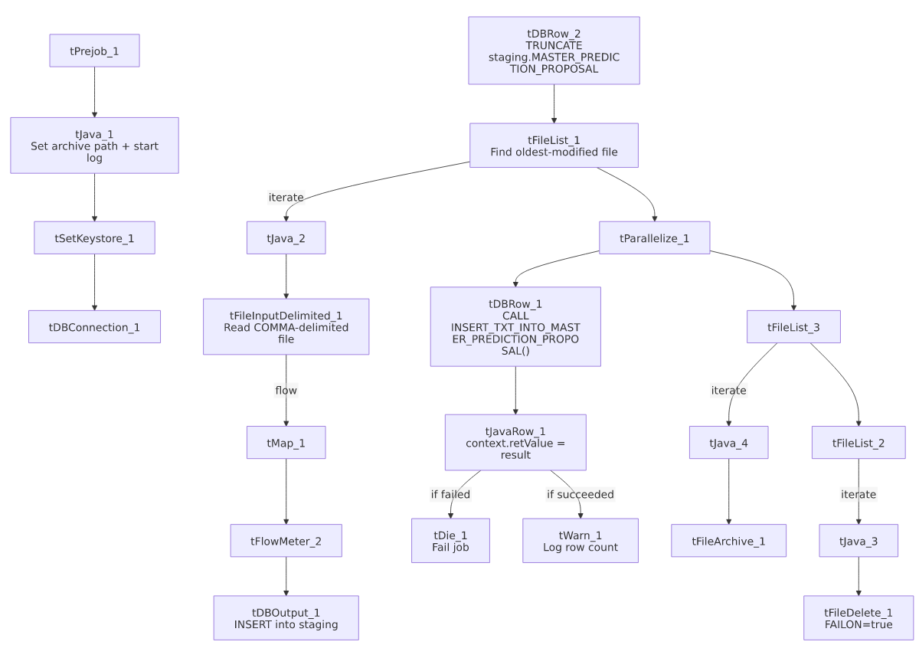

Settings tables

Source: `tFileInputDelimited_1`
Setting | Value | What it means
FILENAME | context.filePath | Reads whichever file tFileList_1 just found.
FIELDSEPARATOR | , | Comma-separated — not the project's usual `\
ROWSEPARATOR | \n | Plain newline-delimited rows.
ENCODING | US-ASCII | Plain ASCII text.
DIRECTORY ordering (tFileList_1) | ORDER_BY_MODIFIEDDATE=true, ascending | Explicitly processes the oldest untouched file first.

Target: `tDBOutput_1`
Setting | Value | What it means
Table | MASTER_PREDICTION_PROPOSAL | Staging table for prediction/proposal records.
Output action | INSERT | Adds rows only.

Insert step & result check: `tDBRow_1` → `tJavaRow_1` → `tDie_1` / `tWarn_1`
Setting | Value | What it means
Query (tDBRow_1) | CALL INSERT_TXT_INTO_MASTER_PREDICTION_PROPOSAL(); | Runs a Snowflake procedure that inserts staged rows into the permanent table — an INSERT, not a MERGE, which is the naming convention every other MERGE_TXT_INTO_* procedure in the project follows.
tDie_1 message | "MERGE failed - error code " + context.retValue (exit code 4) | Fails the job if the procedure reports an error. The message text says "MERGE failed" even though the procedure is an insert — likely reused boilerplate from the standard pattern.
tWarn_1 message | context.retValue + " rows inserted or updated" (severity 42) | Logs a row count and continues on success.

Dependencies & configuration
- Triggers/depends on other jobs: none found — no tRunJob links.
- Context variables used: context.sourceDir, context.archiveDir, context.filePath, context.fileName, context.logDir, context.keystorePath, context.retValue (all Directories_0.1 plus the job-local retValue). Uses the shared Snowflake connection object, not LEGACY_DW_* variables directly.
- Related jobs: the loaded hermes_request_id and VoApps columns closely mirror those in Voapps_Response_Load and the Hermes recommendation jobs, though no tRunJob link exists between them.
- Hardcoded values found: tSetKeystore_1.SSL_TRUSTSERVER_TRUSTSTORE, tFileInputDelimited_1.TEMP_DIR, tFileDelete_1.DIRECTORY/PATH, and tFileArchive_1.SOURCE_FILE are fixed paths rather than context variables.

Glossary
Component type | Plain-English meaning
tPrejob / tParallelize | Setup-before-main-start, concurrent branches (see job_Address_Text_Load.md).
tFileList | Lists files for the job to loop over (see job_Address_Text_Load.md).
tFileInputDelimited | Reads a delimited text file (see job_Address_Text_Load.md).
tMap | Maps/transforms columns (see job_Address_Text_Load.md).
tFlowMeter | Counts rows passing a point, for logging (see job_Address_Text_Load.md).
tDBOutput / tSnowflakeOutput | Writes rows into Snowflake (see job_Address_Text_Load.md).
tDBRow / tSnowflakeRow | Runs a single SQL statement (see job_Address_Text_Load.md).
tJava / tJavaRow | Custom code blocks; tJavaRow here captures the insert procedure's return value (see job_cmi_Hermes_Recommendations_Load.md).
tDie | Fails the job immediately with a message and exit code (see job_cmi_Hermes_Recommendations_Load.md).
tWarn | Logs a warning without failing the job (see job_cmi_Hermes_Recommendations_Load.md).
tFileArchive | Zips a file into an archive location (see job_Address_Text_Load.md).
tFileDelete | Deletes a file from disk (see job_Address_Text_Load.md).
tSetKeystore | Configures the SSL keystore for the Snowflake connection (see job_Address_Text_Load.md).

Issues observed
- This job calls an `INSERT` procedure, not a `MERGE` procedure — unlike every other load job in the project. INSERT_TXT_INTO_MASTER_PREDICTION_PROPOSAL() inserts staged rows rather than reconciling (matching/updating/inserting) them the way MERGE_TXT_INTO_* procedures do elsewhere. This raises a real question of whether reprocessing the same source file (or reprocessing after a failed run) would insert duplicate rows into the permanent `MASTER_PREDICTION_PROPOSAL` table, since there's no merge-key matching to prevent it. This should be confirmed with whoever owns the Snowflake procedure — is there deduplication logic inside the procedure itself, or is this table expected to only ever receive strictly new, never-repeated rows?
- The `tDie_1` failure message says "MERGE failed" even though the procedure being called is an insert — cosmetic, but could mislead someone triaging a failure log into looking for merge-specific issues that don't apply here.
- Component numbering is reversed from the usual convention (tDBRow_1 = the insert/proc call, tDBRow_2 = the truncate) — same quirk as Dialer_CallTracking_Load.
- Source file format deviates from the project standard — comma-delimited rather than the usual \|~\|/\|$\| pipe format, consistent with Voapps_Response_Load's similar VoApps-related data.
- The exact pass/fail threshold on `context.retValue` isn't in the metadata — same caveat as the other tDie/tWarn jobs in this project.
- File pickup order deviates from the norm — explicitly oldest-first.

