Talend Job: Address_Text_Load

Overview
This job is one of roughly four dozen near-identical "text load" jobs in the LATITUDE project: it watches a shared folder for a new address-data file, loads its rows into a Snowflake staging table, merges that staging data into the permanent ADDRESS table using a Snowflake stored procedure, and then archives and deletes the source file so it isn't picked up again. It has no scheduling information in this metadata — something outside Talend (a scheduler or trigger) decides when it runs.

Detail table
Field | Value
Job name | Address_Text_Load
Version | 0.1
Project | LATITUDE
Author | jmach@harriscollect.com
Created | 2025-08-04T10:40:42.490-0700
Last Modified | 2026-07-12T13:49:17.054-0700

Step-by-step data flow
- Set up. The job connects to Snowflake (tDBConnection_1) and appends today's date to the archive path it will use later (context.archiveDir = context.archiveDir + <yyyyMMdd> + "/"), and starts a log file for this run.
- Empty the staging table. tDBRow_1 runs TRUNCATE TABLE LIQUID_STAGING.ADDRESS; — wiping out whatever staging data was left from the previous run before loading anything new.
- Find the file. tFileList_1 lists the files sitting in context.sourceDir, newest-modified first, and skips anything ending in .txt. Its first matching file becomes context.filePath.
- Read and reshape the file. tFileInputDelimited_1 reads that file as a pipe-delimited file (columns separated by |~|, rows separated by |$|, with a header row). tFileProperties_1 grabs the file's last-modified timestamp, and a small piece of custom code (tJavaRow_1) copies that timestamp into context.lastModified so it can be stamped onto every row. tMap_1 then maps the file's columns onto the ADDRESS table's columns.
- Load staging. The mapped rows flow through a row counter (tFlowMeter_1) into tDBOutput_1, which inserts them into the ADDRESS table in Snowflake (action: INSERT, no table-structure changes).
- Merge into the permanent table. In parallel (tParallelize_1), the job calls CALL MERGE_TXT_INTO_ADDRESS(); (tDBRow_2) — a Snowflake stored procedure that reconciles the newly staged rows into whatever the real, permanent ADDRESS table is. What that procedure actually does (which columns it matches on, whether it's really LIQUID_STAGING.ADDRESS → some other schema) is not visible in this metadata — see Issues observed.
- Archive and clean up. The same source file is then zipped into the archive folder (tFileArchive_1, target context.archiveDir/<filename>.zip) and deleted from the source folder (tFileDelete_1).
- Security setup. tSetKeystore_1 configures the SSL client keystore (context.keystorePath) used for the Snowflake connection.
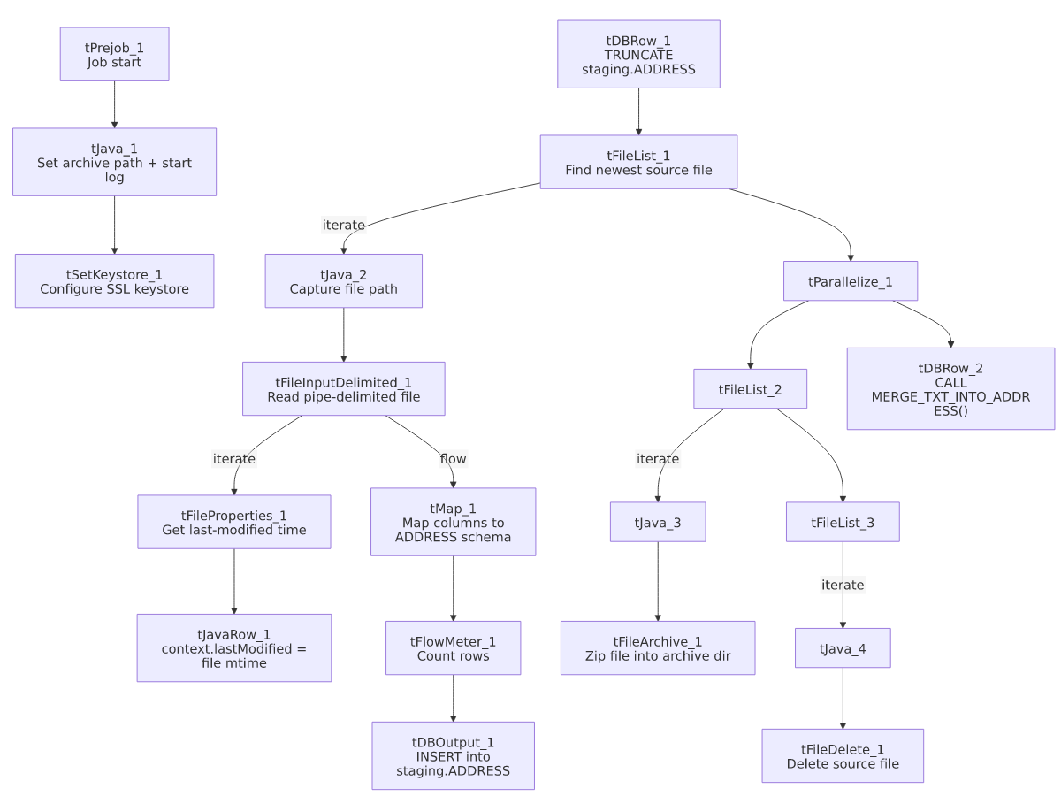

Settings tables

Source: `tFileInputDelimited_1` (reads the source file)
Setting | Value | What it means
FILENAME | context.filePath | Reads whichever file tFileList_1 just found — not a fixed filename.
FIELDSEPARATOR | `\ | ~\
ROWSEPARATOR | `\ | $\
HEADER | 1 | The first line of the file is a header row, not data.
ENCODING | ISO-8859-15 | The file is read as Western European (ISO-8859-15) text, not UTF-8.
EXCLUDEFILEMASK (on tFileList_1) | *.txt | .txt files in the source folder are skipped — the expected input is not a plain .txt extension.

Target: `tDBOutput_1` (loads the Snowflake staging table)
Setting | Value | What it means
Table | ADDRESS | Writes into a table named ADDRESS (in the LIQUID_STAGING schema, per the TRUNCATE statement just before it).
Output action | INSERT | Adds rows; it does not update or delete existing ones (that happens later, in the merge step).
Table action | NONE | Does not create, drop, or truncate the table itself — truncation is done separately by tDBRow_1.

Merge step: `tDBRow_2`
Setting | Value | What it means
Query | CALL MERGE_TXT_INTO_ADDRESS(); | Runs a Snowflake stored procedure (defined outside Talend) that folds the staged rows into the real, permanent table.

Dependencies & configuration
- Triggers/depends on other jobs: none found — this job has no tRunJob links to or from any other job in the extracted metadata.
- Context variables used: context.sourceDir, context.archiveDir, context.filePath, context.fileName, context.logDir, context.keystorePath, context.lastModified (all from the Directories_0.1 context group, plus one job-local variable lastModified set at runtime). It does not reference the LEGACY_DW_0.1 (Snowflake credential) context group by name — its Snowflake connection is a shared, repository-linked connection object instead (see 06_dependency_matrix.md).
- Hardcoded values found: tFileArchive_1's SOURCE_FILE (C:/Talend-Studio-20211109_1610-V8.0.1/workspace/source.csv), tFileDelete_1's DIRECTORY/PATH (C:/Talend-Studio-20211109_1610-V8.0.1/workspace/delete_folder...), tFileInputDelimited_1's TEMP_DIR, and tSetKeystore_1's SSL_TRUSTSERVER_TRUSTSTORE (C:/clientTrustStore.trustStore) are all fixed Windows paths rather than context variables — see Issues observed.

Glossary
Component type | Plain-English meaning
tPrejob / tParallelize | Job-flow control: tPrejob marks setup steps that must finish before the main job starts; tParallelize runs its downstream branches at the same time instead of one after another.
tFileList | Lists files in a folder (optionally matching a pattern), one at a time, so the job can loop over them.
tFileInputDelimited | Reads a delimited (e.g., pipe- or comma-separated) text file row by row.
tFileProperties | Reads file-system metadata about a file (like its last-modified time) rather than its contents.
tMap | Maps and transforms columns from an input format into an output format — the core "translate columns" step.
tFlowMeter | Counts how many rows pass through a point in the job, for logging/monitoring.
tDBOutput / tSnowflakeOutput | Writes rows into a database table — here, Snowflake.
tDBRow / tSnowflakeRow | Runs a single SQL statement against the database (not a full data flow) — used here for TRUNCATE and CALL <procedure>.
tJava / tJavaRow | A small block of custom Java code — used here for simple string/date manipulation the built-in components don't cover.
tFileArchive | Compresses a file (here, into a .zip) and moves it to an archive location.
tFileDelete | Deletes a file from disk.
tSetKeystore | Configures the SSL certificate/keystore used for secure connections (here, for the Snowflake connection).

Issues observed
- The real merge target and logic are invisible from Talend. CALL MERGE_TXT_INTO_ADDRESS(); is a Snowflake stored procedure; its body (and therefore the actual permanent table name, join keys, and update logic) isn't part of this metadata. Confirm with whoever owns Snowflake stored procedures what MERGE_TXT_INTO_ADDRESS actually does.
- Several hardcoded, machine-specific paths exist alongside otherwise-parameterized ones: tFileArchive_1.SOURCE_FILE, tFileDelete_1.DIRECTORY/PATH, tFileInputDelimited_1.TEMP_DIR, and tSetKeystore_1.SSL_TRUSTSERVER_TRUSTSTORE are all fixed to a specific C:/Talend-Studio-20211109_1610-V8.0.1/... or C:/clientTrustStore.trustStore path rather than a context variable, unlike sourceDir/archiveDir/keystorePath, which are already parameterized. This is the same pattern flagged project-wide in 05_operational_runbook.md (51 of 56 jobs) — it means this job is very likely tied to running on one specific machine/install today.
- No explicit error handling on the merge step. Unlike cmi_Hermes_Recommendations_Load and seven other jobs (see 05_operational_runbook.md), this job has no tDie/tWarn component reacting to whether MERGE_TXT_INTO_ADDRESS() succeeded — a failed merge here would only surface as whatever generic error Talend produces, not a job-specific message.

