Talend Job: DeskChangeHistory_Text_Load

Overview
This job loads records of "desk" reassignment history (which collections desk/queue-level an account moved between, and when) into Snowflake. It follows the standard text-load pattern: watch a shared folder for a new file, truncate a staging table, load the file, merge into the permanent DESKCHANGEHISTORY table via a Snowflake stored procedure, and archive/delete the source file.

Detail table
Field | Value
Job name | DeskChangeHistory_Text_Load
Version | 0.1
Project | LATITUDE
Author | jmach@harriscollect.com
Created | 2025-08-05T06:44:11.665-0700
Last Modified | 2026-04-30T09:32:10.950-0700

Step-by-step data flow
- Set up. tPrejob_1 starts the job; tJava_1 appends today's date to the archive path and opens a log file, then tSetKeystore_1 configures the SSL keystore and tDBConnection_1 opens the Snowflake connection.
- Empty the staging table. tDBRow_1 runs TRUNCATE TABLE LIQUID_STAGING.DESKCHANGEHISTORY;.
- Find the file. tFileList_1 lists files in context.sourceDir (skipping .txt), sorted by last-modified date. The match becomes context.filePath (tJava_2).
- Read and reshape. tFileInputDelimited_1 reads the file as pipe-delimited (|~| fields, |$| rows), UTF-8 encoded, with a header row. It also feeds tFileProperties_1, which reads the file's last-modified timestamp; tJavaRow_1 copies that timestamp into context.lastModified. tMap_1 maps the file's columns (plus LOAD_DT and LASTMODIFIED) onto the DESKCHANGEHISTORY schema.
- Load staging. Mapped rows pass through a row counter (tFlowMeter_1) into tDBOutput_1, which inserts them into the staging table.
- Merge and cleanup — in parallel. tParallelize_1 splits into two branches:
- Merge branch: tDBRow_2 runs CALL LIQUID_STAGING.MERGE_TXT_INTO_DESKCHANGEHISTORY(); — note the procedure call is schema-qualified (LIQUID_STAGING.) here, unlike most peer jobs' unqualified CALL MERGE_TXT_INTO_...() (see Issues observed). No tDie/tWarn reacts to its result.
- Cleanup branch: the file is listed again (tFileList_2/tFileList_3), archived as a .zip into context.archiveDir (tFileArchive_1), and deleted (tFileDelete_1, with FAILON=true — see Issues observed).
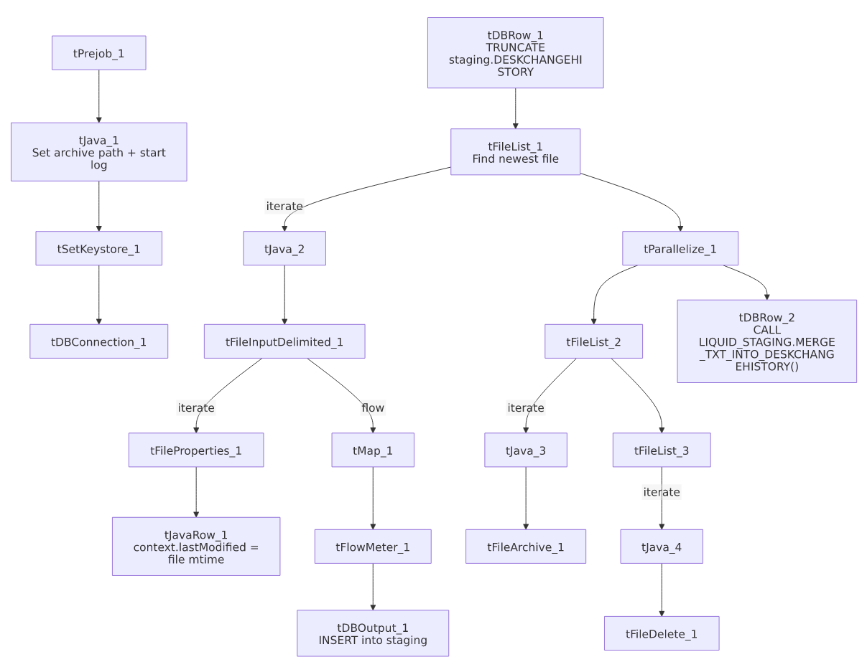

Settings tables

Source: `tFileInputDelimited_1`
Setting | Value | What it means
FILENAME | context.filePath | Reads whichever file tFileList_1 just found.
FIELDSEPARATOR / ROWSEPARATOR | `\ | ~\
ENCODING | UTF-8 | Differs from Address_Text_Load (ISO-8859-15) and Carrier_Text_Load/cmi_Hermes_Recommendations_Load (US-ASCII) — three different encodings across otherwise similar jobs.
DIE_ON_ERROR | true | The file read step fails the job outright on a parse error (many peer jobs set this false).
EXCLUDEFILEMASK (on tFileList_1) | *.txt | .txt files are skipped.

Target: `tDBOutput_1`
Setting | Value | What it means
Table | DESKCHANGEHISTORY | Loads into the staging copy of this table.
Output action | INSERT | Adds rows only.
Table action | NONE | No table create/drop/truncate here — done separately by tDBRow_1.

Truncate & merge: `tDBRow_1` / `tDBRow_2`
Setting | Value | What it means
Query (tDBRow_1) | TRUNCATE TABLE LIQUID_STAGING.DESKCHANGEHISTORY; | Empties staging before load.
Query (tDBRow_2) | CALL LIQUID_STAGING.MERGE_TXT_INTO_DESKCHANGEHISTORY(); | Runs the Snowflake merge procedure, schema-qualified — see Issues observed.

Cleanup: `tFileDelete_1`
Setting | Value | What it means
FAILON | true | If the delete fails, the job fails — unlike Carrier_Text_Load/Insurance_Text_Load/Result_Table_Text_Load/cmi_Dialer_Plan_History_Table_Text_Load, which set this to false.

Dependencies & configuration
- Triggers/depends on other jobs: none found — no tRunJob links.
- Context variables used: context.sourceDir, context.archiveDir, context.filePath, context.fileName, context.logDir, context.keystorePath, plus the job-local context.lastModified (all Directories_0.1). Uses the shared Snowflake connection object, not LEGACY_DW_0.1 directly.
- Hardcoded values found: tFileInputDelimited_1.TEMP_DIR, tFileArchive_1.SOURCE_FILE, tFileDelete_1.DIRECTORY/PATH, and tSetKeystore_1.SSL_TRUSTSERVER_TRUSTSTORE — same fixed Windows paths seen project-wide.

Glossary
Component type | Plain-English meaning
tPrejob / tParallelize | Job-flow control (see job_Address_Text_Load.md).
tFileList | Lists files in a folder to loop over (see job_Address_Text_Load.md).
tFileInputDelimited | Reads a delimited text file (see job_Address_Text_Load.md).
tFileProperties | Reads file-system metadata like last-modified time (see job_Address_Text_Load.md).
tJavaRow | Custom code that runs per row/once to compute a value — here, copying the file's mtime into context.lastModified (see job_cmi_Hermes_Recommendations_Load.md).
tMap | Maps/transforms columns (see job_Address_Text_Load.md).
tFlowMeter | Counts rows passing a point in the flow (see job_Address_Text_Load.md).
tDBOutput / tSnowflakeOutput | Writes rows to Snowflake (see job_Address_Text_Load.md).
tDBRow / tSnowflakeRow | Runs a single SQL statement (see job_Address_Text_Load.md).
tJava | Custom Java code blocks (see job_Address_Text_Load.md).
tFileArchive | Zips a file into an archive location (see job_Address_Text_Load.md).
tFileDelete | Deletes a file from disk (see job_Address_Text_Load.md).
tSetKeystore | Configures the SSL keystore for Snowflake (see job_Address_Text_Load.md).

Issues observed
- The merge call is schema-qualified here (CALL LIQUID_STAGING.MERGE_TXT_INTO_DESKCHANGEHISTORY();) while nearly every other job in the project calls the equivalent procedure unqualified (CALL MERGE_TXT_INTO_<TABLE>();). This likely still works if the default schema is the same, but it's an inconsistency worth normalizing if these procedures are ever moved between schemas.
- File encoding is UTF-8, a third distinct encoding compared to ISO-8859-15 (Address_Text_Load) and US-ASCII (Carrier_Text_Load, cmi_Hermes_Recommendations_Load) — confirm this is intentional for this specific feed.
- `tFileDelete_1.FAILON` is `true` here, meaning a failed delete fails the whole job — a stricter setting than several peer jobs that tolerate a failed delete (FAILON=false).
- No merge-result checking — no tDie/tWarn reacts to whether the merge succeeded, unlike PatientInfo_Text_Load and cmi_Hermes_Recommendations_Load.
- Hardcoded, machine-specific paths exist alongside the parameterized ones (see Dependencies & configuration) — the same project-wide pattern.

