Talend Job: Master_Table_Text_Load_HC15

Overview
This job loads the "master" debtor/account record — the single widest table in this batch, with roughly 180 business columns covering name/address, balances, dates, queue/desk assignment, attorney and legal-status fields, portfolio/placement history, and an SSN field — from a shared folder into Snowflake. It follows the project's standard truncate-load-merge-archive pattern (see job_Address_Text_Load.md), but adds one step none of this batch's other jobs have: a tDataEncrypt component that encrypts the row data before it reaches the tMap transform. It writes to the same staging table (MASTER_TXT) and calls the same merge procedure (MERGE_TXT_INTO_MASTER()) as a separate job, Master_Table_Text_Load — see Issues observed for the collision risk this creates. It has no scheduling information in this metadata — something outside Talend decides when it runs.

Detail table
Field | Value
Job name | Master_Table_Text_Load_HC15
Version | 0.1
Project | LATITUDE
Author | jmach@harriscollect.com
Created | 2026-07-12T13:21:02.519-0700
Last Modified | 2026-07-12T13:37:05.892-0700

Step-by-step data flow
- Set up. tPrejob_1 starts the job; tJava_2 appends today's date to context.archiveDir and opens a log file; tSetKeystore_1 configures the SSL client keystore; tDBConnection_1 opens the Snowflake connection.
- Empty the staging table. In a separate, parallel start point, tDBRow_1 runs TRUNCATE TABLE MASTER_TXT;.
- Find and read the file. tFileList_1 lists files in context.sourceDir (skipping .txt); tJava_1 captures the found path into context.filePath; tFileInputDelimited_1 reads it as a pipe-delimited, US-ASCII-encoded file (using the repository schema named master) with a header row. DIE_ON_ERROR is set to true here — a malformed row stops the job rather than being skipped.
- Count, then encrypt. The raw rows pass through a row counter (tFlowMeter_7) and then into tDataEncrypt_1, which encrypts the row data using AES before it's transformed (see Settings tables and Issues observed — the specific column(s) targeted for encryption aren't captured explicitly in this metadata, though the schema at this point includes an SSN field).
- Transform, count again, and load. tMap_1 maps the (now partly encrypted) ~180 columns onto the MASTER_TXT schema, adding LOAD_DT. The mapped rows pass through a second row counter (tFlowMeter_4) into tDBOutput_1, which inserts them into Snowflake.
- Merge and clean up — in parallel. tParallelize_1 splits into two branches once the file has been listed:
- Merge branch: tDBRow_2 calls CALL MERGE_TXT_INTO_MASTER();.
- Cleanup branch: the source file is listed again and archived (tFileArchive_1, zipped into context.archiveDir); it's also listed a third time and deleted (tFileDelete_1).
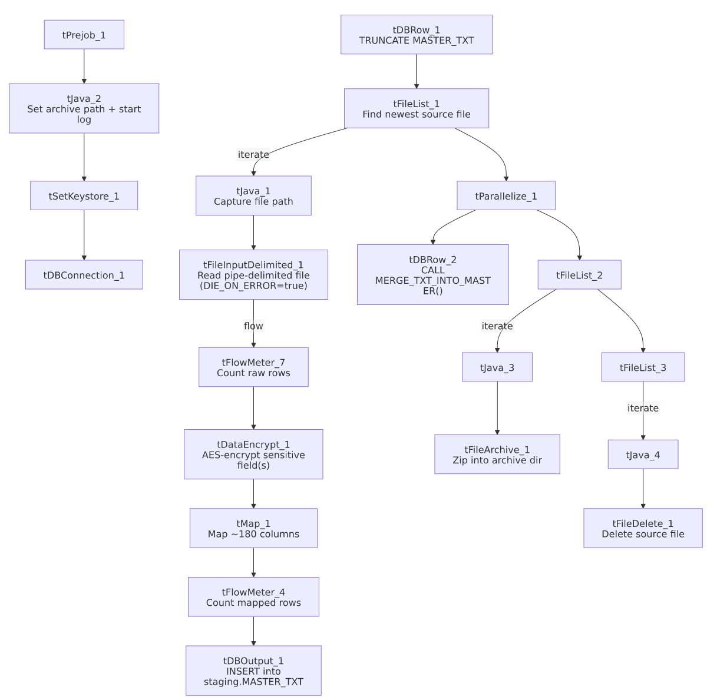

Settings tables

Source: `tFileInputDelimited_1`
Setting | Value | What it means
FILENAME | context.filePath | Reads whichever file tFileList_1 just found.
FIELDSEPARATOR / ROWSEPARATOR | `\ | ~\
HEADER | 1 | First line is a header, not data.
ENCODING | US-ASCII | Plain ASCII, not ISO-8859-15.
DIE_ON_ERROR | true | A malformed row fails the job immediately rather than being skipped — same as cmi_CapioSellerContracts_Table_Text_Load, differs from most peers.
SCHEMA_REJECT:REPOSITORY_SCHEMA_TYPE | master (repository schema) | Uses the same centrally-defined "master" column layout referenced by DebtorCC_Table_Text_Load's reject schema.
EXCLUDEFILEMASK (on tFileList_1) | *.txt | .txt files are skipped.

Encryption: `tDataEncrypt_1`
Setting | Value | What it means
CRYPTO_METHOD | AES | Uses AES symmetric encryption.
ALGO_VERSION | 2 | A version marker for the encryption algorithm/library used — the specific implementation detail lives outside this metadata.
SECRET_TYPE / SECRET_KEY / PASSWORD_M1 | ***REDACTED*** | The encryption key material itself is redacted in this metadata, as expected for a secret.
CRYPTO_FILE_PATH | context.cryptoPath | Points at a file used by the encryption process — this context variable is not one of the Directories_0.1 variables documented in _shared_context.json (see Issues observed).
Which column(s) are encrypted | Unable to determine from metadata — verify with team | The component's schema carries the full ~180-column master record (including SSN), but the specific field(s) actually run through AES encryption aren't captured in the extracted parameters. Given the schema includes an SSN column, that's a reasonable guess, but it isn't confirmed here.

Target: `tDBOutput_1`
Setting | Value | What it means
Table | MASTER_TXT | Loads the staging copy of the master table — the same staging table name used by the separate job `Master_Table_Text_Load` (see Issues observed).
Output action | INSERT | Adds rows only.
Table action | NONE | Truncation is handled separately by tDBRow_1.

Merge step: `tDBRow_2`
Setting | Value | What it means
Query | CALL MERGE_TXT_INTO_MASTER(); | Folds staged rows into the permanent table — the same stored procedure called by `Master_Table_Text_Load` (see Issues observed).

Dependencies & configuration
- Triggers/depends on other jobs: none found — no tRunJob links in either direction.
- Context variables used: context.sourceDir, context.archiveDir, context.filePath, context.fileName, context.logDir, context.keystorePath (all Directories_0.1), plus context.cryptoPath, which is used by tDataEncrypt_1 but is not part of the Directories_0.1 group as documented in _shared_context.json (see Issues observed).
- LEGACY_DW usage: none — this job uses the shared Snowflake connection object, not LEGACY_DW_0.1 variables directly.
- Shared-resource risk: this job shares its staging table (MASTER_TXT) and merge procedure (MERGE_TXT_INTO_MASTER()) with Master_Table_Text_Load. If both jobs run close together — e.g., overlapping schedules, or one kicked off manually while the other is mid-run — one job's TRUNCATE or INSERT could interleave with the other's read of the same staging table, corrupting or dropping rows before the merge runs. This is the same risk flagged project-wide in 06_dependency_matrix.md.

Glossary
Component type | Plain-English meaning
tPrejob / tParallelize | Job-flow control. (see job_Address_Text_Load.md)
tFileList | Lists files in a folder so the job can loop over them. (see job_Address_Text_Load.md)
tFileInputDelimited | Reads a delimited text file row by row. (see job_Address_Text_Load.md)
tFlowMeter | Counts rows passing through a point in the job — used twice here, once before and once after the encryption/mapping steps. (see job_Address_Text_Load.md)
tMap | Maps/transforms columns from input to output. (see job_Address_Text_Load.md)
tDBOutput / tSnowflakeOutput | Writes rows into a Snowflake table. (see job_Address_Text_Load.md)
tDBRow / tSnowflakeRow | Runs a single SQL statement — used here for TRUNCATE and CALL <procedure>. (see job_Address_Text_Load.md)
tJava | A small block of custom Java code. (see job_Address_Text_Load.md)
tFileArchive | Compresses a file into a .zip and archives it. (see job_Address_Text_Load.md)
tFileDelete | Deletes a file from disk. (see job_Address_Text_Load.md)
tSetKeystore | Configures the SSL keystore for the Snowflake connection. (see job_Address_Text_Load.md)
tDataEncrypt | Encrypts one or more fields in each row before they continue down the flow — here configured for AES encryption, keyed via a secret and a crypto file referenced by context.cryptoPath. Not covered in the three reference docs. This is the encryption counterpart to a tDataDecrypt step (which would reverse the process on read); this job only encrypts, it doesn't decrypt anything.

Issues observed
- Shares its staging table and merge procedure with `Master_Table_Text_Load`. Both this job and Master_Table_Text_Load write to MASTER_TXT and call MERGE_TXT_INTO_MASTER(). If the two jobs are ever scheduled to run at overlapping times, one job's TRUNCATE TABLE MASTER_TXT; or INSERT could interfere with the other's in-flight staging data, corrupting or silently dropping rows before either merge runs. This mirrors the collision risk already flagged project-wide in 06_dependency_matrix.md and should be treated as a scheduling constraint (the two jobs should never run concurrently) until/unless the staging design is revisited.
- `context.cryptoPath` is referenced but not documented in `_shared_context.json`'s `Directories_0.1` group. Every other context variable this job (and its peers) use is part of that documented group; cryptoPath is not, meaning its actual dev/prod values aren't visible in the shared context metadata provided. Confirm where this variable is defined and what it points to.
- The exact field(s) encrypted by `tDataEncrypt_1` aren't captured in this metadata. The component's schema includes an SSN column among ~180 others, making SSN a reasonable candidate for the encrypted field, but this is not confirmed — verify directly in Talend Studio or with the job's author.
- `DIE_ON_ERROR` is `true` on the file reader, same as cmi_CapioSellerContracts_Table_Text_Load — a single malformed row stops the whole job rather than being logged and skipped. Given this table's width (~180 columns) and central importance, that's plausibly intentional, but worth confirming.
- No explicit error handling on the merge step (no tDie/tWarn), same as most peers — a failed MERGE_TXT_INTO_MASTER() call would only surface as a generic Talend error.
- The merge procedure's own logic is outside Talend, same caveat as every other job that calls a MERGE_TXT_INTO_* procedure.

