Talend Job: Phones_Consent_Table_Text_Load

Overview
This job loads phone-consent records — whether a given phone number has consented to manual calls, autodialer calls, fax, text, or pre-recorded messages, along with who obtained that consent and when — into Snowflake. It follows the standard truncate → load → merge → archive/delete pattern exactly, with no notable deviations.

Detail table
Field | Value
Job name | Phones_Consent_Table_Text_Load
Version | 0.1
Project | LATITUDE
Author | jmach@harriscollect.com
Created | 2024-12-11T09:26:45.341-0800
Last Modified | 2026-04-29T14:49:08.883-0700

Step-by-step data flow
- Set up. tPrejob_1 triggers tJava_2, which appends today's date to context.archiveDir and opens a log file; this chains into tSetKeystore_1 and tDBConnection_1.
- Empty the staging table. tDBRow_1 runs TRUNCATE TABLE PHONES_CONSENT_TXT; (no explicit schema prefix — see Issues observed).
- Find the file. tFileList_1 lists files in context.sourceDir (skipping *.txt), with no explicit sort order.
- Read and reshape the file. tFileInputDelimited_1 reads the file as pipe-delimited (|~|/|$|), US-ASCII encoded, with a header row, covering consent ID, master phone ID, four Boolean-style consent flags (manual call, autodialer, fax, text), whether written consent was obtained, who obtained it, a documentation ID, effective date, comment, and a pre-recorded-message flag. tMap_1 maps these onto the PHONES_CONSENT_TXT schema, adding LOAD_DT.
- Load staging. Mapped rows flow directly into tDBOutput_1 (no row counter), inserting into PHONES_CONSENT_TXT.
- Merge and clean up — in parallel. Once the file-list subjob completes, tParallelize_1 splits into: tDBRow_2 calling CALL MERGE_TXT_INTO_PHONES_CONSENT();, and a file-listing chain (tFileList_2 → tFileList_3 → delete; tFileList_2 also drives archiving).
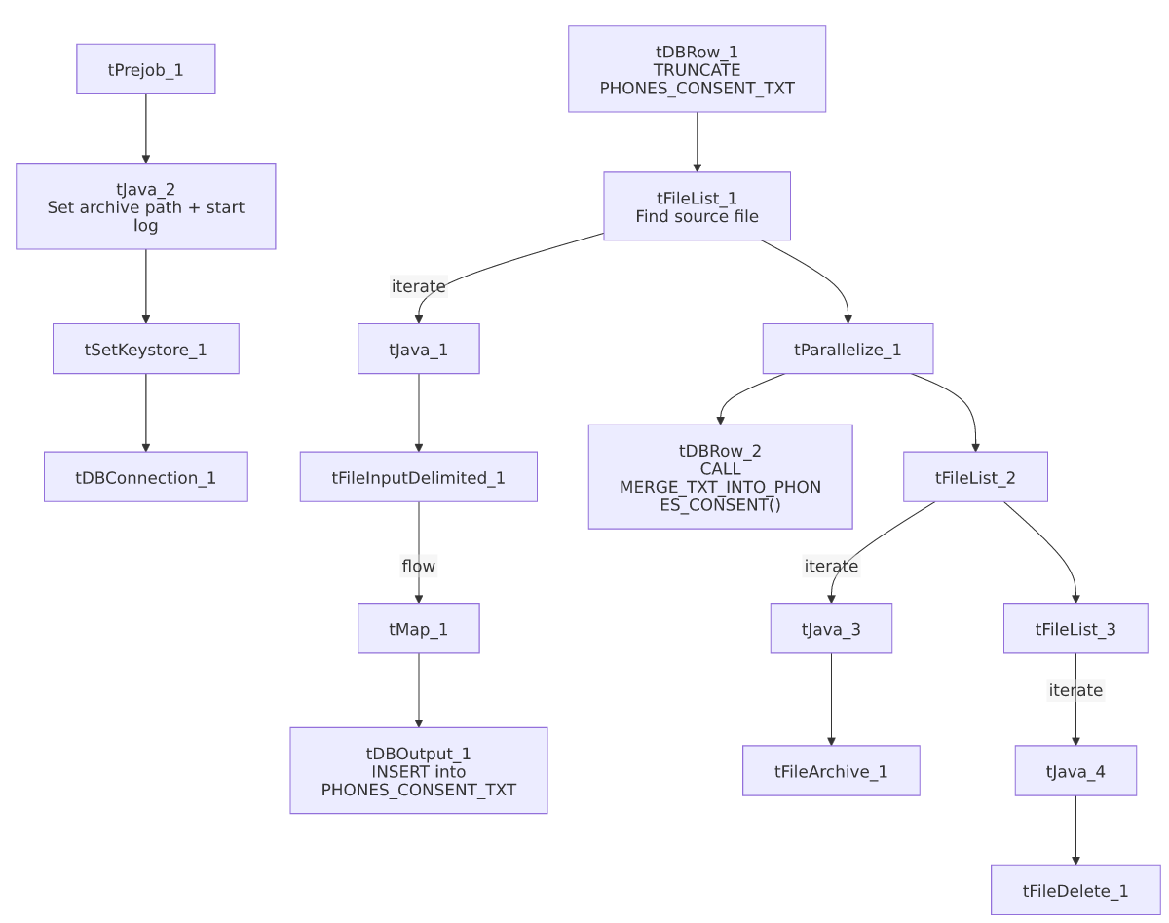

Settings tables

Source: `tFileInputDelimited_1`
Setting | Value | What it means
FILENAME | context.filePath | Reads whichever file tFileList_1 just found.
FIELDSEPARATOR / ROWSEPARATOR | `\ | ~\
HEADER | 1 | First line is a header.
ENCODING | US-ASCII | Plain ASCII text.

Target: `tDBOutput_1`
Setting | Value | What it means
Table | PHONES_CONSENT_TXT | Staging table for phone consent records.
Output action | INSERT | Adds rows only.

Merge step: `tDBRow_2`
Setting | Value | What it means
Query | CALL MERGE_TXT_INTO_PHONES_CONSENT(); | Snowflake procedure that folds staged rows into the permanent PHONES_CONSENT table.

Dependencies & configuration
- Triggers/depends on other jobs: none found — no tRunJob links.
- Context variables used: context.sourceDir, context.archiveDir, context.filePath, context.fileName, context.logDir, context.keystorePath (all Directories_0.1). Uses the shared Snowflake connection object, not LEGACY_DW_* variables directly.
- Hardcoded values found: tFileInputDelimited_1.TEMP_DIR, tFileArchive_1.SOURCE_FILE, tFileDelete_1.DIRECTORY/PATH, and tSetKeystore_1.SSL_TRUSTSERVER_TRUSTSTORE are fixed paths rather than context variables.

Glossary
Component type | Plain-English meaning
tPrejob / tParallelize | Setup-before-main-start, concurrent branches (see job_Address_Text_Load.md).
tFileList | Lists files for the job to loop over (see job_Address_Text_Load.md).
tFileInputDelimited | Reads a delimited text file (see job_Address_Text_Load.md).
tMap | Maps/transforms columns (see job_Address_Text_Load.md).
tDBOutput / tSnowflakeOutput | Writes rows into Snowflake (see job_Address_Text_Load.md).
tDBRow / tSnowflakeRow | Runs a single SQL statement (see job_Address_Text_Load.md).
tJava | Custom Java code block (see job_Address_Text_Load.md).
tFileArchive | Zips a file into an archive location (see job_Address_Text_Load.md).
tFileDelete | Deletes a file from disk (see job_Address_Text_Load.md).
tSetKeystore | Configures the SSL keystore for the Snowflake connection (see job_Address_Text_Load.md).

Issues observed
- The staging truncate doesn't qualify its schema (TRUNCATE TABLE PHONES_CONSENT_TXT;, no LIQUID_STAGING. prefix) — same pattern as other jobs in this batch; likely relies on the connection's default schema.
- No row-count logging — no tFlowMeter component between tMap_1 and tDBOutput_1.
- `tFileDelete_1.FAILON` is `false`, meaning a failed delete of the source file won't fail the job.
- Several hardcoded, machine-specific paths exist alongside parameterized ones — see Dependencies & configuration.
- The merge procedure's own logic is outside Talend and not visible in this metadata.

