Talend Job: ScheduledPayment_Text_Load

Overview
This job loads scheduled-payment records (payment arrangements, transaction status, amounts, surcharges, execution/bounce details, and payment method) into Snowflake. It follows the standard truncate → load → merge → archive/delete pattern, with two small deviations: it deliberately processes the oldest file first, and it pauses for five seconds before deleting the source file.

Detail table
Field | Value
Job name | ScheduledPayment_Text_Load
Version | 0.1
Project | LATITUDE
Author | jmach@harriscollect.com
Created | 2025-07-01T10:41:45.613-0700
Last Modified | 2025-10-02T10:50:11.984-0700

Step-by-step data flow
- Set up. tPrejob_1 triggers tJava_1, which appends today's date to context.archiveDir and opens a log file; this chains into tSetKeystore_1 and tDBConnection_1.
- Empty the staging table. tDBRow_1 runs TRUNCATE TABLE LIQUID_STAGING.SCHEDULEDPAYMENT_TXT; (this one *does* qualify its schema, unlike several peer jobs in this batch).
- Find the file. tFileList_1 lists files in context.sourceDir (skipping *.txt), explicitly sorted by modified date, ascending — processing the oldest matching file first, the same explicit-ordering pattern seen in Dialer_CallTracking_Load.
- Read and reshape the file. tFileInputDelimited_1 reads the file as pipe-delimited (|~|/|$|), ISO-8859-15 encoded (unlike most peers in this batch, which use US-ASCII), with a header row, covering payment ID, account/debtor ID, transaction type/status, amount, surcharge, execution/bounce timestamps and results, and payment method. tMap_1 maps these onto the SCHEDULEDPAYMENT_TXT schema, adding LOAD_DT.
- Load staging. Mapped rows pass through a row counter (tFlowMeter_2) into tDBOutput_1, inserting into SCHEDULEDPAYMENT_TXT.
- Merge and clean up — in parallel. Once the file-list subjob completes, tParallelize_1 splits into: tDBRow_2 calling CALL LIQUID_STAGING.MERGE_TXT_INTO_SCHEDULEDPAYMENT(); (note the explicit schema qualifier on the procedure call itself — see Issues observed), and a file-listing chain that archives (tFileList_2 → tFileArchive_1) and, after a brief pause, deletes (tFileList_3 → tSleep_1 → tFileDelete_1).
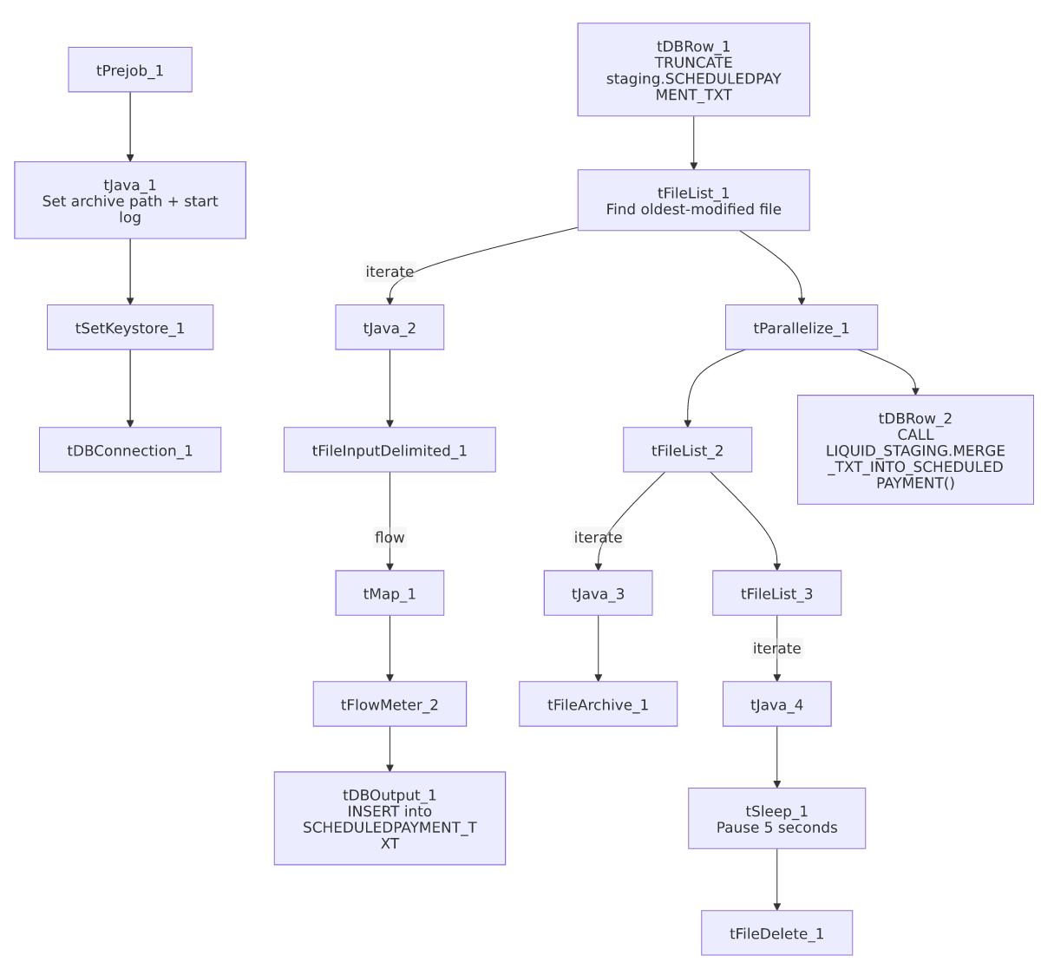

Settings tables

Source: `tFileInputDelimited_1`
Setting | Value | What it means
FILENAME | context.filePath | Reads whichever file tFileList_1 just found.
FIELDSEPARATOR / ROWSEPARATOR | `\ | ~\
ENCODING | ISO-8859-15 | Western European encoding — differs from the US-ASCII used by most jobs in this batch.
REMOVE_EMPTY_ROW | true | Blank rows in the source file are skipped rather than loaded.
DIRECTORY ordering (tFileList_1) | ORDER_BY_MODIFIEDDATE=true, ascending | Explicitly processes the oldest untouched file first.

Target: `tDBOutput_1`
Setting | Value | What it means
Table | SCHEDULEDPAYMENT_TXT | Staging table for scheduled-payment records.
Output action | INSERT | Adds rows only.

Merge step: `tDBRow_2`
Setting | Value | What it means
Query | CALL LIQUID_STAGING.MERGE_TXT_INTO_SCHEDULEDPAYMENT(); | Snowflake procedure that folds staged rows into the permanent SCHEDULEDPAYMENT table — explicitly schema-qualified, unlike the unqualified CALL <procedure>(); form used by most peer jobs.

Pre-delete pause: `tSleep_1`
Setting | Value | What it means
PAUSE | 5 (seconds) | Job waits 5 seconds before deleting the source file — possibly to let a concurrent process (e.g. the archive step) finish releasing its file handle.

Dependencies & configuration
- Triggers/depends on other jobs: none found — no tRunJob links.
- Context variables used: context.sourceDir, context.archiveDir, context.filePath, context.fileName, context.logDir, context.keystorePath (all Directories_0.1). Uses the shared Snowflake connection object, not LEGACY_DW_* variables directly.
- Hardcoded values found: tFileInputDelimited_1.TEMP_DIR, tFileArchive_1.SOURCE_FILE, tFileDelete_1.DIRECTORY/PATH, and tSetKeystore_1.SSL_TRUSTSERVER_TRUSTSTORE are fixed paths rather than context variables.

Glossary
Component type | Plain-English meaning
tPrejob / tParallelize | Setup-before-main-start, concurrent branches (see job_Address_Text_Load.md).
tFileList | Lists files for the job to loop over (see job_Address_Text_Load.md).
tFileInputDelimited | Reads a delimited text file (see job_Address_Text_Load.md).
tMap | Maps/transforms columns (see job_Address_Text_Load.md).
tFlowMeter | Counts rows passing a point, for logging (see job_Address_Text_Load.md).
tDBOutput / tSnowflakeOutput | Writes rows into Snowflake (see job_Address_Text_Load.md).
tDBRow / tSnowflakeRow | Runs a single SQL statement (see job_Address_Text_Load.md).
tJava | Custom Java code block (see job_Address_Text_Load.md).
tFileArchive | Zips a file into an archive location (see job_Address_Text_Load.md).
tFileDelete | Deletes a file from disk (see job_Address_Text_Load.md).
tSetKeystore | Configures the SSL keystore for the Snowflake connection (see job_Address_Text_Load.md).
tSleep | *(Not covered in the reference docs.)* Pauses job execution for a fixed number of seconds — here, a 5-second delay is inserted between listing the file for deletion and actually deleting it.

Issues observed
- Encoding differs from most peer jobs in this batch. tFileInputDelimited_1 uses ISO-8859-15 here, while Customer_Table_Text_Load, Dialer_CallTracking_Load, LetterRequest_Table_Text_Load, Phones_Consent_Table_Text_Load, and cmi_Score_Text_Load all use US-ASCII. Worth confirming this is intentional (e.g., scheduled-payment files can contain accented characters that others don't).
- The merge call is schema-qualified (CALL LIQUID_STAGING.MERGE_TXT_INTO_SCHEDULEDPAYMENT();) while every other job in this batch calls its merge procedure unqualified (CALL MERGE_TXT_INTO_<TABLE>();). Functionally likely equivalent if the default schema is already LIQUID_STAGING, but it's an inconsistency worth flagging for anyone maintaining these procedures.
- A 5-second `tSleep_1` delay before file deletion is unique to this job among the 9 documented here — its purpose isn't stated in the metadata; confirm with the team whether it's working around a file-lock or timing issue.
- File pickup order deviates from the norm — explicitly oldest-first, like Dialer_CallTracking_Load, rather than the default unordered listing most peer jobs use.
- `tFileDelete_1.FAILON` is `false`, meaning a failed delete won't fail the job.
- The merge procedure's own logic is outside Talend and not visible in this metadata.

