Talend Job: StatusHistory_Text_Load

Overview
This job follows the project's standard text-load pattern: it watches a shared folder for a new account-status-change history file, loads it into a Snowflake staging table, merges the staged rows into the permanent table via a stored procedure, and then archives and deletes the source file. Its one notable deviation from peer jobs is a deliberate 5-second pause (tSleep_1) inserted just before the file-delete step.

Detail table
Field | Value
Job name | StatusHistory_Text_Load
Version | 0.1
Project | LATITUDE
Author | jmach@harriscollect.com
Created | 2024-11-22T10:18:14.551-0800
Last Modified | 2025-10-02T11:05:44.255-0700

Step-by-step data flow
- Set up. tPrejob_1 triggers tJava_2, which appends today's date to context.archiveDir and starts a log file, then hands off to tSetKeystore_1 and tDBConnection_1 (Snowflake connect).
- Empty the staging table. tDBRow_1 runs TRUNCATE TABLE STATUSHISTORY_TXT; (unqualified — no LIQUID_STAGING. prefix).
- Find the file. tFileList_1 lists files in context.sourceDir, skipping .txt files. tJava_1 captures the match into context.filePath.
- Read and reshape. tFileInputDelimited_1 reads the file as pipe-delimited (|~|/|$|), US-ASCII-encoded, with a header row (DIE_ON_ERROR = false). tMap_1 maps a small set of columns — ID, AccountID, DateChanged, UserName, OldStatus, NewStatus — onto the target schema, adding LOAD_DT.
- Load staging. Mapped rows flow into tDBOutput_1, which inserts them into STATUSHISTORY_TXT (INSERT, no table-structure changes).
- Merge into the permanent table — in parallel with cleanup. tParallelize_1 splits into:
- Merge branch: tDBRow_2 runs CALL MERGE_TXT_INTO_STATUSHISTORY();.
- Archive sub-branch: the source file is re-listed (tFileList_2) and archived (tFileArchive_2, zipped into context.archiveDir/<filename>.zip).
- Delete sub-branch: tFileList_2 also feeds tFileList_3 (on success), which lists the file again, captures its path, and — unlike every other job in this batch — waits 5 seconds (tSleep_1) before finally deleting it (tFileDelete_1).
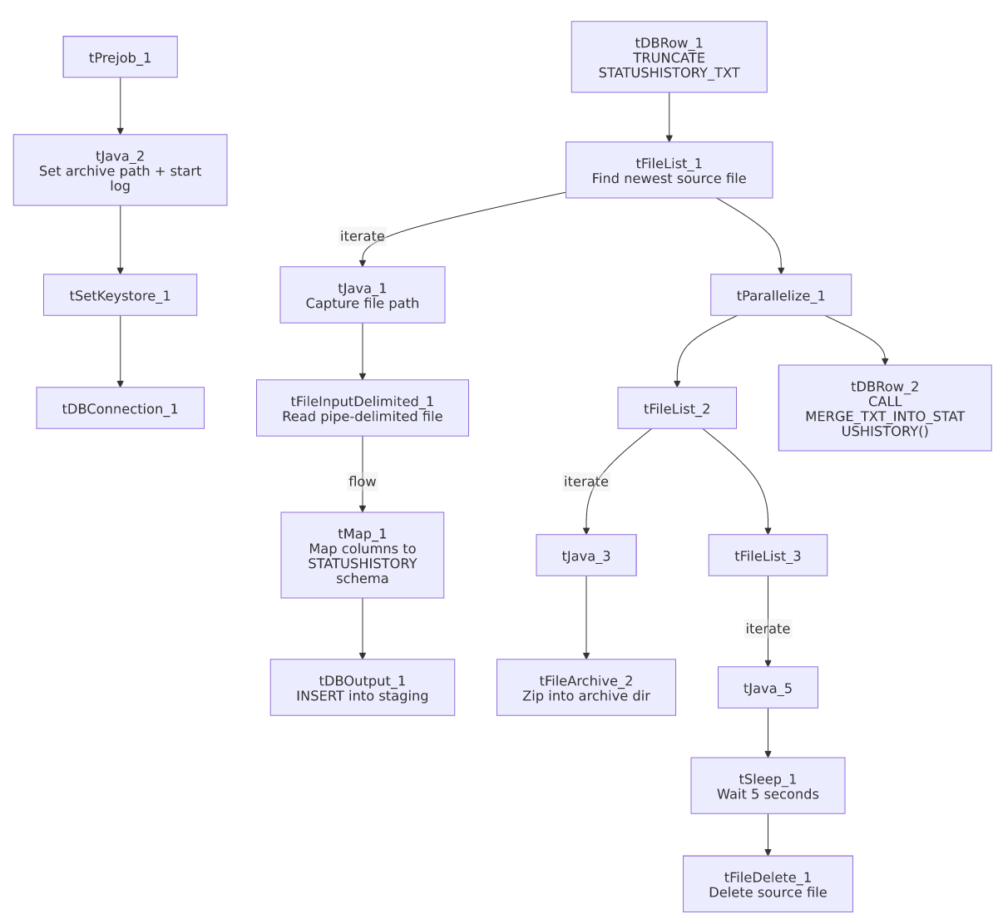

Settings tables

Source: `tFileInputDelimited_1`
Setting | Value | What it means
FILENAME | context.filePath | Reads whichever file tFileList_1 found.
FIELDSEPARATOR / ROWSEPARATOR | `\ | ~\
HEADER | 1 | First line is a header row.
ENCODING | US-ASCII | Not ISO-8859-15.
DIE_ON_ERROR | false | Malformed rows route to the reject schema instead of failing the job.

Target: `tDBOutput_1`
Setting | Value | What it means
Table | STATUSHISTORY_TXT | Staging table for account status-change history.
Output action | INSERT | Adds rows only.
Table action | NONE | No structural changes; truncation handled by tDBRow_1.

Merge step: `tDBRow_2`
Setting | Value | What it means
Query | CALL MERGE_TXT_INTO_STATUSHISTORY(); | Snowflake stored procedure that folds staged rows into the permanent table; logic is outside Talend.

Delay: `tSleep_1`
Setting | Value | What it means
PAUSE | 5 (seconds) | Pauses the job for 5 seconds before proceeding to tFileDelete_1. No comment or explanation is captured in the metadata for why this delay exists — see Issues observed.

Dependencies & configuration
- Triggers/depends on other jobs: none — no tRunJob links found.
- Context variables used: context.sourceDir, context.archiveDir, context.filePath, context.fileName, context.logDir, context.keystorePath (all Directories_0.1). It uses the shared Snowflake connection object (tDBConnection_1), not LEGACY_DW_0.1 variables — no LEGACY_DW_ entries appear in context_vars_referenced.
- Hardcoded values found: tFileInputDelimited_1.TEMP_DIR, tFileArchive_2.SOURCE_FILE, tFileDelete_1.DIRECTORY/PATH, tSetKeystore_1.SSL_TRUSTSERVER_TRUSTSTORE — the same C:/Talend-Studio-20211109_1610-V8.0.1/... machine-specific paths seen in most jobs.

Glossary
Component type | Plain-English meaning
tPrejob / tParallelize | Job-flow control (see job_Address_Text_Load.md).
tFileList | Lists files in a folder to loop over (see job_Address_Text_Load.md).
tFileInputDelimited | Reads a delimited text file row by row (see job_Address_Text_Load.md).
tMap | Maps/transforms input columns to output columns (see job_Address_Text_Load.md).
tDBOutput / tSnowflakeOutput | Writes rows into a Snowflake table (see job_Address_Text_Load.md).
tDBRow / tSnowflakeRow | Runs a single SQL statement against Snowflake (see job_Address_Text_Load.md).
tJava / tJavaRow | Custom Java code snippets (see job_Address_Text_Load.md).
tFileArchive | Zips a file into an archive location (see job_Address_Text_Load.md).
tFileDelete | Deletes a file from disk (see job_Address_Text_Load.md).
tSetKeystore | Configures the SSL keystore for the Snowflake connection (see job_Address_Text_Load.md).
tSleep | Pauses the job for a fixed number of seconds before continuing — not used in any of the 3 reference docs; this is the only job in this batch that includes it.

Issues observed
- A hardcoded 5-second pause (`tSleep_1`) appears only in this job, right before deleting the source file, with no comment explaining its purpose. A plausible reason is to give the parallel archive branch (tFileArchive_2) time to finish reading the file before it's deleted, but this can't be confirmed from the metadata — worth asking the team whether this was a deliberate race-condition fix or leftover debugging code.
- File encoding is US-ASCII, not ISO-8859-15 like Address_Text_Load.
- The `TRUNCATE` statement is unqualified (STATUSHISTORY_TXT rather than LIQUID_STAGING.STATUSHISTORY_TXT) — same pattern flagged in several peer jobs.
- No `tDie`/`tWarn` on the merge step — a failed merge surfaces only as a generic Talend error.
- Standard hardcoded machine-specific paths present across tFileInputDelimited_1, tFileArchive_2, tFileDelete_1, and tSetKeystore_1 — the same project-wide pattern.

