Talend Job: cmi_CapioSellerContracts_Table_Text_Load

Overview
This job loads Capio seller-contract reference data (seller name, contract ID/name/description, bid and purchase dates, placement phase, customer, and an attorney-general flag) from a shared folder into Snowflake, following the project's standard truncate-load-merge-archive pattern (see job_Address_Text_Load.md). Unlike most peers, it is configured to fail immediately (DIE_ON_ERROR: true) if the source file can't be parsed, rather than continuing quietly. It has no scheduling information in this metadata — something outside Talend decides when it runs.

Detail table
Field | Value
Job name | cmi_CapioSellerContracts_Table_Text_Load
Version | 0.1
Project | LATITUDE
Author | jmach@harriscollect.com
Created | 2024-10-29T12:47:43.495-0700
Last Modified | 2025-09-29T10:31:47.689-0700

Step-by-step data flow
- Set up. tPrejob_1 starts the job; tJava_3 appends today's date to context.archiveDir and opens a log file; tSetKeystore_1 configures the SSL client keystore; tDBConnection_1 opens the Snowflake connection.
- Empty the staging table. In a separate, parallel start point, tDBRow_1 runs TRUNCATE TABLE CMI_CAPIOSELLERCONTRACTS_TXT;.
- Find and read the file. tFileList_1 lists files in context.sourceDir (skipping .txt); tJava_1 captures the found path into context.filePath; tFileInputDelimited_1 reads it as a pipe-delimited, US-ASCII-encoded file (using the repository schema named capslr) with a header row. This component has DIE_ON_ERROR set to true — a malformed row here fails the job rather than being skipped or logged.
- Transform and load. tMap_1 maps the file's columns (ID, seller name, contract ID/name/description, file bid date, purchase date, placement phase, customer, MN attorney general flag) onto the CMI_CAPIOSELLERCONTRACTS_TXT schema, adding LOAD_DT. The mapped rows go directly into tDBOutput_1, which inserts them into Snowflake.
- Merge and clean up — in parallel. tParallelize_1 splits into two branches once the file has been listed:
- Merge branch: tDBRow_2 calls CALL MERGE_TXT_INTO_CMI_CAPIOSELLERCONTRACTS();.
- Cleanup branch: the source file is listed again and archived (tFileArchive_1, zipped into context.archiveDir); it's also listed a third time and deleted (tFileDelete_1).
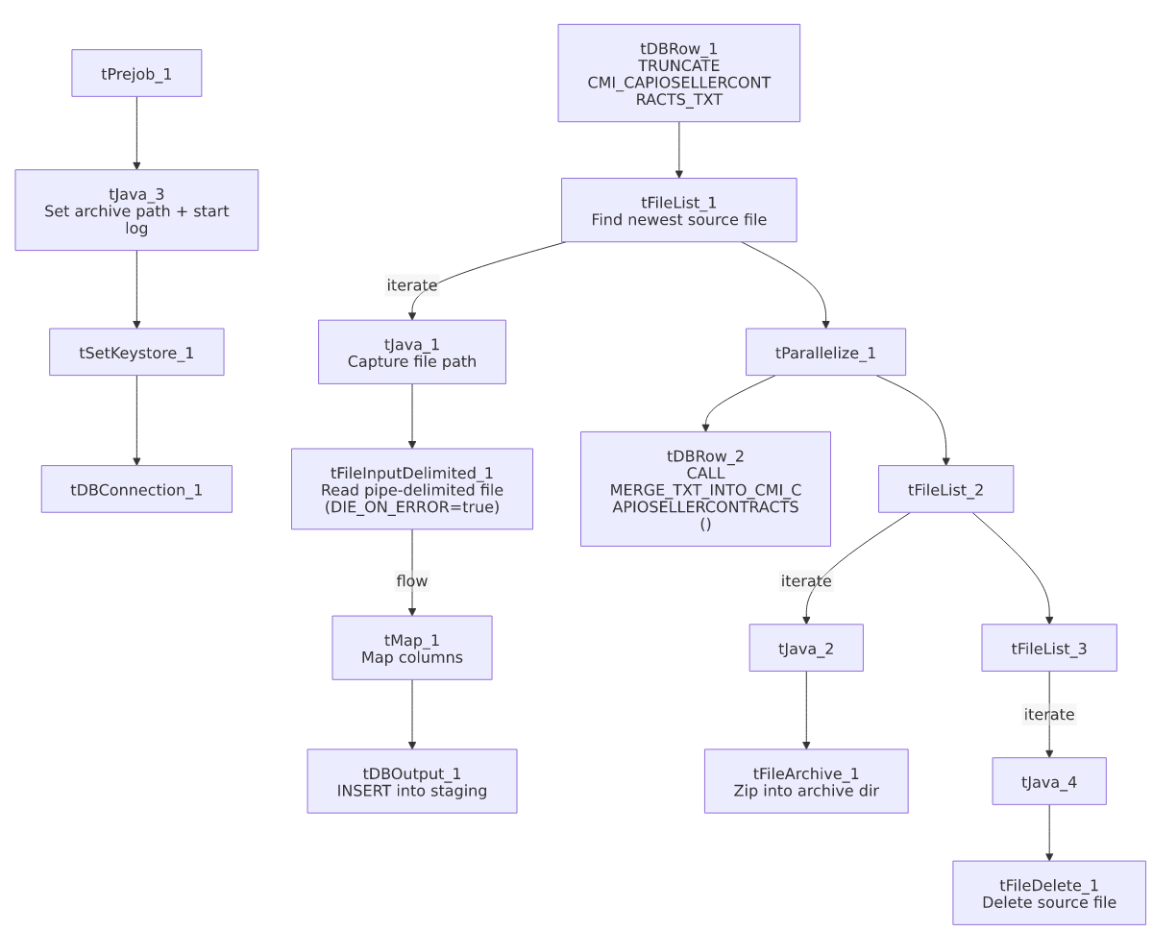

Settings tables

Source: `tFileInputDelimited_1`
Setting | Value | What it means
FILENAME | context.filePath | Reads whichever file tFileList_1 just found.
FIELDSEPARATOR / ROWSEPARATOR | `\ | ~\
HEADER | 1 | First line is a header, not data.
ENCODING | US-ASCII | Plain ASCII, not ISO-8859-15.
DIE_ON_ERROR | true | If a row fails to parse against the schema, the job stops immediately rather than continuing — differs from most peers (e.g., Address_Text_Load, Phones_Master_Table_Text_Load), which set this to false.
SCHEMA:REPOSITORY_SCHEMA_TYPE | capslr (repository schema) | Uses a centrally-defined column layout.
EXCLUDEFILEMASK (on tFileList_1) | *.txt | .txt files are skipped.

Target: `tDBOutput_1`
Setting | Value | What it means
Table | CMI_CAPIOSELLERCONTRACTS_TXT | Loads the staging copy of the seller-contracts table.
Output action | INSERT | Adds rows only.
Table action | NONE | Truncation is handled separately by tDBRow_1.

Merge step: `tDBRow_2`
Setting | Value | What it means
Query | CALL MERGE_TXT_INTO_CMI_CAPIOSELLERCONTRACTS(); | Folds staged rows into the permanent table; its own logic lives in Snowflake.

Dependencies & configuration
- Triggers/depends on other jobs: none found — no tRunJob links.
- Context variables used: context.sourceDir, context.archiveDir, context.filePath, context.fileName, context.logDir, context.keystorePath (all Directories_0.1).
- LEGACY_DW usage: none — this job uses the shared Snowflake connection object, not LEGACY_DW_0.1 variables directly.

Glossary
Component type | Plain-English meaning
tPrejob / tParallelize | Job-flow control. (see job_Address_Text_Load.md)
tFileList | Lists files in a folder so the job can loop over them. (see job_Address_Text_Load.md)
tFileInputDelimited | Reads a delimited text file row by row. (see job_Address_Text_Load.md)
tMap | Maps/transforms columns from input to output. (see job_Address_Text_Load.md)
tDBOutput / tSnowflakeOutput | Writes rows into a Snowflake table. (see job_Address_Text_Load.md)
tDBRow / tSnowflakeRow | Runs a single SQL statement — used here for TRUNCATE and CALL <procedure>. (see job_Address_Text_Load.md)
tJava | A small block of custom Java code. (see job_Address_Text_Load.md)
tFileArchive | Compresses a file into a .zip and archives it. (see job_Address_Text_Load.md)
tFileDelete | Deletes a file from disk. (see job_Address_Text_Load.md)
tSetKeystore | Configures the SSL keystore for the Snowflake connection. (see job_Address_Text_Load.md)

Issues observed
- `DIE_ON_ERROR` is `true` on the file reader, unlike most peer "Text Load" jobs. A single malformed row in the source file will stop the entire job rather than being logged and skipped — worth confirming this is intentional given how small and reference-like this dataset is (contract metadata, not transactional data).
- No row counter (`tFlowMeter`) between tMap_1 and tDBOutput_1, unlike some peer jobs.
- No explicit error handling on the merge step (no tDie/tWarn), same as most peers.
- The merge procedure's own logic is outside Talend, same caveat as every other job that calls a MERGE_TXT_INTO_* procedure.

