Talend Job: cmi_Customer_Ext_Text_Load

Overview
This job follows the project's standard text-load pattern: it watches a shared folder for a new "customer extension" configuration file (per-client rules like letter phone numbers, minimum score for a letter, email/SMS eligibility flags, FDCPA/legal-firm flags, payment-site URL, etc.), loads it into a Snowflake staging table, merges the staged rows into the permanent table via a stored procedure, and then archives and deletes the source file. It has no tDie/tWarn reacting to the merge outcome.

Detail table
Field | Value
Job name | cmi_Customer_Ext_Text_Load
Version | 0.1
Project | LATITUDE
Author | jmach@harriscollect.com
Created | 2025-03-18T15:04:42.721-0700
Last Modified | 2026-07-30T10:14:48.462-0700

Step-by-step data flow
- Set up. tPrejob_1 triggers tJava_4, which appends today's date to context.archiveDir and starts a log file, then hands off to tSetKeystore_1 and tDBConnection_1 (Snowflake connect).
- Empty the staging table. tDBRow_1 runs TRUNCATE TABLE LIQUID_STAGING.CMI_CUSTOMER_EXT_TXT; (schema-qualified, unlike several peer jobs' unqualified truncates).
- Find the file. tFileList_1 lists files in context.sourceDir (note: CASE_SENSITIVE = NO here, unlike most peer jobs' tFileList components, which use YES), skipping .txt files. tJava_1 captures the match into context.filePath.
- Read and reshape. tFileInputDelimited_1 reads the file as pipe-delimited (|~|/|$|), US-ASCII-encoded, with a header row. DIE_ON_ERROR = true here — a malformed row fails the job immediately rather than routing to a reject flow. tMap_1 maps ~29 customer-configuration columns onto the target schema, adding LOAD_DT.
- Load staging. Mapped rows flow into tDBOutput_1, which inserts them into CMI_CUSTOMER_EXT_TXT (INSERT, no table-structure changes).
- Merge into the permanent table — in parallel with cleanup. tParallelize_1 splits into:
- Merge branch: tDBRow_2 runs CALL LIQUID_STAGING.MERGE_TXT_INTO_CMI_CUSTOMER_EXT(); (also schema-qualified).
- Cleanup branch: the source file is re-listed, archived (tFileArchive_1, zipped into context.archiveDir/<filename>.zip), and — via a separate file-list/capture — deleted (tFileDelete_1).
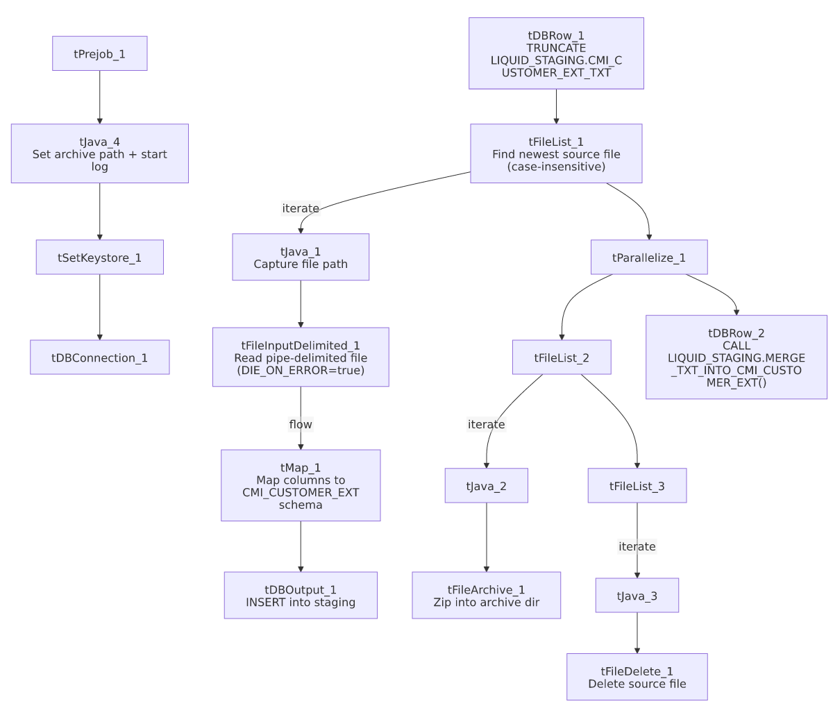

Settings tables

Source: `tFileInputDelimited_1`
Setting | Value | What it means
FILENAME | context.filePath | Reads whichever file tFileList_1 found.
FIELDSEPARATOR / ROWSEPARATOR | `\ | ~\
HEADER | 1 | First line is a header row.
ENCODING | US-ASCII | Not ISO-8859-15.
DIE_ON_ERROR | true | A malformed row fails the whole job rather than routing to a reject output — differs from PDC_Text_Load, Promises_Text_Load, and StatusHistory_Text_Load, which all set this to false.
CASE_SENSITIVE (on tFileList_1) | NO | File-name matching in the source folder is case-insensitive here, unlike most peer jobs' file lists.

Target: `tDBOutput_1`
Setting | Value | What it means
Table | CMI_CUSTOMER_EXT_TXT | Staging table for the per-client customer-extension configuration data.
Output action | INSERT | Adds rows only.
Table action | NONE | No structural changes; truncation handled by tDBRow_1.

Merge step: `tDBRow_2`
Setting | Value | What it means
Query | CALL LIQUID_STAGING.MERGE_TXT_INTO_CMI_CUSTOMER_EXT(); | Snowflake stored procedure that folds staged rows into the permanent table; logic is outside Talend.

Dependencies & configuration
- Triggers/depends on other jobs: none — no tRunJob links found.
- Context variables used: context.sourceDir, context.archiveDir, context.filePath, context.fileName, context.logDir, context.keystorePath (all Directories_0.1). It uses the shared Snowflake connection object (tDBConnection_1), not LEGACY_DW_0.1 variables — no LEGACY_DW_ entries appear in context_vars_referenced.
- Hardcoded values found: tFileInputDelimited_1.TEMP_DIR, tFileArchive_1.SOURCE_FILE, tFileDelete_1.DIRECTORY/PATH, tSetKeystore_1.SSL_TRUSTSERVER_TRUSTSTORE — the same C:/Talend-Studio-20211109_1610-V8.0.1/... machine-specific paths seen in most jobs.

Glossary
Component type | Plain-English meaning
tPrejob / tParallelize | Job-flow control (see job_Address_Text_Load.md).
tFileList | Lists files in a folder to loop over (see job_Address_Text_Load.md).
tFileInputDelimited | Reads a delimited text file row by row (see job_Address_Text_Load.md).
tMap | Maps/transforms input columns to output columns (see job_Address_Text_Load.md).
tDBOutput / tSnowflakeOutput | Writes rows into a Snowflake table (see job_Address_Text_Load.md).
tDBRow / tSnowflakeRow | Runs a single SQL statement against Snowflake (see job_Address_Text_Load.md).
tJava / tJavaRow | Custom Java code snippets (see job_Address_Text_Load.md).
tFileArchive | Zips a file into an archive location (see job_Address_Text_Load.md).
tFileDelete | Deletes a file from disk (see job_Address_Text_Load.md).
tSetKeystore | Configures the SSL keystore for the Snowflake connection (see job_Address_Text_Load.md).

Issues observed
- `tFileList_1`/`tFileList_2`/`tFileList_3` are case-insensitive (`CASE_SENSITIVE = NO`) here, unlike most peer text-load jobs which set this to YES. This means a file named e.g. Customer_Ext.TXT would also be excluded by the *.txt exclusion mask here, where a case-sensitive job might not exclude it — worth confirming this difference is intentional.
- `DIE_ON_ERROR = true` on the file reader means a single malformed row aborts the entire load, unlike PDC_Text_Load/Promises_Text_Load/StatusHistory_Text_Load, which route bad rows to a reject flow instead. Given this file drives per-client behavior flags (FDCPA compliance, legal-firm status, email/SMS eligibility), failing loudly on bad data may be a deliberate safety choice rather than an oversight — but it's inconsistent with peer jobs' handling.
- Both the `TRUNCATE` and merge `CALL` are schema-qualified (LIQUID_STAGING.CMI_CUSTOMER_EXT_TXT / LIQUID_STAGING.MERGE_TXT_INTO_CMI_CUSTOMER_EXT()), unlike CBR_Metro2_Accounts_Table_Text_Load, PDC_Text_Load, Promises_Text_Load, and StatusHistory_Text_Load, which all omit the schema prefix. Functionally likely equivalent, but the inconsistency suggests these jobs weren't all built from a single, strictly enforced template.
- File encoding is US-ASCII, not ISO-8859-15 like Address_Text_Load.
- No `tDie`/`tWarn` on the merge step — a failed merge surfaces only as a generic Talend error.
- Standard hardcoded machine-specific paths present across tFileInputDelimited_1, tFileArchive_1, tFileDelete_1, and tSetKeystore_1 — the same project-wide pattern.

