# Perquisite Tasks

1. Copy everything from ‘MapleMacro’ folder into your location of choice
2. Set Language for non-Unicode programs to Chinese (Simplified, China):
   1. Navigate to Region Setting in windows
   2. Additional date, time & regional settings
   3. Change date, time, or number formats
   4. Administrative tab, change system locale to Chinese (Simplified, China)

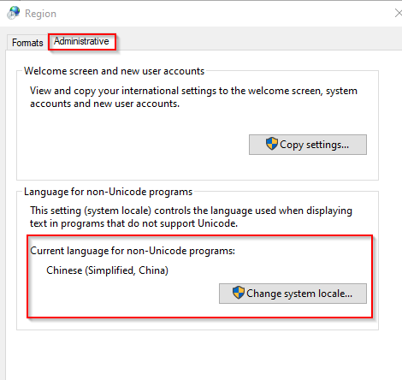

* 1. Restart pc

1. Set Regional format to Chinese (Simplified, China):
   1. Navigate to Region Settings in Window
   2. Set format to Chinese (Simplified, China)

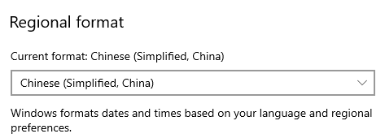

1. Add ‘MapleMacro’ folder to windows security exception:
   1. Navigate to Windows Security
   2. Virus & threat protection
   3. Virus & threat protection settings (manage settings)
   4. Add or remove exclusions
   5. Add the folder to exception
2. You are ready to start!

# Configuring Maplestory

1. Set in game resolution to 1366x768 window mode
2. Turn off V-Sync
3. Put all cooldown skills in the hotkey bar. If they are not in the hotkey bar they will not be used. Please make sure hotkey bar is FULLY expanded



1. Fully expand mini map



1. The mouse or window inside the game should not block any of the red frame sections. Do not minimize the game. This macro works without having Maplestory in focus however do not turn on full screen mode when playing other games, but you can play them in window mode.

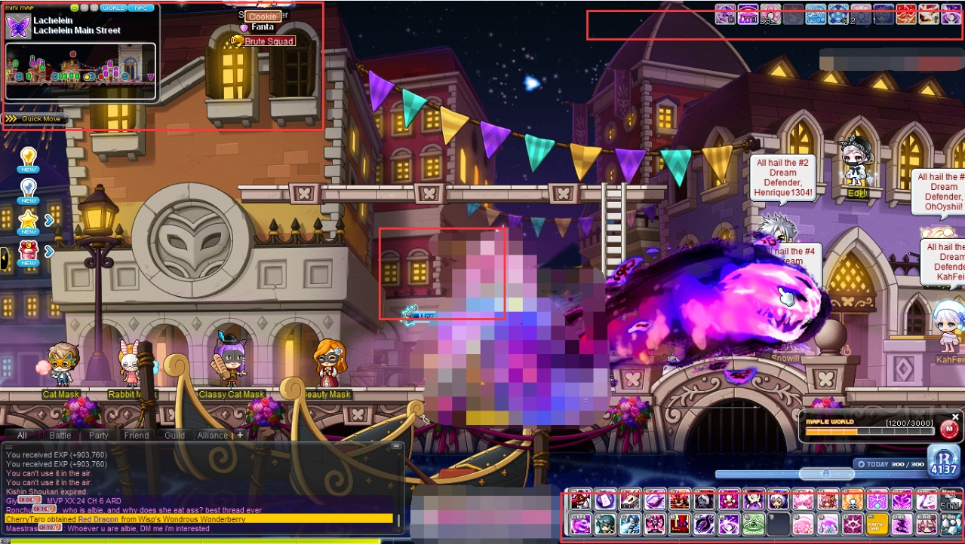

# QMacro – English Translation

## Activating Macro

1. Activating Macro (Or 30minute trial then it will automatically close)
   1. Go to activation menu



* 1. Enter activation code

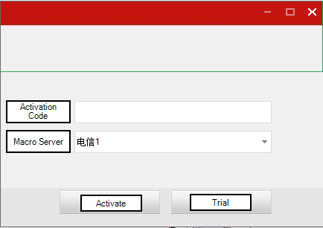

Server list:

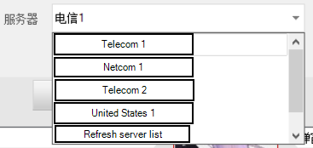

* 1. Activate

## Toolbar menu

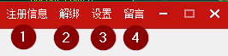

### Toolbar 1 – Registration information

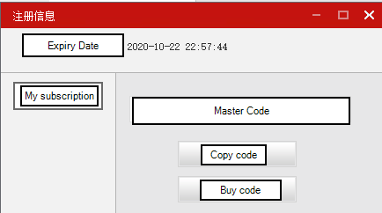

### Toolbar 2 – Unbind pc to subscription

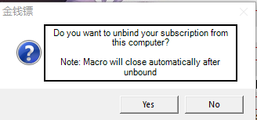

### Toolbar 3 – Settings

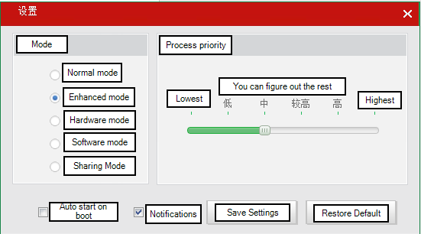

### Toolbar 4 – QQ Message Settings

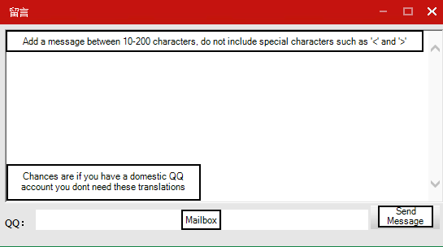

## Control Page

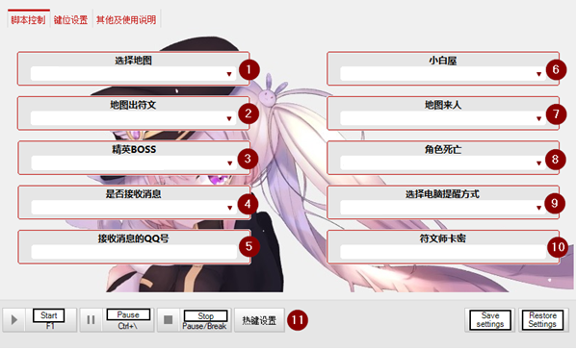

### Control 1 – Maps

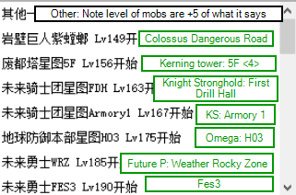

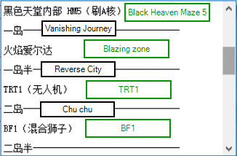

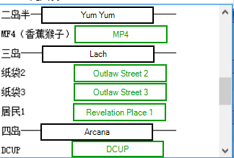

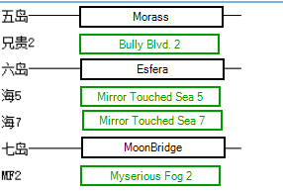

### Control 2 – Rune Configuration

**Note:** Rune master is the Macro’s auto rune solver which is super expensive to use around $14usd/day per client if its running 24/7.

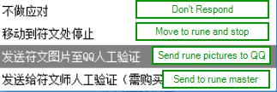

### Control 3 – Elite Configuration

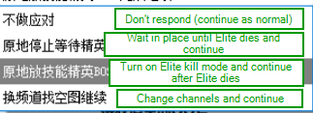

### Control 4 – Whether to Receive Messages/Notifications



### Control 5 – QQ Address

QQ number to receive messages (Unless you have QQ domestic you can’t use this, very hard to get access to QQ domestic if you don’t have a Chinese mobile number or invite).

### Control 6 – Little White house?

To be honest no idea what this is.



### Control 7 – Evasion Settings



### Control 8 – Character Death



### Control 9 – Computer Notification Setting

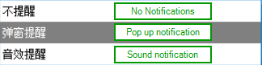

### Control 10 – Runemaster Code

Code to use Macro’s auto rune solver

**Note:** Rune master is the Macro’s auto rune solver which is super expensive to use around $14usd/day per client if its running 24/7.

### Control 11 – Macro Hotkey Settings

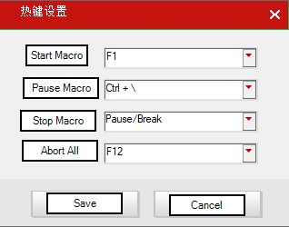

## Hotkey Page

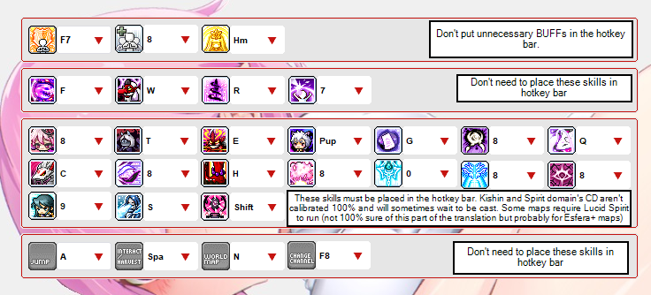

## Other Page

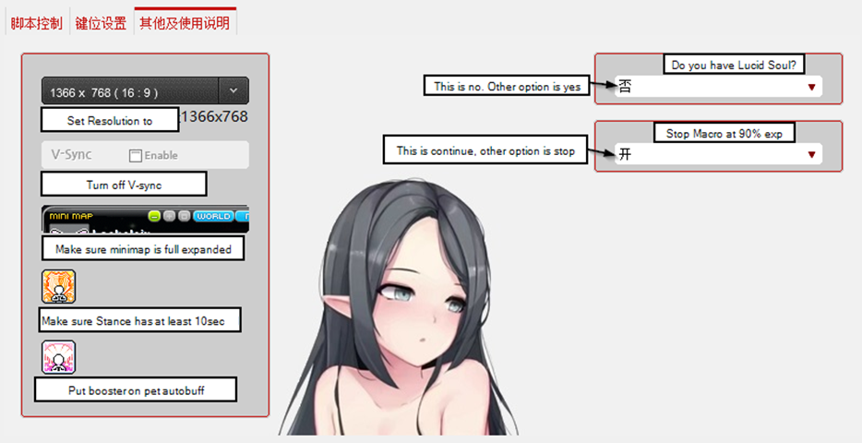

## Recommended Settings for Maximum Daily Rates

* Rune Settings – send message to QQ or runemaster (don’t have runemaster code entered just need these set to be compatible with Rune Solver)
* Elite Boss Setting – Turn on kill mode and continue after Elite death
* Character death – Teleport back to map (requires HTR)
* 3 pets with auto move and extended range
* HS node
* Ropelift node (required for auto rune to work in arcane river)
* Level 2 Mihile link skill (Stance)
* Grit node (To have perma stance)
* Gearing up more clients gives more meso than investing in Meso % Equip in normal servers (Cost of gear vs Daily rates)

# RuneSolver

Unlike the Macro you will need to be focused into Maplestory for auto rune and other features to work. So you can just use then on VMs or when you are away from the computer.

Auto Open Elite Box – Automatically opens elite box before they expire.

Anti Death Loop – Sometimes the macro will enter a death loop when anti afk mob is sitting on spawn point and you go in with 50hp. This will use a potion/cast Haku from time to time to prevent this.

Unstick Character – Sometimes the macro will get stuck on a rope/ladder. Although it does fix itself when it goes to cast Kishin or solve a rune, this functionality will speed up the process by manually jumping off to maximum farming rates. (Map dependent. Some maps its better not to use this feature)

