# **Algorithmic Awareness - Action Handbook**

## **OVERVIEW**

## This is a practice-oriented action handbook that provides background, resources, and good practices to guide libraries in implementing algorithmic awareness as a digital literacy.

Our Montana State University team, with grant funding from the Institute of Museum and Library Services, IMLS, has conducted research in order to develop an Action Handbook, a web-based teaching tool, and a standard curriculum to support the teaching of "Algorithmic Awareness": an understanding around the rules that govern our software and shape our digital experiences. There is a focus on search engines to bring into focus our teaching tool which delivers transparency to the many filters and variables at play within a query. This Action Handbook consists of two parts with an introduction describing the in-depth definition of an algorithm. The first part will focus on technical aspects of algorithmic awareness such as an overview of both the teaching tool and the auditing computational software. The second part will explain algorithms in the context of computer systems, give a brief overview of their implication with reference to case studies that demonstrate societal influence, discuss Algorithmic Awareness as a form of information literacy, and finally, we will propose ‘Context and Framing Principles’ for the further teaching of Algorithmic Awareness. All of the Grant Deliverables and Teaching Tools are available as Open Educational Resources (OERs). While there are arguably many ramifications surrounding gender and racial bias, these aspects of the paper will be limited in order to maintain a restricted scope.

This guide contains two main parts, followed by an appendix.

* Part 1— Technical: defining algorithm as a term, describing the teaching tool, auditing computational software, explaining the first principles of algorithms, noting the modules and methods for teaching algorithmic awareness
* Part 2— Social: establishing the problem, explaining material consequences, noting general audience interest in algorithmic awareness, advocating for algorithmic awareness, establishing aspects and ethics

## **TECHNICAL — Implementation Strategies for Algorithmic Awareness**

## The definition of “algorithm” has evolved over time and depending upon a given context. The common definition according to Wikipedia is “an unambiguous specification of how to solve a class of problems” in relation to mathematics and computer science.” Like a math problem, an algorithm is a set of rules that dictates how an input *x* results in the output *y*. Another definition derived by Kevin Slavin, an assistant professor and founder of the Playful Systems group at the MIT Media Lab, is that algorithms, “the math that computers use to decide stuff… they repeat over and over again, and they ossify and calcify,” becoming a real force in the world (Kevin Slavin: TED Talk, How Algorithms Shape Our World). Matthew Reidsma, a researcher focusing on design ethics and user experience, provides another way to look at the definition of an algorithm. Reidsma claims a simple interpretation of a complex idea perpetuates misunderstanding. Instead, he claims, algorithms should be viewed as a large set of binary choices that create a "decision tree" based upon many variables that are not necessarily apparent to the user.

For our purposes, we are defining algorithms in terms of how they are applied within computer programs. In this context, an algorithm is an “instance of logic written in software by software developers to be effective for the intended "target" computer(s) to produce output from given (perhaps null) input” (Wikipedia article on Computer Algorithms, 2017). Our focus is on how these logical rules are explicated and can be brought into the library’s pedagogical environment.

**Teaching Tool**

Our team created a teaching tool to demonstrate transparent software design. (Code is available in [our Montana State University Library GitHub](https://github.com/jasonclark/algorithmic-awareness/tree/master/app) repository.) The [teaching tool is a search engine application that provides users the opportunity to see an “x-ray” of the variables affecting their query](https://www.lib.montana.edu/~jason/files/algorithms-teaching-tool/). For example, depending upon weather and location data, the search for the Montana State University Library may recommend a hot beverage at the Brewed Awakening coffee stand.

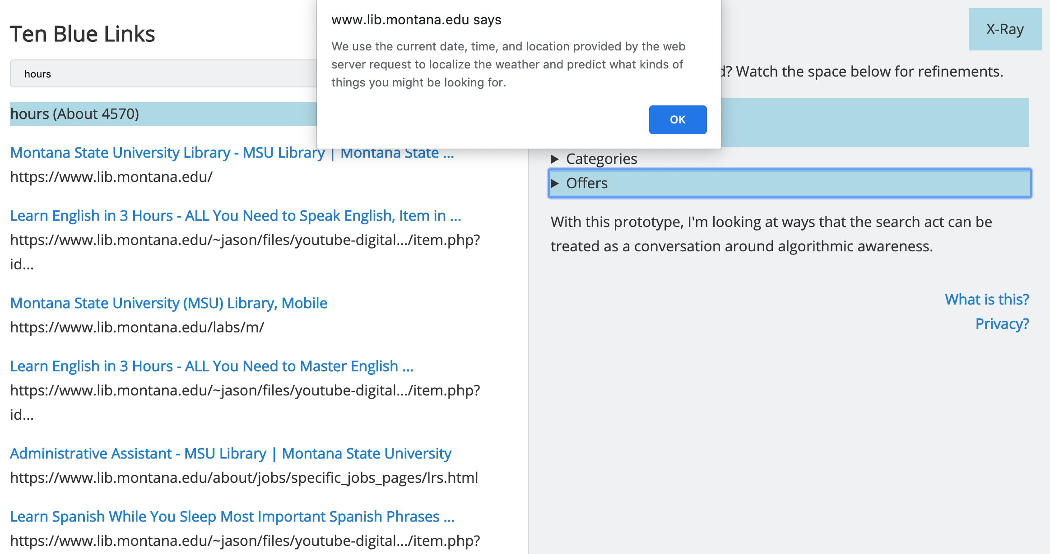

[Figure 1: The algorithmic teaching tool annotating the algorithms in use to create the search results view.]

Additionally, users are able to interact with these variables to facilitate understanding usually hidden in the algorithmic process. The tool is useful when a teacher needs an immediate example of algorithms in action within a common experience, like searching online.

**Auditing Computational Software**

Part of the challenge of algorithmic literacy is the hidden and proprietary rules that create our digital experiences are not transparent. In an effort to reverse engineer these rules and the strategies for discerning the hidden components of a software experiences, the team conducted research and created a series of auditing strategies and scripts to look at these hidden processes. With this work, our team developed algorithm auditing practices using code, web scraping methods, and structured data analysis to uncover proprietary algorithms. (Code is available in [our Montana State University Library GitHub](https://github.com/jasonclark/algorithmic-awareness/tree/master/audit-tool) repository.) Our case study for this work was the YouTube Video Recommendation Algorithm which has come under [criticism for its tactics in drawing parents’ and childrens’ attention to their videos](https://medium.com/@jamesbridle/something-is-wrong-on-the-internet-c39c471271d2). Our goal was to show the generic patterns, data points, and scripts one can use to analyze algorithms and to demonstrate how code can be used to introduce transparency and digital literacies to our students. In the end, teachers who apply these routines will realize actionable steps for teaching about algorithms, gain a sense of the first steps one can take to programmatically audit these systems with code.

**First Principles of Algorithms**

Teaching about the often obfuscated processes of algorithms requires that you establish a context or live experience with algorithms in action. Common online experiences, like social media or search engines, can provide this context. We [created a reference worksheet explaining algorithms in action within common interfaces](https://github.com/jasonclark/algorithmic-awareness/blob/master/modules/algorithms-decoded-first-principles.docx). Note that many of these algorithms are proprietary, but they have a foundation in common algorithms that we are calling “first-principle” algorithms. Use the simple explanations in this reference document to begin the technical conversations around algorithmic awareness.

**Modules and Methods**

Our team has created three modules to distribute to professionals as a means of enhancing and expanding the Algorithmic Awareness concept. Available as OERs, each module can be presented individually, collectively, or built upon to create a robust understanding of this digital literacy in conglomeration with a variety of academic interests. Listed below is an outline and a general overview of each module

The purpose of Module One is to introduce the concept of Algorithmic Awareness while building a comprehensive overview of the contemporary concept through real-world examples such as Amazon, Netflix, and Facebook. Additionally, students will gain a brief synopsis of coding during the break out activity, pushing many outside their comfort zone in order to facilitate a discussion surrounding the bias of programming. Finally, students will be able to interact with the Teaching Tools and identify key user features of transparency, connecting all parts of the presentation together.

Module One: Algorithmic Awareness

* 1. An introduction to the term and general overview of material consequences. This module delves into common encounters with algorithms such as E-commerce, entertainment, and social media
  2. Break out activity: Program a library
  3. Demonstrate the Teaching Tool

Module Two delves into many contemporary implications of biased algorithms from ad targeting to digital redlining to ground the importance of this research and Algorithmic Awareness. In the break out sessions, students will explore comparisons between various web browsers, queries, and digital profiles. Moreover, through a comprehensive activity, students will be empowered to download their Google or Facebook data profiles and discuss the nuanced discrepancies of their online profiles.

Module Two: Data Profiles, Transparency, Personalization, and Algorithms

* 1. Discusses ad targeting and digital redlining
  2. Break out activities: anonymous and personal profile comparison
  3. Break out activity: data download

Shifting gears a bit, Module Three offers an exploration of the promising directions and positive changes such as GDPR and the software design codes of ethics. Furthermore, the Algorithmic Auditing tool shows students a specific example in Youtube of our efforts to mediate the Black Box of search recommendations. Finally, students will step into the shoes of software designs and collaborate in small groups to take an established or hypothetical software and implement Algorithmic Awareness into its design, bringing their ideas to the plenary discussion.

Module Three: Promising Directions

* 1. Introduces positive changes made: GDPR and codes of ethics
  2. Demonstrate the Algorithmic Auditing tool
  3. Break out activity: sprinting to create transparency in software and elevator pitch

**Four-Point Plan for Teaching Algorithmic Awareness**

At times, algorithms have a way of defying explanation. Over the course of our teaching and workshop activity, we were able to understand a series of teaching principles that helped facilitate learning in multiple contexts. Refer to these principles as potential guidelines when you are wanting to introduce an algorithm for learners.

**Teaching Principle 1: Frame the algorithm with a material consequence.** Example: Show how Google search results might impact a person’s reputation.

**Teaching Principle 2: Introduce “First Principle” of the algorithm, not the math formula.** Example: Frame what the primary intention of algorithm is.

**Teaching Principle 3: Demonstrate the algorithm in action.** Example: Demonstrate the algorithm in a piece of software or online experience, like the Twitter timeline or Netflix recommendations.

**Teaching Principle 4: Leave space for the group to discuss.** Example: Set a discussion prompt asking how the learners experience the impact of a particular algorithm.

## **SOCIAL — Communication Strategies for Algorithmic Awareness**

In addition to the technical aspects and methodologies of algorithmic awareness, developing robust understanding requires engaging in dialogue with a variety of stakeholders. This section presents some strategies for handling some of the questions and (perhaps) objections that may emerge.

**Building out the dialogue**

1. Material Consequences
2. Digital Redlining
3. Ethical considerations
4. Emerging forms of regulation

**Literature Review**

In our literature review, we noted increasing calls to consider the algorithm as an object of study. What was striking in this review was that most of the earlier studies looking at the efficacy or construction of algorithms. This focus on the practice of building algorithms is seen in many studies featuring the benchmarking or comparison of algorithms in practice (dos Santos et. al 2016, Kibekbaev et. al. 2017). However more recently, the research takes a turn towards the social impacts of algorithms. Safiya Umoja Noble was leading this discussion when she asked: “What kinds of results do Google’s search engine provide about black girls when keyword searching?” (Noble 2013). These questions referencing the deleterious effects of common algorithms are picked up again by Michelle Willson when she considers the place of algorithms in our everyday online experiences (Willson 2017). Even further, these questions are given a vocabulary when Taina Bucher introduces her concept of “the algorithmic imaginary - ways of thinking about what algorithms are, what they should be and how they function” in looking at people’s experience of the algorithms present in Facebook (Bucher 2017). Bucher’s concept of the “algorithmic imaginary” maps directly into our ideas around an “Algorithmic Awareness” competency for librarians. And finally, we were particularly interested in Rob Kitchin’s study where he notes the “three main challenges that hinder research about algorithms (gaining access to their formulation; they are heterogeneous and embedded in wider systems; their work unfolds contextually and contingently), which require practical and epistemological attention.” We agree with Kitchin’s formulation and see our project as an answer to his call for “practical and epistemological attention”. We also see the design of our project with our emphasis on algorithms in a prototype search application where we can “gain access to their formulation” as a means to bring some transparency to how the algorithms work in practice.

**Survey of the Field**

To gain a better understanding of interest in further learning and teaching about algorithms, we surveyed a group of people present for our Associate of College & Research Libraries (ACRL) Digital Scholarship Section’s Open Research and Digital Collections Discussions webinar. Although this small group already demonstrates a strong interest in learning about Algorithmic Awareness, the survey questions delve into the understanding of algorithms, personal anecdotes, access to further instruction, and

* General interest in Algorithmic Awareness
* Current interest (professional and general)
* Background info, group surveyed, survey questions, why it’s important

**Digital Literacy**

ACRL has a history of supporting and building the framework for institutes of higher education to design instructional sessions, courses, curricula, and assignments. This *Framework* envisions information literacy as, “the set of integrated abilities encompassing the reflective discovery of information, the understanding of how information is produced and valued, and the use of information in creating new knowledge and participating ethically in communities of learning” [(ACRL Framework for Information Literacy for Higher Education](http://www.ala.org/acrl/standards/ilframework), Adopted January 2016). The six concepts, all of which appear in alphabetical order, that anchor the frames are *Authority is Constructed and Contextual, Information Creation as a Process, Information Has Value, Research as Inquiry, Scholarship as Conversation,* and *Searching as Strategic Exploration*.

**Advocate Algorithmic Awareness**

* Establishing ethics

**REFERENCES**

**Related Organizations**

**APPENDIX**

**Technical**

* Teaching Tool
* Auditing Software
* Modules
* Breakout Activities

**Social**

* Reading List

## **AUTHORSHIP and ACKNOWLEDGEMENTS**

This *Action Handbook* is co-authored by [Jason Clark](http://jasonclark.info) and Julian Kaptanian. This publication is a part of [“RE:Search” - Unpacking the Algorithms That Shape Our UX](https://www.imls.gov/grants/awarded/re-72-17-0103-17) grant, and is generously supported by the [Institute of Museum and Library Services](https://www.imls.gov/).

The structure of this handbook was generously provided by Scott Young.