- (a)linkage isomerism, some ligands have two or more σ-donor atoms, which could bond to the metal through different atoms.
Ex.

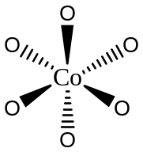
(b)Δ form of Co(ox)₃³⁻, see text book Figure 9-14, Rotate the molecule to place a triangular face at the back, with on ring on the top in a horizontal position. If it takes a clockwise twist orient the front ligand properly, the ring have a Δ relationship.
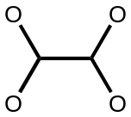
 ^{O O} means

(c)Ligand field stabilization energy, the coming ligand will make the d orbital of metal split, and the total energy will decrease. The whole molecule will become more stable.
Ex. If a d2 octahedral complex, e_{g}

t_{2g}
d orbital
the final energy is lower, ( -2/5Δ_{O} X 2 = -4/5Δ_{O} )

(d)Spectrochemical series, determine the Δ_{O} from the absorption of d-d transition.
(When λis small, it means the Δ_{O} is large ) Then make the series of ligands by the strength of ligand field.
Ex. CO > CN⁻ > NO₂ > en > NH₃ > H₂O > F⁻ > OH⁻ > Cl⁻ > Br⁻
Large Δ_{O} Small Δ_{O}

(e)Labile and inert transition metal ion, labile means the reaction rate of a metal complex is quick. Usually, t_{1/2} < 1 min. Contrary to labile, the inert complex means the reaction is slow. (t_{1/2} > 1 min). They are both kinetic terms.

Ex. Labile, Fe(NH₃)₆³⁺ Inert, Fe(CN)₆³⁻

(f)Inner-sphere electron transfer reaction, The reaction use a bridging lagand as a conduit to transfer electrons by tunneling effect. It’s usually through 3 steps. First, oxidant and reactant linked by a bridging ligand. Second, electron transfer, and then separation.
Ex.﹝Co(NH₃)₅Cl﹞²⁺ +﹝Cr(H₂O)₆﹞²⁺→﹝(NH₃)₅CoH₂O﹞²⁺ +﹝ClCr(H₂O)₅﹞²⁺

(h)Binap ligand, a common ligand usually applied in the organicmetallic reaction. Because the molecule has large steric hinderance, the σ bond can’t rotate. It has two isomers.

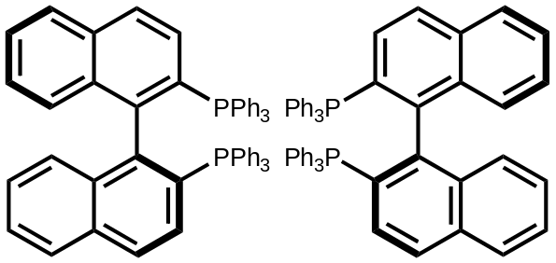
(s)-BINAP (R)-BINAP

(i)EAN rule, It means 18 electrons rule. When the central metal has 18 valence electrons, the electrons will fill the outer s. p. d orbital , and make it have noble gas configuration. The complex will be more stable.
Ex. Cr(CO)₆

(j)π acid, It means π acceptor. The ligand with π* orbital will have back bonding phenomenon. The electron will transfer from metal to ligand. (π acceptors usually considered as strong field ligands.)
Ex. CN⁻, CO

(k)fac- and mer- isomer, Complex of the formula ML₃L₃’, where L and L’ are monodentate ligands. Fac isomers have three identical ligands on one triangular face. Mer isomers have three identical ligands in a plane bisecting the molecule.
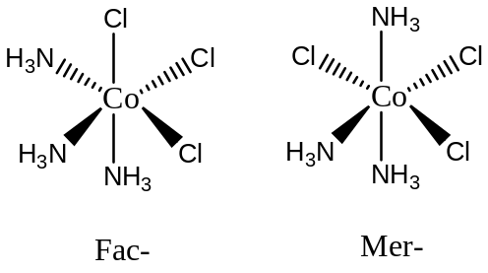Ex.

(l) chelate effect, Ligands wih two or more points to chelate with metal. It represents the abilities of chelating ligands are stronger than monodentates.
Ex. Ca²⁺ + EDTA⁴⁻ → CaEDTA²⁻

(m)Dewar-Chatt-dunkenson Model, The model explains the binding between an alkene and metal. π acid donates electron into metal, and the metal donates electrons back to fill the π* orbital. The effect will reduce the bond order.
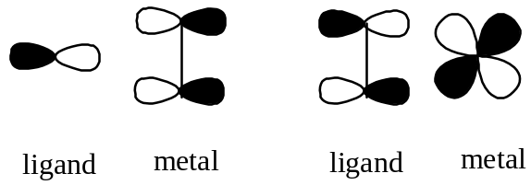Ex.

(n)carbonylation reaction, It means carbonyl insertion reation, a kind of CO insertion.
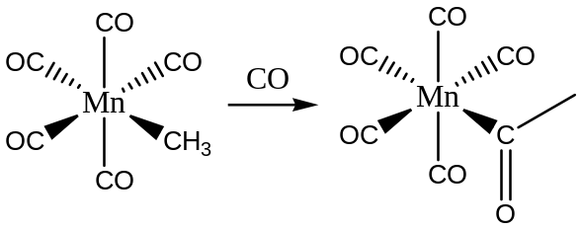Ex.

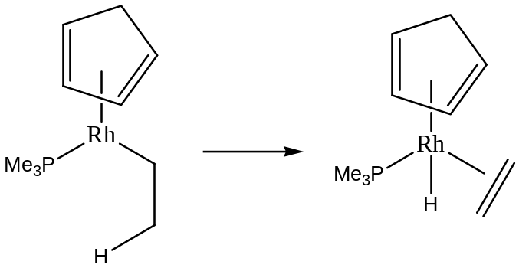(o)β-hydride elimination, the proton on β position in the ligand is transferred to the metal.
Ex.

(p) trans effect, The trans-position ligand is easier to be replaced by trans influence or π-bonding effect.
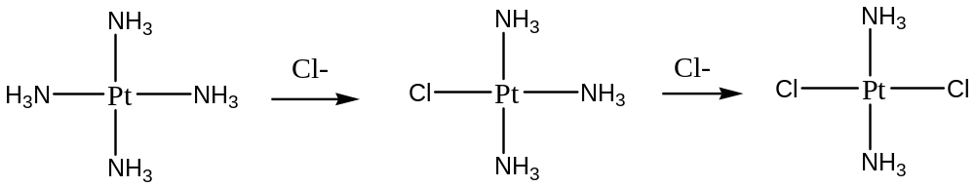Ex.

