1. (a)C2v (b)Cs (c)C3v (d)Cs (e)Cs
2. (b)D5d, D5h, D5(與所畫結構配合) (b) D2h (c)D4h (d)D4d (e)D3
3.
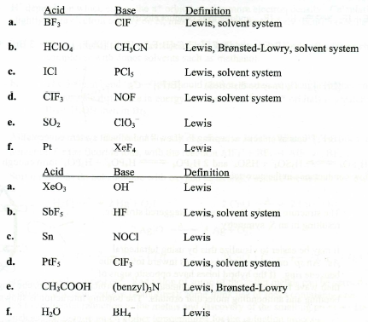
e. ClO₃⁻ SO₂ Lewis
SO₂ ClO₃⁻ Lux-Flood
f. NOCl Sn Lewis

4.
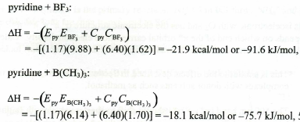
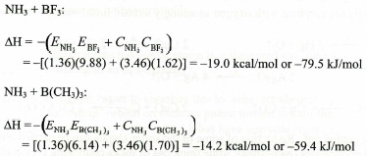

5.
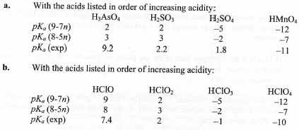
6.
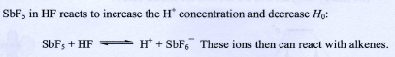
7. (a)7, (b)8, (c)11, (d)9, (e)5, (f)1, (g)4, (h)2, (i)3, (j)6, (k)10, (l)12
8.詳見上課內容
9.
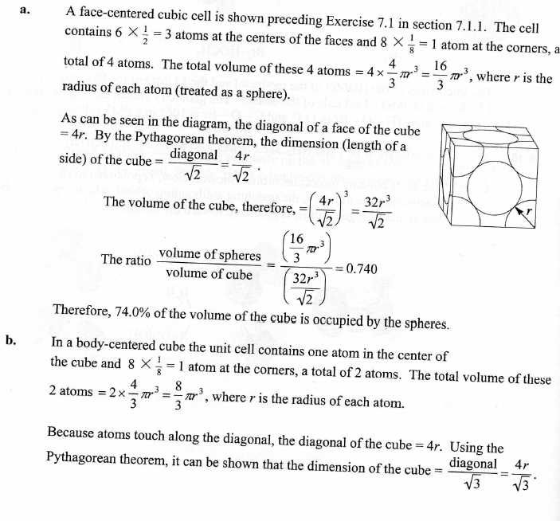

10.
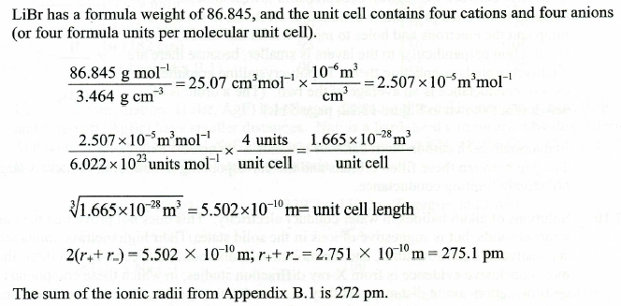

11.詳見上課內容
12. (a)(b)(c)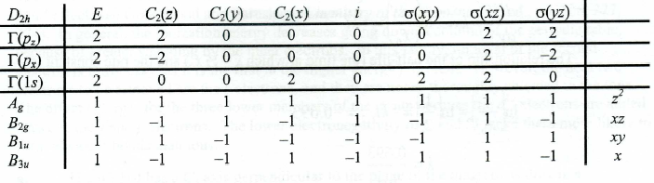
(d)
Table 4 | designations | Group Orbitals Sketches
p_{z} | A_{g}
p_{z} | B_{1u}
p_{x} | B_{2g} | 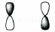
p_{x} | B_{3u} | 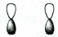
s | A_{g} | 
s | B_{3u}
13.
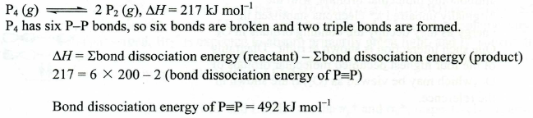
14.
15.
Table 5 Neutral and Ionic O₂ and O₃ Species
Formula | Name | Magnetic  Property | O-O Distance (pm)
O₂⁺ | Dioxygenyl | Para | 111.6
O₂ | Dioxygen | Para | 120.8
O₂⁻ | Superoxide | Para | 135
O₂²⁻ | Peroxide | Dia | 149
O₃ | Ozone | Dia | 127.8
O₃⁻ | ozonide | para | 134
總共一分，錯其中ㄧ個就沒有了

