2. Choose five complexes to name according to the IUPAC nomenclature. (12)
(a) Pt(NH₃)BrCl(MeNH₂) Amminebromochloromethylamineplatinum(II)
(b) Cs₃[AgF₄] Cesium tetrafluoroargentate(I)
(c) [Cu(NH₂CH₂CH₂NH₂)Cl₄]²⁻ Tetrachloroethylenediaminecuprate(II)
(d) K₂PtCl₄ Potassium tetrachloroplatinate(II)
(e) Ir(CO)Cl(PPh₃)₂ Carbonylchlorobis(triphenylphosphine)iridium(I)
(f) Fe(CN)₂(CH₃CN)₄ Tetrakis(acetonitrile)dicyanoiron(II)

3. Sketch the structure, including all the structural isomers. (15)
(a) [Cr(o-phen)(NH₃)₂Cl₂]⁺
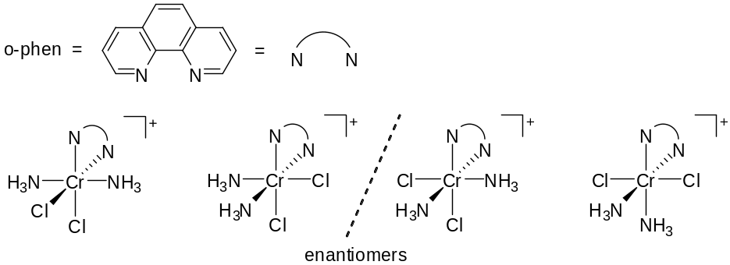

(b) μ-amido-μ-hydroxobis(tetraamminecobalt)(4+)
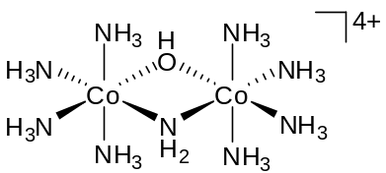

(c) [Co(en)₂(CO₃)]Br
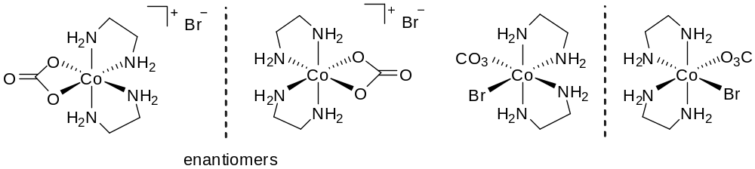

(d) tetraamminechloronitritocobalt(+1)
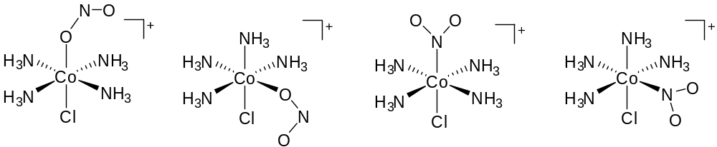

(e) Re(dien)Br₂Cl
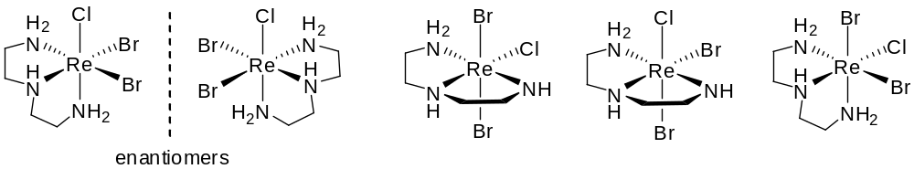

4. Choose one to answer.
4-1 The metalloporphyrin skeleton of heme is shown below. Answer and explain the following questions.
- Complete the fully conjugate macrocycle by filling the double bonds at the suitable positions. How many sp² carbon atoms in this unit? (4)
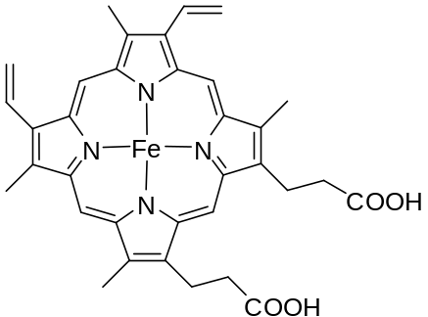 26 sp² carbon atoms

- Estimate the Δ_{o} and the LFSE in cm⁻¹? (6)
Hemeporphyrin is the ingredient that makes blood red, and the red color results from electrons in the d orbital of iron absorb green color visible light (Δ_{o}). The absorbing range of green color is about 495 ~ 570 nm, and is 20202 ~ 17544 in the unit of cm⁻¹ as well. Taking middle value 18800 cm⁻¹ for calculation, the resulting LFSE is about 7520 cm⁻¹.

LFSE = 4×(2/5Δ_{o}) - 2×(3/5Δ_{o}) = 2/5Δ_{o} = (2/5)×18800 = 7520 (cm⁻¹)
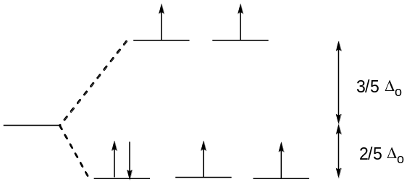

4-2 (a) Assign absolute configurations to the structures of (1) and (2). (4)
- Λ (2)Δ
(b)Draw their structures with the C₃ axis (assuming O_{h}) being at the center and directing toward you. (6)
(1) (2)
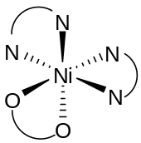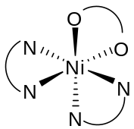

5. Choose one to answer
5-1 The rate of substitution for the following reaction depends on [py]
- Draw the structures for the reactants and products. (4)
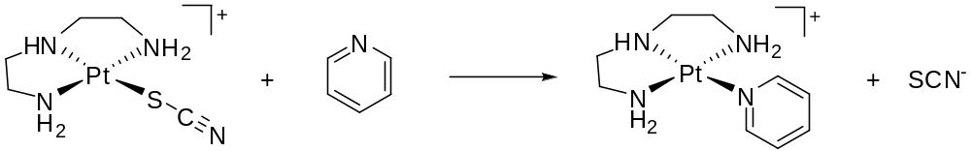
- Derive the rate law of this reaction and evaluate the rate constants. (6)
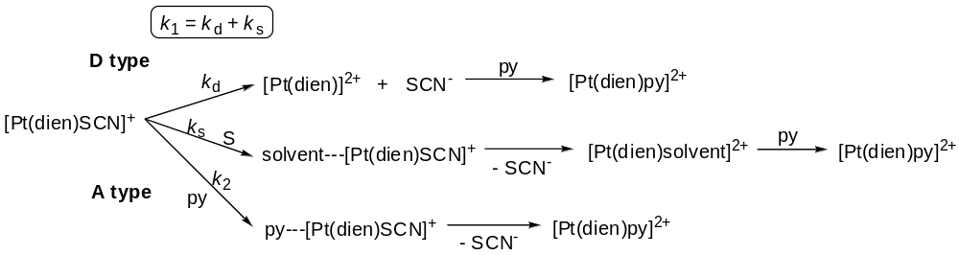

This reaction is a mainly associative type mechanism with competition of solvent or dissociation of SCN, and the rate law can be written as following equation:
Rate = -d[Pt(dien)SCN]⁺/dt = (k₁ + k₂[py])[Pt(dien)SCN]⁺ = k_{obs}[Pt(dien)SCN]⁺
k₁ represents the combined rate constant of A-type competition of solvent and D-type pathway of SCN⁻, and k₂ represents the rate constant of A-type pathway of pyridine. k₁ and k₂ can be evaluated by following equation:
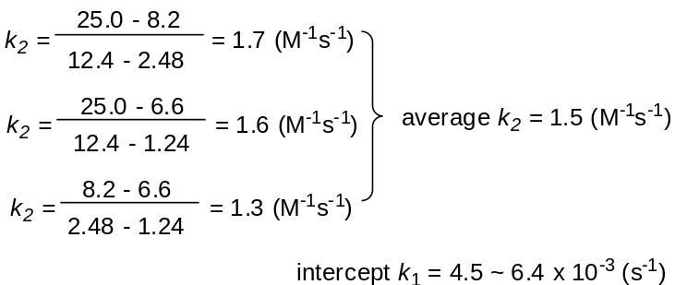

- Propose a mechanism to elaborate the data and the following table. (8)
The metal-X bond is broken in the transition state. Ligands that are good trans directors are also strongly bonded to the metal, and as a result are poor leaving groups. Furthermore, the bond-strengthening effect of the metal-to-ligand π bonding reduces the reactivity of these ligands significantly. In addition, π bonding to the leaving group uses the same orbitals as those bonding to the entering group in the trigonal plane. These two effects result in the slow displacement of metal-to-ligand π-bonding ligands (ex: CN⁻) when compared with ligands with only σ bonding ligand or ligand-to-metal π bonding (ex: H₂O). In other words, different leaving groups strongly affect the k_{d} value which is the D-type mechanism to k₁ in the reaction.
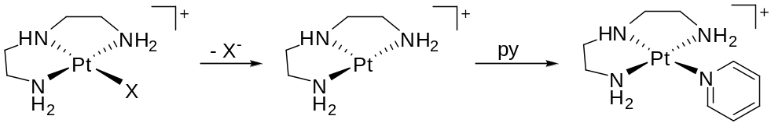

5-2 Consider the following reaction
Pt(PPh₃)₃ + MeI → trans-Pt(I)Me(PPh₃)₂ + PPh₃
The rate of the reaction is governed by the following expression:
-d[Pt(PPh₃)₃]/dt = A[MeI][Pt(PPh₃)₃]/{[MeI] + B[PPh₃]} (A, B = constants)
** error: B[Pt(PPh₃)₃] should be B[PPh₃] **
(a) Classify this reaction. (4)
This reaction should be a D-type mechanism. One of PPh₃ dissociates form Pt metal in the beginning, and then MeI reacts with Pt(PPh₃)₂ via oxidative addition.

(b) Write a plausible mechanism for this reaction and show it agrees with the rate law. (6)
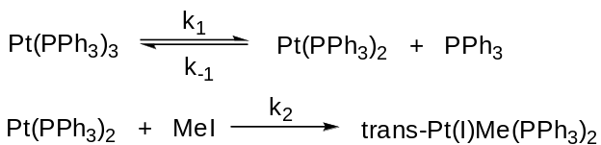
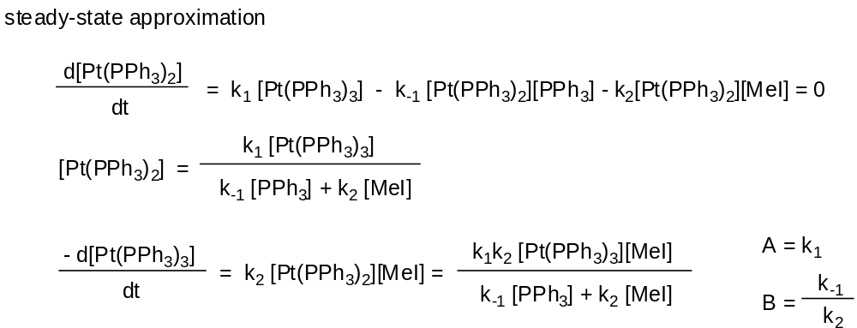

(c) Suggest an experiment that may confirm your proposed mechanism. Explain. (8)
From the rate law proposed before, the k_{obs} can be written as following:
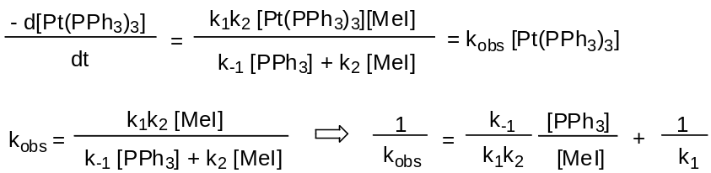
Kinetic studies of this reaction can be operated to confirm the proposed mechanism. Different amount of PPh₃ can be added in the reaction to measure the resulting k_{obs} values, and a straight line should result with a slope of k₋₁/k₁k₂ and an intercept of 1/k₁ in the plot of 1/k_{obsd} vs. [PPh₃]. The same result should be obtained to the plot of 1/k_{obsd} vs.1/[MeI] by using different amount of MeI as well.

6. Choose one to answer.
6-1 Answer the following questions based on the data in Figure 13.6
- Determine the rate law for this reaction and evaluate the rate constants. (15)
The original data can be re-ploted 1/k_{obsd} vs.1/[SCN⁻], and then a straight line is obtained with a slope of A and an intercept of B showing below:
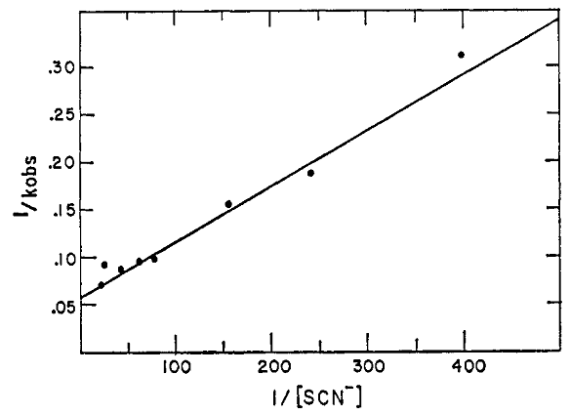
And the rate law can be written as following equation: 1/k_{obsd} = A(1/[SCN⁻]) + B. Calculation from the plot, the slope A is about 5.4×10⁻⁴ MS and the intercept B is about 5.7×10⁻² s.

- Propose a plausible mechanism that can match with the data. (10)
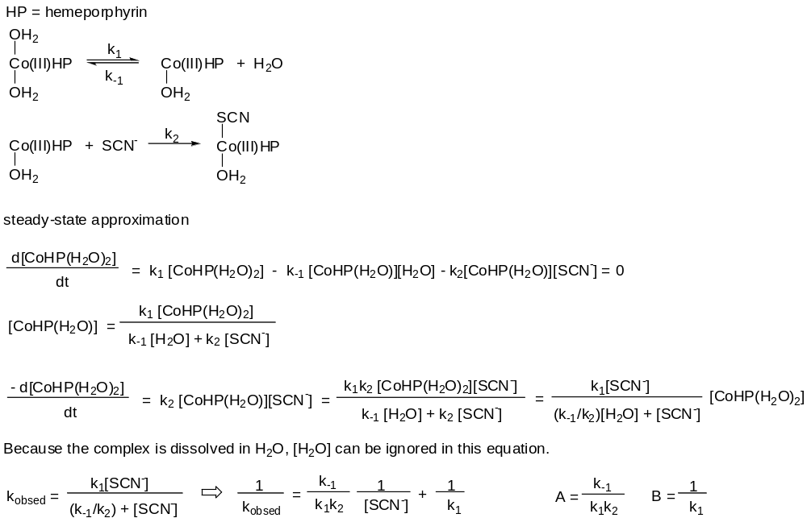
From the rate law of the reaction, the rate constants can be calculated as following:
k₋₁/k₁k₂ = 1850 M⁻¹s⁻¹ , k₁ = 17.4 s⁻¹ , k₋₁/k₂ = 0.010

6-2 Given the kinetic results in Fig 13.1 for the reaction of
Pt(Py)₂Cl₂ + X⁻ → Pt(Py)₂ClX + Cl⁻
- Write the rate law and evaluate the rate constants. (15)
**The unit of X-axis in the figure is error, and it should be 10²[Y⁻] according to the text in the literature. Although the unit is wrong, original unit is still used for this question. By the way, 10²[Y⁻] means the value of [Y⁻] is multiplied 100 in this axis of the figure. **

rate = (k₁ + k₂[Y⁻])[Pt(Py)₂Cl₂] = k_{obs}[Pt(Py)₂Cl₂] k₁ = intercept, k₂ = slope
k₁ ~ 10⁻⁴ s⁻¹
k₂ : SCN⁻ ~ 1.8×10⁻³ M⁻¹s⁻¹
I⁻ ~ 1.07×10⁻³ M⁻¹s⁻¹
C₆H₅SH ~ 5.7×10⁻⁵ M⁻¹s⁻¹
Br⁻ ~ 3.7×10⁻⁵ M⁻¹s⁻¹
NH₂OH ~ 2.9×10⁻⁵ M⁻¹s⁻¹
N₃⁻ ~ 1.55×10⁻⁵ M⁻¹s⁻¹
NO₂⁻ ~ 6.8×10⁻⁶ M⁻¹s⁻¹

- Propose a mechanism as detail as possible to explain the kinetic results. (10)
k₁ is came from dissociation of Cl⁻ and solvent-assisted mechanism:
D-type mechanism
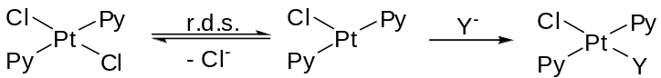

Solvent-assisted mechanism

k₂ is came from A-type mechanism of Y⁻:
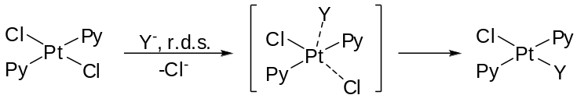

When Y⁻ = SCN⁻, I⁻, the reaction is mainly predominated by A-type mechanism (k₂). When Y⁻ = C₆H₅SH, Br⁻, NH₂OH, N₃⁻, the rate of reaction is controlled by A-, D- type and solvent-assisted mechanism which k₁ and k₂ are in similar order. When Y⁻ = NO₂⁻, the reaction is predominated by D-type and solvent-assisted mechanism which k₁ is almost zero.

7. The following reaction is found to proceed by an inner-sphere mechanism.
[Fe(CN)₆]³⁻ + [Co(CN)₅]³⁻ → [Fe(CN)₆]⁴⁻ + [Co(CN)₅]²⁻
- Propose a plausible intermediate and how would you verify the mechanism? (8)
Because this reaction proceeds by an inner-sphere mechanism, the electron must transfers via a bridging ligand in the intermediate showing below:
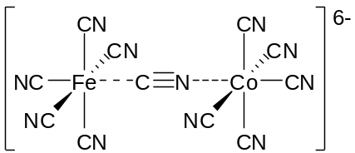
This intermediate may be observed by measuring IR frequency of bridging CN triple bond in solution or by kinetic studies for this reaction. Furthermore, the intermediate is stable enough to precipitate out as a Ba²⁺ salt.

- Explain why there is no ligand transfer. (6)
Because Fe and Co are all electron deficient metals, electron rich C⁻ of cyano group coordinates to metal more tightly than N of cyano group. Besides, the antibonding orbitals of CN group are mostly located on carbon atom, and the Co-N bond isn’t easier to be stabilized by back bonding via d orbital of Co. In other words, the C-bound cyano group stabilizes the d⁶ (Fe²⁺) configuration of [Fe(CN)₆]⁴⁻ more than the N-bound cyano group would stabilize a d⁶ (Co³⁺) configuration in [Co(CN)₅(NC)]³⁻, indicating that Fe-C bond isn’t broken during electron transfer.

- According to Marcus’ model, what energy contribution will be important to the energy of activation of outer sphere electron transfer process? (6)
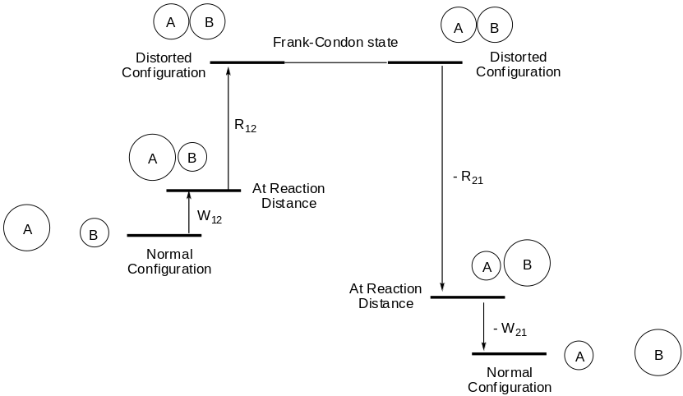
In the Markus model, outer sphere reactions are regarded as involving five steps:
- Reactants diffuse together to form an outer-sphere complex in which both metal coordination spheres remain intact. (W₁₂)
- Bond distance around each metal change to become more “productlike”, and the solvent shell around the outer-sphere complex reorganizes. (R₁₂)
- The electron is transferred. (Frank-Condon state)
- The coordination and solvent shells of the newly formed A and B relax to their equilibrium configurations. (R₂₁)
- The products diffuse away. (W₂₁)
In these five steps, no energy is required for electron transfer in Frank-Condon state, indicating that the rate of electron transfer is very fast and the rate determining steps should be R₁₂ and W₁₂. The W₁₂ involves electrostatic attraction and other non-reorganizational work, and R₁₂ involves energies of bond distance change and solvent reorganization. These two steps are important to the energy of activation of outer sphere electron transfer process.

8. The CO de-insertion reaction below could either undergo migration of acetyl CO or migration of the methyl group.
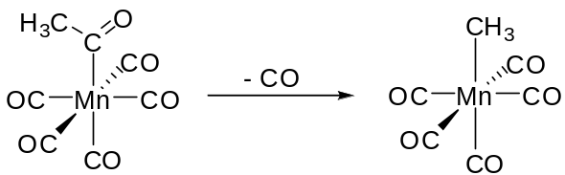
- Explain how the pathway may be confirmed by isotope labeling with the acetyl carbonyl carbon? (8)
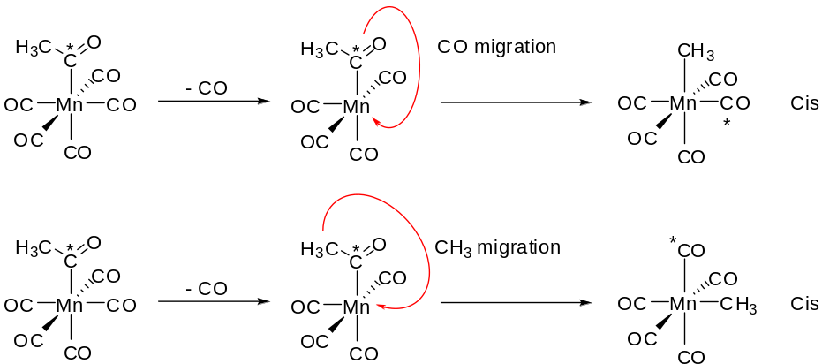
No matter which one of unlabeled CO is lost, the mechanism of CO or CH₃ migration results in cis configuration of CH₃ and labeled CO, and this method of isotope labeling with acetyl carbonyl carbon cannot identify that the mechanism proceeds by methyl or carbonyl migration.

- Can the experiment be done by labeling other functional groups such as the methyl group or the terminal carbonyls to achieve the same purpose? Explain your results. (8)

The purpose of experiment can be achieved by labeling CO near the acetyl carbonyl group. All of the products in CO de-insertion reaction proceeds CO migration are cis configuration of CH₃ and C*O groups. However, the mechanism of CH₃ migration would result in one trans configuration complex, this different resulting product can be used to identify the pathway of CO de-insertion reaction
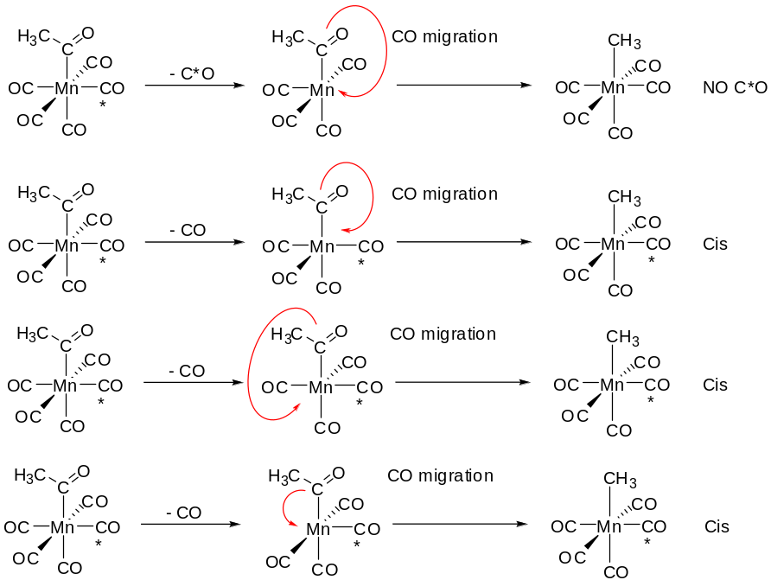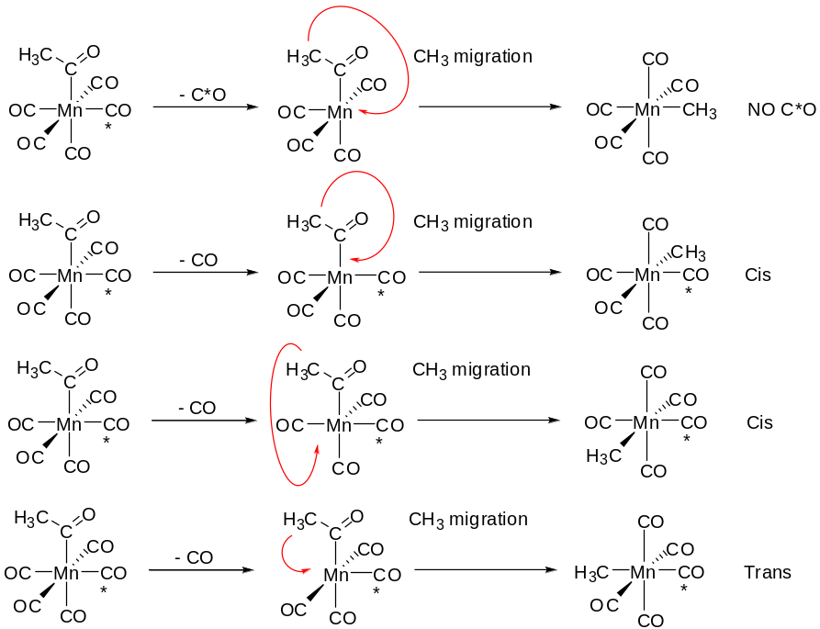

9. In the reaction of ethylene hydrogenation with RhH₂Cl(PPh₃)₃, a rate law as below is obtained.
-d[RhH₂Cl(PPh₃)₃]/dt = k_{obsd}[RhH₂Cl(PPh₃)₃]
k_{obsd}⁻¹ = A([PPh₃]/[C₂H₄]) + B
- Propose a mechanism that can explain the rate law. (10)
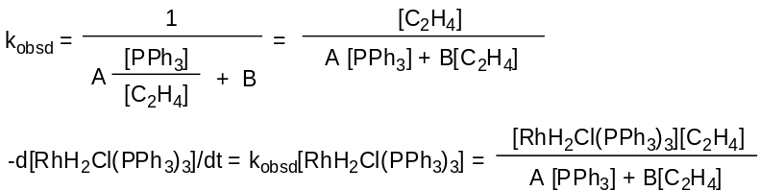
From the rate law of hydrogenation, this reaction should be a D-type mechanism. The rate determining steps are the dissociation of PPh₃ and the coordination of ethylene, and the following hydride migration should be very fast in the hydrogenation. Although coordinated ethylene may also dissociated, rate constants k₋₂ is ignored for the reason of high pressure ethylene in this reaction.
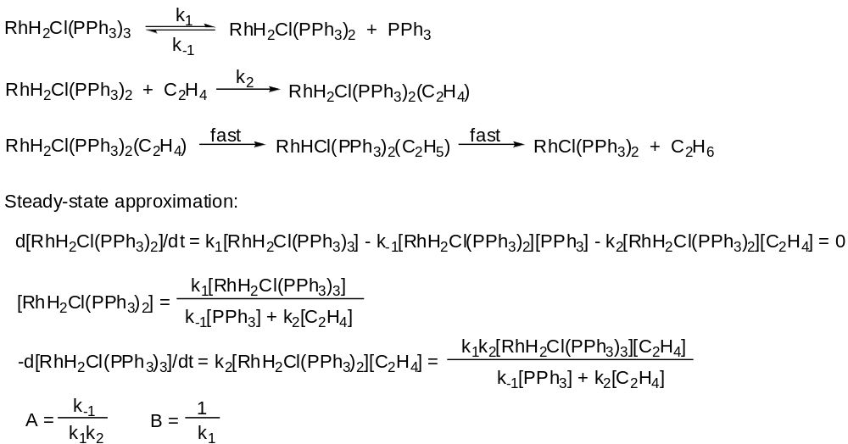

- What results you would expect if RhH₂Cl(PPh₃)₃ and RhD₂Cl(PPh₃)₃ in 1:1 ratio were used for the reaction. Explain. (10)
From the mechanism proposed before, the hydride migration isn’t the rate determining step and the rate of it should be very fast. The ethyl group bounded on Rh metal won’t easily undergo de-insertion reaction, indicating that H and D won’t be exchanged via β-deuteride elimination following with decoordination of ethylene. When RhH₂Cl(PPh₃)₃ and RhD₂Cl(PPh₃)₃ in 1:1 ratio are used for the reaction, C₂H₆ and C₂H₄D₂ in 1:1 ratio would be obtained, and C₂H₅D wouldn’t be observed in this reaction.

