MAP524A Assignment 2:

Implementation for MyCharity App

Written By

Ka Yee Jason Fung
051640126

Instructor: Prof. John Selmys
Course Code: MAP524A
Due Date: April 10, 2015
Submitted Date: April 17, 2015
Table of Contents

1. Executive Summary of MyCharity App 2

2. Description of MyCharity App 2

3. Features 3

4. Snapshots of App 4

5. Conclusion 5

1. Executive Summary of MyCharity App
MyCharity is a simple to use mobile app that allows users to make donations easily and quickly to support their favourite charities.

There are a number of apps on the Play Store that resembles MyCharity app. But none of them is tailored to the Canadian public. The goal of this app is to make a positive impact to the charity sector in Canada by making it highly accessible for Canadian to donate their money to charity, whenever they feel like. It also provides a new platform for charitable organizations to promote their brands and engage their audiences.

The MyCharity app will use the government data below to obtain a complete list of charitable organizations in Canada.
http://open.canada.ca/data/en/dataset/8a4fbee5-f2f0-4974-83bf-66644e93988c

2. Description of MyCharity App
The app has a functional search list which allows user to search for the 30 most popular charities in Canada. It gives the user a brieft overview of the chairty in the charity profile page and also allows users to select or specify an amount to donate. But overall, my final app is not as complete as I hoped due to difficulties in implementating some of the features, such as in-app billing. The app is not connected to Google Play so the user can not actually donate money to charity. But it does provide users with a feel of donation process inside the app.

3. Features
MyCharity app has the following features:

1. A searchable 30 most popular charities in Canada Completed

2. Charity profile Completed
- Displays the charity’s name, logo and missions. Also includes a “Donate” button.

3. Donation feature Completed
- Each charity profile has a “Donate” button that allows users to make a donation. Users can specify how much they want to donate.

4. Donation history (in the Menu) Partially Completed
- Calculates the total amount of donations made by the user

5. Help and About (in the Menu) Completed
- Lists the author and explains the purpose of this app

4. Snapshots of App
Note: When you do a search for a charity, please enter its full name and click on the first result. Otherwise, the app may crash.
Charity Page (Using Salvation Army
The Main Page as an example)
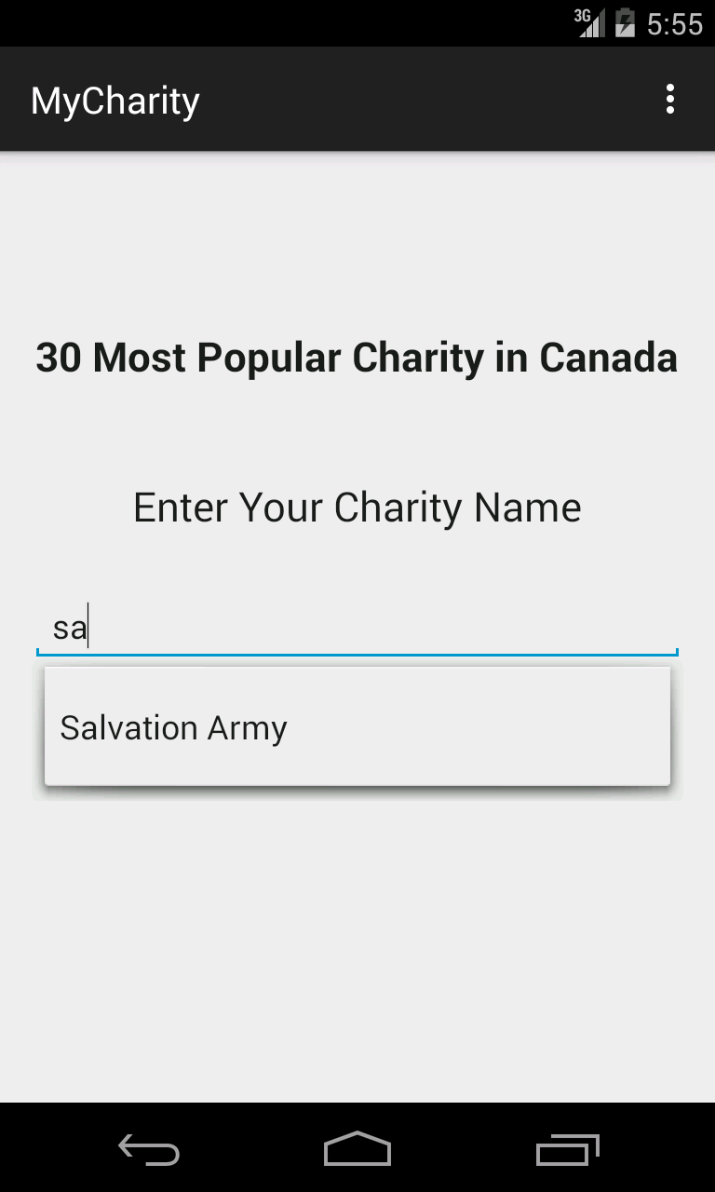
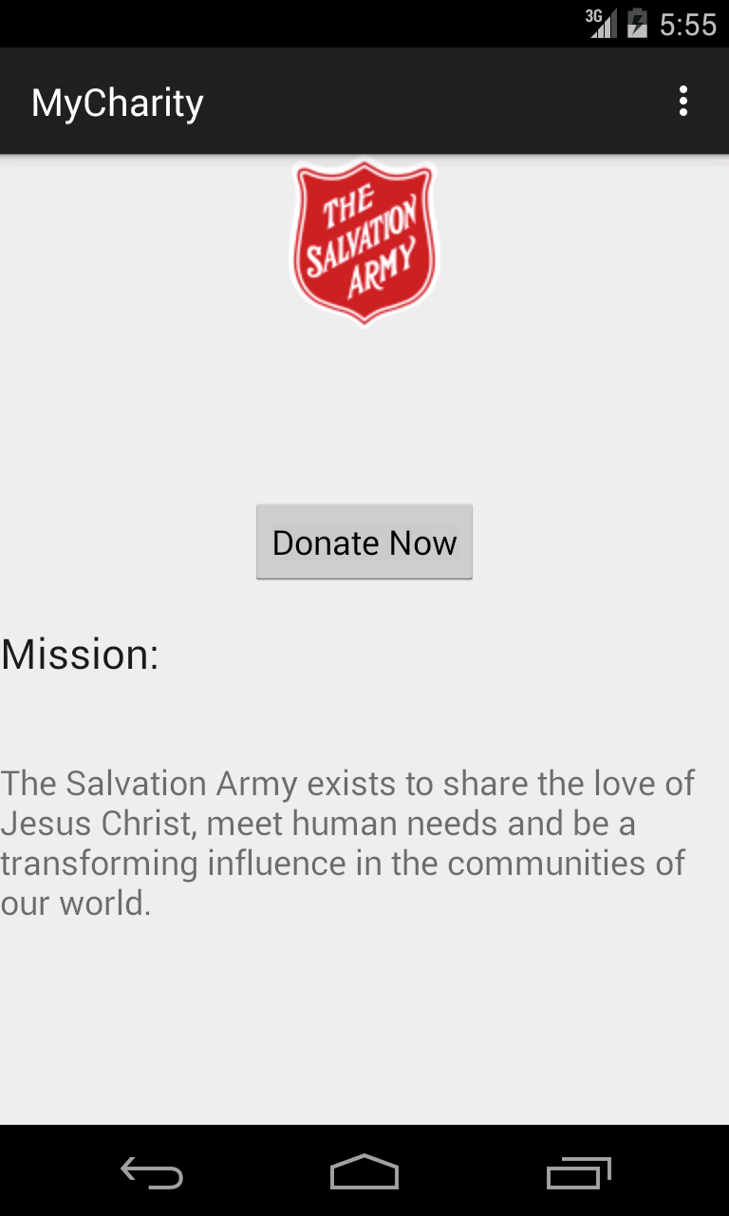

Choose A Donation Amount Confirmation Page
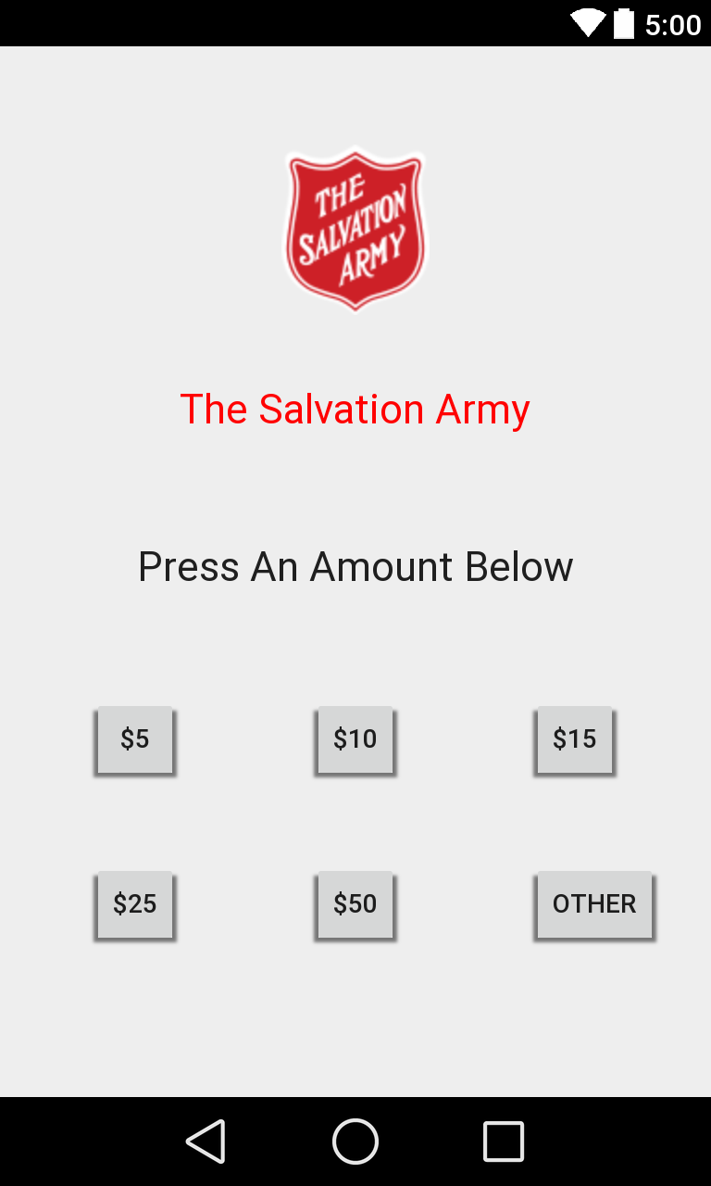
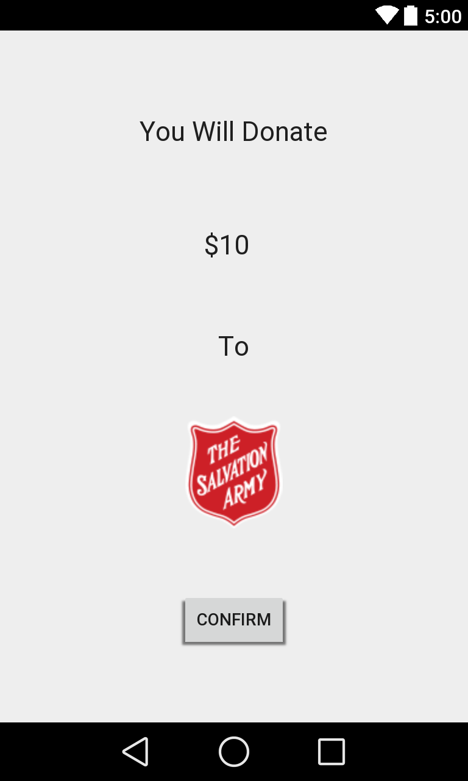

Transaction Completed
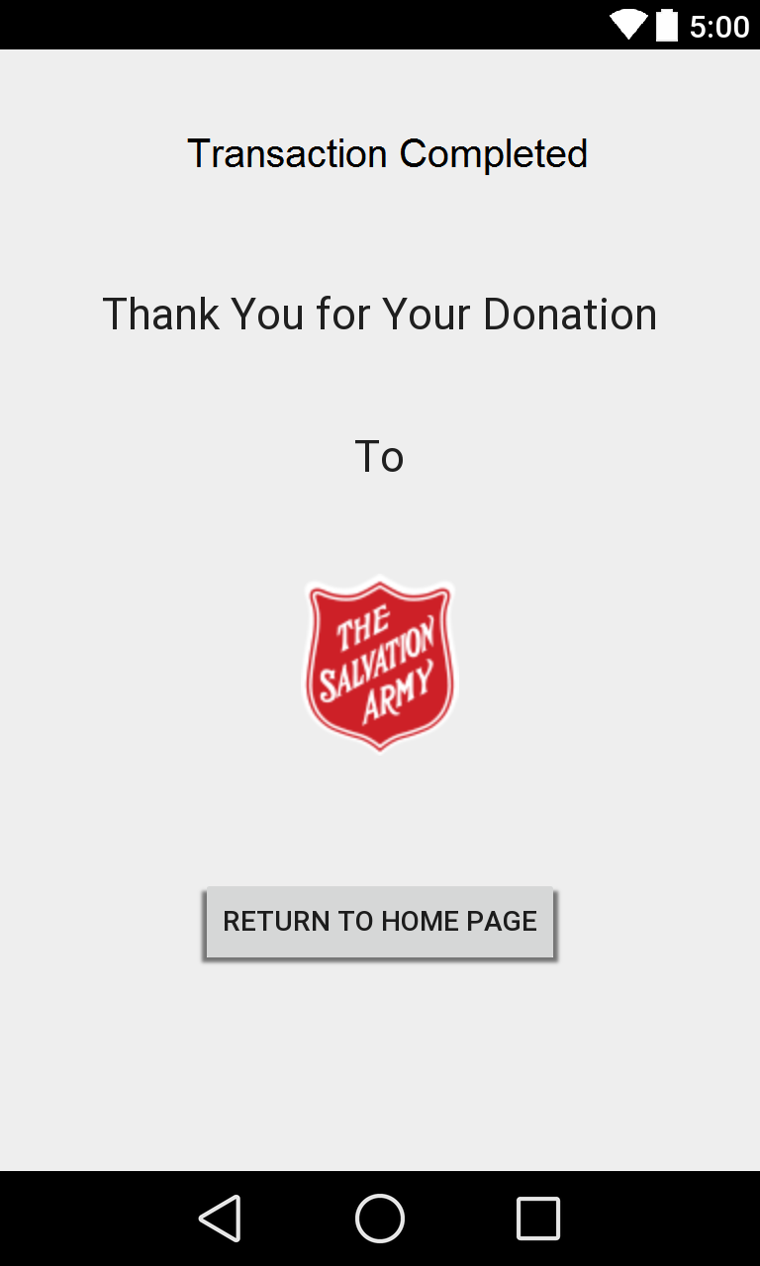

5. Conclusion
The Help and About Menu options have been added to this app so that users can learn more about the purpose of this app. If more time is given, I should be able to complete the donation history feature. Overall, this app has been a good practice for me to learn how to design user interface and to create a working prototype from a concept.

