MAP524A Assignment 1:

A Proposal for MyCharity App

Written By

Ka Yee Jason Fung
051640126

Instructor: Prof. John Selmys
Course Code: MAP524A
Due Date: February 27, 2015
Submitted Date: March 15, 2015
Table of Contents

1. Executive Summary of MyCharity App 2

2. Why Is MyCharity App a Good Mobile App? 2

3. Basic Features 3

4. Summary of Expected Users 3

5. Mockup Views 4

6. Descriptions of Common Test Cases 5

7. Timeline for Implementation 7

8. Conclusion 7

1. Executive Summary of MyCharity App
MyCharity is a simple to use mobile app that allows users to look up charitable organizations in Canada and check for their latest news. It allows users to make donations easily and quickly to support their favourite charities. It also keeps a record of a user’s past donations and automatically calculates the amount of donations made by the user per year. In addition, it provides a list of the most popular charities in Canada so that users can learn more about charities that other people are supporting.

There are a number of apps on the Play Store that resembles MyCharity app. But none of them is tailored to the Canadian public. The goal of this app is to make a positive impact to the charity sector in Canada by making it highly accessible for Canadian to donate their money to charity, whenever they feel like. It also provides a new platform for charitable organizations to promote their brands and engage their audiences.

The MyCharity app will use the government data below to obtain a complete list of charitable organizations in Canada.
http://open.canada.ca/data/en/dataset/8a4fbee5-f2f0-4974-83bf-66644e93988c

2. Why is MyCharity a Good Mobile App?
MyCharity is a good idea for mobile app because it makes it easy for users to make a donation to their favourite charities via their phone at anytime, whenever they feel generous. With some initial setups of billing information, users can make donations by pressing a few buttons on their phone without re-entering billing information again. This is a more convenient way than going directly to a charity website to donate. The app also allows users to always stay connected with a charity’s latest news and activities. When a charity is raising money for a new initiative, users can be notified and be asked if they are willing to make a small donation.
3. Basic Features
MyCharity app will have the following features:
1. Charity Profile
- Displays the charity’s name, history, recent news and activities. Also includes a “Donate” button.

2. A list of most popular charities in Canada

3. Donation Feature
- Each charity profile has a “Donate” button that allows users to make a donation

4. Donation history
- Calculates total amount of donations made by the user using the app

4. Summary of Expected Users
The expected users of this app would be individuals who are passionate about contributing to charity and would like to support it by donating some of their incomes. They should possess a credit card because MyCharity will only accept credit card as a payment method. Since most provinces require people to reach 18 or 19 years old in order to obtain a credit card, the users of this app are expected to have reached this age limit. Younger people are encouraged to use this app as well because we believe it is never too young to learn about charity work via our app and to become a donor. But if young people want to donate, they may need an adult to accompany them and to make a donation on their behalf.

5. Mockup Views
Charity Page (Using Salvation Army
The Main Page as an example)
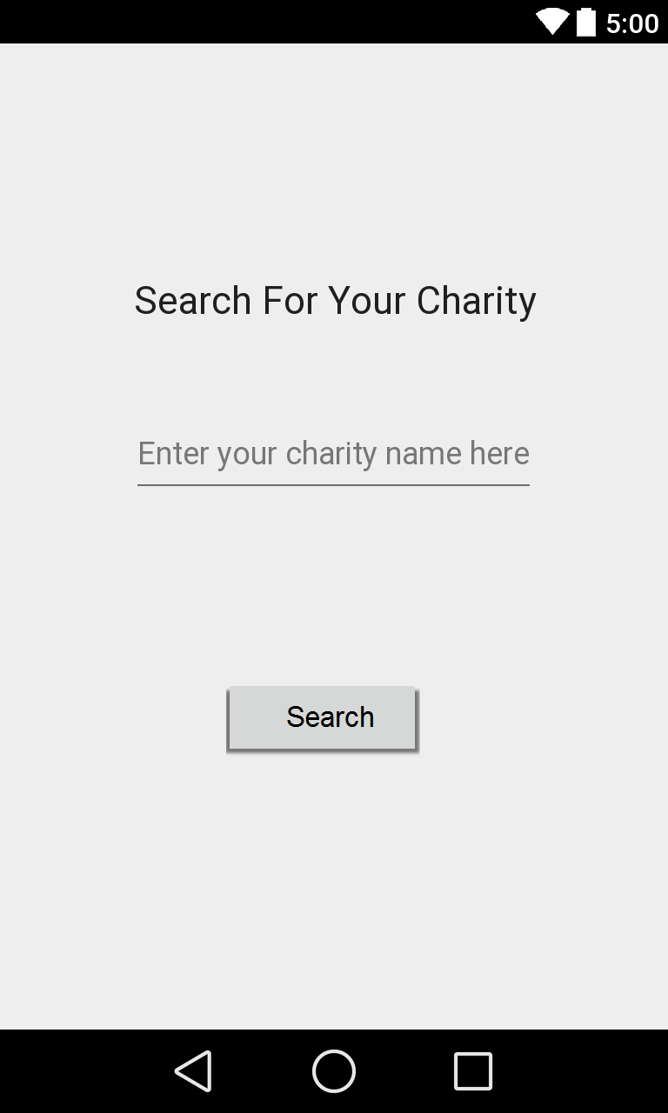
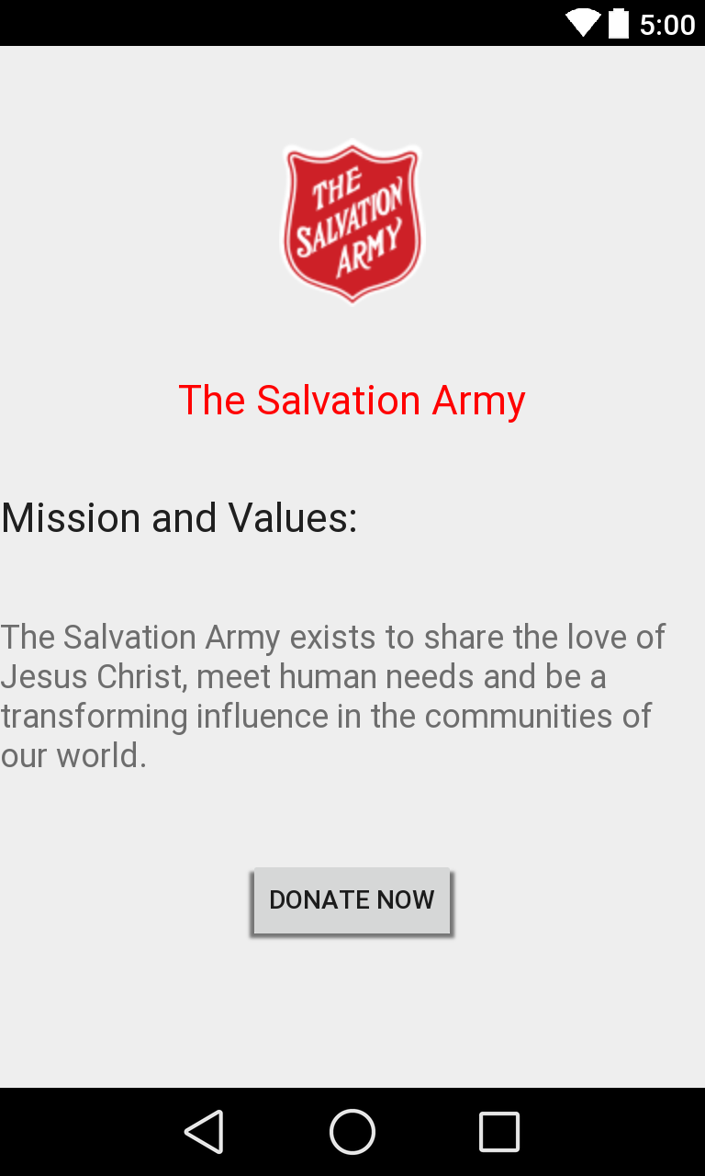

Choose A Donation Amount Confirmation Page
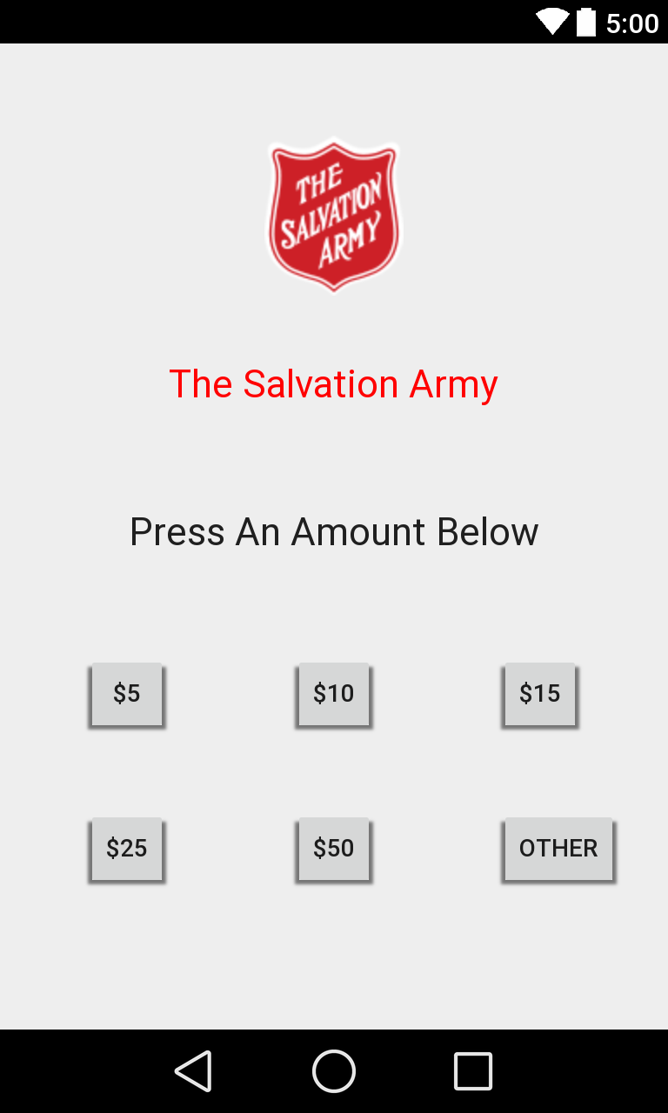
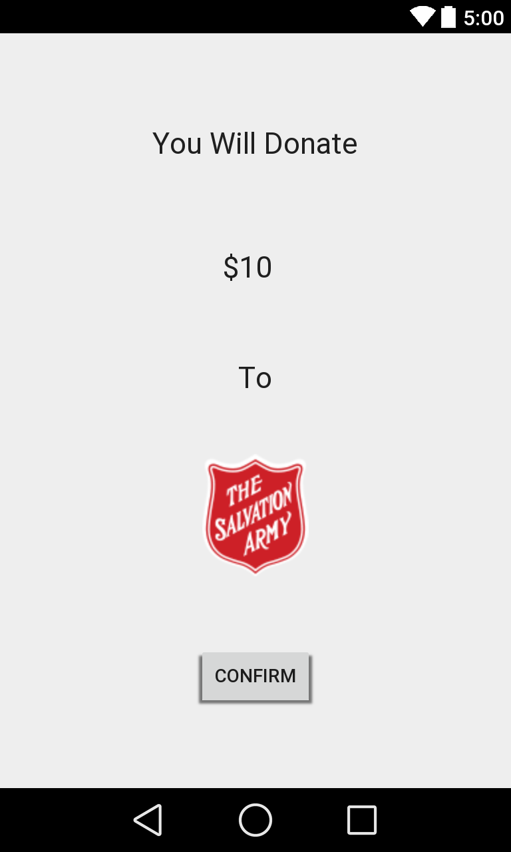

Transaction Completed
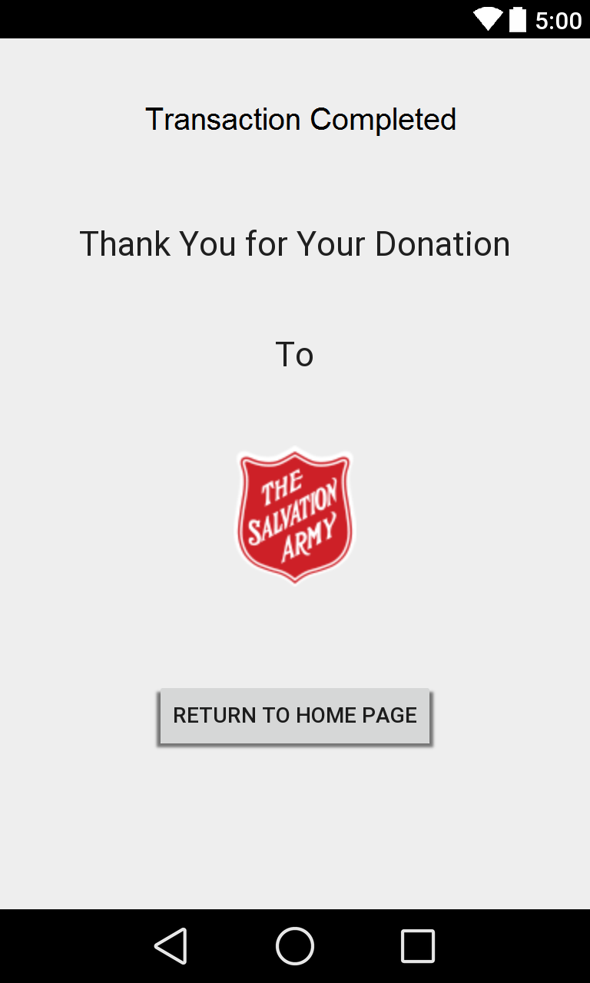

Note: Donation history of a user and a list of most popular charities in Canada are not shown in this mockup. The latest news and activities for each charity are also not shown here.

6. Descriptions of Common Test Cases
Scenario 1: Search for a charity

Precondition: This search is only for Canadian charity.

Step# | Actor | System
1 | Type “Salvation Army” in the autocomplete search field on main page. | The autocomplete search field suggests “Salvation Army” after entering three characters.
2 | Select “Salvation Army” in the search field. | “Salvation Army” is selected and is displayed in the search field
3 | Click on the “Search” button. | Displays the “Salvation Army” profile page.

Successful Post Conditions: The Salvation Army profile page is displayed to the user.

Scenario 2: Make a Donation

Preconditions: Billing Information has been setup for the user. The user is on the Salvation Army profile page.

Step# | Actor | System
1 | Click on the “Donate Now” button on the Salvation Army profile page. | Displays the page that allows user to choose a donation amount. The page has a “$5”, “$10”, “$15”, “$25”, “$50” and “Other” button.
2 | Click on the “$10” button. | Displays the confirmation page with a message: “You will donate $10 to the Salvation Army”.
3 | Click on the “Confirm” button. | Displays the transaction completed page. The page has a “Return to Home Page” button.

Successful Post Conditions: A donation is made successfully to the Salvation Army.
7. Timeline for Implementation

Date | Completion of Task
March 15, 2015 | The user interface of each page is complete. There are five pages: Main page, Charity profile page, Transaction Completed page, Choose a donation amount page and Confirmation page.
March 22, 2015 | A complete list of charity will be extracted from government data. The autocompletion search field will work on the main page and give suggestions after users have entered three characters.
March 29, 2015 | News and activities added to each charity profile. A list of most popular charities in Canada is added on the main page.
April 5, 2015 | The payment feature is added. User can donate money to any charity on the list. Donation history of a user is also added.
April 12, 2015 | QA testing and fix any remaining bugs. The app is ready to be launched

8. Conclusion
MyCharity app makes it easier for users to follow their favourite charities and make donations swiftly without the hassles of entering their billing information every time. It makes donation a more seamless and user-friendly experience and encourages more people to be generous. We hope that the app will increase the amount and frequency of donations made by people to charities so that more help can be provided to people in need.

