Posted on TPG web site with permission from Charlie Riggs
http://www.cclay.com/criggs/

RAKU KILN BUILDING INSTRUCTIONS
Charlie Riggs

- Cut expanded metal to size: a) 22 ½” by 22 ½” - lid / top
b) 24" by 72 ½” - body
- Roll up and screw together kiln body.
- Add handles and "L" brackets.
- Install top of kiln and use wire to add additional strength.
- Cut 5" by 5" flue hole in top center.
- Cut fiber circles and lay them into kiln.
- Cut lengths for kiln sides. Roll up and press them into place one at a time.
- Make staples from high temperature wire and use to pin fiber on to expanded metal.
- Cut peephole into metal using wire cutters.
- Use sharp knife to cut through fiber to open up peephole and flue hole. (Flue is 4" by 4").
4’x8’ Expanded Metal
“Cut” Sheet List

2 – 72 ½” x 24” Panels
2 – 22 ½” x 22 ½” Panels

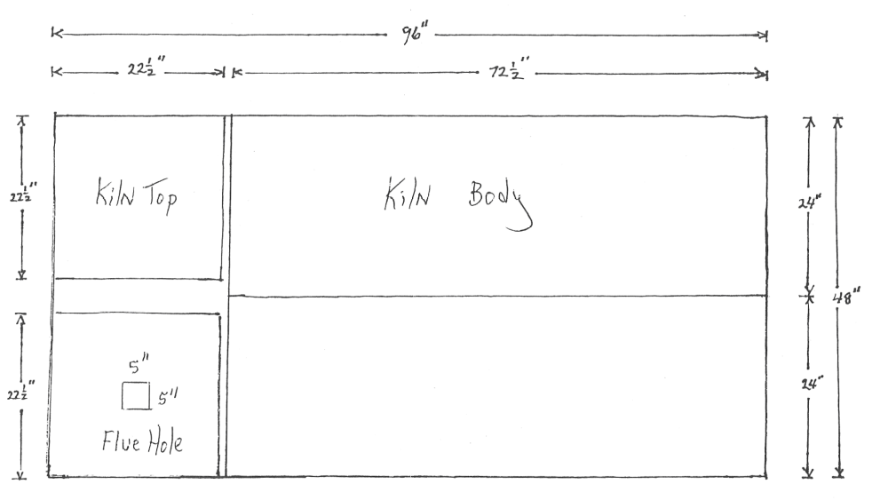

Roll Metal into Cylinder

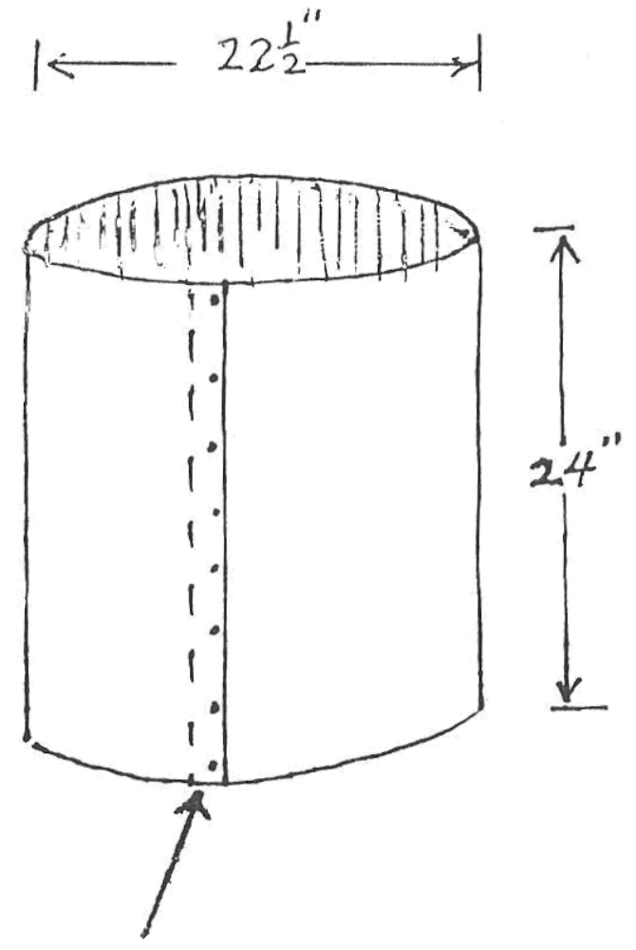
Overlap 2” – Install Screws

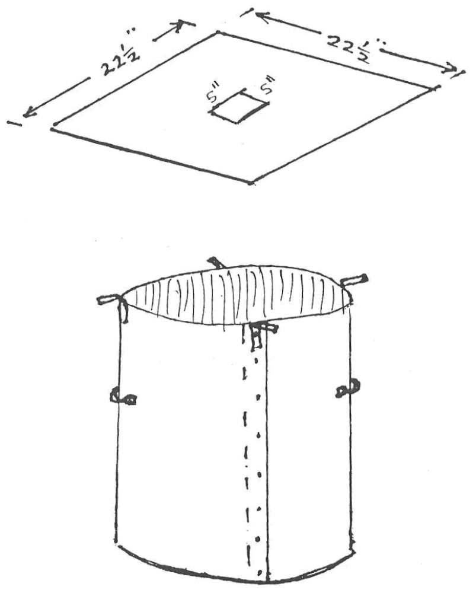

Attach handles and brackets
Attach top to brackets

Lining the Kiln

Step I
Cut 2 – 22 ½” circles from fiber roll.
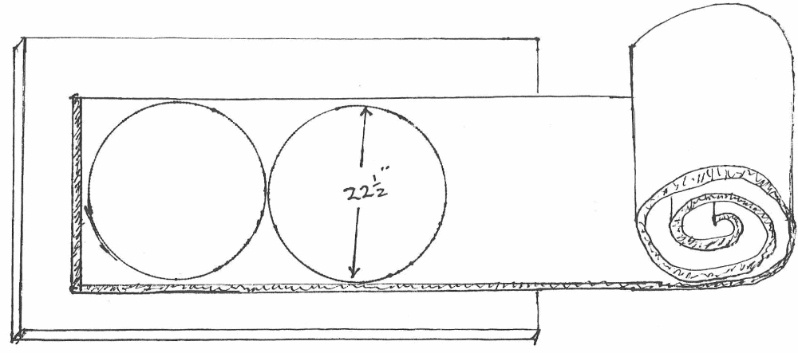

Step II
Cut two lengths 1 – 67” and 1 – 62”
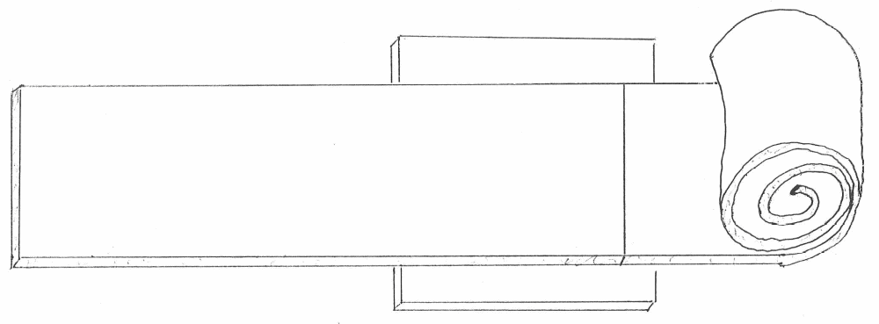

Cut Flue and Peep Hole

Use Razor knife to cut 4” Flue thru Fiber
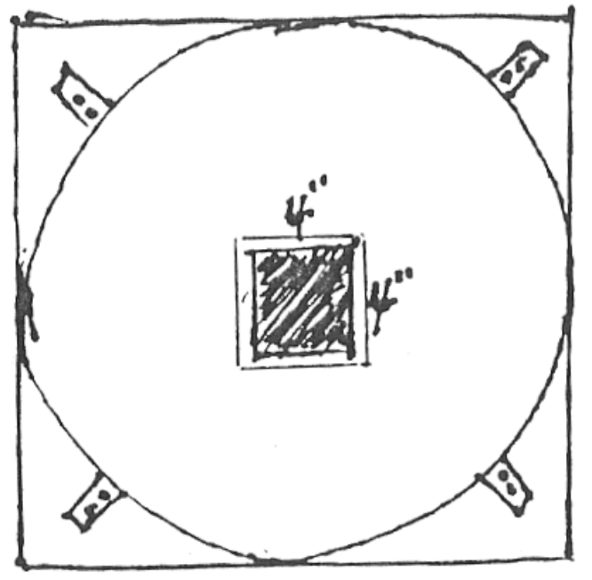

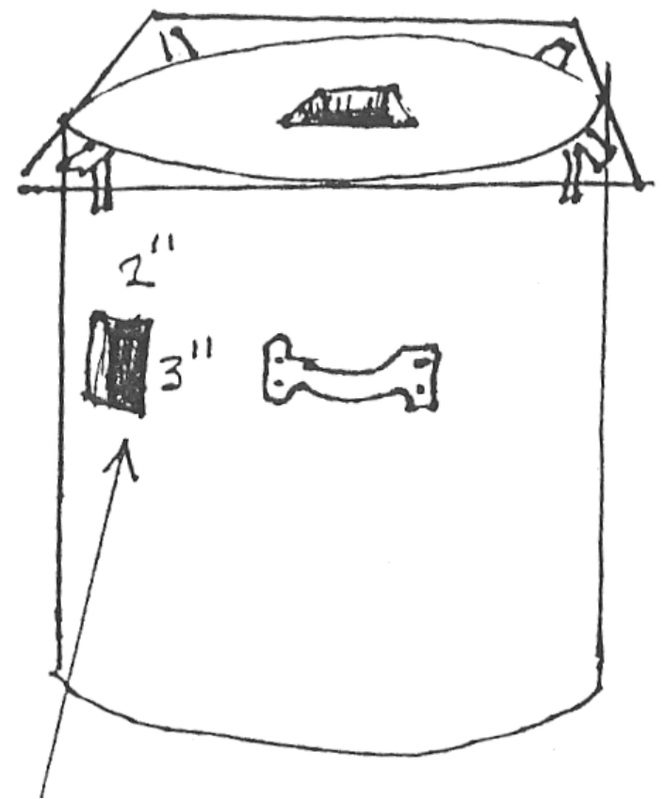
Use wire cutters to cut 2” x 3” peep hole. Use Razor to cut hole in fiber.
