Explaining regional patterns in morphosyntactic dialect features: The case of *BE sat/stood* in England and beyond

In this study we examine a well-known yet little understood dialect feature of English, namely the past participle forms *sat* and *stood* with progressive meaning, as illustrated in (1) and (2).

1. My work colleague ***is sat*** eating honey out of a jar with a spoon.
2. I ***was stood*** chatting with a friend in the street in Darlington when we saw it.

Though frequently mentioned in dialect surveys (e.g. Cheshire, Edwards & Whittle 1989; Kortmann & Lunkenheimer 2014), relatively little is known about this feature’s precise geographical distribution or historical origins. Prior studies have relied on relatively small datasets (e.g. Klemola 1999; Stange 2016), which limit our ability to discern reliable synchronic or diachronic patterns. For this study we collected over 100k tokens from large-scale corpora, both contemporary (Table 1) and historical (Table 2), to explore the current geographical distribution of *BE sat/stood* and reconsider some competing claims about its origins. Drawing upon this evidence, we argue that *BE sat/stood* is most likely a recent innovation, rather than a remnant of an older Germanic *BE* perfect system, e.g. *I’m not seen it* (cf. Buchstaller & Corrigan 2015).

On Twitter, *BE sat/stood* is widespread throughout most of England and Wales, and is particularly prominent in the North and Southwest of England (Figure 1). Data from the corpus of Global Web-based English (GloWbE) confirms that *BE sat/stood* is quite rare outside the UK (Figure 2; see also Kortmann & Lunkenheimer (2014)), and we find no mention of it in the literature of other English varieties, including regions that retain a more productive *BE* perfect system (Filppula 2004:75; Melchers 2004:39–40; Werner 2016). This is all the more striking in light of well documented founder effects in North America for other (older) morphosyntactic features (e.g. Montgomery 2009; Strelluf 2020; Yerastov 2016). Further, we find only scant traces of *BE sat/stood* in historical corpora prior to the 1700s (cf. Kytö 1997), and no mention of it in pre-20th century dialect surveys or commentaries. Our findings therefore suggest that *BE sat/stood* is not likely an echo of the *BE* perfect, despite their superficial similarities.

Following Klemola (1999), we propose that *BE sat/stood* is more likely an 18th century innovation, and represents a curious case of a change from above resulting in a change from below. It is likely that progressive *BE sat* is a result of a hypercorrection of the older past participle form *sitten* as it was increasingly replaced by the standard form *sat* in the 17th and 18th centuries. This older variant persisted in the North of England into the 1800s (Klemola 1999), where northern speakers over-extended *sat* to progressive contexts in which *sitten* was largely homophonous with the progressive participle variant *sittin’* ([sɪtɪn]).

We conclude with a brief look at the linguistic and external factors conditioning variation between *sat* and *sitting*, and discuss directions for future research.

Table 1: Frequencies of BE sat/sitting and BE stood/standing in four modern corpora

|  | *sat* | | *sitting* | | *stood* | | *standing* | |
| --- | --- | --- | --- | --- | --- | --- | --- | --- |
| Twitter | 64,785 | (59.9%) | 43,348 | (40.1%) | 9,361 | (40.2%) | 13,931 | (59.8%) |
| GloWbE | 2,182 | (6.3%) | 32,655 | (93.7%) | 836 | (4.1%) | 19,498 | (95.9%) |
| Bank of English | 468 | (3.0%) | 15,045 | (97.0%) | 253 | (2.3%) | 10,860 | (97.7%) |
| Spoken BNC 2014 | 273 | (33.7%) | 537 | (66.3%) | 66 | (27.5%) | 174 | (72.5%) |

Table 2: Frequencies of BE sat/sitting and BE stood/standing in historical corpora (counts are approximate)

|  | Period | *sat* | *sitting* | *stood* | *standing* |
| --- | --- | --- | --- | --- | --- |
| Corpus of Early English Correspondence | 1400-1681 | 0 | ?? | 0 | ?? |
| Early English Books Online (EEBO) | 1470-1690 | 20 | 1400 | 50 | 1000 |
| ARCHER | 1600-1999 | 0 | 49 | 0 | 48 |
| Corpus of Late Modern English Texts (CLMET) | 1710-1920 | 6 | 950 | 1 | 750 |
| Old Bailey Corpus | 1720-1913 | 7 | 2440 | 3 | 4380 |
| Hansard Corpus (British Parliament) | 1800-1900 | 10 | 2000 | 0 | 550 |
| Corpus of Historical American English | 1800-pres | 80 | 18000 | 200 | 17000 |

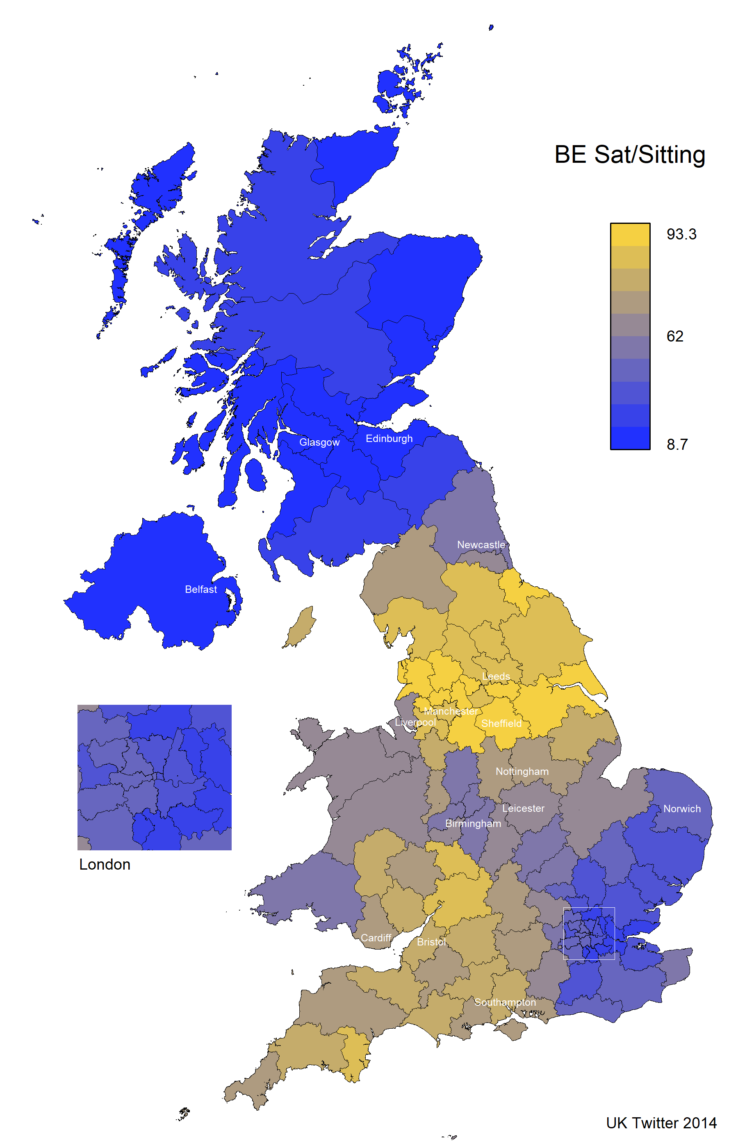

Figure 1: Percentage of *BE sat* vs. *sittng* on UK Twitter 2014 (N*sat* = 64785, N*sitting* = 43348).

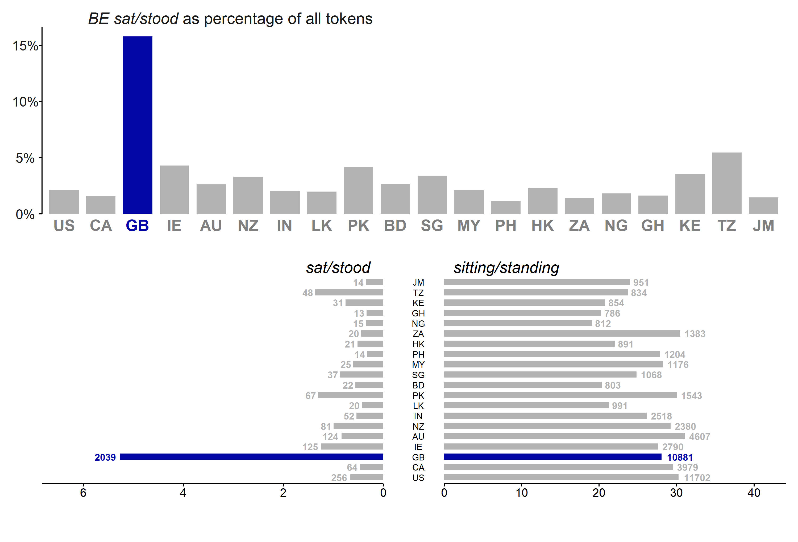

Figure 2: Proportions and requencies of *BE sat/stood* and *BE sitting/standing* in GloWbE (N = 55171).

# References

Buchstaller, Isabelle & Karen P. Corrigan. 2015. Morphosyntactic features of Northern English. In Raymond Hickey (ed.), *Researching Northern English*, 71–98. Amsterdam: John Benjamins Publishing Company.

Cheshire, Jenny, Viv K. Edwards & Pamela Whittle. 1989. Urban British Dialect Grammar: The Question of Dialect Levelling. *English World-Wide* 10(2). John Benjamins. 185–225. doi:[10.1075/eww.10.2.02che](https://doi.org/10.1075/eww.10.2.02che).

Filppula, Markku. 2004. Irish English: Morphology and syntax. In Bernd Kortmann, Edgar Schneider, Kate Burridge, Raj Mesthrie & Clive Upton (eds.), *A Handbook of Varieties of English*, vol. 2: Morphology and Syntax, 73–101. Berlin: Mouton de Gruyter.

Klemola, Juhani. 1999. Still sat in your car? Pseudopassives with sat and stood and the history of non-standard varieties of English English. *Sociolinguistica* 13(1). De Gruyter. 129–140. doi:[10.1515/9783110245189.129](https://doi.org/10.1515/9783110245189.129).

Kortmann, Bernd & Kerstin Lunkenheimer. 2014. The electronic world atlas of varieties of English. http://ewave-atlas.org.

Kytö, Merja. 1997. *Be/Have* + past participle: The choice of the auxiliary with intransitives from Late Middle to Modern English. In Matti Rissanen, Merja Kytö & Kirsi Heikkonen (eds.), *English in transition*, 17–86. Berlin ; New York: Mouton de Gruyter.

Melchers, Gunnel. 2004. English spoken in Orkney and Shetland: Morphology, syntax, and lexicon. In Bernd Kortmann, Edgar Schneider, Kate Burridge, Raj Mesthrie & Clive Upton (eds.), *A Handbook of Varieties of English*, vol. 2, 34–46. Berlin: Mouton de Gruyter.

Montgomery, Michael B. 2009. Historical and comparative perspectives on *A*-prefixing in the English of Appalachia. *American Speech* 84(1). 5–26. doi:[10.1215/00031283-2009-002](https://doi.org/10.1215/00031283-2009-002).

Stange, Ulrike. 2016. I was sat there talking all night: A corpus-based study on factors governing intra-dialectal variation in British English 1. *English Language & Linguistics* 20(3). Cambridge University Press. 511–531. doi:[10.1017/S1360674316000319](https://doi.org/10.1017/S1360674316000319).

Strelluf, Christopher. 2020. *Needs* +PAST PARTICIPLE in regional Englishes on Twitter. *World Englishes* 39(1). 119–134. doi:[ggk4b6](https://doi.org/ggk4b6).

Werner, Valentin. 2016. Rise of the undead? Be-perfects in World Englishes. In Valentin Werner, Elena Seoane & Cristina Suárez Gómez (eds.), *Re-assessing the present perfect*, 259–294. (Topics in English Linguistics volume 91). Berlin ; Boston: De Gruyter.

Yerastov, Yuri. 2016. Reflexes of the transitive be perfect in Canada and in the US: A comparative corpus study. *Dialectologia: revista electrònica*. 167–199.