Something somthing the curious case of *BE sat*

05/05/2021

We’re looking at the curious case of what we call the (*be+SAT*) variable, which involves variation between the copula followed by the present participle (*-ing*) form or the preterite/past participle (*-ed*) form to express ongoing or progressive aspect with verbs like *sit* and *stand*, as illustrated in (1) and (2).

1. *sit*
   1. Helplessly crying, she ***was sitting*** there Day after day, it never will end
   2. ive never felt fear more than when a teacher ***is sat*** watching you type on google slides/docs
2. *stand*
   1. An old man ***was standing*** on the kerb side.
   2. I ***was stood*** chatting with a friend in the street in Darlington when we saw it.

While it is widely mentioned in the literature (Britain 2007:89;@buchstaller_morphosyntactic_2015; Hudson & Holmes 1995), little is known about its precise origins or distribution. Buchstaller & Corrigan (2015) characterize the *-ed* variant in (1b) and (2b) as a Northern English feature, found only rarely found outside of the British Isles, but claim that it is also found in the South East of England. Evidence from contemporary corpus data support the first two claims 1 are supported by They suggest that it is a conservative remnant of the Germanic *be* perfect, as in *I’m seen it*, which is found in a number of varieties in the North of the UK and Ireland (Kortmann 2004). This seems reasonable, but there are still some peculiarities about this construction that suggest something more complicated is going on.

For one, the distribution of does not seem to fit with the distribution of the *be*-perfect more generally. *Be+SAT* bears some similarities to perfect constructions in Irish English, specifically the *be*-perfect and the extended-now perfect (Filppula 2004:75), but again, this is does not seem to be quite the same.

1. *be*-perfect in Irish English, from Filppula (2004)
   1. I think the younger generations ***are gone*** idle over it.
   2. [How many brothers and sisters you have, and what they’re all doing?] They***’re not left*** school yet.
   3. [Well, how long are you [have you been] in here now?] Oh, I’m in, I***’m in here*** about four months.

The *be*-perfect is also found in Insular Scottish English and Scots (Melchers 2004:39–40; Millar 2007:75), though it does not appear to be found in mainland Scottish English or in other Northern varieties (as far as I can tell). So why this particular construction should persist in the North of England, but not in these other areas is a bit of a mystery. *BE+sat* seems to appear only in areas of the UK where the general *be*-perfect has been lost, and yet *BE+sat* is not found in regions that have retained the *be*-perfect.

A second issue is that the variation here is not between the *be* and *have* perfect, as the standard examples of *be* perfect typically illustrate. That is, the equivalent alternative to a *be* perfect such as *I’m sat on the couch* would be *I’ve sat on the couch*, not *I’m sitting on the couch*. Yet what *be+SAT* expresses does not seem to be typical perfective aspect, but rather something closer to the ongoing aspect often expressed with *-ing* forms. Thus it seems unlikely that *BE+sat* is a vestigial *be*-perfect variant, and rather an alternative to the more common progressive variant. In this sense it is more similar to the *needs V-ed* construction (Strelluf 2020).

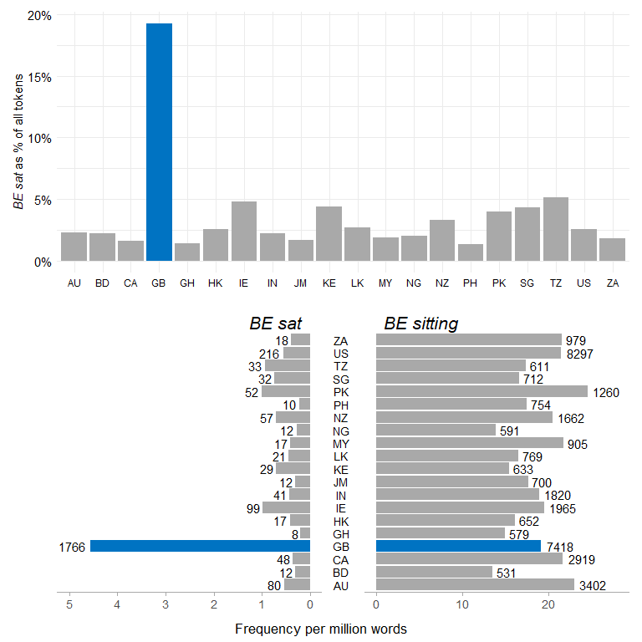

Figure 1: Normalized frequencies of BE+sat and BE+sitting in GloWbE. Bar values reflect raw counts in the corpus.

Table 1: this is a table caption.

|  |  |  |
| --- | --- | --- |
| Table |  |  |
|  |  |  |

# References

Britain, David. 2007. Grammatical variation in England. In David Britain (ed.), *Language in the British Isles*, 75–104. Cambridge: Cambridge University Press.

Buchstaller, Isabelle & Karen P. Corrigan. 2015. Morphosyntactic features of Northern English. In Raymond Hickey (ed.), *Researching Northern English*, 71–98. Amsterdam: John Benjamins Publishing Company.

Filppula, Markku. 2004. Irish English: Morphology and syntax. In Bernd Kortmann, Edgar Schneider, Kate Burridge, Raj Mesthrie & Clive Upton (eds.), *A Handbook of Varieties of English*, vol. 2: Morphology and Syntax, 73–101. Berlin: Mouton de Gruyter.

Hudson, Richard & Jasper Holmes. 1995. *Children’s Use of Spoken Standard English*. London: School Curriculum and Assessment Authority.

Kortmann, Bernd. 2004. Synopsis: Morphological and syntactic variation in the British Isles. In Bernd Kortmann, Edgar Schneider, Kate Burridge, Raj Mesthrie & Clive Upton (eds.), *A Handbook of Varieties of English*, vol. 2: Morphology and Syntax, 1089–1103. Berlin: Mouton de Gruyter.

Melchers, Gunnel. 2004. English spoken in Orkney and Shetland: Morphology, syntax, and lexicon. In Bernd Kortmann, Edgar Schneider, Kate Burridge, Raj Mesthrie & Clive Upton (eds.), *A Handbook of Varieties of English*, vol. 2, 34–46. Berlin: Mouton de Gruyter.

Millar, Robert McColl. 2007. *Northern and insular Scots*. (Dialects of English). Edinburgh: Edinburgh Univ. Press.

Strelluf, Christopher. 2020. *Needs* +PAST PARTICIPLE in regional Englishes on Twitter. *World Englishes* 39(1). 119–134. doi:[ggk4b6](https://doi.org/ggk4b6).