da410_project4_grahn

Jason Grahn

2/7/2019

Use R built-in function (e.g. knn) to do 9.7 (c), try different k values and find out the best solution.

Do some EDA at the very beginning and make a clean explanation of how and why you choose your final model.

# Data Load

#iris is already loaded but I dont like camelcase headers so lets fix those then show head()  
data.table::setnames(iris, tolower(names(iris[1:5])))  
head(iris,5)

## sepal.length sepal.width petal.length petal.width species  
## 1 5.1 3.5 1.4 0.2 setosa  
## 2 4.9 3.0 1.4 0.2 setosa  
## 3 4.7 3.2 1.3 0.2 setosa  
## 4 4.6 3.1 1.5 0.2 setosa  
## 5 5.0 3.6 1.4 0.2 setosa

# Summary Statistics of the Iris flower data set

summary(iris)

## sepal.length sepal.width petal.length petal.width   
## Min. :4.300 Min. :2.000 Min. :1.000 Min. :0.100   
## 1st Qu.:5.100 1st Qu.:2.800 1st Qu.:1.600 1st Qu.:0.300   
## Median :5.800 Median :3.000 Median :4.350 Median :1.300   
## Mean :5.843 Mean :3.057 Mean :3.758 Mean :1.199   
## 3rd Qu.:6.400 3rd Qu.:3.300 3rd Qu.:5.100 3rd Qu.:1.800   
## Max. :7.900 Max. :4.400 Max. :6.900 Max. :2.500   
## species   
## setosa :50   
## versicolor:50   
## virginica :50   
##   
##   
##

# Mean and standard deviation within each species

#means  
iris %>% group_by(species) %>%   
 summarise(mean(sepal.length),  
 mean(sepal.width),  
 mean(petal.length),  
 mean(petal.width))

## # A tibble: 3 x 5  
## species `mean(sepal.len… `mean(sepal.wid… `mean(petal.len…  
## <fct> <dbl> <dbl> <dbl>  
## 1 setosa 5.01 3.43 1.46  
## 2 versic… 5.94 2.77 4.26  
## 3 virgin… 6.59 2.97 5.55  
## # … with 1 more variable: `mean(petal.width)` <dbl>

#standard deviations  
iris %>% group_by(species) %>%   
 summarise(sd(sepal.length),  
 sd(sepal.width),  
 sd(petal.length),  
 sd(petal.width))

## # A tibble: 3 x 5  
## species `sd(sepal.lengt… `sd(sepal.width… `sd(petal.lengt…  
## <fct> <dbl> <dbl> <dbl>  
## 1 setosa 0.352 0.379 0.174  
## 2 versic… 0.516 0.314 0.470  
## 3 virgin… 0.636 0.322 0.552  
## # … with 1 more variable: `sd(petal.width)` <dbl>

sepal width shows the smallest variation of means. petal length appears to have the largest differences.

# Visualization

common_theme <- theme_light() +  
 theme(legend.position = "bottom")  
  
histogram <- iris %>%   
 ggplot() +  
 geom_histogram(aes(x = petal.length, fill=species)) +  
 labs(title = "Histogram") +  
 common_theme  
  
density <- iris %>%   
 ggplot() +   
 geom_density(aes(x=petal.length, fill=species), alpha = 0.5) +  
 labs(title = "Density") +  
 common_theme  
  
cowplot::plot_grid(histogram, density)

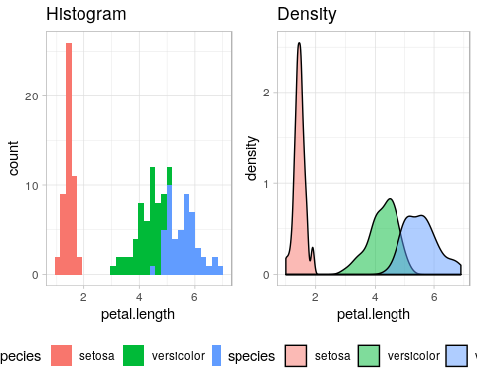

The histogram shows setosa clearly sits on it’s own with very short petal lengths; but virginica and veriscolor have some overlap.

Density plotting reiterates what we saw in the histogram and does a better job showing the overlap between virginica and versicolor.

## Scatter Plots

sepal.scatter <- iris %>% ggplot() +   
 geom_point(aes(x = sepal.length, y = sepal.width, color = species)) +  
 labs(title = "Sepal vars") +  
 common_theme  
  
petal.scatter <- iris %>% ggplot() +   
 geom_point(aes(x = petal.length, y = petal.width, color = species)) +  
 labs(title = "Petal vars") +  
 common_theme  
  
cowplot::plot_grid(sepal.scatter, petal.scatter)

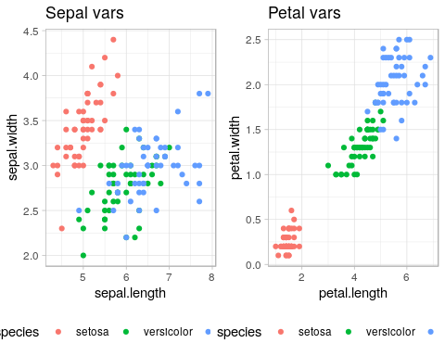

Scatterplotting for sepal variables show similar information that we saw in the histogram and density plots. Clustering of the setosa lengths and widths and mixtures of versicolor and viginica points. The petal variables are a bit more defined. Setosa certainly sits on it’s own, and now we can see better definitions between versicolor and virginica species; with virginica having (generally) longer and wider petals than versicolor.

## Correlation

# correlation matrix  
R <- round(cor(iris %>% select(-species)), 2)  
  
# Identify which pairs of variables seem to be strongly associated  
#and describe the nature (strength and direction) of the relationship between these variable pairs.  
ggcorrplot(R, #the correlation matrix  
 type = "lower", #only color the bottom half  
 title = "correlation matrix of iris data", #give it a header  
 show.legend = TRUE, #show the legend  
 digits = 2, #round all digits  
 lab = TRUE) #and show the values in the boxes

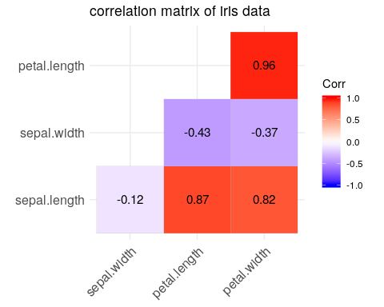

Correlation shows us the strongest relationships exist between petal width and length; then petal and sepal length; finally petal width and sepal length. Clearly the petals bind the strongest relatinships.

# Building K-Nearest Neighbor

## Normalization

Given the range of values for the *iris* dataset, no normalization is required.

## Splitting Data Set into Training and Test Sets

set.seed(1234)  
  
ind <- sample(2,   
 nrow(iris),   
 replace=TRUE,   
 prob=c(0.66, 0.34))  
  
# make training set and labels  
iris.training <- iris[ind==1, 1:4]  
iris.trainLabels <- iris[ind==1,5]  
  
# make testing set and labels  
iris.test <- iris[ind==2, 1:4]  
iris.testLabels <- iris[ind==2, 5]

## K-Nearest Neighbor in R

iris.knn <- knn(train = iris.training,  
 test = iris.test,   
 k = 3,  
 cl = iris.trainLabels)  
  
table(iris.knn)

## iris.knn  
## setosa versicolor virginica   
## 13 14 15

## Analyse the correctness

table(iris.testLabels, iris.knn)

## iris.knn  
## iris.testLabels setosa versicolor virginica  
## setosa 13 0 0  
## versicolor 0 13 0  
## virginica 0 1 15

The output of the kNN misclassified 1 *versicolor* iris as a *verginica* iris.

### Prediction scatter plot

accuracy.table <- iris %>%   
 mutate(ind = ind) %>%   
 filter(ind == 2) %>%   
 mutate(iris.knn = iris.knn,  
 predict.true = if_else(species == iris.knn, TRUE, FALSE))  
  
sepal.scatter.2 <- accuracy.table %>% ggplot() +   
 geom_point(aes(x = sepal.length, y = sepal.width, color = species)) +  
 labs(title = "Sepal vars") +  
 common_theme  
  
petal.scatter.2 <- accuracy.table %>% ggplot() +   
 geom_point(aes(x = petal.length, y = petal.width, color = species)) +  
 labs(title = "Petal vars") +  
 common_theme  
  
sepal.predict <- accuracy.table %>% ggplot() +   
 geom_point(aes(x = sepal.length, y = sepal.width, color = iris.knn)) +  
 labs(title = "Sepal vars") +  
 common_theme  
  
petal.predict <- accuracy.table %>% ggplot() +   
 geom_point(aes(x = petal.length, y = petal.width, color = iris.knn)) +  
 labs(title = "Petal vars") +  
 common_theme  
  
cowplot::plot_grid(sepal.scatter.2, sepal.predict)

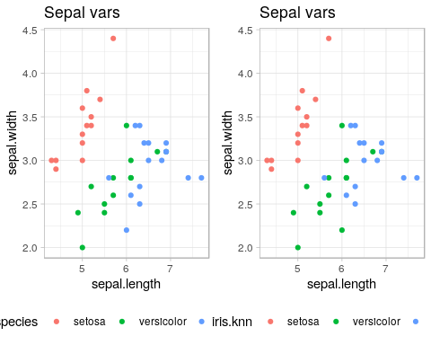

cowplot::plot_grid(petal.scatter.2, petal.predict)

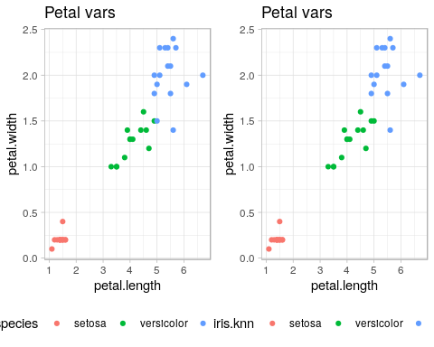

Plotting sepal and petal variables before and after training shows very close alignment. We know from the above table that there was only 1 misclassified flower from the test set, but which flower was hard to discern in the plots. Let’s work to call out which flower was incorrectly labelled.

petal.tf <- accuracy.table %>% ggplot() +   
 geom_point(aes(x = petal.length, y = petal.width, color = iris.knn, size = desc(predict.true))) +  
 labs(title = "Petal vars") +  
 common_theme+  
 theme(legend.position = "none")  
  
sepal.tf <- accuracy.table %>% ggplot() +   
 geom_point(aes(x = sepal.length, y = sepal.width, color = iris.knn, size = desc(predict.true))) +  
 labs(title = "Sepal vars") +  
 common_theme +  
 theme(legend.position = "none")  
  
cowplot::plot_grid(petal.tf, sepal.tf)

