da420_PROJECT2_GRAHN

Jason Grahn

1/17/2019

Download Dodger.csv

dodgers <- read_csv("dodgers.csv",   
 col_types = cols(month = col_factor(levels = c("JAN", "FEB", "MAR", "APR",  
 "MAY", "JUN", "JUL", "AUG",  
 "SEP", "OCT", "NOV", "DEC"))))  
glimpse(dodgers)

## Observations: 81  
## Variables: 12  
## $ month <fct> APR, APR, APR, APR, APR, APR, APR, APR, APR, APR, AP…  
## $ day <dbl> 10, 11, 12, 13, 14, 15, 23, 24, 25, 27, 28, 29, 7, 8…  
## $ attend <dbl> 56000, 29729, 28328, 31601, 46549, 38359, 26376, 440…  
## $ day_of_week <chr> "Tuesday", "Wednesday", "Thursday", "Friday", "Satur…  
## $ opponent <chr> "Pirates", "Pirates", "Pirates", "Padres", "Padres",…  
## $ temp <dbl> 67, 58, 57, 54, 57, 65, 60, 63, 64, 66, 71, 74, 67, …  
## $ skies <chr> "Clear", "Cloudy", "Cloudy", "Cloudy", "Cloudy", "Cl…  
## $ day_night <chr> "Day", "Night", "Night", "Night", "Night", "Day", "N…  
## $ cap <chr> "NO", "NO", "NO", "NO", "NO", "NO", "NO", "NO", "NO"…  
## $ shirt <chr> "NO", "NO", "NO", "NO", "NO", "NO", "NO", "NO", "NO"…  
## $ fireworks <chr> "NO", "NO", "NO", "YES", "NO", "NO", "NO", "NO", "NO…  
## $ bobblehead <chr> "NO", "NO", "NO", "NO", "NO", "NO", "NO", "NO", "NO"…

use R to develop two side-by-side boxplots, as seen in Figure 2.1 and Figure 2.2

#need to transform full name days to abbreviated; ie "monday" to "mon"  
#and turn that, and day/night into factors.  
dodgers <- dodgers %>%   
 select(month, attend, day_of_week, opponent, temp, skies, day_night, fireworks, bobblehead) %>%   
 mutate("Attend/1000" = attend/1000,  
 day_of_week_f = case_when(day_of_week == "Monday" ~ "Mon",  
 day_of_week == "Tuesday" ~ "Tue",  
 day_of_week == "Wednesday" ~ "Wed",  
 day_of_week == "Thursday" ~ "Thur",  
 day_of_week == "Friday" ~ "Fri",  
 day_of_week == "Saturday" ~ "Sat",  
 day_of_week == "Sunday" ~ "Sun"),  
 #and need to assign them factor levels  
 day_of_week_f = factor(day_of_week_f, levels = c("Mon", "Tue", "Wed",  
 "Thur", "Fri", "Sat", "Sun")),  
 day_night_f = factor(day_night, levels = c("Night", "Day")))  
  
# boxplots with ggplot using the dodger data  
## day of week on X  
## attendence in K's on Y  
dow_box <- dodgers %>%   
 ggplot(aes(x = day_of_week_f, y = (attend/1000))) +  
 geom_boxplot(fill = "pink") +  
 theme_light() +  
 theme(legend.position="none") +  
 labs(y = "Attendence (1000)",  
 x = "Day of the Week")  
## month on X  
## attendence in K's on Y  
mon_box <- dodgers %>%   
 ggplot(aes(x = month, y = (attend/1000))) +  
 geom_boxplot(fill = "dodgerblue1") +  
 theme_light() +  
 theme(legend.position="none") +  
 labs(y = "", x = "Month of Year")  
  
#put these side by side  
cowplot::plot_grid(dow_box, mon_box)

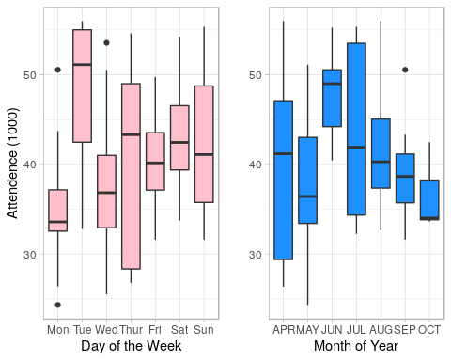

and two scatter plots, as seen in Figure 2.3

#we're analyzing days with fireworks against day / night, clear / cloudy, AND temperature  
#fireworks by shape and color  
#attendence (K's) on Y  
#temp on X  
dodgers %>%   
 ggplot(aes(x = temp,   
 y = attend/1000,  
 shape = fireworks,  
 color = fireworks)) +  
 geom_point() +  
 theme_bw() +  
 theme(legend.position="top") +  
 labs(y = "Attendence (thousands)",  
 x = "Temperature (Degrees Fahrenheit)") +  
 facet_wrap(day_night_f ~ skies)

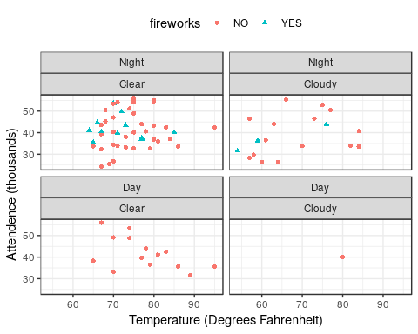

and Figure 2.4

# scatterplot teams against attendence   
# y axis is opposing teams  
# x axis is attendence (K's)  
# fill by day/night  
dodgers %>%   
 ggplot(aes(x = (attend/1000), y = opponent)) +   
 geom_point(aes(color = day_night)) +  
 theme_bw() +  
 theme(legend.position="top") +  
 labs(y = "",  
 x = "Attendence (thousands)")

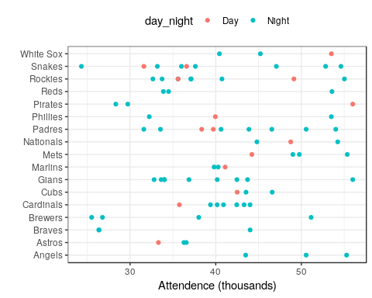

Use R to develop a Regression Model Performance, as seen in Figure 2.5. Examine regression diagnostics for the fitted model. Hint: Look at the Exhibit 2.1 in page 25-27.

#prediction will predict attendence based on act. attendence, month, and day_of_week_f, bobbleheads  
#with a test and a train set  
  
#pseudocode:   
#build a test/train array with 2/3 "test" data obvs and 1/2 "train" obvs  
#randomize it   
#union it to dodgers data  
# set seed for repeatability of training-and-test split   
# and the seed is always 42 because 42 is the answer to everything  
set.seed(42)   
  
training_test <- c(rep(1,length=trunc((2/3)*nrow(dodgers))),  
 rep(2,length=(nrow(dodgers) - trunc((2/3)*nrow(dodgers)))))  
  
dodgers$training_test <- sample(training_test) # random permutation  
dodgers$training_test <- factor(dodgers$training_test,  
 levels=c(1,2),   
 labels=c("TRAIN","TEST"))  
  
dodgers.train <- dodgers %>% filter(training_test == "TRAIN")  
#print(str(dodgers.train)) # check training data frame  
  
dodgers.test <- dodgers %>% filter(training_test == "TEST")  
#print(str(dodgers.test)) # check test data frame  
  
# build and save model from filtered "train" data  
# specify a simple model with bobblehead entered last  
my.model <- {attend ~ month + day_of_week_f + bobblehead}  
  
# fit the model to the training set  
train.model.fit <- lm(my.model, data = dodgers.train)  
# summary of model fit to the training set  
print(summary(train.model.fit))

##   
## Call:  
## lm(formula = my.model, data = dodgers.train)  
##   
## Residuals:  
## Min 1Q Median 3Q Max   
## -10888 -3753 -1002 2400 13802   
##   
## Coefficients:  
## Estimate Std. Error t value Pr(>|t|)   
## (Intercept) 32258 3687 8.750 7.84e-11 ***  
## monthMAY -3438 3297 -1.043 0.3034   
## monthJUN 8089 3692 2.191 0.0343 *   
## monthJUL 5299 3918 1.352 0.1839   
## monthAUG 3706 3355 1.104 0.2760   
## monthSEP 1029 3568 0.288 0.7745   
## monthOCT -1456 5712 -0.255 0.8001   
## day_of_week_fTue 9907 3870 2.560 0.0143 *   
## day_of_week_fWed 4975 3433 1.449 0.1550   
## day_of_week_fThur 4855 4026 1.206 0.2349   
## day_of_week_fFri 5083 3628 1.401 0.1690   
## day_of_week_fSat 8208 3428 2.395 0.0214 *   
## day_of_week_fSun 8516 3530 2.413 0.0205 *   
## bobbleheadYES 7083 3065 2.311 0.0261 *   
## ---  
## Signif. codes: 0 '***' 0.001 '**' 0.01 '*' 0.05 '.' 0.1 ' ' 1  
##   
## Residual standard error: 6768 on 40 degrees of freedom  
## Multiple R-squared: 0.523, Adjusted R-squared: 0.3679   
## F-statistic: 3.373 on 13 and 40 DF, p-value: 0.001528

# training set predictions from the model fit to the training set  
dodgers.train$predict_attend <- predict(train.model.fit)  
# test set predictions from the model fit to the training set  
dodgers.test$predict_attend <- predict(train.model.fit, newdata = dodgers.test)  
  
# compute the proportion of response variance  
# accounted for when predicting out-of-sample  
cat("\n","Proportion of Test Set Variance Accounted for: ",  
round((with(dodgers.test,cor(attend,predict_attend)^2)),digits=3),"\n",sep="")

##   
## Proportion of Test Set Variance Accounted for: 0.335

# merge the training and test sets for plotting  
dodgers.plotting.frame <- rbind(dodgers.train,dodgers.test)  
  
# generate predictive modeling visual for management  
group.labels <- c("No Bobbleheads","Bobbleheads")  
group.symbols <- c(21,24)  
group.colors <- c("black","black")  
group.fill <- c("black","red")  
xyplot(predict_attend/1000 ~ attend/1000 | training_test,  
 data = dodgers.plotting.frame, groups = bobblehead, cex = 2,  
 pch = group.symbols, col = group.colors, fill = group.fill,  
 layout = c(2, 1), xlim = c(20,65), ylim = c(20,65),  
 aspect=1, type = c("p","g"),  
 panel=function(x,y, ...)  
 {panel.xyplot(x,y,...)  
 panel.segments(25,25,60,60,col="black",cex=2)  
 },  
 strip=function(...) strip.default(..., style=1),  
 xlab = "Actual Attendance (thousands)",  
 ylab = "Predicted Attendance (thousands)",  
 key = list(space = "top",  
 text = list(rev(group.labels),col = rev(group.colors)),  
 points = list(pch = rev(group.symbols),  
 col = rev(group.colors),  
 fill = rev(group.fill))))

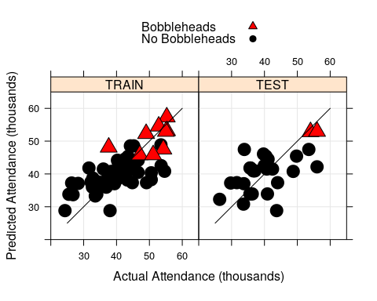

# use the full data set to obtain an estimate of the increase in  
# attendance due to bobbleheads, controlling for other factors  
my.model.fit <- lm(my.model, data = dodgers)  
  
# use all available data  
print(summary(my.model.fit))

##   
## Call:  
## lm(formula = my.model, data = dodgers)  
##   
## Residuals:  
## Min 1Q Median 3Q Max   
## -12670.9 -4004.4 -245.7 2819.5 14632.6   
##   
## Coefficients:  
## Estimate Std. Error t value Pr(>|t|)   
## (Intercept) 33621.3 2690.5 12.496 < 2e-16 ***  
## monthMAY -2213.7 2445.2 -0.905 0.36853   
## monthJUN 7627.9 2915.7 2.616 0.01098 *   
## monthJUL 3509.8 2745.4 1.278 0.20551   
## monthAUG 2845.0 2560.8 1.111 0.27055   
## monthSEP -184.3 2691.0 -0.069 0.94559   
## monthOCT -889.1 4319.8 -0.206 0.83757   
## day_of_week_fTue 9423.9 2864.0 3.290 0.00160 **   
## day_of_week_fWed 2490.4 2683.7 0.928 0.35676   
## day_of_week_fThur 3673.9 3597.7 1.021 0.31084   
## day_of_week_fFri 4359.0 2681.9 1.625 0.10878   
## day_of_week_fSat 6972.1 2720.1 2.563 0.01262 *   
## day_of_week_fSun 6998.4 2674.6 2.617 0.01096 *   
## bobbleheadYES 7486.0 2477.9 3.021 0.00356 **   
## ---  
## Signif. codes: 0 '***' 0.001 '**' 0.01 '*' 0.05 '.' 0.1 ' ' 1  
##   
## Residual standard error: 6533 on 67 degrees of freedom  
## Multiple R-squared: 0.4807, Adjusted R-squared: 0.3799   
## F-statistic: 4.771 on 13 and 67 DF, p-value: 8.77e-06

# tests statistical significance of the bobblehead promotion  
# type I anova computes sums of squares for sequential tests  
print(anova(my.model.fit))

## Analysis of Variance Table  
##   
## Response: attend  
## Df Sum Sq Mean Sq F value Pr(>F)   
## month 6 946221193 157703532 3.6946 0.0031275 **   
## day_of_week_f 6 1311493419 218582236 5.1208 0.0002213 ***  
## bobblehead 1 389581557 389581557 9.1269 0.0035640 **   
## Residuals 67 2859880298 42684781   
## ---  
## Signif. codes: 0 '***' 0.001 '**' 0.01 '*' 0.05 '.' 0.1 ' ' 1

cat("\n","Estimated Effect of Bobblehead Promotion on Attendance: ",  
round(my.model.fit$coefficients[length(my.model.fit$coefficients)],  
digits = 0),"\n",sep="")

##   
## Estimated Effect of Bobblehead Promotion on Attendance: 7486

# standard graphics provide diagnostic plots  
plot(my.model.fit)

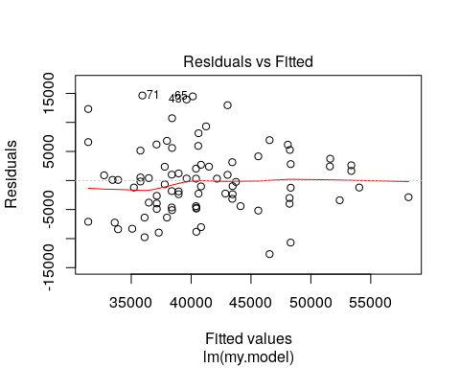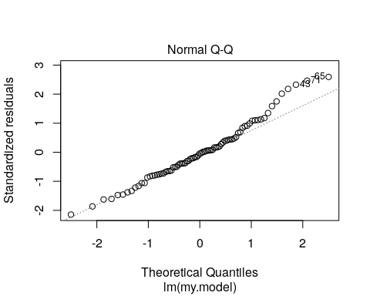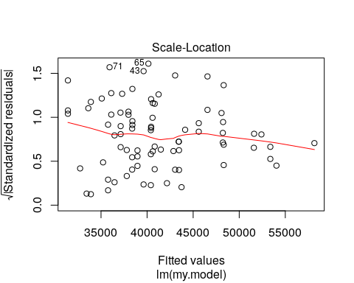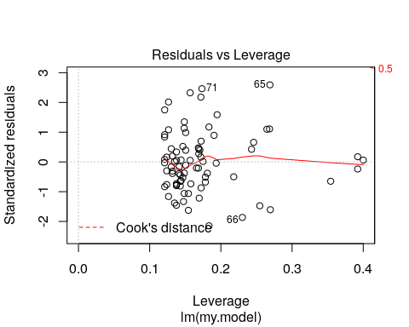

# additional model diagnostics drawn from the car package  
  
residualPlots(my.model.fit)

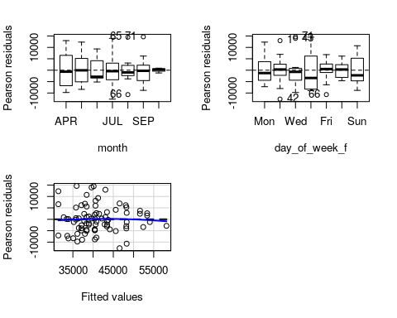

## Test stat Pr(>|Test stat|)  
## month   
## day_of_week_f   
## Tukey test -0.3992 0.6898

print(outlierTest(my.model.fit))

## No Studentized residuals with Bonferonni p < 0.05  
## Largest |rstudent|:  
## rstudent unadjusted p-value Bonferonni p  
## 65 2.712424 0.0085088 0.68921