da420_hw0_grahn

jason grahn

9/20/2018

Handout 0 looks like it’s mostly in base-R, so we can jump right in with the first provided command.

# Exercise 1

What command would you use to extract just the counts of girls baptized? ##Solution 1

arbuthnot$girls

## [1] 4683 4457 4102 4590 4839 4820 4928 4605 4457 4952 4784 5332 5200 4910  
## [15] 4617 3997 3919 3395 3536 3181 2746 2722 2840 2908 2959 3179 3349 3382  
## [29] 3289 3013 2781 3247 4107 4803 4881 5681 4858 4319 5322 5560 5829 5719  
## [43] 6061 6120 5822 5738 5717 5847 6203 6033 6041 6299 6533 6744 7158 7127  
## [57] 7246 7119 7214 7101 7167 7302 7392 7316 7483 6647 6713 7229 7767 7626  
## [71] 7452 7061 7514 7656 7683 5738 7779 7417 7687 7623 7380 7288

#which provides a pretty poor display so we can use tidy-style with   
select(arbuthnot, girls)

## girls  
## 1 4683  
## 2 4457  
## 3 4102  
## 4 4590  
## 5 4839  
## 6 4820  
## 7 4928  
## 8 4605  
## 9 4457  
## 10 4952  
## 11 4784  
## 12 5332  
## 13 5200  
## 14 4910  
## 15 4617  
## 16 3997  
## 17 3919  
## 18 3395  
## 19 3536  
## 20 3181  
## 21 2746  
## 22 2722  
## 23 2840  
## 24 2908  
## 25 2959  
## 26 3179  
## 27 3349  
## 28 3382  
## 29 3289  
## 30 3013  
## 31 2781  
## 32 3247  
## 33 4107  
## 34 4803  
## 35 4881  
## 36 5681  
## 37 4858  
## 38 4319  
## 39 5322  
## 40 5560  
## 41 5829  
## 42 5719  
## 43 6061  
## 44 6120  
## 45 5822  
## 46 5738  
## 47 5717  
## 48 5847  
## 49 6203  
## 50 6033  
## 51 6041  
## 52 6299  
## 53 6533  
## 54 6744  
## 55 7158  
## 56 7127  
## 57 7246  
## 58 7119  
## 59 7214  
## 60 7101  
## 61 7167  
## 62 7302  
## 63 7392  
## 64 7316  
## 65 7483  
## 66 6647  
## 67 6713  
## 68 7229  
## 69 7767  
## 70 7626  
## 71 7452  
## 72 7061  
## 73 7514  
## 74 7656  
## 75 7683  
## 76 5738  
## 77 7779  
## 78 7417  
## 79 7687  
## 80 7623  
## 81 7380  
## 82 7288

#or with...  
arbuthnot %>%   
 select(girls)

## girls  
## 1 4683  
## 2 4457  
## 3 4102  
## 4 4590  
## 5 4839  
## 6 4820  
## 7 4928  
## 8 4605  
## 9 4457  
## 10 4952  
## 11 4784  
## 12 5332  
## 13 5200  
## 14 4910  
## 15 4617  
## 16 3997  
## 17 3919  
## 18 3395  
## 19 3536  
## 20 3181  
## 21 2746  
## 22 2722  
## 23 2840  
## 24 2908  
## 25 2959  
## 26 3179  
## 27 3349  
## 28 3382  
## 29 3289  
## 30 3013  
## 31 2781  
## 32 3247  
## 33 4107  
## 34 4803  
## 35 4881  
## 36 5681  
## 37 4858  
## 38 4319  
## 39 5322  
## 40 5560  
## 41 5829  
## 42 5719  
## 43 6061  
## 44 6120  
## 45 5822  
## 46 5738  
## 47 5717  
## 48 5847  
## 49 6203  
## 50 6033  
## 51 6041  
## 52 6299  
## 53 6533  
## 54 6744  
## 55 7158  
## 56 7127  
## 57 7246  
## 58 7119  
## 59 7214  
## 60 7101  
## 61 7167  
## 62 7302  
## 63 7392  
## 64 7316  
## 65 7483  
## 66 6647  
## 67 6713  
## 68 7229  
## 69 7767  
## 70 7626  
## 71 7452  
## 72 7061  
## 73 7514  
## 74 7656  
## 75 7683  
## 76 5738  
## 77 7779  
## 78 7417  
## 79 7687  
## 80 7623  
## 81 7380  
## 82 7288

plot(x = arbuthnot$year, y = arbuthnot$girls, type = "l")

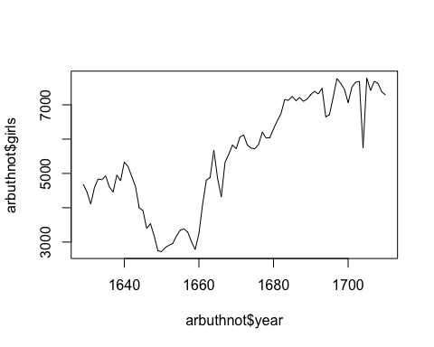

# Exercise 2

Is there an apparent trend in the number of girls baptized over the years? How would you describe it? ##solution 2 Yes, there appears to be an upward trend in the number of girls baptized over the years for the window of time for which we have data. It drops between 1640 and 1660, but increases sharply thereafter and continues to grow.

# Exercise 3

Make a plot of the proportion of boys over time. What do you see? ##Solution 3 First, the plot:

plot(arbuthnot$year, arbuthnot$boys / (arbuthnot$boys + arbuthnot$girls), type = "l")

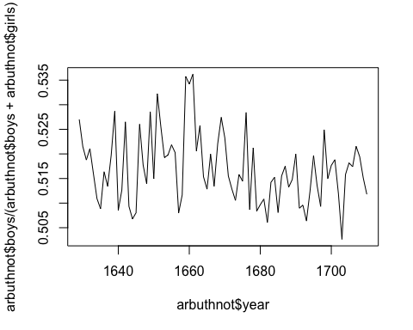

#but this is really hard to understand / read. So if we use tidyverse...  
arbuthnot %>%  
 mutate(proportion_boys = boys / (boys + girls)) %>%  
 ggplot() +  
 geom_line(aes(year, proportion_boys))

