da460_assignment2_grahn

jason grahn

2018-10-05

download.file("http://www.openintro.org/stat/data/kobe.RData", destfile = "kobe.RData")  
load("kobe.RData")  
head(kobe,5)

## vs game quarter time  
## 1 ORL 1 1 9:47  
## 2 ORL 1 1 9:07  
## 3 ORL 1 1 8:11  
## 4 ORL 1 1 7:41  
## 5 ORL 1 1 7:03  
## description basket  
## 1 Kobe Bryant makes 4-foot two point shot H  
## 2 Kobe Bryant misses jumper M  
## 3 Kobe Bryant misses 7-foot jumper M  
## 4 Kobe Bryant makes 16-foot jumper (Derek Fisher assists) H  
## 5 Kobe Bryant makes driving layup H

## 1. Describe the distribution of streak lengths. What is the typical streak length for this simulated independent shooter with a 45% shooting percentage? How long is the player’s longest streak of baskets in 133 shots?

#first we have to generate the data for the simulated player  
#first the outcomes vector  
outcomes <- c("H", "M")  
  
#then run the shooting simulation with the 45% hit rate  
sim_basket <- sample(outcomes, size = 133, replace = TRUE, prob = c(0.45, (1-.45)))  
  
#role that into a table  
tibble(sim_basket)

## # A tibble: 133 x 1  
## sim_basket  
## <chr>   
## 1 M   
## 2 M   
## 3 M   
## 4 M   
## 5 H   
## 6 H   
## 7 H   
## 8 M   
## 9 M   
## 10 H   
## # ... with 123 more rows

##run the calc_streak function to generate the kobe_steak dataset  
sim_streak <- calc_streak(sim_basket)  
  
#make a barchart and save it for reference  
sim_bar <- tibble(sim_streak) %>%   
 ggplot() +  
 geom_bar(aes(x = sim_streak))  
  
#display that barchart  
sim_bar

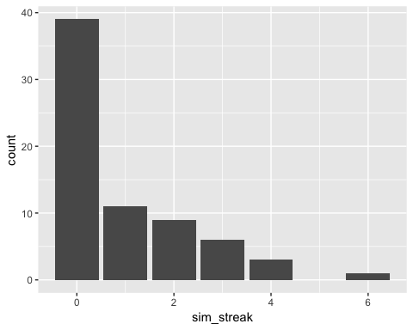

#and lets save those counts to their own dataframe  
sim_aggregate <- tibble(sim_streak) %>%   
 group_by(sim_streak) %>%   
 summarise(sim_count = n())

The distrubution is right skewed with a maximum streak of 6. The typical streak length, if we don’t include streaks of zero, is *one*.

## 2. If you were to run the simulation of the independent shooter a second time, how would you expect its streak distribution to compare to the distribution from the question above? Exactly the same? Somewhat similar? Totally different? Explain your reasoning.

No code is required to answer this question. Running the simulation a second time will still maintain the right skewness, but the individual values of the streaks will change. It would likely appear similar, but with different values for each of the streak lengths. This is because the simulation doesn’t include proportions of streak lengths, just random selections of ‘hit’ or ‘miss’.

## 3. How does Kobe Bryant’s distribution of streak lengths compare to the distribution of streak lengths for the simulated shooter? Using this comparison, do you have evidence that the hot hand model fits Kobe’s shooting patterns? Explain.

#run the calc_streak function to generate the kobe_steak dataset  
kobe_streak <- calc_streak(kobe$basket)  
  
#and let's plot that, saving the bar chart  
kobe_bar <- tibble(kobe_streak) %>%   
 ggplot(aes(x = kobe_streak)) +  
 geom_bar()  
  
#show that plot  
kobe_bar

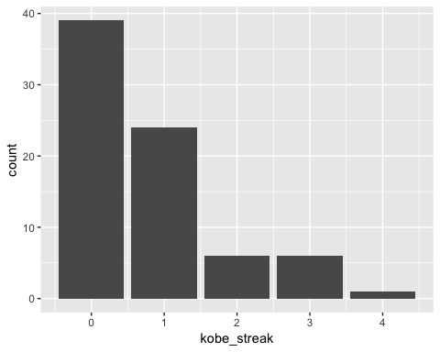

#but more importantly, we need to see the counts of each next to each other.  
kobe_aggregate <- tibble(kobe_streak) %>%   
 group_by(kobe_streak) %>%   
 summarise(kobe_count = n()) %>%   
 rename(streak_length = kobe_streak)  
  
#save the two tables as one, so we can compare  
streak_difference <- sim_aggregate %>%   
 rename(streak_length = sim_streak) %>%   
 full_join(kobe_aggregate) %>%   
 replace_na(list(kobe_count = 0)) %>%   
 replace_na(list(sim_count = 0)) %>%   
 mutate(streak_delta = kobe_count - sim_count)

## Joining, by = "streak_length"

streak_difference

## # A tibble: 6 x 4  
## streak_length sim_count kobe_count streak_delta  
## <dbl> <dbl> <dbl> <dbl>  
## 1 0 39 39 0  
## 2 1 11 24 13  
## 3 2 9 6 -3  
## 4 3 6 6 0  
## 5 4 3 1 -2  
## 6 6 1 0 -1

sim_bar



kobe_bar



#and plot a viz of the difference  
ggplot(streak_difference) +  
 geom_bar(aes(x = streak_length, y = streak_delta), stat = "identity") +  
 labs(title = "Kobe versus Simulation",  
 subtitle = "positive values indicate Kobe did better") +   
 theme_light()

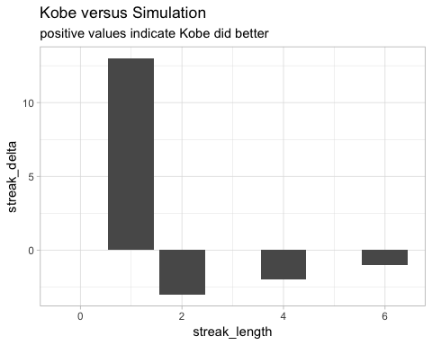

### How does Kobe Bryant’s distribution of streak lengths compare to the distribution of streak lengths for the simulated shooter?

They are both right-skewed streaks for sure, with 1-hit streaks making the longest (with zero-streak lengths excluded). The simulated player has a longer right tail than Kobe because it has streaks that lasted longer, *and* it has less streaks of zero.

### Using this comparison, do you have evidence that the hot hand model fits Kobe’s shooting patterns? Explain.

The simulated model has a higher streak maximum and did quite a bit better at 2-run streaks. If the simulated “hot hand” model were more like Kobe, we would see less streaks last as long. From this simple analysis, it doesn’t seem like we have evidence that the hot hand simulation fit’s Kobe’s shooting patterns, it’s too good!