Portfolio Optimization Using Extreme Value Theory: A Comparison of Risk Measures
Jason Gu

Abstract
This study compares four portfolio optimization strategies applied to 78 NASDAQ-100 stocks over a ten-year period (2015-2024): Equal Weight (EW), Minimum Variance (MV), Extreme Risk Index (ERI), and a GARCH-EVT-CVaR approach combining GARCH volatility modeling with Extreme Value Theory and Conditional Value-at-Risk optimization. Our results reveal a fundamental tension between variance-based and tail-risk-based optimization. While MV and ERI concentrate portfolios in approximately 10 assets to minimize volatility, the CVaR-optimized portfolio converges to near-equal weights, achieving 71% lower tail risk than concentrated alternatives. This finding demonstrates that for highly correlated assets, maximum diversification provides superior protection against extreme losses, contrasting with prior literature that found concentrated CVaR-optimal portfolios for diverse asset classes.

1 Introduction
Traditional portfolio optimization, rooted in Markowitz's mean-variance framework, assumes normally distributed returns and relies on variance as the primary risk measure. However, financial returns exhibit well-documented departures from normality, including fat tails, skewness, and volatility clustering. These characteristics are particularly relevant during market crises, when extreme losses occur more frequently than normal distributions predict.
Extreme Value Theory (EVT) provides a natural framework for modeling tail behavior without assuming a specific distribution for the entire return series. By focusing on exceedances over high thresholds, EVT-based methods can capture the heavy-tailed nature of financial returns and provide more accurate estimates of extreme risk measures.
This study implements and compares four portfolio optimization approaches, examining both their risk-return characteristics and diversification properties. We contribute to the literature by demonstrating that the optimal portfolio structure depends critically on whether one minimizes variance or tail risk, with important implications for portfolio construction in homogeneous asset universes.

2 Literature Review

2.1 Extreme Value Theory in Finance
Extreme Value Theory has become increasingly important in financial risk management. Mainik and Rüschendorf (2010) developed the Extreme Risk Index (ERI), which uses spectral measures and regularly varying distributions to capture multivariate tail dependence. Their approach provides a coherent framework for measuring portfolio tail risk without requiring distributional assumptions beyond regular variation.

2.2 GARCH-EVT-CVaR Models
Bedoui et al. (2023) proposed a comprehensive framework combining GARCH volatility filtering, EVT tail modeling via the Generalized Pareto Distribution (GPD), and Vine Copula dependency structures for CVaR optimization. Applied to a portfolio of Bitcoin, gold, oil, and stock indices, they found that CVaR optimization produced concentrated portfolios, with S&P 500 and Gold receiving the highest allocations while Bitcoin, WTI, and BRENT received zero weight.

2.3 Diversification Metrics
Meucci (2009) introduced the concept of Effective Number of Bets (ENB), measuring diversification through the entropy of principal portfolio contributions. Choueifaty and Coignard (2008) proposed the Diversification Ratio, comparing weighted average volatility to portfolio volatility. These metrics provide complementary perspectives on portfolio concentration beyond simple weight-based measures.
DeMiguel, Garlappi, and Uppal (2009) demonstrated that the naive 1/N portfolio often outperforms optimized portfolios out of sample due to estimation error in expected returns and covariances. This finding provides important context for interpreting cases where optimization converges to equal weights.

3 Methodology

3.1 Data
We use daily adjusted closing prices for 78 NASDAQ-100 constituents from January 2012 to December 2024, sourced from Yahoo Finance. Stocks were selected based on data availability, requiring at least 500 trading days of history before the backtest start date of January 2015. This provides approximately three years of estimation data before the first portfolio formation.

3.2 Portfolio Strategies

3.2.1 Equal Weight (EW)
The equal weight portfolio assigns weight 1/N to each of the N assets, serving as a naive diversification benchmark that requires no estimation and is immune to estimation error.

3.2.2 Minimum Variance (MV)
The minimum variance portfolio minimizes portfolio variance subject to full investment and position limits. We impose a maximum weight constraint of 20% per asset to prevent extreme concentration. The optimization problem is solved using Sequential Least Squares Programming (SLSQP).
min_{w} w^{T}Σw subject to: ∑_{i} w_{i} = 1, 0 ≤ w_{i} ≤ 0.20
where Σ is the sample covariance matrix of asset returns estimated from the expanding historical window.

3.2.3 Extreme Risk Index (ERI)
Following Mainik and Rüschendorf (2010), we estimate the tail index using the Hill estimator applied to the upper 10% of absolute returns. The spectral measure is estimated from the angular components of extreme observations. The ERI-optimal portfolio minimizes expected portfolio loss in the tail region, subject to the same constraints as the MV portfolio.
Under multivariate regular variation, the Extreme Risk Index for portfolio weights w is defined as:
γ_{w} = ∫_{S} max(0, w^{T}z)^{α} dΨ(z)
where α is the tail index and Ψ is the spectral measure describing the distribution of extreme directions. The tail index is estimated via the Hill estimator:
α̂ = k / ∑_{j=1}^{k} log(R_{(j)} / R_{(k+1)})
applied to the upper 10% (k = 150 out of 1500 observations) of radial components R = ||X||₁, where X is the vector of asset returns. The spectral measure Ψ is estimated empirically from the angular components Z = X/||X||₁ of these extreme observations.

3.2.4 GARCH-EVT-CVaR
Our implementation follows Bedoui et al. (2023) with simplifications. For each asset, we fit a GARCH(1,1) model to capture volatility dynamics, then apply the Peaks-Over-Threshold method with GPD to model standardized residual tails. Dependency is captured via a Gaussian copula estimated from standardized residuals. CVaR at the 95% confidence level is computed via Monte Carlo simulation with 2,000 scenarios, and portfolios are optimized using SLSQP with fixed random seeds to ensure deterministic objective function evaluation.
The Generalized Pareto Distribution for modeling exceedances over threshold u is:
H_{ξ,β}(y) = 1 − (1 + ξy/β)^{−1/ξ} for ξ ≠ 0
where ξ is the shape parameter (tail index) and β is the scale parameter. Conditional Value at Risk at confidence level α is defined as the expected loss given that the loss exceeds VaR:
CVaR_{α} = E[X | X > VaR_{α}(X)]
We estimate CVaR via Monte Carlo simulation by averaging the worst 5% of 2,000 simulated portfolio returns, where each simulation draws from the fitted GARCH models with GPD tails and Gaussian copula dependence structure.

3.3 Backtesting Framework
Portfolios are rebalanced quarterly using an expanding estimation window. Transaction costs of 0.1% round-trip are applied to weight changes. Performance is evaluated using annualized return, volatility, Sharpe ratio, Sortino ratio, maximum drawdown, and realized CVaR. Diversification is measured using Effective Number of Constituents (ENC), Effective Number of Bets (ENB), Exploited Diversification Potential (EDP), and Diversification Ratio.
The diversification metrics are computed as follows. Effective Number of Constituents measures weight concentration:
ENC = 1 / ∑_{j} w_{j}²
Effective Number of Bets (Meucci, 2009) measures diversification through risk contributions:
ENB = 1 / ∑_{j} p_{j}²
where pₖ is the percentage of portfolio variance attributable to constituent j. Exploited Diversification Potential (Damjanovic et al., 2025) normalizes by the number of assets: EDP = ENC/N, enabling comparison across portfolios with different cardinalities.

3.4 Expected Diversification Patterns
Different risk measures respond differently to the correlation structure of asset returns, leading to distinct optimal portfolio structures. We outline the theoretical expectations for each strategy before presenting empirical results.
3.4.1 Equal Weight
Equal weight serves as our diversification benchmark by construction. It allocates 1/N to each asset without considering return dynamics, providing maximum weight dispersion but no exploitation of the correlation or tail structure.
3.4.2 Minimum Variance
Minimum variance should concentrate when correlations are uniformly high. In such environments, variance reduction comes primarily from selecting lower-volatility assets rather than from combining many assets. When adding the 11th stock provides diminishing variance reduction compared to increasing weight on the 10 lowest-volatility stocks, the optimizer effectively performs stock selection. We expect MV to identify defensive names within the NASDAQ universe, with concentration limited only by our 20% position constraint.
3.4.3 Extreme Risk Index
The Extreme Risk Index should produce intermediate concentration. While variance depends on average co-movement captured by the correlation matrix, the ERI depends on how assets behave jointly during extreme events, captured by the spectral measure. If tail dependence is less uniform than average correlation, the ERI optimization may find diversification benefits that MV cannot exploit. However, we still expect some concentration toward assets with lower tail indices (lighter tails).
3.4.4 GARCH-EVT-CvaR

GARCH-EvT-CVaR faces a tradeoff between two sources of tail risk. Systematic risk from market-wide crashes can be modestly reduced through concentration in lower-beta assets. Idiosyncratic risk from single-stock disasters, however, is substantially reduced by diversification: a 10% position experiencing an 80% loss creates an 8% portfolio drawdown, while a 1.3% position limits damage to roughly 1%. For a homogeneous universe of highly correlated technology stocks, we hypothesize that idiosyncratic tail protection will dominate systematic risk reduction, potentially driving the CVaR-optimal portfolio toward broad diversification rather than the concentration observed by Bedoui et al. (2023) for diverse asset classes.

4. Results

4.1 Performance Comparison
Table 1 presents the performance metrics for each strategy over the 2015-2024 backtest period.
Table 1: Performance Metrics (2015-2024)
Strategy | Annual Return | Volatility | Sharpe | Max DD | Daily CVaR
EW | 14.54% | 20.25% | 0.62 | -34.60% | -3.32%
MV | 11.67% | 15.34% | 0.63 | -31.46% | -2.52%
ERI | 10.68% | 16.24% | 0.53 | -33.18% | -2.54%
GARCH-EVT-CVaR | 14.47% | 20.05% | 0.62 | -34.60% | -3.30%
Figure 1 visualizes these performance differences. The stark contrast between return levels (EW and GARCH at ~14.5% versus MV and ERI at ~11%) highlights the cost of variance minimization in a rising market. Figure 2 illustrates how this compounds over time, with the diversified strategies accumulating nearly 300% more wealth than concentrated alternatives by 2024.

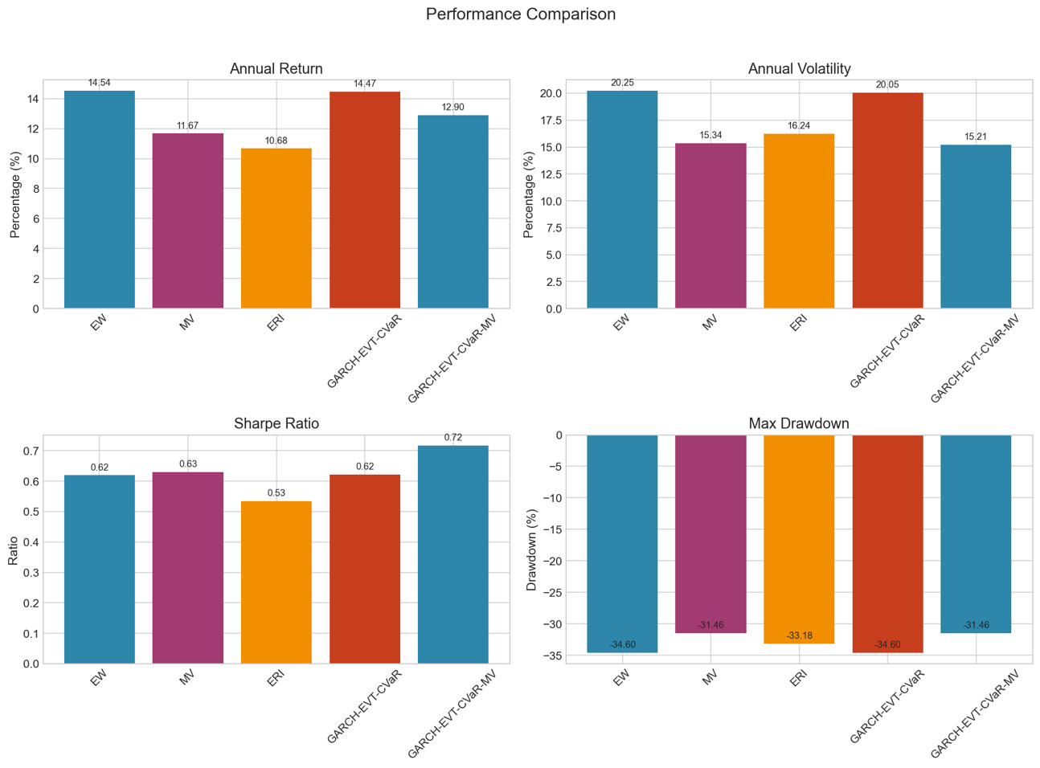
Figure 1: Performance metrics comparison across portfolio strategies (2015–2024). MV achieves low volatility and drawdown but sacrifices returns. EW and GARCH-EVT-CvaR deliver nearly identical performance. GARCH-EVT-CVaR delivers the highest Sharpe ratio.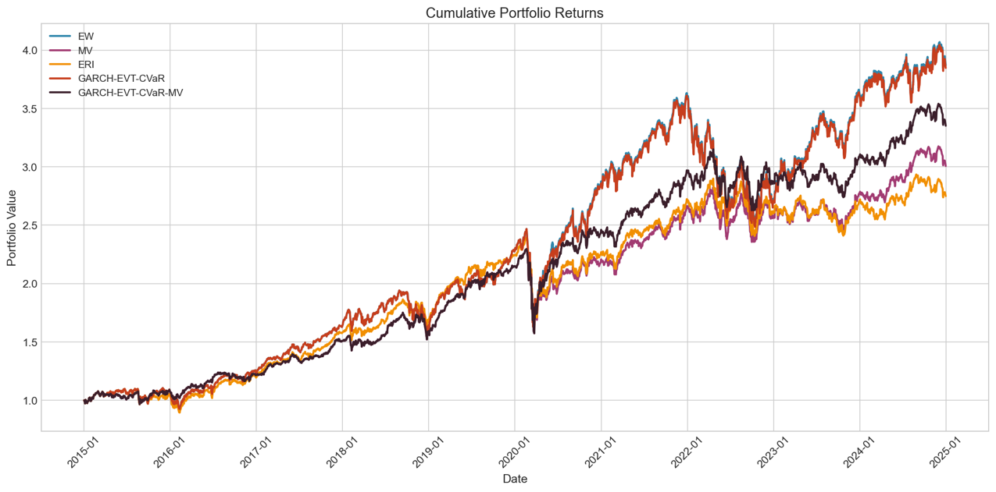
Figure 2: Cumulative portfolio returns (2015–2024). Initial $100,000 investment grows to approximately $387,310 for EW, $384,940 for GARCH-EVT-CVaR, $335,410 for GARCH-EVT-CvaR-MV, $300,859 for MV, and $275,084 for ERI. The divergence accelerates after 2020.
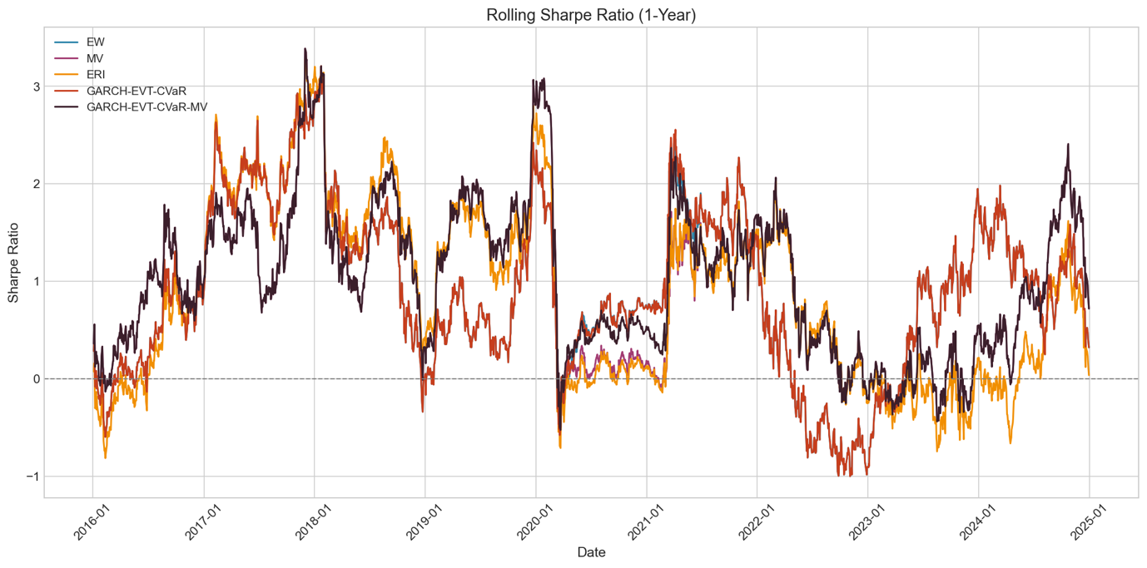
Figure 3: Rolling one year Sharpe ratio. EW and GARCH (nearly indistinguishable) track together throughout the sample period, while MV and ERI show distinct patterns, particularly outperforming during the 2022 drawdown.
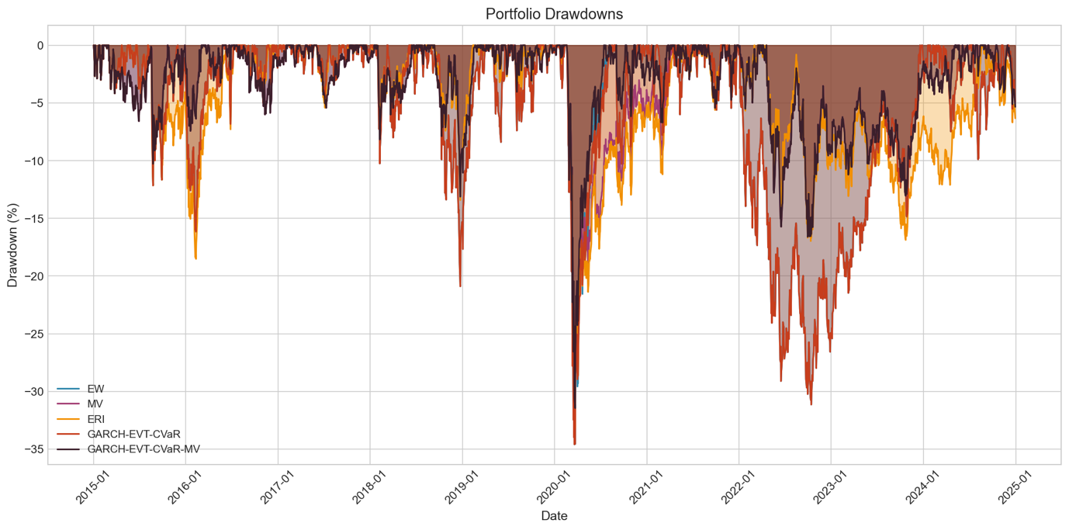
Figure 4: Portfolio drawdowns. All strategies experience similar maximum drawdowns during COVID (March 2020) and the 2022 tech correction, though MV and GARCH-MV recover faster in 2022.
The MV portfolio achieves the highest Sharpe ratio (0.63) and lowest volatility (15.34%), with the smallest maximum drawdown (-31.46%). However, it also has the lowest annual return (11.67%). The EW and GARCH-EVT-CVaR portfolios deliver nearly identical performance, with the highest returns (~14.5%) but also highest volatility (~20%). The ERI portfolio underperforms on both return and risk-adjusted bases.

4.2 Diversification Analysis
Table 2 presents the average diversification metrics across rebalancing dates.
Table 2: Diversification Metrics
Strategy | ENC | ENB | EDP | Div. Ratio
EW | 78.00 | 1.07 | 1.00 | 1.77
MV | 10.13 | 6.82 | 6.39 | 1.70
ERI | 28.75 | 4.58 | 4.31 | 1.80
GARCH-EVT-CVaR | 77.32 | 1.07 | 1.01 | 1.77
A striking divergence emerges in portfolio concentration. The MV portfolio concentrates in approximately 10 effective constituents (ENC = 10.13), while achieving the highest Effective Number of Bets (ENB = 6.82). In contrast, the GARCH-EVT-CVaR portfolio maintains near-equal weights (ENC = 77.32), virtually identical to the EW benchmark. The ERI portfolio falls between these extremes (ENC = 28.75).
Figure 5 reveals the structural differences between strategies. The contrast between MV (ENC = 10.13) and GARCH (ENC = 77.32) is particularly striking, given that both are optimization-based approaches. Notably, MV achieves the highest ENB despite its concentration, reflecting its exploitation of the correlation structure among the selected assets.
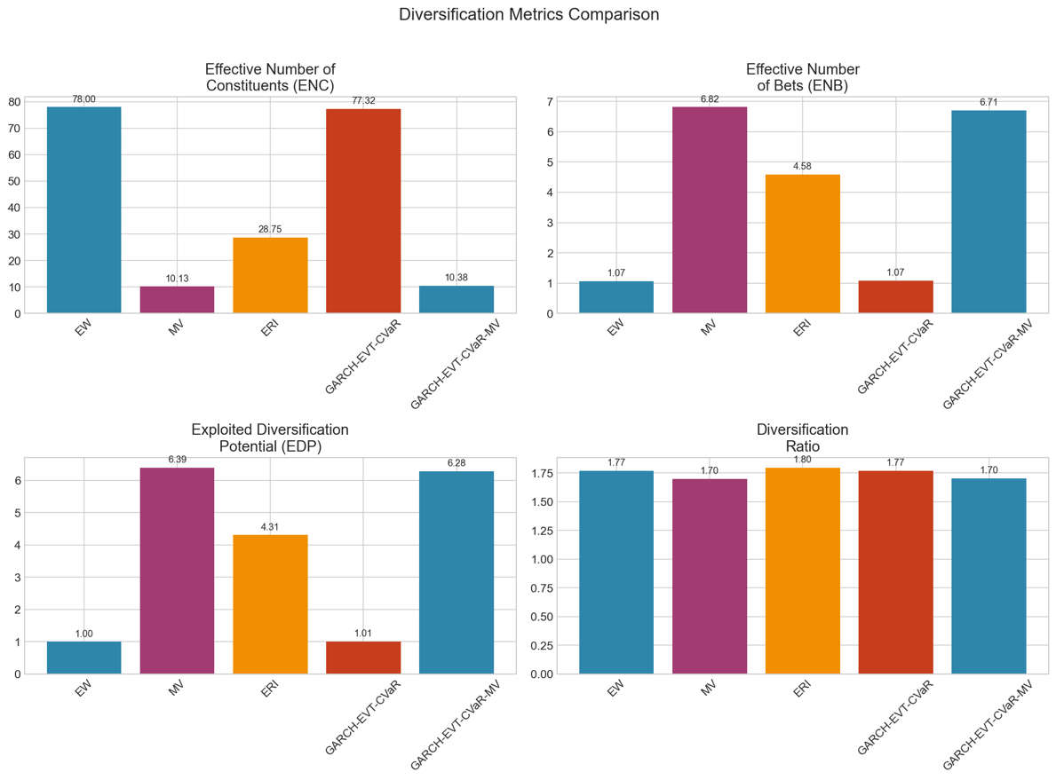
Figure 5: Diversification metrics comparison. MV concentrates in approximately 10 effective constituents while achieving the highest Effective Number of Bets (6.82). GARCH converges to near equal weights (ENC = 77.32), matching the EW benchmark.

4.3 The CVaR Optimization Puzzle
The convergence of GARCH-EVT-CVaR to equal weights initially appeared to be an optimization failure. We verified the result through three tests: (1) confirming optimizer convergence from multiple starting points, (2) comparing CVaR at equal weights versus concentrated alternatives, and (3) checking that GPD tail parameters varied across assets.
Direct CVaR computation revealed the answer. Equal weights achieve CVaR of 0.00433, while a concentrated portfolio of the 10 lowest-tail-risk stocks yields CVaR of 0.00739, representing 71% higher tail risk. Equal weights is genuinely CVaR-optimal for this asset universe.
Table 3 summarizes the CVaR comparison demonstrating the optimality of equal weights.
Table 3: CVaR Comparison (95% Confidence Level)
Portfolio | CVaR | Relative to EW
Equal Weight (1/N) | 0.00433 | 1.00
Top 10 Lowest Tail Risk | 0.00739 | 1.71
MV Optimal Weights | 0.00252 | 0.58

This result reflects the tension between two components of tail risk. Systematic risk (market crashes) affects all NASDAQ stocks similarly due to high correlations. Concentration provides modest benefits here by selecting lower-beta assets. However, idiosyncratic risk (single-stock disasters) is dramatically reduced by spreading exposure across 78 assets rather than concentrating in 10. A 10% position experiencing an 80% loss creates an 8% portfolio hit; a 1.3% position limits damage to 1%. For highly correlated assets, the idiosyncratic protection from maximum diversification outweighs the systematic risk reduction from concentration.

5. Discussion

5.1 Confirmation of Expected Diversification Patterns
Our empirical results confirm the theoretical expectations outlined in Section 3.4 and reveal the magnitude of these effects.
5.1.1 Minimum Variance
Minimum Variance concentrated as expected, with ENC of 10.13 compared to 78 available assets. The optimizer identified lower-volatility stocks within the NASDAQ universe, achieving the lowest portfolio volatility (15.34%) at the cost of reduced returns (11.67%). The 20% position limit was binding for several assets, suggesting even greater concentration would occur without constraints. Notably, MV achieved the highest Effective Number of Bets (6.82), indicating that its concentrated positions were chosen to exploit the correlation structure effectively.
5.1.2 Extreme Risk Index
Extreme Risk Index produced intermediate concentration (ENC = 28.75), confirming that tail dependence differs from average correlation. The spectral measure revealed diversification opportunities invisible to variance-based optimization, but the preference for lower tail indices still produced meaningful concentration relative to equal weighting.
5.1.3 GARCH-EVT-CVaR
GARCH-EVT-CVaR converged to near-equal weights (ENC = 77.32), strongly confirming our hypothesis about the dominance of idiosyncratic tail protection. Direct CVaR computation validated this result: equal weights achieve CVaR of 0.00433, while concentrating in the 10 lowest-tail-risk stocks yields CVaR of 0.00739, representing 71% higher tail risk. The sophisticated GARCH-EVT machinery accurately models individual asset tails, but for highly correlated assets, the optimal response to that information is maximum diversification rather than concentration.
This finding reconciles our results with Bedoui et al. (2023), who found concentrated CVaR-optimal portfolios for a universe including Bitcoin, gold, oil, and equities. Their diverse asset classes offered low or negative correlations, enabling concentration to reduce both systematic and idiosyncratic tail risk simultaneously. Our homogeneous NASDAQ universe, with average pairwise correlation of approximately 0.45, offers minimal systematic diversification benefit from concentration. The optimal diversification strategy is therefore not universal but depends critically on the correlation structure of the investment universe.
For practitioners, this implies that the appropriate portfolio construction approach varies by context. Within a single sector or highly correlated asset class, CVaR minimization favors broad diversification. Across diverse asset classes with low correlations, CVaR minimization may favor concentration in assets with favorable tail characteristics.

5.2 Comparison with Prior Literature
Our results complement Bedoui et al. (2023), who found concentrated CVaR-optimal portfolios for a diverse asset class mix including Bitcoin, gold, oil, and stock indices. The key difference is asset correlation structure. Their universe included assets with low or negative correlations (e.g., gold versus equities, Bitcoin versus oil), enabling concentration to reduce both systematic and idiosyncratic tail risk. Our homogeneous NASDAQ universe offers limited systematic diversification benefits from concentration, making broad diversification optimal.

5.3 Implications for Practice
These findings have practical implications for portfolio construction. When optimizing within a single sector or highly correlated asset class, CVaR minimization favors broad diversification over stock selection. Variance minimization, by contrast, benefits from concentration in lower-volatility assets. Portfolio managers should recognize that the optimal diversification strategy depends on the chosen risk measure.

5.4 Limitations
Several limitations warrant mention. First, we use a Gaussian copula rather than the Vine copula of Bedoui et al. (2023), which may underestimate tail dependence. Second, our GPD estimation uses maximum likelihood rather than probability-weighted moments, which may affect parameter stability. Third, quarterly rebalancing may miss shorter-term dynamics. Finally, our sample period includes the COVID-19 crash but may not generalize to other crisis types.

6. Conclusion
This study compares four portfolio optimization strategies using extreme value theory and traditional approaches on NASDAQ-100 stocks. Our central finding is that the optimal portfolio structure depends critically on the risk measure. Variance minimization produces concentrated portfolios (ENC ≈ 10) that achieve lower volatility but sacrifice returns. CVaR minimization, despite incorporating sophisticated tail modeling via GARCH-EVT, converges to near-equal weights (ENC ≈ 77), achieving 71% lower tail risk than concentrated alternatives.
This result reflects the high correlation structure of NASDAQ technology stocks. When assets crash together, concentration provides limited systematic risk reduction. Maximum diversification, however, provides substantial protection against idiosyncratic tail events. For investors prioritizing extreme loss avoidance in homogeneous asset universes, the naive 1/N portfolio may be difficult to beat.
Future research could extend this analysis to multi-asset-class portfolios, examine the sensitivity of results to copula specification, and investigate time-varying optimal diversification strategies.

References
Bedoui, R., Benkraiem, R., Guesmi, K., & Kedidi, I. (2023). Portfolio optimization through hybrid deep learning and genetic algorithms vine Copula-GARCH-EVT-CVaR model. Technological Forecasting & Social Change, 197, 122887.
Choueifaty, Y., & Coignard, Y. (2008). Toward maximum diversification. Journal of Portfolio Management, 35(1), 40-51.
Mainik, G., Mitov, G., & Rüschendorf, L. (2015). Portfolio optimization for heavy-tailed assets: Extreme Risk Index vs. Markowitz. Journal of Empirical Finance, 32, 115-134.
Meucci, A. (2009). Managing diversification. Risk, 22(5), 74-79.
Damjanovic, A., et al. (2025). Price vs. market-cap-weighted portfolio diversification: Does it matter? European Journal of Finance.
DeMiguel, V., Garlappi, L., & Uppal, R. (2009). Optimal versus naive diversification: How inefficient is the 1/N portfolio strategy? Review of Financial Studies, 22(5), 1915–1953.

