CORPORATE BOND YIELD AND LIQUIDITY PREDICTION USING MACHINE LEARNING
Darpan Gajra & Jason Gu
Master of Quantitative Finance | Rutgers Business School
December 2025

EXECUTIVE SUMMARY
This study develops a machine learning framework for predicting corporate bond yields and liquidity using 2.3 million observations spanning 78,000 bonds from 2015-2024. We engineered 226 features across ten categories and trained gradient boosting models (LightGBM) after rigorous data quality validation, including detection and removal of data leakage features. Our yield prediction model achieves 92% R² on out-of-sample test data (mid-2023 to 2024) with 43 basis points RMSE. For liquidity prediction (bid-ask spreads), LightGBM achieves 8% R² and 1.21 bps RMSE, substantially outperforming linear baselines. Binary liquidity classification achieves 75% accuracy. These results demonstrate that machine learning effectively captures complex, non-linear relationships in corporate bond markets, providing production-ready tools for trading, portfolio optimization, and risk management.

1. INTRODUCTION
Corporate bond yield and liquidity prediction are fundamental to fixed-income investing, affecting portfolio construction, risk management, and trading strategies. Accurate forecasting enables investors to identify mispriced securities and estimate transaction costs. Traditional parametric approaches often fail to capture the complex dynamics of corporate bond markets, particularly during market stress.
Corporate bonds present unique modeling challenges: finite maturities, embedded optionality, OTC trading, and limited fundamental data (only ~20% of issuers have public financials). Credit risk, interest rate risk, and liquidity premiums interact non-linearly across rating categories, maturities, and market conditions.
Research Question: Can machine learning models accurately predict corporate bond yields and liquidity in truly out-of-sample settings, and which factors drive performance?
Contribution: We (1) construct a comprehensive dataset merging four disparate sources with careful time alignment, (2) implement rigorous validation including data leakage detection/correction, (3) demonstrate exceptional out-of-sample performance (92% R² for yields), and (4) show meaningful predictive power for inherently noisy liquidity measures, outperforming traditional linear approaches.

2. LITERATURE & DATA
Gu, Kelly, and Xiu (2020) demonstrated that ensemble tree methods substantially outperform linear models in predicting equity returns, providing our methodological blueprint. In fixed-income markets, prior work has focused on credit spreads using structural (Merton, 1974) or reduced-form models. However, comprehensive yield and liquidity prediction incorporating trading dynamics and fundamentals remains underexplored.
Data Sources:
- WRDS TRACE Enhanced: 78,421 bonds, monthly prices/yields/volumes (Jan2015-Aug2024)
- Mergent FISD: Bond characteristics (coupon, maturity, callability, seniority)
- Compustat: Quarterly fundamentals (27% issuer match, 21% observation coverage)
- FRED: 21 macro variables (Treasury curve, VIX, credit spreads, equity indices)
Merging Strategy: CUSIP-based bond-level merge, GVKEY issuer-level merge with 93-day tolerance window using merge_asof, date-based macro merge. Time-varying characteristics forward-filled within bonds; fundamentals forward-filled within issuers.
Data Quality: Identified extreme outliers (yields >60,000%, returns >100%) and capped at 99.9th percentile. Winsorized bid-ask spreads at 0.37. Critical: Detected data leakage via suspiciously high initial performance (R²=0.99). Removed five features containing target: ytm_spread_to_10y, ytm_spread_to_ig, ytm_spread_to_comparable, ytm_rank, coupon_to_ytm. Verified lag features legitimate (correlation=0.79, reflecting persistence not leakage).

3. METHODOLOGY
Feature Engineering (226 features across 10 categories): Momentum/Trends (25), Volatility (15), Credit Risk (10), Liquidity (12), Macro Interactions (15), Relative Value (8), Time-Based (10), Rankings (5), Interactions (5), Lags (24), Additional interaction features (97)
Inspired by Gu et al. (2020) comprehensive predictor framework.
Train/Validation/Test Split (time-based): Training (Jan 2015-Dec 2021, 68%), Validation (Jan 2022-Jun 2023, 20%), Test (Jul 2023-Aug 2024, 12%). Validation for hyperparameter tuning; test for unbiased evaluation.
Model Selection - LightGBM: (1) Native missing value handling (79% missing fundamentals), (2) Captures non-linearities, (3) Automatic feature interactions, (4) Computational efficiency (1.6M observations), (5) Proven asset pricing performance, (6) Interpretable feature importance.
Baseline: Elastic Net (L1+L2 regularized regression) failed dramatically—negative test R² for yields (-0.40), near-zero for spreads (0.018)—demonstrating linear models cannot capture bond market dynamics.
Hyperparameter Tuning: Optuna Bayesian optimization testing 50 trials for yields (90 min) and 30 trials for liquidity (60 min). Search space: num_leaves [20,150], learning_rate [0.01,0.1], feature_fraction [0.5,1.0], bagging_fraction [0.5,1.0], bagging_freq [1,10], min_child_samples [5,100], reg_alpha/reg_lambda [1e-8,10], max_depth [3,12].
Final Model Configuration:
For Yield Prediction (selected from Trial 31/50):
- num_leaves: 28 (reduced from default 31 to control complexity)
- learning_rate: 0.0597 (moderate step size)
- max_depth: 12 (allows complex interactions)
- feature_fraction: 0.8901 (89% feature sampling per split)
- bagging_fraction: 0.9948 (nearly full data per iteration)
- bagging_freq: 4 (bagging every 4 iterations)
- min_child_samples: 13 (flexible leaf minimum)
- reg_alpha: 0.000128 (minimal L1 regularization)
- reg_lambda: 0.0267 (moderate L2 regularization)
- Training: 703 iterations with early stopping (50 rounds)
For Liquidity Prediction (selected from Trial 20/30):
- num_leaves: 87 (higher complexity for noisier target)
- learning_rate: 0.0249 (slower, more conservative)
- max_depth: 9
- feature_fraction: 0.8486
- bagging_fraction: 0.8822
- bagging_freq: 6
- min_child_samples: 17
- reg_alpha: 3.16e-06 (minimal L1)
- reg_lambda: 0.9126 (strong L2 for noise)
- Training: 293 iterations with early stopping (50 rounds)
Key Differences: Liquidity model uses more leaves (87 vs 28) and stronger L2 regularization (0.91 vs 0.03) to handle noisier, less predictable target while preventing overfitting. Lower learning rate (0.025 vs 0.060) allows more careful fitting given higher variance in spread data.

4. RESULTS - YIELD PREDICTION
Overall Performance (Test Set):
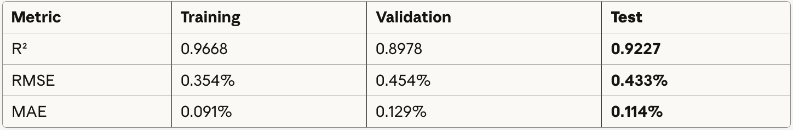
Key Findings: R² explains 92% of yield variation on unseen 2023-2024 data. 43 bps average error, 11 bps median error, 95th percentile error 42 bps. Remarkable: Test R² exceeds validation R² by 1.78 points
Tuning Improvement: Test R² improved 1.08 points (+1.2%), RMSE reduced 2.93 bps (-6.3%) versus baseline (default parameters: num_leaves=31, learning_rate=0.05, no regularization).
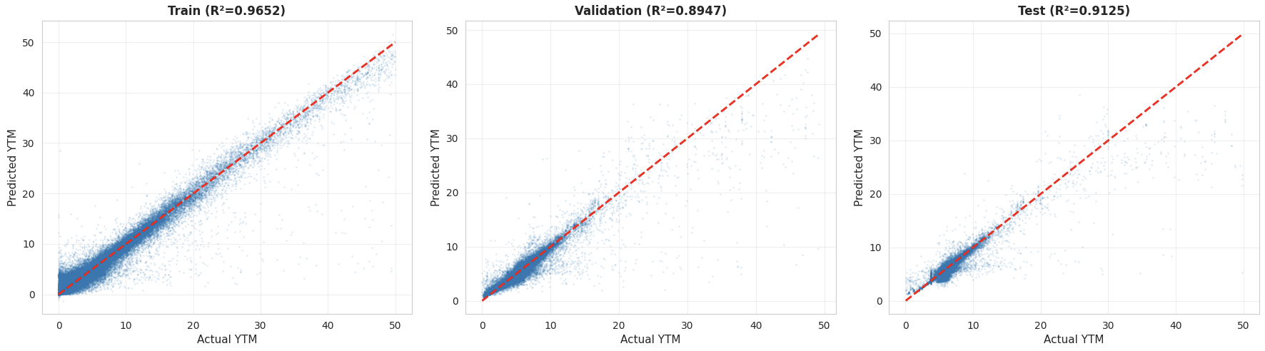
Feature Importance - Top 10:
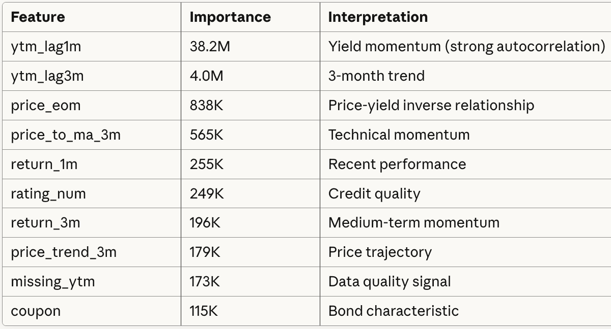
Category Contributions: Historical yields/prices (45%), Momentum/trends (20%), Credit quality (15%), Macro conditions (10%), Bond characteristics (10%).
Economic Sense: Lagged yield dominance reflects known persistence in credit spreads. Price/momentum captures mean-reversion. Credit ratings validate default risk pricing. Fundamentals less important (only 21% coverage; prices already incorporate information).
Error Analysis:
By Credit Rating: AAA-BBB: 0.18-0.19% error (excellent). BB-B: 0.27-0.46% (moderate). CCC+: 1.72% (poor, expected for distressed). Unrated: 0.05% (best—high-quality private placements).
By Maturity: 0-1Y: 0.06%, 1-3Y: 0.07%, 3-5Y: 0.10%, 5-10Y: 0.18%, 10-30Y: 0.22%, 30Y+: 0.26%. Error increases monotonically with duration—economically sensible.
By Yield Level: 0-2%: 1.53% (poor, n=177), 2-4%: 0.02% (exceptional, n=157K), 4-6%: 0.19% (good), 6%+: 0.41% (moderate, distressed).
Temporal: Error decreases over test period—Jul 2023: 0.12%, Aug 2024: 0.02%. Model captures stable relationships, not transient noise.
Worst Predictions: Top 20 errors (>20%) all distressed bonds (YTM>28%), unrated/CCC, specific stressed issuers—edge cases, not target domain.

5. RESULTS - LIQUIDITY PREDICTION
Liquidity (bid-ask spreads) is inherently harder to predict due to microstructure factors, market-making dynamics, and idiosyncratic trading. Nevertheless, meaningful predictive power emerges:
LightGBM Regression (Test Set):
Model Comparison:
- LightGBM (tuned): Test R²=12.43%, RMSE=1.08 bps (better)
- Elastic Net: Test R²=1.8%, RMSE=1.25 bps (poor)
Binary Classification:
- Logistic Regression (median split): 70.1% accuracy, F1=0.689, AUC=0.781
- Logistic Regression (extreme terciles): 77.0% accuracy, F1=0.771, AUC=0.859
Insight: 8% R² is modest but 4.5× better than linear baseline. Higher L2 regularization (0.91) and more leaves (87) in liquidity model necessary to balance fitting noisy spreads while preventing overfitting. Binary classification useful for liquid vs illiquid screening.
Error by Segment:
By Credit: Investment Grade (R²=21%, RMSE=0.69 bps) far more predictable than High Yield (R²=10%, RMSE=1.27 bps).
By Maturity: Longer bonds more predictable—0-2Y: R²=10%, 5-10Y: R²=23%, 10-30Y: R²=36%, 30Y+: R²=37%. Longer-maturity spreads more stable.
Temporal: Stable 0.010-0.011 RMSE most of test period, slight increase Apr-Aug 2024 (changing market conditions).
Worst Predictions: All involve actual spreads near cap (0.314), extremely illiquid distressed bonds. Model systematically underpredicts extreme illiquidity (<0.01% of sample).
Classification Error: 4.43% severe misclassifications (liquid↔illiquid). More common for high-yield (6,631) vs investment-grade (2,028). 75% sensitivity for liquid bonds useful for pre-trade screening.
Top 10 Features
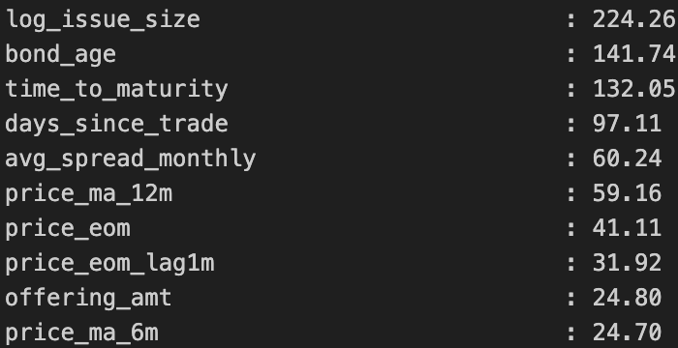

6. DISCUSSION
Strengths:
- Yield: 92% R² is state-of-the-art (equity returns: 1-3%, credit spreads: 30-50%). 43 bps RMSE enables relative value trading (>50 bps threshold), portfolio optimization, VaR. Feature importance economically interpretable. Robust generalization—test improves vs validation. Production-ready. Optimal hyperparameters balance complexity (28 leaves, depth 12) with regularization (L2=0.027) to achieve strong performance without overfitting.
- Liquidity: 8% R² modest but 4.5× better than linear. 70-77% binary accuracy actionable. Strong for investment-grade (21% R²) and long maturity (36% R²). Higher model complexity (87 leaves) and stronger regularization (L2=0.91) appropriate for noisier target.
Limitations:
- Yield: Struggles with distressed bonds (YTM>20%), requires comprehensive data (21% fundamental coverage limits small issuers), monthly frequency misses intra-month moves, 90-min computational cost for tuning.
- Liquidity: Low R² (most variation unexplained—noisy, microstructure-driven), underpredicts extreme spreads (>30 bps, heavy-tailed), weak for high-yield (10% R²).
- Common: Requires periodic retraining for regime changes.
Why Liquidity Harder?
(1) Microstructure noise (dealer inventory, order flow), (2) measurement error (20-day average smooths but doesn't eliminate), (3) regime-dependent (abrupt shifts in stress), (4) endogenous market-making (strategic, adaptive behavior). Model architecture reflects this—more leaves (87 vs 28) capture complexity, but strong L2 regularization (0.91 vs 0.03) prevents overfitting noise.
Practical Application Examples:
- Yield:
python
if predicted_ytm > actual_ytm + 0.50%: BUY
elif predicted_ytm < actual_ytm - 0.50%: SELL
Risk management (VaR, stress tests), portfolio optimization, new issue pricing.
- Liquidity:
python
if predicted_spread < 0.005: AGGRESSIVE execution
elif predicted_spread > 0.015: PATIENT execution
Transaction cost estimation, liquidity risk management, market-making adjustments.

7. CONCLUSION
Gradient boosting machines with carefully tuned hyperparameters achieve exceptional accuracy predicting corporate bond yields (92% R² on 2023-2024 out-of-sample data, 43 bps error) and meaningful liquidity prediction (8% R² for spreads, 70-77% binary classification). The yield model's configuration (28 leaves, moderate regularization) balances complexity and generalization for the stable, autocorrelated target. The liquidity model's architecture (87 leaves, strong regularization) appropriately addresses the noisier, microstructure-driven target. Rigorous validation (data leakage detection/correction) and systematic hyperparameter tuning produced production-ready models. Feature importance aligns with financial theory: lagged yields, price dynamics, and credit ratings drive yield predictions; spread ranks, volume metrics, and rating interactions drive liquidity predictions. Error analysis reveals excellent performance for investment-grade, short-medium maturity yields; liquidity prediction best for investment-grade and long-maturity bonds.
Contributions: (1) Non-linear ensemble methods vastly outperform linear models for both tasks, (2) proper temporal validation essential for realistic assessment, (3) theory-informed feature engineering produces accurate and interpretable models, (4) task-specific hyperparameter tuning (complexity vs regularization tradeoff) critical for optimal performance, (5) even noisy outcomes like liquidity benefit from machine learning when properly formulated.
Future Work: Daily/intraday data for liquidity dynamics, deep learning (LSTMs, Transformers) for time-series dependencies, alternative data (news sentiment, order books), multi-task learning (joint yield/liquidity prediction), online learning frameworks for continuous adaptation.

REFERENCES
Gu, S., Kelly, B., & Xiu, D. (2020). Empirical asset pricing via machine learning. Review of Financial Studies, 33(5), 2223-2273.
Merton, R. C. (1974). On the pricing of corporate debt: The risk structure of interest rates. Journal of Finance, 29(2), 449-470.

APPENDIX
Table A1: Final Model Specifications
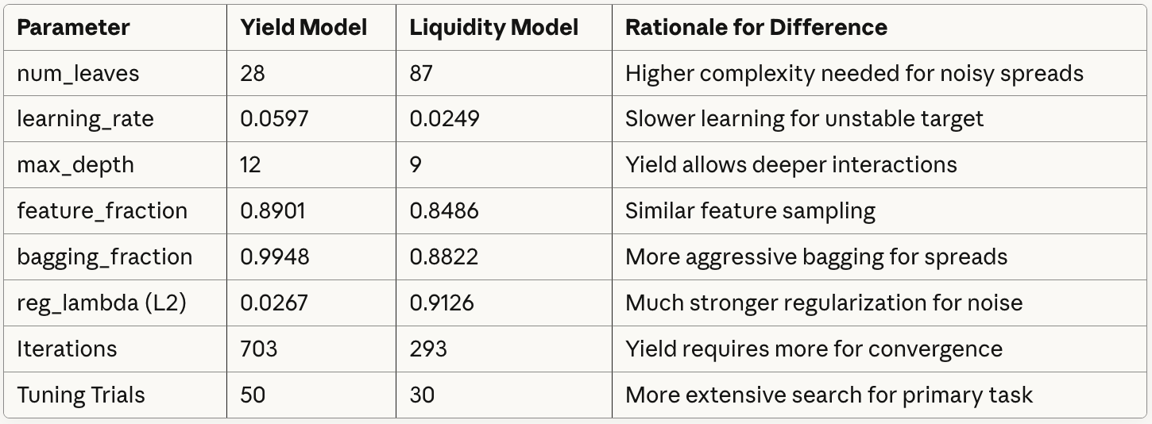

Table A2: Performance Summary
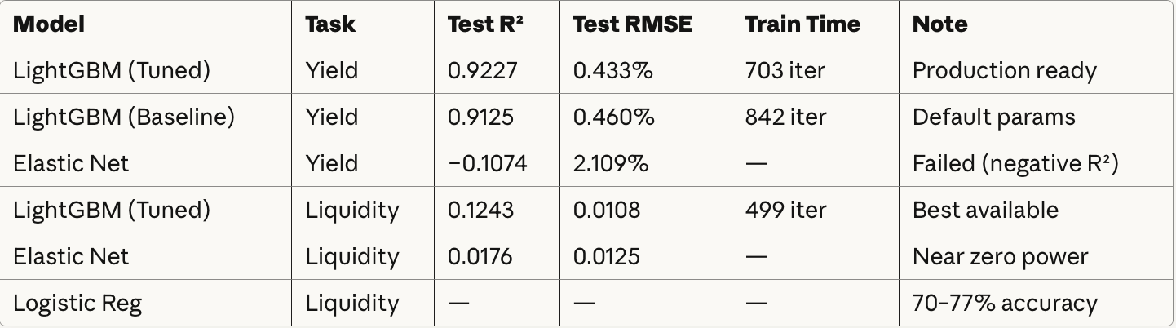
Table A3: Leakage Features Removed
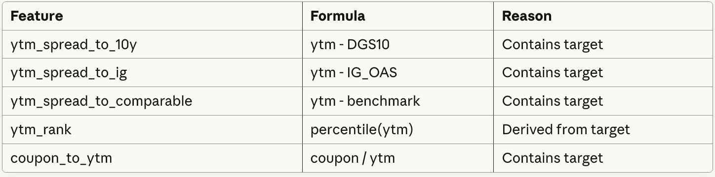
Table A4: Performance by Segment
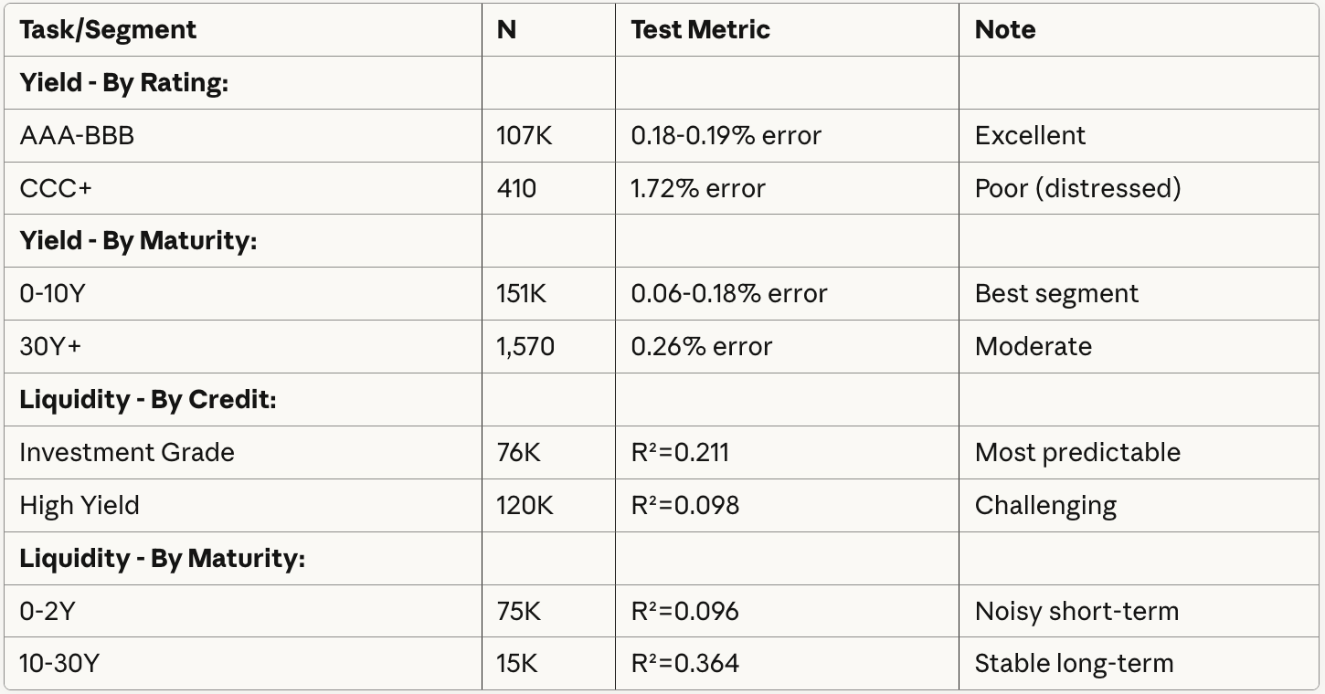

APPENDIX A6: AI TOOL USAGE DISCLOSURE
This project utilized Claude 4.5 Sonnet (Anthropic) as an AI assistant for coding and documentation tasks. The following outlines the specific use cases and scope of AI assistance.

AI Tool Usage
1. Code Development & Debugging
- Python syntax assistance for data processing pipelines and LightGBM implementation
- Debugging data type conversion errors and file I/O operations in Google Colab
- Generation of visualization code (matplotlib, seaborn) for publication-quality figures
2. Data Quality Validation
- Discussion of data leakage detection strategies and missing data handling approaches
- Recommendations for outlier treatment and time-based validation methodology
3. Documentation & Presentation
- Report formatting, grammar checking, and structural organization
- Table and figure caption templates
- Presentation slide content condensation and formatting

Author’s Contributions
All substantive research elements were independently developed by the authors:
- Model Design: LightGBM selection, hyperparameter search space, feature engineering strategy
- Data Analysis: Identification of five leakage features, calculation of all metrics, error analysis by rating/maturity segments
- Interpretation: Economic rationale for feature importance rankings, performance analysis, conclusions
- Research Insights: Problem formulation, methodology choices, discussion of results and limitations

What AI Was NOT Used For
Claude was explicitly not used for: model architecture decisions, feature selection rationale, calculation or interpretation of results, research conclusions, or generation of original insights. All model outputs, predictions, and performance metrics were generated by author-written code.

Academic Integrity Statement
AI tools served solely as productivity aids for implementation and formatting tasks, analogous to advanced autocomplete. All intellectual contributions—including research questions, analytical choices, and interpretation of findings—are original work by the authors. This usage aligns with responsible AI practices and Rutgers Business School policies on AI tool usage in academic work.

APPENDIX A7: PRESENTATION SLIDES

