|  |
| --- |
| A-Z80 CPU User’s Guide |
| An FPGA project recreating the Z80 |
| *© 2014-2016 Goran Devic* |

3/6/2016

# Revision History

|  |  |  |
| --- | --- | --- |
| Date | Revision | Change |
| 2014-12-14 | 1.0 | Initial revision. |
| 2014-12-21 | 1.1 | Added ZX Spectrum Turbo mode, speaker blink etc. |
| 2015-01-22 | 1.2 | Added section on file generators; other small updates. |
| 2016-03-06 | 1.3 | Added Xilinx support. |

Table of Contents

Revision History 1

Introduction 3

Project Directory Structure 4

Environment 5

Test Boards 6

Simulation 7

Module simulations 7

Top-level simulations 10

Verification 12

Fuse tests 12

Selected functional tests 13

Z80 Assembly level tests 14

Tools 15

PLA Checker Tool 15

Arduino Tools 18

Integration 19

Interface 20

Sample Implementations 21

Simple host 21

Sinclair ZX Spectrum 24

Advanced Topics 26

Modifying the A-Z80 CPU Core 26

File Generators 28

Building the CPU 28

Verification/Tests 30

# Introduction

A-Z80 is a conceptual implementation of the venerable Zilog® Z80 processor targeted to synthesize and run on a modern FPGA device. It differs from the existing Z80 implementations in that it is designed from the ground-up through the schematics and low-level gates.

This design is capable of mimicking the actual Z80 CPU and it illustrates its inner workings.

The A-Z80 implementation strives to be internally structurally identical to the original Z80. Using this approach, the model achieves a full cycle accuracy and has identical behavior for all documented and undocumented features (*) not by explicitly hard-coding them but by mimicking their actual design.

Various *Zilog Z80* references are widely available so the CPU, its instructions and behavior will not be covered in this document.

This document focuses on the structure and mechanics of working with the A-Z80 project; it should help you understand it and incorporate it into your designs.

You can read more about the conception and implementation of the A-Z80 on its home website: [www.baltazarstudios.com](http://www.baltazarstudios.com) .

If you simply want to integrate A-Z80 into your own project, you can skip to section *Integration*.

# Project Directory Structure

A-Z80 project can be downloaded from two locations:

* OPENCORES (SVN): <http://opencores.org/project,a-z80>
* Bitbucket (git): <https://bitbucket.org/gdevic/a-z80> .

The following table describes the directory structure:

|  |  |  |
| --- | --- | --- |
| Directory | Sub-directory | Description |
| cpu |  | Contains all core files of the A-Z80 CPU |
|  | alu | Arithmetical and Logical Unit files |
|  | bus | Various bus-related files |
|  | control | Control unit files |
|  | registers | Register block files |
|  | toplevel | A-Z80 top level interfaces and projects |
| docs |  | Documentation and images of schematics |
| host |  | Several implementations using A-Z80 on Altera and Xilinx boards |
|  | basic | Basic computers for testing and verification, uses UART |
|  | zxspectrum | Sinclair ZX Spectrum implementation for Altera DE1 board |
| resources |  | General project resources and scripts |
| tools |  | Building and testing utilities and misc. files |
|  | Arduino | Software for Arduino Mega dongle to interface with a Z80 |
|  | dongle | Dongle and simulation scripts and golden files |
|  | z80_pla_checker | Windows utility to test and create A-Z80 PLA tables |
|  | zmac | Z80 test and verification assembler files |

# Environment

A minimal set of tools needed to **compile** various parts of the project is:

* Altera Quartus II Web Edition (free) OR
* Xilinx ISE Webpack (free)
* ModelSim (Altera edition, free) – needed for simulation of various modules
* Python 3.5.x – needed to change or recompile A-Z80 files
* Microsoft Visual Studio 2013 – needed to recompile the z80_pla_checker tool

If you are only going **to use** A-Z80 in your project, all Verilog files that you need are already checked in and ready to be included and you don’t need any of the extra tools listed.

This project was developed and tested on a 64-bit Windows 7 OS. Your mileage may vary on other platforms.

# Test Boards

**Altera**: Designs are tested on a Terasic DE1 board: <http://www.altera.com/education/univ/materials/boards/de1/unv-de1-board.html>

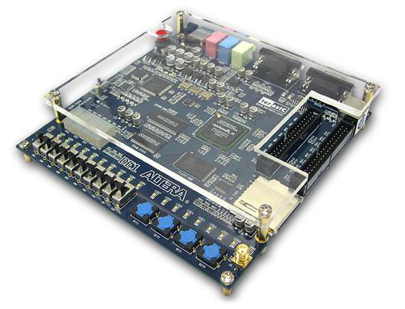

This particular board has a **Cyclone II EP2C20F484C7** FPGA alongside a number of useful peripherals including a 512 KB SRAM bank, PS/2 keyboard, UART and a VGA connector.

**Xilinx**: Designs are tested on a Digilent Nexys3 board:

<http://store.digilentinc.com/nexys-3-spartan-6-fpga-trainer-board-limited-time-see-nexys4-ddr/>

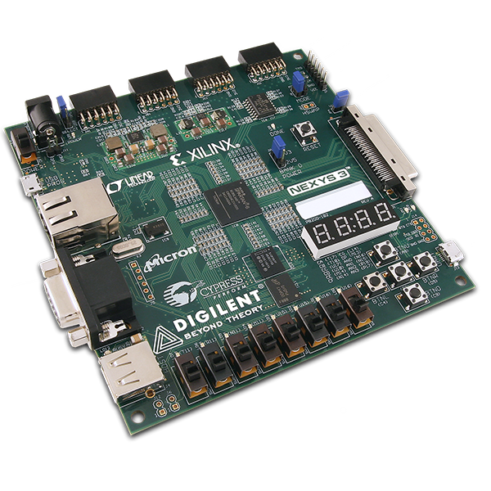

This board features a **Spartan-6 XC6LX16**-CS324 FPGA and several useful peripherals such are UART, PS/2 keyboard and VGA.

# Simulation

## Module simulations

If you make any change to the core files of A-Z80, you should run one or more simulations to verify the correctness of your modifications.

Each module in the “**cpu**” directory contains a ModelSim simulation project that verifies the functionality of one or more of its blocks. Before opening a project in ModelSim, run “**modelsim_setup.py**” script located in the project root directory. That script will set up *relative file mappings* to enable project to reside anywhere on your drive.

If you have installed and configured ModelSim correctly, double-clicking on any **\*.mpf** file will open a project in the ModelSim GUI.

This particular example will illustrate setting up and starting a simulation of a specific logic block in the **alu** module.

Before you can compile a simulation test bench, create a library by typing “**vlib work**” as shown:

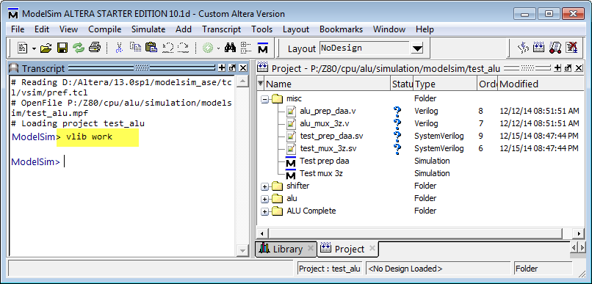

Next, select “**Compile->Compile All**” to compile all files that are part of a module simulation.

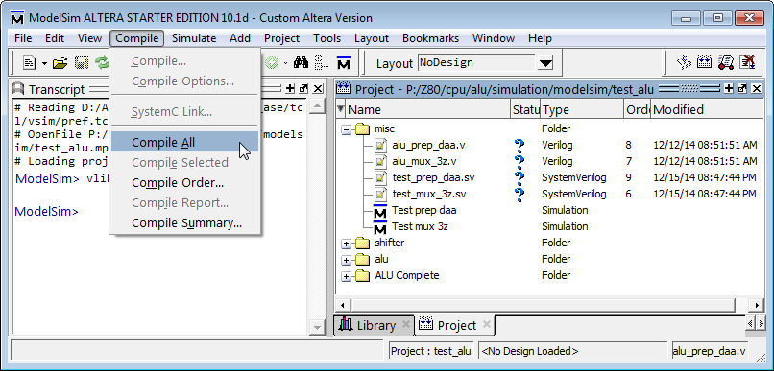

Each project has one or more *simulation configurations*; each configuration tests a specific block of logic. In addition, each configuration has its own wave file which you can load before you run a simulation. Wave files are customized for a specific test and provide a handy way to quickly see all relevant signals.

In this example, we will run “Test prep daa” configuration. DAA is a Z80 instruction that adjusts accumulator for a decimal operation. It requires calculating the adjustment addend based on the result of a previous operation. Hence, this test is written to verify the correctness of that calculation.

Each test configuration is run by a main test bench file that is always written in a *System Verilog* language with the extension **\*.sv**. A file that runs the “Test prep daa” configuration is “**test_prep_daa.sv**”.

Double-click on the “Test prep daa” configuration and your simulation should be loaded.

Open the wave window if it is not already visible and select File->Open to load a wave file as shown:

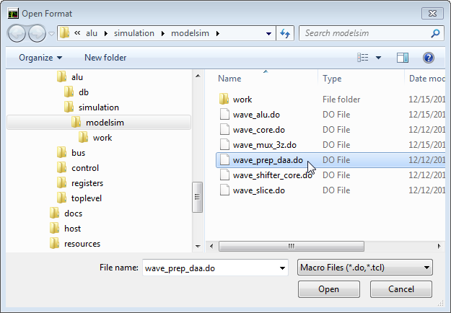

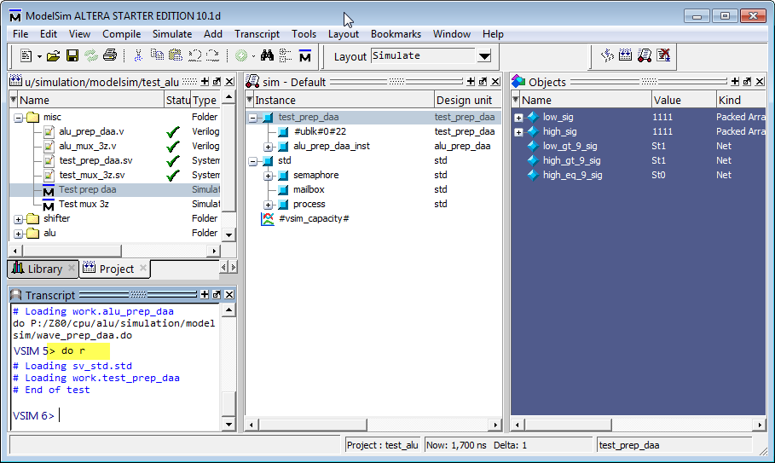

A shortcut is provided to run simulation: each ModelSim directory contains a small text file with the name “r” that contains command “**restart -f ; run -all**”. Run, or rerun, a test simply by typing “**do r**” as shown above.

After running this particular example, you should see a waveform of the DAA preparation block:

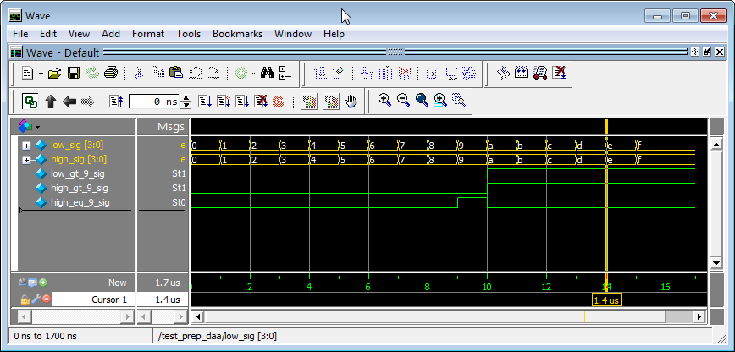

Although a very simple as an example, this hopefully illustrated a method of running a simulation. The same process can be repeated on other configurations and modules. The pattern of configurations, files and waveform names is the same.

Each main test bench file (just like the “**test_prep_daa.sv**”) contains a set of **assert()** statements to verify the signal correctness. These asserts will fail and your simulation will stop if the signals take unexpected values.

Most simulations run for a predetermined number of clocks. The exceptions are top-level simulations (in the directory “**cpu\toplevel\simulation\modelsim**”) and a basic host simulation (in the directory “**host\basic\simulation\modelsim**”). These simulations need to be stopped manually since they simply continue to execute given Z80 executable code.

## Top-level simulations

The two top-level simulations are designed to load an arbitrary Z80 assembly code and execute it. A simple unidirectional UART model is provided for the Z80 software to write to the ModelSim console. The UART model will simulate behavior of a synthesized serial port. When the same design is synthesized for the FPGA, the same Z80 code will write messages through a physical serial port.

UART is using 115200 baud data transfer rate, 8 data, 1 stop bit, no parity.

|  |  |
| --- | --- |
| Module | Simulation project |
| Toplevel | cpu\toplevel\simulation\modelsim\test_top.mpf |
| Basic host | host\basic\simulation\modelsim\test_host.mpf |

Those two simulation configurations can run any Z80 code; several sample test sources can be found in the directory “**tools\zmac**” along with ZMAC assembler and a few batch scripts that simplify compilation and the test setup. Z80 test files are somewhat based on CP/M and have a BDOS style text print interface.

Two MS DOS batch files are used to compile and run tests:

|  |  |
| --- | --- |
| Batch file | Description |
| tools\zmac\make_modelsim.bat | Compiles and generates executable code for a ModelSim test at “cpu\toplevel\simulation\modelsim\test_top.mpf”, for “test_top” configuration. |
| tools\zmac\make_fpga.bat | 1. Compiles and generates executable code in Intel HEX file format to be included into the target FPGA data file for basic host “host\basic\ host_board.qpf” 2. Also generates executable code for the basic host ModelSim test at “host\basic\simulation\modelsim\ test_host.mpf” |

You can create your own Z80 assembly tests to run: simply drag and drop an assembly source file onto one of those two batch files and they will compile a file and copy the results into proper target directories.

For this example, we will compile and run a “Hello, world” test (“**tools\zmac\hello_world.asm**”).

Drag and drop “**hello_world.asm**” onto the “**make_modelsim.bat**” and start a top level simulation (“**test_top**” configuration) in the ModelSim.

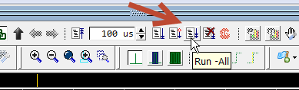

Shortly, you should see the output in the ModelSim console window.

After you see the text being written to the virtual UART device, you can stop the simulation.

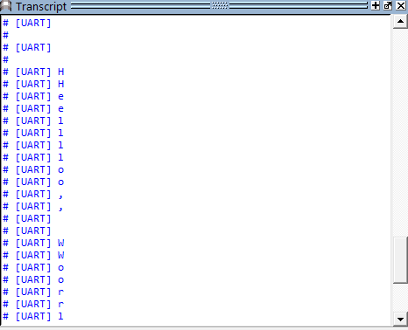

# Verification

## Fuse tests

Fuse is a set of tests to verify Z80 at the individual instruction level. Written for software emulator designers, it contains a fairly complete set of input and output states for each instruction.

Files that are used in this verification are subset of the Fuse emulator source package: <http://fuse-emulator.sourceforge.net> . You can find them in the “**cpu\toplevel\fuse**” directory.

The files describe individual instruction’s tests and need to be processed into a format that we can run – which is Verilog. A Python script “**cpu\toplevel\genfuse.py**” generates Verilog test code for a selected number of Fuse tests.

See that script file for more details on how to configure it before running.

When run, it creates “**cpu\toplevel\test_fuse.vh**” include file.

|  |
| --- |
| // Automatically generated by genfuse.py  force dut.reg_file_.reg_gp_we=0;  force dut.reg_control_.ctl_reg_sys_we=0;  force dut.z80_top_ifc_n.fpga_reset=1;  #2 //--------------------------------------------------------------------------------  force dut.instruction_reg_.ctl_ir_we=1;  force dut.instruction_reg_.db=0;  #2 release dut.instruction_reg_.ctl_ir_we;  release dut.instruction_reg_.db;  $fdisplay(f,"Testing opcode 00 NOP");  ... |

Once generated, this include file needs to be compiled with a ModelSim project file “**cpu\toplevel\simulation\modelsim\test_top.mpf**” to run a set of tests. The test output will show in the ModelSim window and the test will also create and write a file “**fuse.result.txt**”.

**Hint:** You can speed up Fuse simulation if you disable output to the wave window by typing:

|  |
| --- |
| VSIM 10> nolog –all |

The following command re-enables the output:

|  |
| --- |
| VSIM 10> nolog –reset |

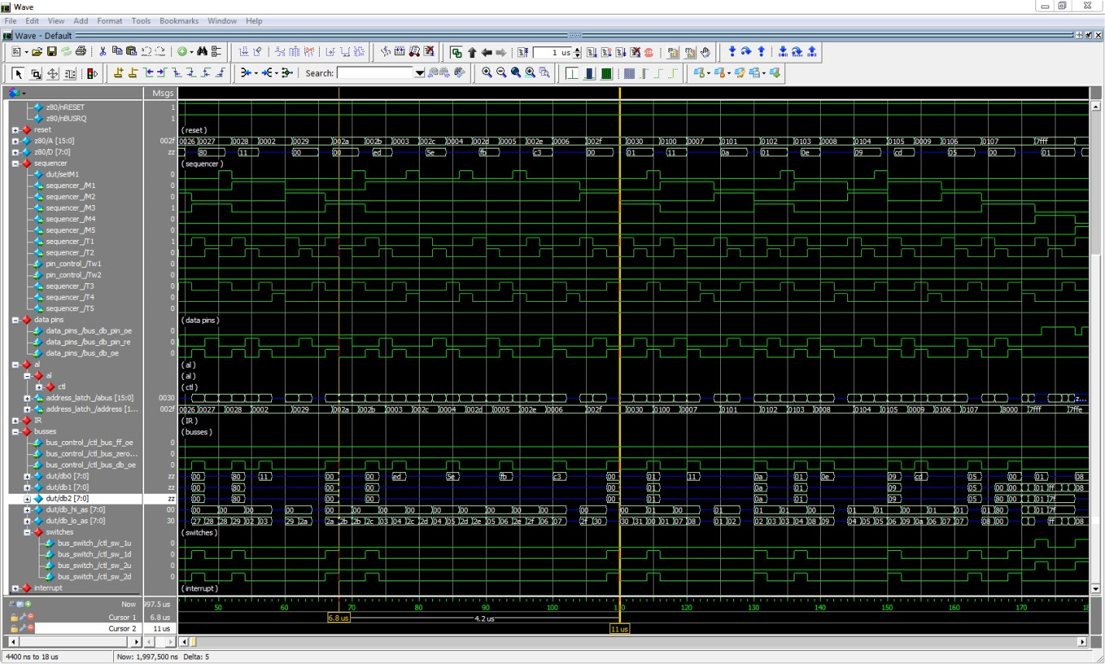

Image : Fuse tests in ModelSim

Results of Fuse tests are written in the file “**fuse.result.txt**”, one instruction per line:

|  |
| --- |
| Testing opcode 00 NOP  Testing opcode ed67 RRD  Testing opcode ed6f RLD  Testing opcode 81 ADD A,C  Testing opcode cb41 BIT 0,C  Testing opcode cb93 RES 2,E  ... |

## Selected functional tests

There are 3 tests that verify specific ALU operations by cross-checking the results run on a real Z80 with the algorithm written in Python:

|  |  |  |
| --- | --- | --- |
| Test directory | Z80 test file | Description |
| tools\dongle\daa | tools\zmac\test.daa.asm | Execute DAA instruction for all values 0-255 |
| tools\dongle\neg | tools\zmac\test.neg.asm | Execute NEG instruction for all values 0-255 |
| tools\dongle\sbc | n/a | Simulate SUB and SBC instructions |

Python scripts run the Arduino Z80 dongle (described in the Tools section) and generate output files. Those files are then compared with the output produced by another set of Python scripts (they implement corresponding algorithms). Lastly, the same text files are compared with ModelSim simulation of those instructions and also by running the same executable on the Simple Host FPGA implementation and capturing the UART output.

The “golden” files include values of flags and accumulator going into the instruction and the result after the instruction has completed:

|  |
| --- |
| F:00 A:00 -> 00 F:44  F:00 A:01 -> 01 F:00  F:00 A:02 -> 02 F:00  F:00 A:03 -> 03 F:04  F:00 A:04 -> 04 F:00  F:00 A:05 -> 05 F:04  F:00 A:06 -> 06 F:04  F:00 A:07 -> 07 F:00  ... |

## Z80 Assembly level tests

Folder “**tools/zmac**” contains several Z80 assembly level tests.

|  |  |
| --- | --- |
| Test source file | Description |
| tools\zmac\hello_world.asm | A mandatory “Hello, World” |
| tools\zmac\zexdoc.asm | Tests documented Z80 instructions and flags |
| tools\zmac\zexall.asm | Tests ALL Z80 instructions and flags (documented and undocumented) |

While all of them can run in ModelSim, the last two are comprehensive and very long tests which should normally be run only on an FPGA hardware in full speed mode.

“**hello_world.asm**” is written to allow test bench “**cpu\toplevel\test_top.sv**” to exercise various interrupt modes. It contains interrupt handlers and logging for the test bench to run the following cases:

* Inject a single or periodic NMI
* Inject a single or periodic INT
* Test response to the nWAIT signal
* Test response to the nBUSRQ signal
* Test resets

# Tools

## PLA Checker Tool

PLA checker tool in “**tools\z80_pla_checker**” directory is a test utility to verify and create PLA code used to statically decode Z80 instruction groups.

Since you normally don’t have to compile that code, a Windows executable is checked in.

When started, the PLA checker loads a number of files from “**resources**” directory. That includes a raw PLA table definition as reverse-engineered from an image of a Z80 die.

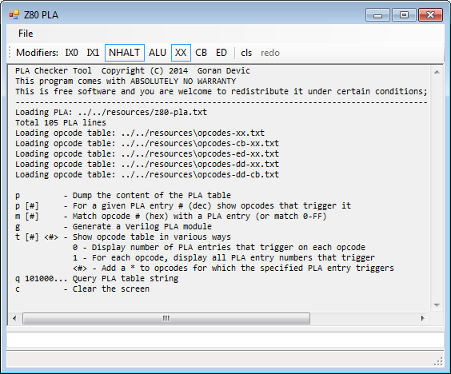

The tool was invaluable in the development of A-Z80 and maintain its value as a cross-checker for the PLA code. Available commands are:

|  |  |
| --- | --- |
| Cmd | Description |
| h or ? | Help, list all commands. |
| p | PLA table contains a set of modifiers and a gate-level logic array that ‘filters’ various instruction opcode groups. This command shows you those groups.  C:\Users\gdevic\AppData\Local\Temp\SNAGHTML294146f7.PNG |
| p # | Given a PLA entry number (decimal), show opcodes that are activated by it   |  | | --- | | 10>>> p 3  PLA Entry: 3 Modifier: XX, NHALT  DD => [3] IX/IY prefix  FD => [3] IX/IY prefix | |
| m # | This is a reverse-lookup that shows all PLA table entries that would activate a specific opcode given as a hex number:   |  | | --- | | 12>>> m 76  Opcode: 76  [58] ld r,(hl)  [59] ld (hl),r  [61] ld r,r'  [95] halt | |
| t | Dumps the opcode table in several ways. One or two optional arguments are given which restrict the table or show extra information including the number of PLA entries that trigger for each opcode etc.  C:\Users\gdevic\AppData\Local\Temp\SNAGHTML29487d90.PNG |
| q # | Useful only while simulating the CPU design, this command decodes the actual PLA table string which is a long sequence of binary digits (105 bits in total) |
| g | Generates Verilog code that implements the PLA decode. The output of this command is used to create “**cpu\control\pla_decode.sv**” source file which is at the core of the design.  C:\Users\gdevic\AppData\Local\Temp\SNAGHTML295b3710.PNGThe image shows the start of the PLA decode module implemented in Verilog. |

Z80 has several opcode tables and addressing modes selected either by a combination of instruction prefix bytes (0xCB, 0xED and IX/IY) or by the internal state (HALT, ALU…)

PLA checker tool lets you set or unset any of these modifiers:

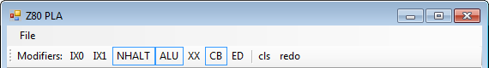

The modifier buttons directly correspond to modifiers in the PLA table and let you simulate the exact PLA logic behavior as you are executing various tool dumps.

The tool keeps a history of commands that are typed in; a number displayed at the front of a *prompt* “>>>” is a location in the history buffer. Pressing **PgUp** and **PgDown** selects a command from the history buffer; **ESC** clears the command line.

## Arduino Tools

Directory “**tools\Arduino\Z80_dongle**” contains firmware for the *Arduino Mega* connected to a Zilog Z80 through a custom dongle. This setup can be used to pace Z80 in a controlled way and to execute individual instructions and monitor bus activity. You can read more about that dongle at [www.baltazarstudios.com](http://www.baltazarstudios.com).

It was heavily used to generate tables for the correct bus behavior. These tables and Python scripts to create them are checked in the directory “**tools\dongle**”.

# Integration

This section describes how to integrate A-Z80 CPU into your own project.

The method is tested with Altera and Xilinx design tools on several test boards.

The process of integration involves adding all relevant source files and setting up interfaces. For convenience, all files needed to synthesize a CPU are listed in the file “cpu/top-level-files.txt” and a Python script “**cpu/export.py**” can be run to copy all design files to your project folder.

|  |
| --- |
| Usage: export.py <destination-folder>  Copies all core A-Z80 Verilog files to a destination of your choice.  The files copied are necessary and sufficient to include with your project. |

Several fully working sample implementations (*basic host* and *zxspectrum*) should provide good starting point.

# Interface

The top-level file “**cpu\toplevel\z80_top_direct_n.sv**” exports the following interface:

|  |
| --- |
| module z80_top_direct_n(  output wire nM1,  output wire nMREQ,  output wire nIORQ,  output wire nRD,  output wire nWR,  output wire nRFSH,  output wire nHALT,  output wire nBUSACK,  input wire nWAIT,  input wire nINT,  input wire nNMI,  input wire nRESET,  input wire nBUSRQ,  input wire CLK,  output wire [15:0] A,  inout wire [7:0] D  ); |

The interface pinout is 100% identical to a Zilog Z80 package. This interface implements Z80 bus timings and features tri state signals and buses. (While admittedly not optimal for an FPGA implementation, it perfectly mimics the actual Z80 silicon which was one of the goals of this project).

# Sample Implementations

Several working implementations are included. They are all located in the “**host**” directory and use Altera DE1 and Xilinx Nexys3 development boards.

Warning: The synthesis and *fMax* numbers as shown might vary depending on your tool version, applied timing constraints and the exact configuration.

## Simple host

“*basic host*” project has two targets: “basic_de1” can be used on a Terasic DE1 board and “basic_nexys3” can be used on a Digilent Nexys 3 board. Each contains the A-Z80 CPU, 16 KB RAM configured as single port RAM and a unidirectional implementation of the UART for the text output. Each target project also includes a corresponding verification ModelSim configuration (for Altera) or an ISim test bench (for Xilinx).

|  |  |
| --- | --- |
| File | Description |
| host\basic_de1\basic_de1.qpf | Quartus project file |
| host\...\simulation\modelsim\test_host.mpf | ModelSim project file for simulation |
| host\basic_de1\basic_de1_fpga.sv | Top-level board source file for FPGA implementation |
| host\basic_de1\basic_de1_ModelSim.sv | Top-level board source file for ModelSim board model |
| host\basic_de1\test_host.sv | ModelSim test bench for the simulation |

|  |  |
| --- | --- |
| File | Description |
| host\basic_nexys3\basic_nexys3.xise | Xilinx ISE project file |
| host\basic_nexys3\basic_nexys3_fpga. v | Top-level board source file for FPGA implementation |
| host\basic_nexys3\test_host.v | Test bench for the **iSim** simulation tool |

This host board can load and run any Z80 executable (for example, one of those in “**tools\zmac**” directory). Programs can print to UART and, on a physical DE1 or Nexys3 boards, the text is seen through the attached serial terminal.

When run within a simulation environment, the text is written to a ModelSim or ISim output windows.

The following image shows the output of “**tools\zmac\hello_world.asm**” being captured through a serial port:

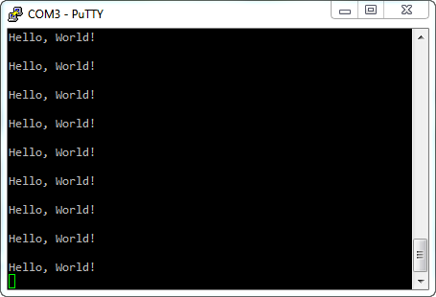

Image : "Hello, World"

Synthesis result of this simple design on an Altera DE1 board shows only 11% of the total LE resources used:

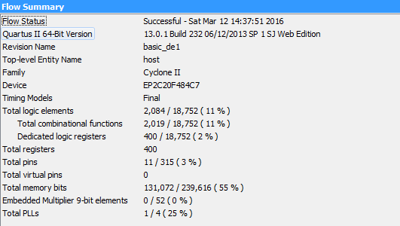

The CPU CLK is derived from the *pll_clk* and the effective Slow Model *fMax* for this compilation is 18.89 MHz.

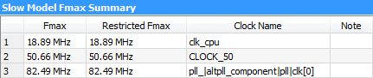

Xilinx ISE tools synthesize the design using about 19% of Nexys3 device slice resources:

|  |
| --- |
| Selected Device: 6slx16csg324-2  Slice Logic Utilization:  Number of Slice Registers: 396 out of 18224 2%  Number of Slice LUTs: 1819 out of 9112 19%  Number used as Logic: 1819 out of 9112 19%  Slice Logic Distribution:  Number of LUT Flip Flop pairs used: 2113  Number with an unused Flip Flop: 1717 out of 2113 81%  Number with an unused LUT: 294 out of 2113 13%  Number of fully used LUT-FF pairs: 102 out of 2113 4%  Number of unique control sets: 70  IO Utilization:  Number of IOs: 37  Number of bonded IOBs: 36 out of 232 15%  Specific Feature Utilization:  Number of Block RAM/FIFO: 8 out of 32 25%  Number using Block RAM only: 8  Number of BUFG/BUFGCTRLs: 3 out of 16 18% |

## Sinclair ZX Spectrum

This project fully implements a *Sinclair ZX Spectrum 48K* computer on an Altera DE1 board. See directory “**host\zxspectrum_de1**” containing a Quartus project file.

Directory “**host\zxspectrum\ula**” contains drivers for a PS/2 keyboard, video (using a VGA port), sound, RAM memory and clocks. Those were kinds of functions handled by Spectrum’s custom Ferranti ULA chip.

There are 2 system ROM images included in the “**host\zxspectrum\rom**” directory – the original ZX Spectrum ROM and an improved, so-called “Gosh Wonderful” ROM – merged into a single image which is to be flashed into the DE1’s flash memory starting at the address 0. Use a flash tool that came with your DE1 board software to flash this data.

The following table shows the function of buttons and switches. When a switch is activated, a red LED above it glows.

|  |  |
| --- | --- |
| Button and Switch | Description |
| KEY0 | Reset |
| KEY1 | Issues NMI |
| SW0 | Selects “Gosh Wonderful ROM” image versus the original ROM image |
| SW1 | Disables interrupts |
| SW2 | Turbo mode (3.5 MHz x 2 = 7.0 MHz) |

Function of **green LED**s is to show:

|  |  |
| --- | --- |
| GREEN LED | Description |
| LEDG0-LEDG4 | Kempston joystick UP, DOWN, LEFT, RIGHT, FIRE is pressed |
| LEDG5 | A key is pressed |
| LEDG6 | When blinking, a speaker or line-in is active |

If you decide to try this design on your DE1 board and then want to play actual games, connect an Android device earphone jack out to DE1’s LINE-IN and use one of several apps to “play” a game into the device. For example, Baltazar Studio’s **PlayZX** was written for that purpose only:

<http://play.google.com/store/apps/details?id=com.baltazarstudios.playzxtapes>

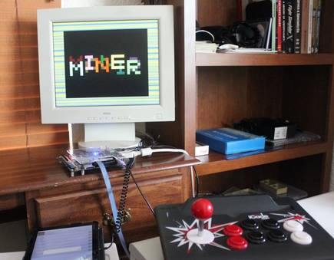

Image : Sinclair ZX Spectrum on Altera DE1

Image 3 shows a game “*Manic Miner*” being loaded through the audio line-in connector into the FPGA board visible in the middle and a Kempston compatible joystick in the foreground.

This is a synthesis result of a ZX Spectrum host design on an Altera DE1 board:

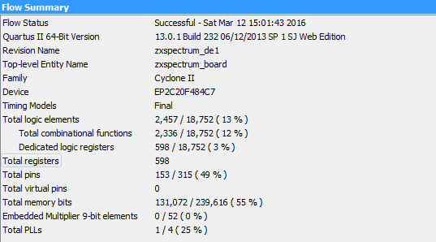

# Advanced Topics

## Modifying the A-Z80 CPU Core

If you want to make a change to any instruction’s timing or a sequence of micro-operations, modify “**cpu\control\Timings.xlsm**” file. This is a Microsoft Excel spreadsheet that contains timing tables for each group of instruction as decoded by opcode PLA and sequencer state. Vertical columns contain operations on specific CPU blocks. Instruction groups are listed by the **M** and **T**-clocks providing the exact timing for each set of operations.

Micro-operations are represented by short tokens (for example, “PC” or “mr”) which are defined in the file “**cpu\control\timing_macros.i**”. Every token is translated into one or more discrete control signals causing desired operation.

After changing the timing spreadsheet, export it into a TAB-delimited file. The spreadsheet contains a macro that will do it for you: click on the “Developer” menu and run Macros:

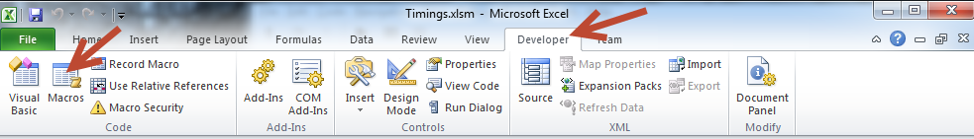

Running “CopyToCSV” macro will replace the existing CSV file with changed timings.

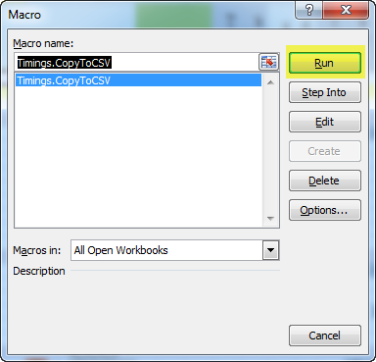

The next step is to create a Verilog file based on those timings by running a python script “**cpu\control\genmatrix.py**”. That script reads in the CSV file containing timing tables and generates “**exec_matrix.vh**” that implements actual Verilog code to control the timings.

Although Altera Quartus synthesis tool can use that file to compile a working design, Xilinx synthesis tool is not able to handle its complexity, so for Xilinx devices an additional step is needed which takes that file and converts it to a format their tools are able to handle. Run “**cpu\control\gencompile.py**” to generate “**exec_matrix_compiled.vh**” file that defines the same set of combinatorial operations but in a sum-of-product terms.

All Python scripts in this project can be run in-place without the need to specify any arguments. You can run them either through a command line or by simply double-clicking on them.

If you change any *schematic file*,where your change adds or removes global input or output signals, you need to run three Python scripts to recreate various lists of global includes:

“**cpu\control\gencoremodules.py**” – generates instantiation file for all modules:

* “core.vh” contains all instantiated CPU modules

“**cpu\control\genref.py**” – generates global include files using all exported module signals:

* “exec_module.vh” contains input/output definitions to be included in the module def.
* “exec_zero.vh” contains Verilog code to set all input wires to zero.

“**cpu\toplevel\genglobals.py**” – generates a list of global *wire* defines:

* “globals.vh” contains Verilog code that defines all global signal wires.

*Quartus* project files (*.qpf, *.qsf) in “**cpu\alu**”, “**cpu\bus**”, “**cpu\control**” and “**cpu\registers**” directories are non-functional and just conveniently hold sets of files together within a conceptually modular overall design. *Quartus* project in the “**cpu\toplevel**” directory only contains a top-level schematic diagram which is not functional. Hence, they are only containers to hold files.

When modifying a schematic file (and most of the A-Z80 blocks are designed at the schematic level), open a corresponding *Quartus* container project (for example, when modifying a schematic in the ALU block, open “**cpu\alu\test_alu.qpf**”). Change the schematics, compile it (to make sure it has no errors) and then export it to both the Verilog equivalent and a symbol file, as shown below:

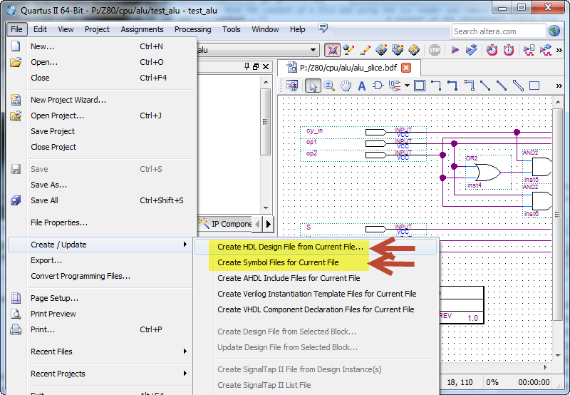

|  |
| --- |
| Verilog versions are used as final target files that compile with the rest of the A-Z80 core files while symbol files are (at the moment) optional but could be used in the future to create a fully working schematic top-level (TBD). |

## File Generators

This section describes scripts and processes that generate various files. **Generated files should never be edited manually!** Many Python scripts have additional options which are hard-coded within the scripts so the scripts can be run in very simple ways (for example, by simply double-clicking on them).

See each individual Python script for more information.

### Building the CPU

|  |  |
| --- | --- |
| Process: | cpu/control/Timings.xlsm |
| Generates file: | cpu/control/Timings.csv |
| Uses files: | - |

This is a *MS Excel* spreadsheet that defines a matrix of timings vs. operations for each group of instructions. The spreadsheet contains an embedded macro that exports that data in a suitable format; go to the Developer tab, and in the Code group, click on Macros. Run a macro “Timings.CopyToCSV”.

|  |  |
| --- | --- |
| Process: | cpu/control/genmatrix.py |
| Generates file: | cpu/control/exec_matrix.vh |
| Uses files: | Timings.csv, timing_macros.i |

This script reads the A-Z80 instruction timing data from a (generated) spreadsheet text file and creates a Verilog include file which defines the control block execution logic matrix. Token keywords in the timing spreadsheet are substituted using a list of keys stored in the timing macros file.

|  |  |
| --- | --- |
| Process: | cpu/control/gencompile.py |
| Generates file: | cpu/control/exec_matrix_compiles.vh, temp_wires.vh |
| Uses files: | cpu/control/exec_matrix.vh |

This script reads the exec matrix file and compiles it into an alternate format that can be used with Xilinx tools.

|  |  |
| --- | --- |
| Process: | cpu/control/genref.py |
| Generates file: | cpu/control/exec_module.vh, exec_zero.vh |
| Uses files: | top_level_files.txt + list of files in that file |

This script reads a list of files from the “top_level_files.txt” and processes each file to extract selected names of wires defined in their respective modules to be used to easily define and initialize them.

|  |  |
| --- | --- |
| Process: | cpu/toplevel/gencoremodules.py |
| Generates file: | cpu/toplevel/coremodules.vh |
| Uses files: | top_level_files.txt + list of files in that file |

This script reads and parses all top-level modules and generates a core block file containing instantiation of these modules in Verilog format. The generated file in included by core.vh.

|  |  |
| --- | --- |
| Process: | cpu/toplevel/genglobals.py |
| Generates file: | cpu/toplevel/globals.vh |
| Uses files: | top_level_files.txt + list of files in that file |

This script reads a list of files from the “top_level_files.txt” and processes each file to extract selected names of wires defined in their respective modules to be used as *global* wires.

|  |  |
| --- | --- |
| Process: | tools/z80_pla_checker.exe |
| Generates file: | Verilog PLA decode module |
| Uses files: | PLA and opcode defines from resource folder |

This executable program reads a PLA table in a simple format (reverse-engineered from a picture of a die) and generates a Verilog PLA decode module.

### Verification/Tests

|  |  |
| --- | --- |
| Process: | cpu/toplevel/genfuse.py |
| Generates file: | cpu/toplevel/test_fuse.vh |
| Uses files: | fuse/tests.in, tests.expected, regress.in, regress.expected |

This script creates a *Fuse* test in Verilog from several test description files.

|  |  |
| --- | --- |
| Process: | tools/zmac/make_fpga.bat, make_modelsim.bat |
| Generates file: | Compiled HEX files |
| Uses files: | Z80 assembler source files |

These DOS batch files compile and create HEX files from any Z80 assembler source files dropped onto it. They speed up running and testing of Z80 programs.