Hack and Backpack
Penetration Testing Report for EvilCorp
v.1.0

Report by Jason Downey for demonstrating write-up capabilities.
This was written about the retired box Sunday on HackTheBox.eu, a standalone
CTF style machine where the goal is to capture a user flag and root flag.
502 – 509 – 2408 | Jason@HackandBackpack.com

Table of Contents
1.0 Hack and Backpack – EvilCorp Penetration Test Report 3
1.1 Introduction 3
1.2 Objective 3
1.3 Requirements 3
2.0 High-Level Summary 3
2.1 Recommendations 4
3.0 Methodologies 4
3.1 Sample Report – Information Gathering 4
3.2 Service Enumeration 5
3.3 Penetration 5
3.4 Privilege Escalation 8
3.5 Sample Report – House Cleaning 9

1.0 Hack and Backpack – EvilCorp Penetration Test Report

1.1 Introduction
Hack and Backpack evaluated the security of EvilCorp during a two-week period beginning on 5/9. The goal of this assessment was to identify information security vulnerabilities in Evil Corps systems. All issues identified were manually verified and exploited when applicable to demonstrate the risk to EvilCorp’s employees, clients, and shareholders.

1.2 Objective
The objective of this assessment was to perform an internal penetration test against the Evil Corp’s network. Hack and Backpack followed a methodical approach in Reconnaissance, Threat Modeling, Exploitation, and Post Exploitation & Analysis, all steps of which are reported on this document.

1.3 Requirements
Hack and Backpack is required to perform a full Penetration Test on a machine called Sunday located on https://hackthebox.eu. The Penetration Test should consist of two parts, obtaining user level access to the box and then privilege escalating to a root level account.
- Overall High-Level Summary and Recommendations (non-technical)
- Methodology walkthrough and detailed outline of steps taken
- Each finding with included screenshots, walkthrough, sample code, and proof.txt if applicable.
- Any additional items that were not included

2.0 High-Level Summary
Hack and BackPack was tasked with performing an internal Penetration Test against EvilCorp’s machine named Sunday. The focus of this test was to perform attacks, similar to those of a hacker and attempt to infiltrate the machine “Sunday” located on https://hackthebox.eu. Hack and Backpack’s objective was to evaluate the system and exploit flaws while reporting the findings back to EvilCorp.
During this Penetration Test Hack and Backpack was able to gain user level access and escalate to a privileged user primarily due to poor security configurations. This testing allowed Hack and Backpack to have full administrative access to all systems on the machine Sunday.
Here is a brief description based on how access was obtained and privileges escalated.
- Identified the internet facing service Finger allowing for username enumeration.
- Used enumerated users combined with password brute forcing to log-in via SSH.
- Found a backup of the /etc/shadow file revealing other users/passes.
- Escalated to root access due to misconfigured permissions on a user.

2.1 Recommendations
Hack and Backpack recommends disabling the Finger service, removing all backups of usernames and passwords saved on the box, and reviewing access each user has – specifically for using the sudo and wget commands. This combined with a stricter password policy will help to protect against additional vulnerabilities that are discovered at a later date.

3.0 Methodologies
Hack and Backpack utilized a widely adopted methodology to performing penetration testing that is effective in testing how well Evil Corp’s machine “Sunday” is kept securely. Below is a breakout of how Hack and Backpack was able to identify and exploit a variety of systems and includes all individual vulnerabilities found.

3.1 Sample Report – Information Gathering
The information gathering portion of a penetration test focuses on identifying the scope of the penetration test. During this penetration test, Hack and Backpack was tasked with exploiting the lab and exam network. The specific IP addresses were:
Host Machine Sunday
10.10.10.76

3.2 Service Enumeration
The service enumeration portion of a penetration test focuses on gathering information about what services are alive on a system or systems. This is valuable for an attacker as it provides detailed information on potential attack vectors into a system. Understanding what applications are running on the system gives an attacker needed information before performing the actual penetration test. In some cases, some ports may not be listed.
Server IP Address | Ports Open
10.10.10.76 | TCP: 79 - Finger, 111 - RPCBind, 6472, 7783, 22022 - SSH, 48975, 49646, 52162 - smserverd

3.3 Penetration
The penetration testing portions of the assessment focus heavily on gaining access to the system and escalating privileges.
Taking the results of our NMAP scan we began a deeper enumeration of each service. The Finger service is used on Solaris based systems to display information about users both local and remote. Sending a finger command without a username specified returns all the users that are currently logged into the machine. This gives us our first user to work with – “sunny”.
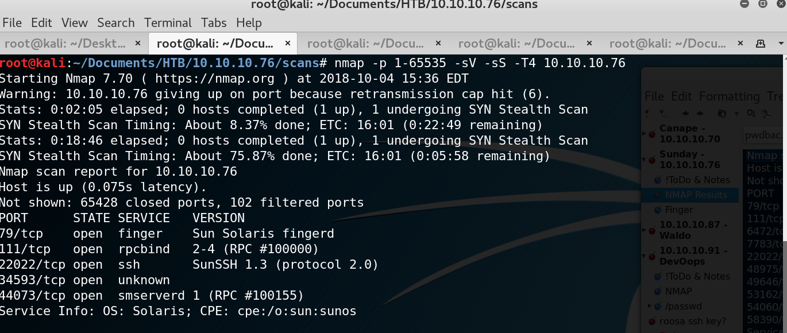
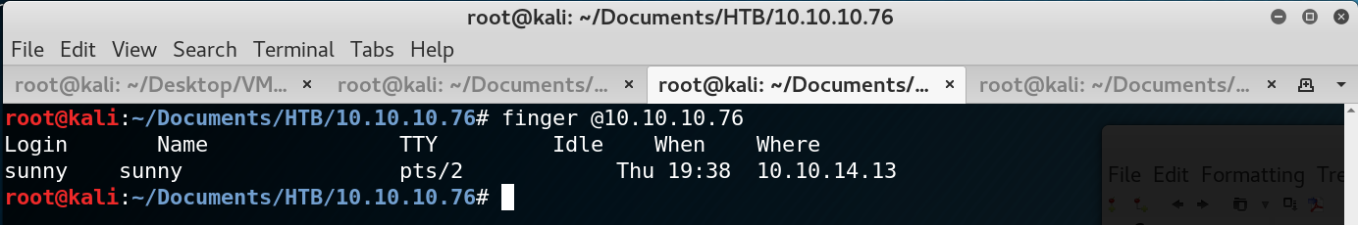
After discovering the username “sunny” we moved to port SSH running on 22022. We attempted to bruteforce into the SSH connection using the username the username “sunny” and the rockyou wordlist which is widely used and comes pre-loaded on the Kali distribution. We used a piece of software called Hydra to perform the attack.
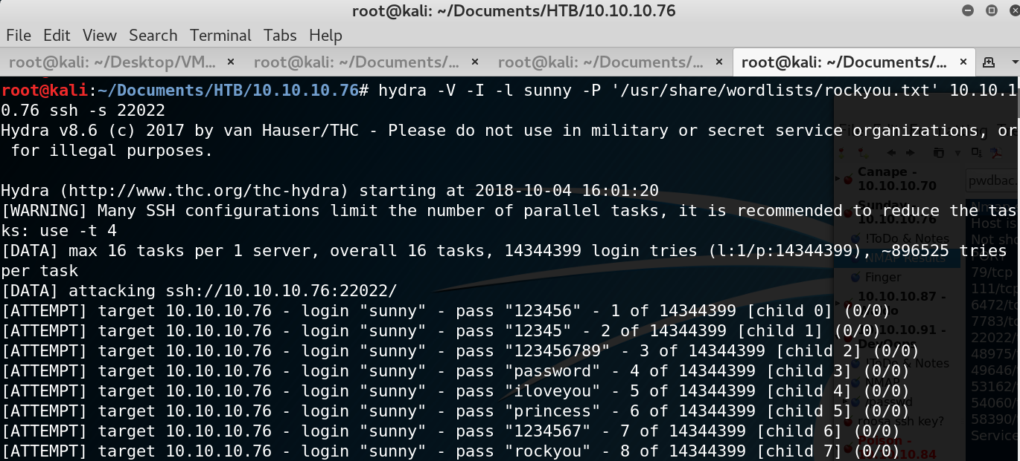
The Hydra attempt was successful and we were able to log in via SSH using the account “sunny” and the discovered password “sunday”.

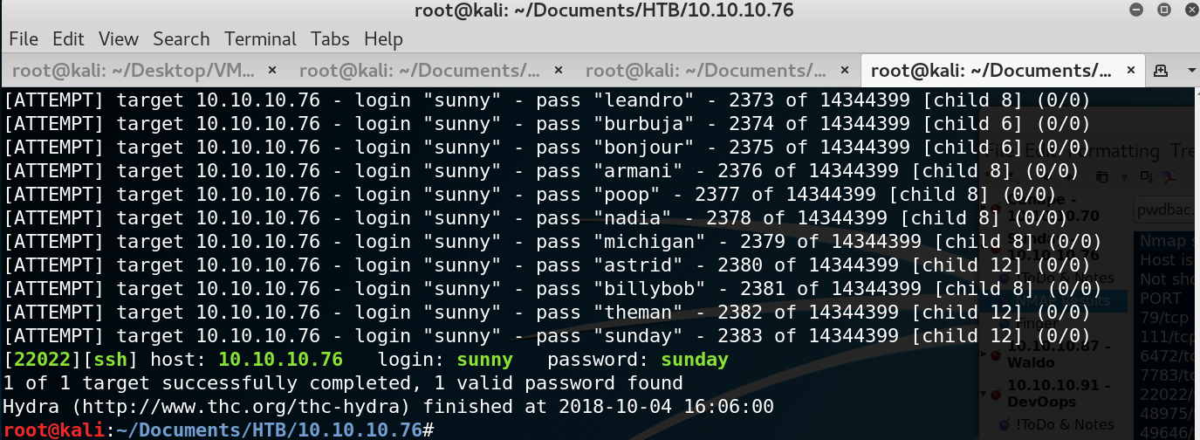
After logging in via SSH with the user sunny we discovered the /backup directory that had a backup of the shadow file containing other users and their password hashes. Using john we were able to crack the hashes in the shadow file giving us the password “cooldude!” for user “sammy”.
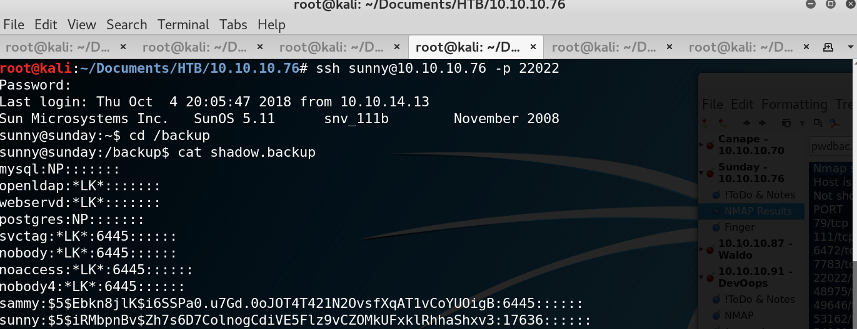
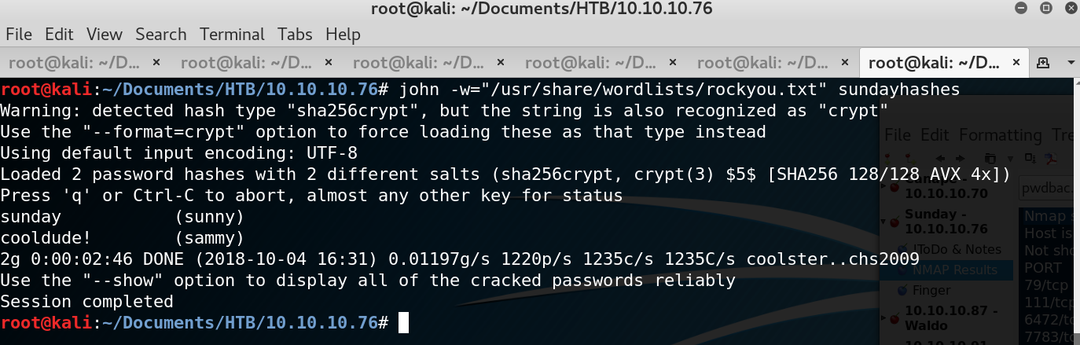

3.4 Privilege Escalation
Escalating access to a system is important to us as attackers, it ensures that we can move freely across all services running on the system and setup a method of persistence. Many exploits may only be able to ran once or might be later detected by a systems administrator. Having a admin level of access will allow us to revert any changes made post exploitation or allow us to move even more freely across the EvilCorp network.
After gaining access to the users “sunny” and “sammy” we checked what privileges each user had. “sunny” can run the /root/troll file as a root user and “sammy” can run the software wget. Using wget to pull a file from our home system we are able to overwrite the /root/troll file and then execute it.
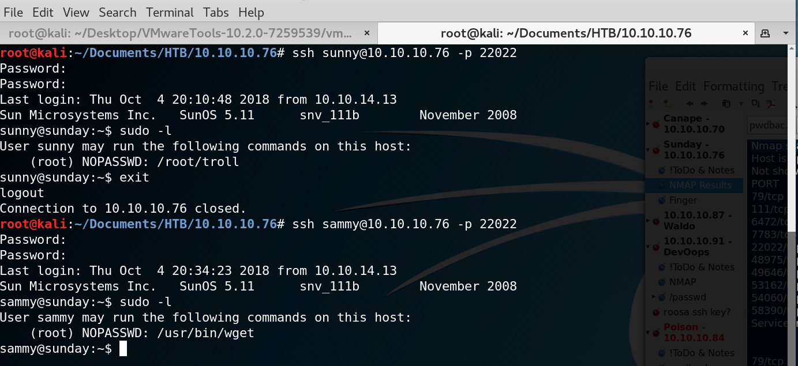
Setting up the Python HTTP Server on our home machine.
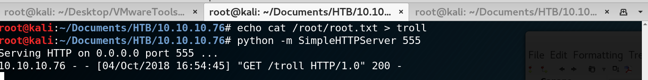
Downloading the modified file troll and overwriting /root/troll using wget.
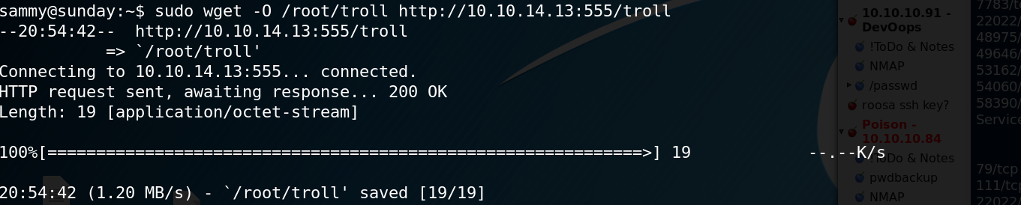
Executing the modified troll file with user “sunny” to reveal information saved in the /root directory.
