July’s Salon — Smart Appointment and Service Booking Platform
Software Development Life Cycle (SDLC) Documentation
GitHub: jasonharwell61 — UT Arlington AI-Centric Software Engineering Bootcamp Capstone
October 2026
How to read this document. Nothing in this document claims testing that was not run. Where a result was not recorded, it says so. Screenshots are photographs of the author’s screen taken with a phone; sensitive values were kept out of frame.

1. Project overview
July’s Salon is a full-stack web application for an eyelash salon. Customers browse services, ask an AI assistant which service fits their request, book an appointment, and manage their bookings. An admin can see all bookings and manage services.
Item | Value
Live frontend | https://julys-salon-booking.vercel.app
Live API | https://julys-salon-api.onrender.com
Health check | https://julys-salon-api.onrender.com/api/health
Repository | https://github.com/jasonharwell61/julys-salon-booking
Stack | React 19 + Vite 8, Node.js + Express 5, MongoDB Atlas + Mongoose 9, Google Gemini
Hosting | Vercel (client), Render free web service (API), MongoDB Atlas free cluster (database)

2. Problem statement
Small appointment businesses often take bookings through texts and direct messages. This causes double bookings, missed messages, and no reliable record of who is coming and when. Customers also find it hard to choose between similar services (for example Classic, Volume and Hybrid lash sets).
The platform addresses both problems: the server enforces booking rules so the same time cannot be booked twice, and a grounded AI assistant helps customers choose from the salon’s real service list.

3. Scope
In scope
- Account registration and login with role-based access (customer, admin)
- Service catalog with categories, durations, prices and tags
- Booking with business-hours, notice-time, booking-window and no-overlap rules
- Customer booking management: view, reschedule, edit note, cancel
- Admin bookings view with status filter; admin marks bookings completed; admin manages services
- AI Lash Service Recommender (AI Feature A) with safe fallback
- Deployment to public hosting, with documentation and tests
Out of scope (not built)
- Online payments or deposits
- Email or SMS confirmations and reminders
- Multiple staff members or locations
- Admin-editable business hours
- Service Comparison Helper (planned optional AI Feature B; skipped for time)

4. Target users
User | Needs
Customer | Find the right service, book a time quickly, change or cancel without calling
Salon admin / owner | See all appointments, avoid double bookings, keep the service list current

5. User stories and acceptance criteria
ID | User story | Acceptance criteria
US-01 | As a visitor, I can create an account so I can book. | Valid name, email and password creates an account and logs me in. Duplicate email is rejected with a clear message. Weak password shows a field error. The response never includes the password hash. A role sent in the body is ignored (new users are customers).
US-02 | As a user, I can log in and stay logged in. | Correct credentials log me in. Wrong password and unknown email give the same message. A page refresh keeps me logged in. A garbage token is treated as logged out without crashing.
US-03 | As a visitor, I can browse services. | Active services show name, category, price and duration. Category filter works. Unknown service ID shows “not found”. Inactive services are hidden.
US-04 | As a customer, I can book a service at an available time. | Only valid slots (Mon–Sat, 9:00–18:00 Central Time, 15-minute grid, at least 2 hours ahead, within 90 days) are accepted. An overlapping booking returns 409 and a friendly message. Price and duration are copied from the service at booking time.
US-05 | As a customer, I can view, reschedule, edit the note of, and cancel my bookings. | I see only my own bookings. Another user’s booking returns not found. Rescheduling re-applies all booking rules. Cancel sets the status to cancelled and frees the slot.
US-06 | As an admin, I can see all bookings and mark them completed. | Admin view lists every booking with customer name and email and filters by status. Customers cannot access it. Only admins can mark completed.
US-07 | As an admin, I can create, edit and deactivate services. | Admin-only endpoints. Deactivating hides the service from customers but keeps old bookings intact (snapshot).
US-08 | As a customer, I can describe what I want and get service suggestions. | Logged-in users only. Input 3–300 characters. Up to 3 suggestions, each a real service with a short reason. Price and duration come from the database. If AI fails, I still get fallback suggestions, labeled as such. The AI cannot create a booking.
US-09 | As a user, I get clear feedback on every screen. | Loading, empty and error states exist. Errors show friendly text, not stack traces.

6. Requirements

6.1 Functional requirements
ID | Requirement
FR-1 | Users can register, log in and retrieve their profile.
FR-2 | The system supports two roles, customer and admin, with different permissions.
FR-3 | The system lists and filters services publicly.
FR-4 | Admins can create, update and deactivate services.
FR-5 | Customers can create bookings subject to the business rules in Section 6.3.
FR-6 | Customers can read, reschedule, edit notes on, and cancel only their own bookings.
FR-7 | Admins can list all bookings and mark them completed.
FR-8 | The system suggests up to 3 services from a free-text request using an AI provider, grounded in the real service list.
FR-9 | The system falls back to keyword matching if the AI is unavailable, times out or returns invalid output.

6.2 Non-functional requirements
ID | Category | Requirement | How it is met
NFR-1 | Security | Passwords are never stored in plain text | bcryptjs hashing; passwordHash hidden from API output
NFR-2 | Security | Protected routes require authentication; admin routes require the admin role | JWT middleware and role middleware
NFR-3 | Security | Brute-force and abuse limits | Auth routes limited to 20 requests per 15 minutes per IP; AI route limited per user
NFR-4 | Security | Secrets are not in the repository | .env ignored by git; .env.example has placeholders; production secrets set in host dashboards
NFR-5 | Security | Input is validated on the server | Validators return field-level errors; 10 kb JSON limit
NFR-6 | Reliability | No double booking | Overlap check plus an in-process slot lock (single-instance protection)
NFR-7 | Reliability | AI failure must not break the feature | Timeout (15 s) and keyword fallback
NFR-8 | Privacy | Customer AI text is not stored or logged; personal data is not sent to the AI | Logger records safe fields only; emails and long digit strings are rejected
NFR-9 | Usability | Responsive on phone and desktop; accessible states | Bootstrap layout, custom CSS, aria-live on AI results
NFR-10 | Maintainability | Clear structure and tests | Layered server (routes, controllers, services, models, validators); automated test scripts
NFR-11 | Availability | Public deployment | Vercel + Render + Atlas. Free-tier API sleeps after 15 minutes idle (about 1 minute to wake).

6.3 Business rules
Timezone America/Chicago. Open Monday–Saturday 9:00–18:00. 15-minute time grid. Minimum notice 2 hours. Booking window 90 days. A booking must fit entirely inside opening hours. Overlapping bookings are rejected (409). Prices are stored in cents. Times are stored as ISO UTC. Statuses: confirmed, completed, cancelled.

7. Wireframes
Low-fidelity layouts of the implemented screens. Screenshots from a local test run (sample data) are in docs/screenshots/.
Services page with AI assistant
+--------------------------------------------------+
| July's Salon Home Services MyBookings Account |
+--------------------------------------------------+
| Services |
| [ Describe what you want... ] [Ask] |
| -> up to 3 suggestions with reasons |
| [All] [Full Sets] [Fills] ... [search....] |
| +------------+ +------------+ +------------+ |
| | Service | | Service | | Service | |
| | $ / time | | $ / time | | $ / time | |
| | [Details] | | [Details] | | [Details] | |
| +------------+ +------------+ +------------+ |
+--------------------------------------------------+
Service detail and booking
+--------------------------------------------------+
| <- All services |
| CATEGORY |
| Service name |
| description |
| PRICE TIME [tag] [tag] |
| +----------------------------+ |
| | Book this service | |
| | Date [ mm/dd/yyyy ] | |
| | Time [ available slots v ]| |
| | Note [ optional ] 0/300 | |
| | [ BOOK APPOINTMENT ] | |
| +----------------------------+ |
+--------------------------------------------------+
My bookings / Admin bookings
+--------------------------------------------------+
| My bookings (Admin: All bookings) |
| (Admin: [All][Confirmed][Completed][Cancelled]) |
| +----------------+ +----------------+ |
| | Service STATUS| | Service STATUS| |
| | Date/time CT | | Date/time CT | |
| | duration/price | | duration/price | |
| | note | | (admin: customer name, |
| | [Change][Cancel]| | email, Mark completed) |
| +----------------+ +----------------+ |
+--------------------------------------------------+

8. Three-tier architecture
Tier | Technology | Responsibility
Presentation | React + Vite single-page app on Vercel | Screens, forms, routing, protected routes, calls the API with a Bearer token. Contains no secrets.
Application / logic | Node.js + Express API on Render | Authentication, authorization, validation, booking rules, AI orchestration, error handling, rate limiting
Data | MongoDB Atlas via Mongoose | Persistent users, services and bookings
Browser (React SPA, Vercel)
| HTTPS, Authorization: Bearer <JWT>
v
Express API (Render) ----> Gemini API (server-side only, key in env)
| Mongoose (fallback: keyword matcher)
v
MongoDB Atlas (julys_salon_prod)
Separation of concerns on the server: routes map URLs to controllers; controllers call services (business logic, such as bookingService and the AI service); services use models (Mongoose schemas); validators check input; middleware handles authentication, rate limiting and errors. The browser only talks to the API; only the API talks to the database and the AI provider.

9. Database schema and relationships
MongoDB with three collections.
users
Field | Notes
name | required
email | required, unique (unique index), lowercase
passwordHash | bcrypt hash; never returned by the API
role | customer (default) or admin
timestamps | created and updated
services
Field | Notes
name, category, description | category is an enumerated value
durationMinutes | validated number
priceCents | integer, avoids floating-point money errors
tags | validated array of short strings
isActive | false hides the service (soft delete)
index | { isActive: 1, category: 1 } for the public menu query
bookings
Field | Notes
user | reference to users
service | reference to services
serviceSnapshot | copy of name, duration and price at booking time
startTime, endTime | UTC dates; end must be after start
status | confirmed, completed, cancelled
customerNote | optional, up to 300 characters
cancelledAt | set on cancel
indexes | { user: 1, startTime: 1 } and { startTime: 1 } for “my bookings” and overlap checks
Relationships: one user has many bookings; one service has many bookings; each booking belongs to exactly one user and one service (one-to-many, both directions, using ObjectId references). The snapshot keeps old bookings accurate if a service’s price or name changes later or the service is deactivated.

10. REST API design
JSON over HTTPS. Errors use one shape: { "error": "message", "details": [ { "field": "...", "message": "..." } ] }.
Method | Endpoint | Access | Purpose | Typical status codes
GET | /api/health | Public | Server and database status | 200
POST | /api/auth/register | Public | Create account (role forced to customer) | 201, 400, 409, 429
POST | /api/auth/login | Public | Log in, return JWT | 200, 400, 401, 429
GET | /api/auth/me | User | Current user | 200, 401
GET | /api/services | Public | List active services (?category=) | 200, 400
GET | /api/services/:id | Public | One service | 200, 404
POST | /api/services | Admin | Create service | 201, 400, 401, 403
PATCH | /api/services/:id | Admin | Update service | 200, 400, 403, 404
DELETE | /api/services/:id | Admin | Deactivate service | 200, 403, 404
POST | /api/bookings | User | Create booking | 201, 400, 401, 404, 409
GET | /api/bookings/mine | User | My bookings | 200, 401
GET | /api/bookings/:id | Owner or admin | One booking | 200, 404
PATCH | /api/bookings/:id | Owner (customer: time/note); admin (mark completed) | Reschedule, edit note, complete | 200, 400, 403, 404, 409
DELETE | /api/bookings/:id | Owner (admin may also cancel) | Cancel booking (customers cannot cancel past appointments) | 200, 404, 409
GET | /api/admin/services | Admin | All services including inactive | 200, 403
GET | /api/admin/bookings | Admin | All bookings (status filter) | 200, 403
POST | /api/ai/recommend-service | User | AI recommendation | 200, 400, 401, 429
Design choices: nouns for resources, HTTP verbs for actions, status codes that match outcomes (409 for conflicts, 429 for rate limits), and validation on every input.

11. Authentication and authorization design
Authentication. Users register with name, email and password. Passwords are hashed with bcryptjs. Login returns a signed JWT (HS256) containing only the user ID. The secret must be at least 32 characters and is stored only in environment variables. Tokens expire (1 day). The client sends the token in the Authorization: Bearer header. Login failures return the same message for a wrong password and an unknown email, to avoid revealing which emails exist.
Authorization. Middleware verifies the token, loads the user from the database, and attaches it to the request. A role middleware restricts admin routes. Booking endpoints check ownership: a customer asking for someone else’s booking gets “not found” (does not reveal that it exists). Admin privileges cannot be self-assigned at registration; an admin is created by changing the role in the database.
Other protections. helmet security headers, CORS restricted to the exact frontend origin, rate limiting on auth and AI routes, request size limit, centralized error handler that hides internals.
Known tradeoffs. The token is kept in localStorage, which is simple but exposed to XSS. Logout removes the token from the browser only; a copied token stays valid until it expires. These are recorded in docs/security-review.md.

12. AI feature: purpose, flow, limitations, safety, evaluation
Purpose. Help a customer who does not know which service to choose. The AI suggests; the customer decides and books manually.
Flow.
- Logged-in customer types a request (3–300 characters).
- Server validates the input (control characters stripped; emails and long digit runs rejected).
- Server loads active services from the database and sends only id, name, category, description, duration, price and tags.
- The customer’s text is wrapped in <customer_message> tags with angle brackets neutralized (prompt-injection resistance).
- Gemini returns structured JSON.
- Server validates the JSON, keeps only service IDs that exist, removes duplicates, caps at 3, trims text, and replaces any reason or summary that makes unsupported claims (prices, guarantees, safety, medical, discounts, availability, “booked/confirmed”).
- Server fills in real names, prices and durations from the database and returns the result.
- On provider error, timeout (15 s) or bad output, a keyword matcher answers instead and the response is labeled fallback.
Limitations. It is not a consultation and cannot assess allergies, eye health or suitability. Quality depends on the model and the service descriptions. The free Gemini tier may let the provider use submitted content to improve its products, which is why personal data is blocked at input.
Safety controls. Grounding in database data; ID whitelist; claim filter; input limits; per-user rate limit (default 20 per 15 minutes); API key on the server only; logs contain no customer text; the AI cannot create, change or cancel bookings.
Evaluation. A fixed set of 19 test cases (normal requests, vague requests, off-topic requests, prompt-injection attempts, requests with personal data, unsupported claims) is run by npm run eval:ai, which writes docs/ai-evaluation-results.md. The first run flagged one case for human review (a reason containing the word “safely”). After tightening the claim filter, the second run recorded 19 pass, 0 review, 0 fail on the automated checks. The file also has columns for human usefulness ratings (1–5) and reviewer notes; see that file for what has been completed. The automated checks do not replace human judgement of usefulness.

13. Testing evidence
All automated tests run from server/ with npm test and use fakes, so they need no database or API key.
Test area | Script | Checks | Status
Booking rules (hours, notice, window, grid) | test:booking-rules | rule-based | Passing in the last local run
Ownership / authorization | test:ownership | rule-based | Passing in the last local run
AI service (validation, injection, bad output, fallback, whitelist) | test:ai-service | 48 | 48 passed, 0 failed
AI route (auth, validation, rate limit shape) | test:ai-route | 16 | Passing in the last local run
Booking race condition (slot lock) | test:booking-race | 8 | Passing in the last local run
AI evaluation set | eval:ai | 19 cases | 19 pass, 0 review, 0 fail (automated checks)
Frontend | npm run lint, npm run build | — | Lint clean, build passes
Dependencies | npm audit | — | 0 vulnerabilities at last check
Manual and live testing. A full manual test plan with 74 cases mapped to requirements is in docs/test-plan.md. Its Status and Actual columns were generated as “Not run”. The author performed a live smoke test of the production site covering register, login, services, AI recommendation, booking, change and cancel, logout, page refreshes and data persistence, and reported that it worked. Postman checks of the AI endpoint returned the expected 200 (valid request), 400 (invalid body) and 401 (no token).
Results for the manual tests that were run are recorded in the Actual and Status columns of docs/test-plan.md. Tests not recorded there were not run.
Figure 1. Terminal output of npm test for the booking race test: concurrent requests for the same time produce exactly one booking, the other gets 409.
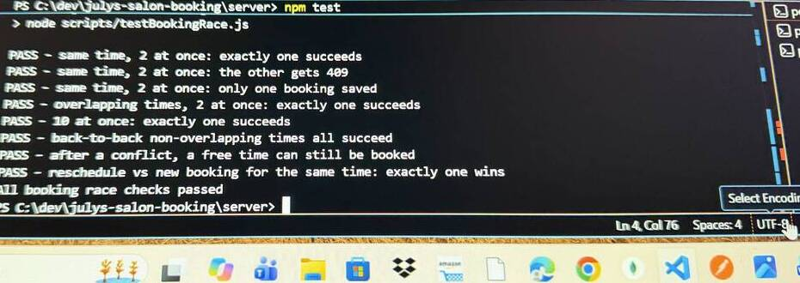
Booking race test output
Figure 2. Postman: POST /api/ai/recommend-service with a valid body returns 200 OK (local server).
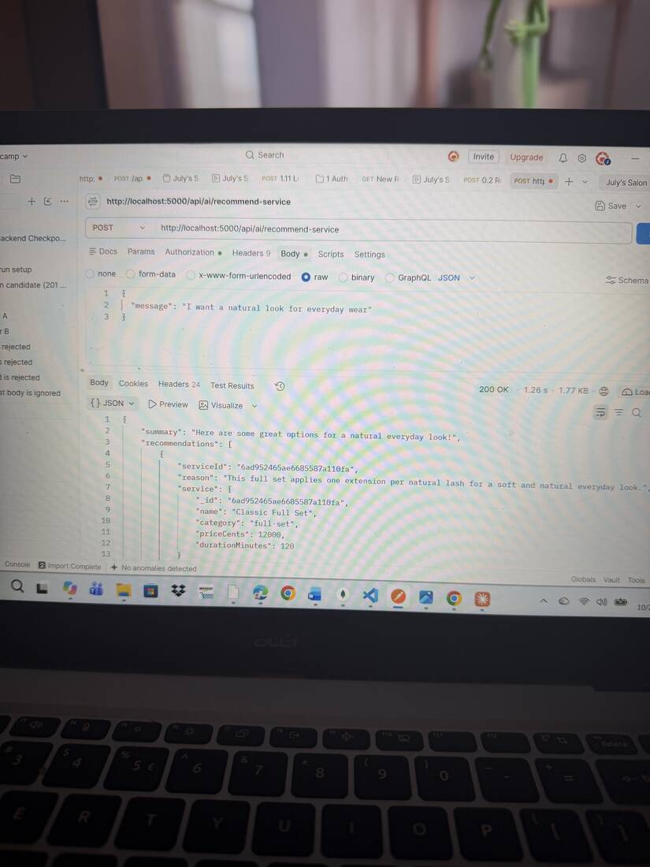
Postman 200 OK
Figure 3. Postman: the same endpoint without a token returns 401 Authentication required.
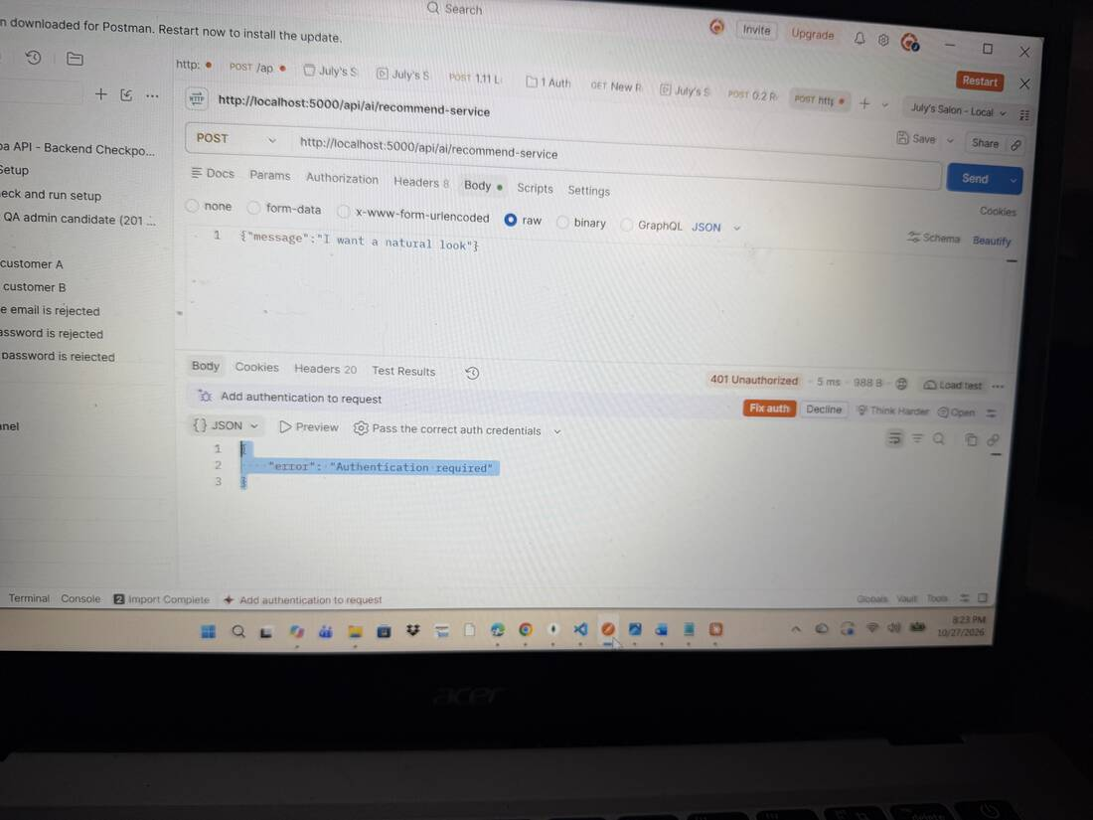
Postman 401
Figure 4. Postman against the live API: a message that is too short returns 400 Validation failed.
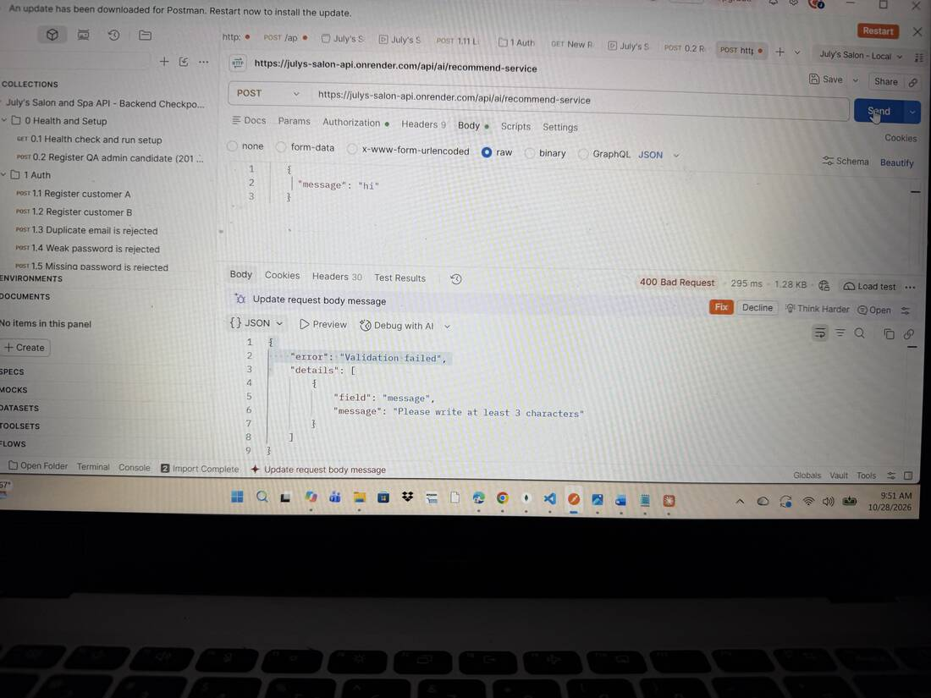
Postman 400 on the live API
Figure 5. Live site: the AI assistant on the Services page. In this capture the assistant showed its fallback message (“Our smart assistant is busy, so these suggestions are simple keyword matches”), which demonstrates the fallback path working.
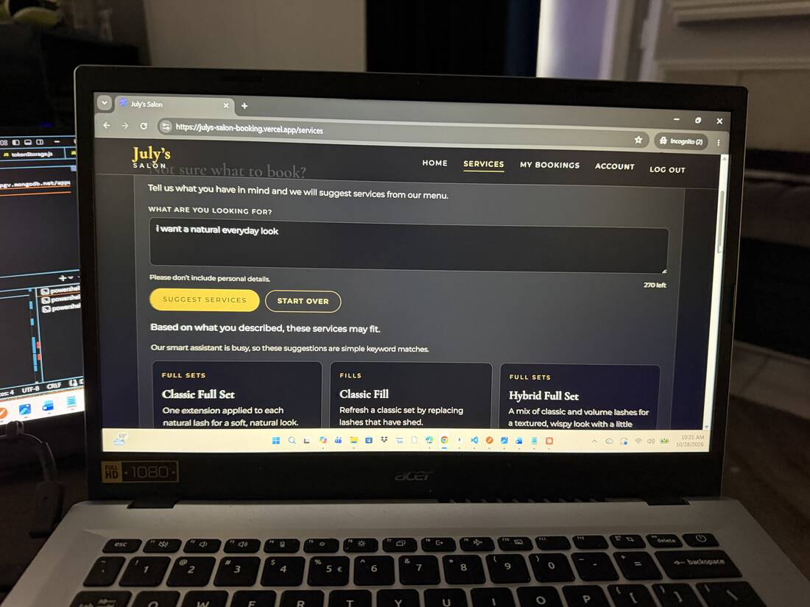
AI assistant on the live site
Figure 6. Live site: a confirmed booking in My Bookings.
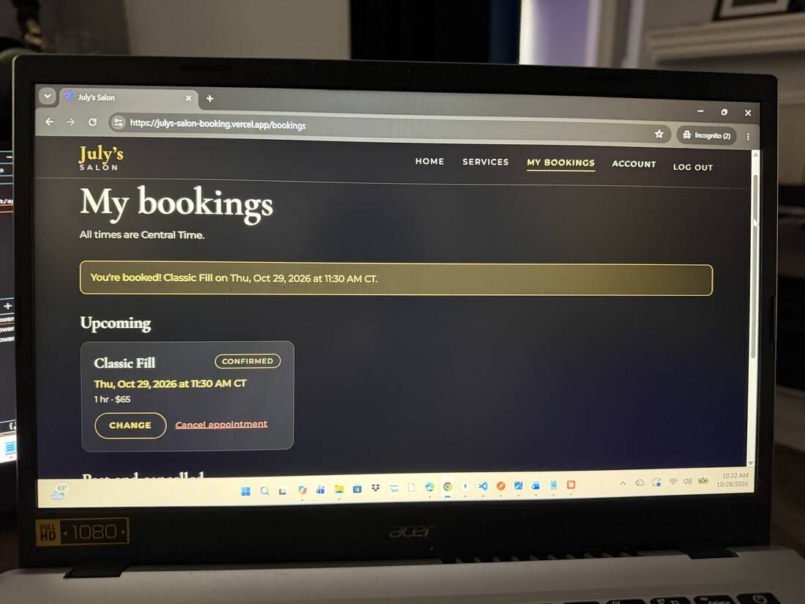
Live booking
Figure 7. Live site: the admin all-bookings view with status filters and “Mark completed” buttons.
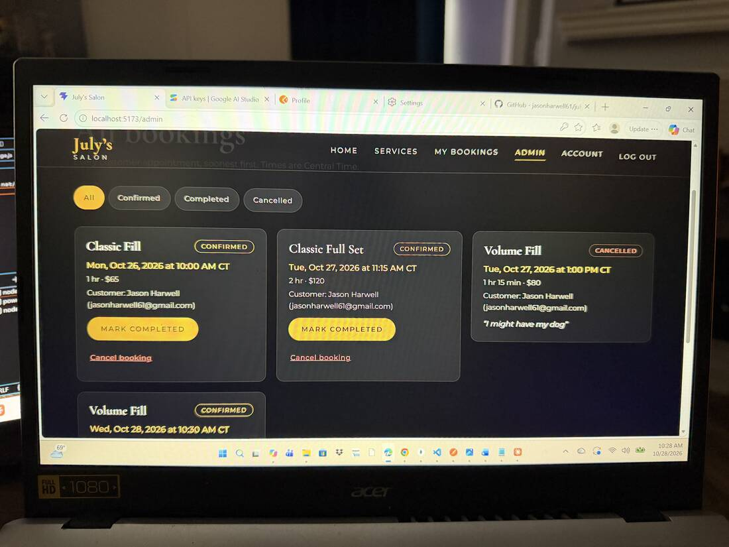
Admin bookings on the live site
A failed test with a documented fix is acceptable evidence; do not mark a test as passed unless you ran it.

14. Deployment architecture and links
Component | Host | Configuration
Database | MongoDB Atlas free cluster | Database julys_salon_prod; dedicated user with readWrite on that database only; network access 0.0.0.0/0 because Render’s free tier has no fixed outbound IP (protected by a strong password and least-privilege user)
API | Render free web service | Root directory server; build npm install; start npm start; health check /api/health; Node 24; environment variables set in the dashboard
Frontend | Vercel Hobby | Root directory client; Vite preset; output dist; vercel.json rewrite so page refreshes work; VITE_API_BASE_URL points to the API
Links: frontend https://julys-salon-booking.vercel.app, API https://julys-salon-api.onrender.com, health https://julys-salon-api.onrender.com/api/health.
Environment variable names: server — PORT, NODE_ENV, MONGODB_URI, JWT_SECRET, JWT_EXPIRES_IN, CLIENT_ORIGIN, AI_PROVIDER, AI_MODEL, AI_API_KEY, AI_TIMEOUT_MS, AI_RATE_LIMIT_MAX, TRUST_PROXY; client — VITE_API_BASE_URL. Values are never committed.
Free-tier note: the API sleeps after 15 minutes idle; the first request can take about a minute.
Figure 8. Render deploy log: the API started and connected to the production database (julys_salon_prod).
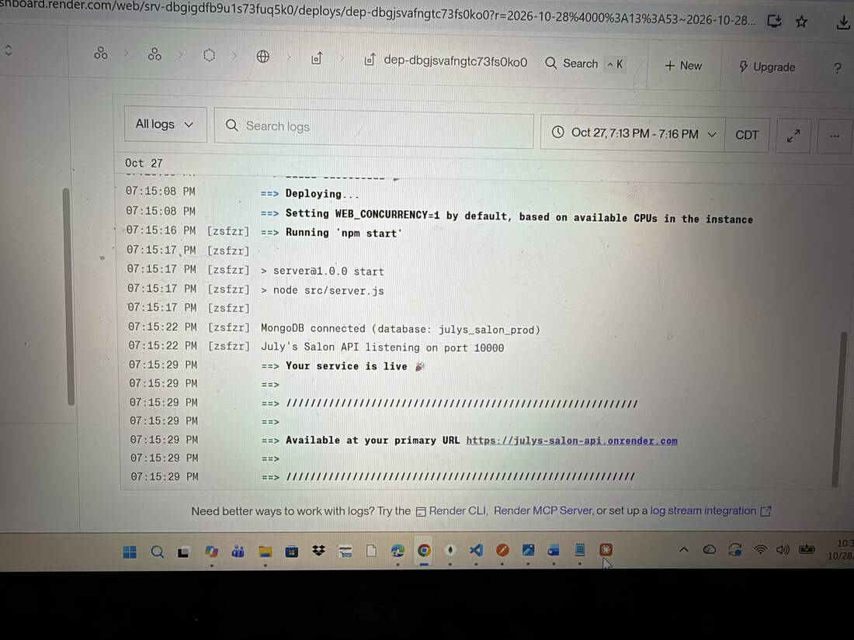
Render logs
Figure 9. Vercel deployments for the frontend project (latest commit “Add SDLC documentation”).
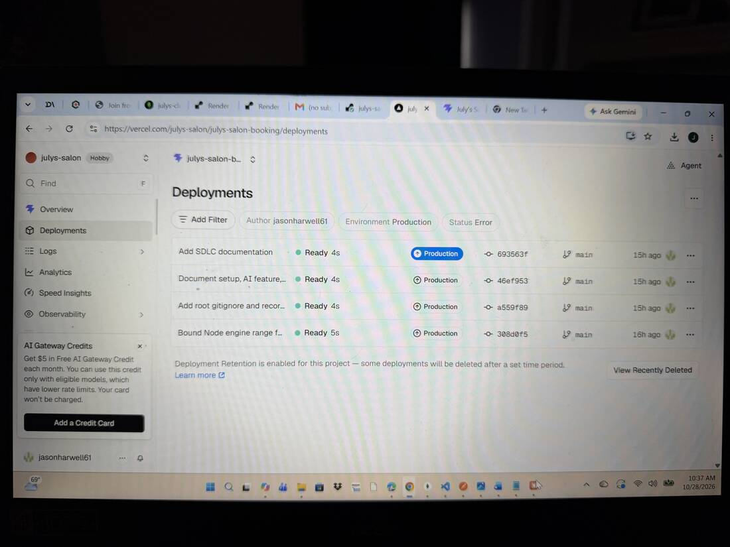
Vercel deployments
Figure 10. MongoDB Atlas cluster overview.
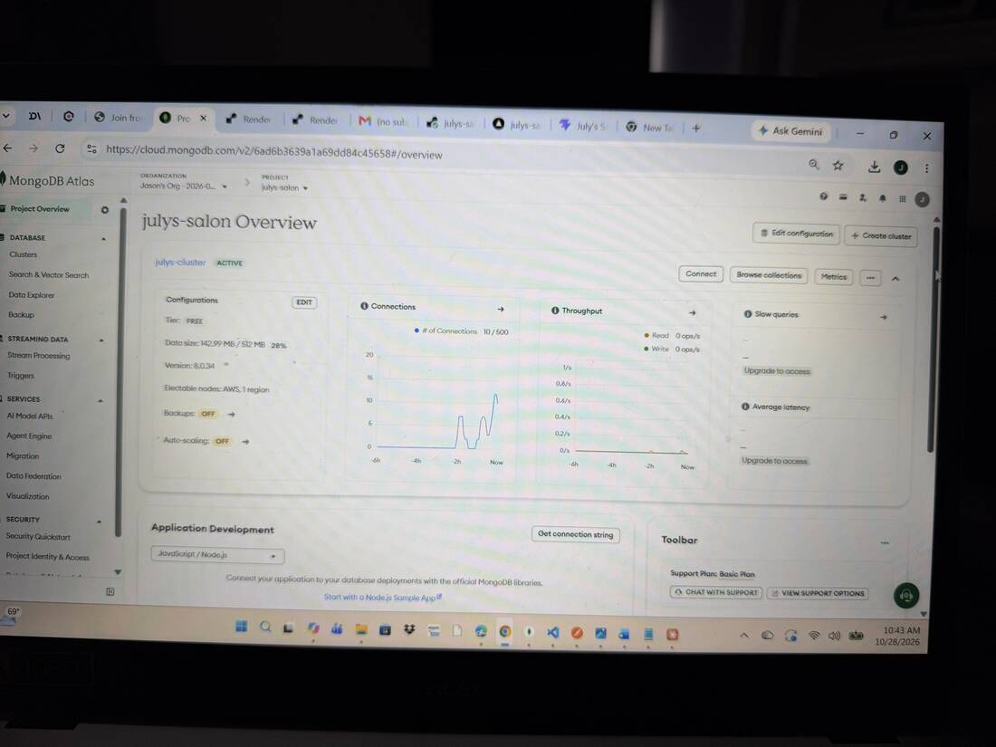
Atlas overview
Figure 11. MongoDB Atlas Data Explorer showing the julys_salon_prod database.
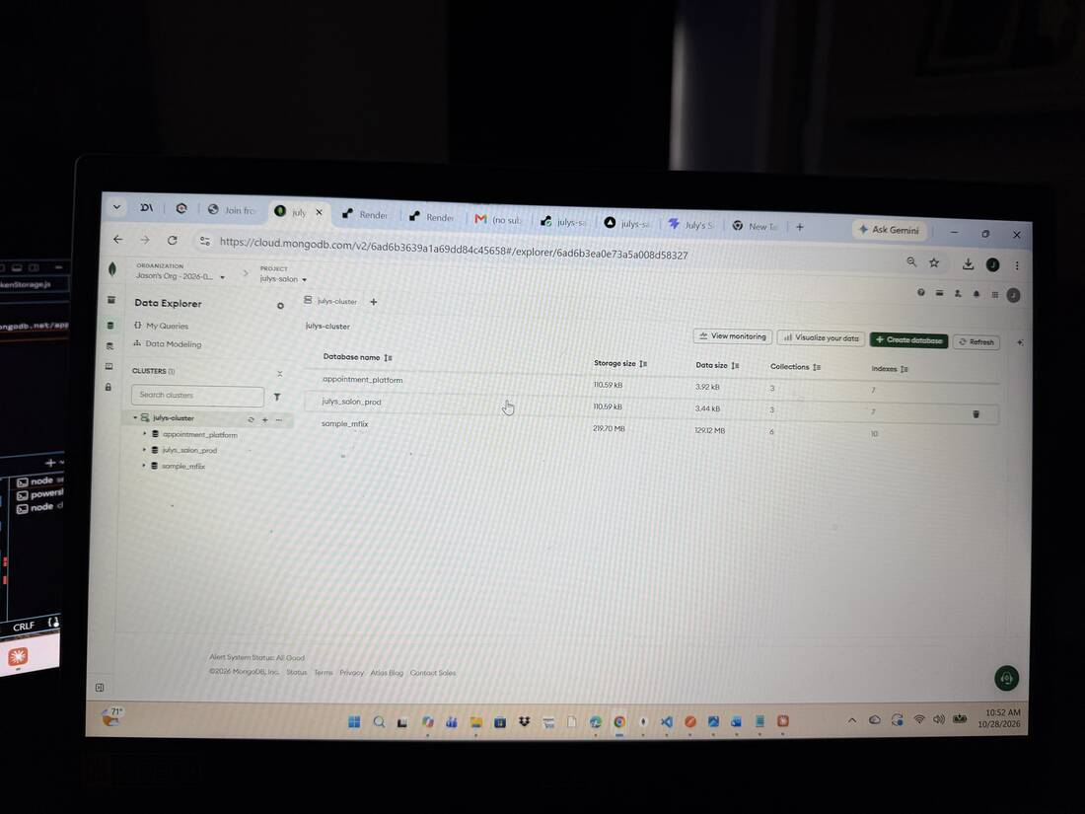
Atlas data explorer

15. Git development evidence
The repository has 30 commits between October 19 and October 27, 2026, each representing one working step. Examples (hash, date, message):
Date | Commit | Message
Oct 19 | a537013 | Set up Express server skeleton with health route and error handling
Oct 21 | f20ff77 | Connect Express to MongoDB Atlas with Mongoose
Oct 21 | 687eb0e | Add Booking model with service snapshot and time indexes
Oct 22 | 6a5e215 | Implement registration, login and current-user API with JWT
Oct 22 | b50316b | Add booking creation with business rules and conflict detection
Oct 25 | bfa5dbc | Connect service screens to the API with black and gold theme
Oct 25 | 6c8a47f | Add AI recommendation service with validation and keyword fallback
Oct 25 | b6105ca | Add AI evaluation results and tighten safety-claim filter
Oct 25 | e328c47 | Prevent double booking with a slot lock; add race test; cleanup
Oct 27 | 0f2aca3 | Add deployment plan, readiness audit and SPA rewrite
Oct 27 | 46ef953 | Document setup, AI feature, and architecture
Commit 9038f10 (Oct 25, “Replace JWT secret with placeholder in env example”) and the later security review document an honest correction: an early .env.example commit (e9ec178) contained a real-looking JWT secret. The secret was rotated everywhere it was used; the git history was not rewritten, so the old value remains visible in history but is no longer valid.
The full commit history is visible at https://github.com/jasonharwell61/julys-salon-booking/commits/main and in the Vercel deployment list in Figure 9, which shows the most recent commits.

16. How AI assisted development
Claude (Anthropic) acted as a mentor and reviewer through a step-by-step plan: one step at a time, each with files, commands, expected results, negative tests and a security check. The author created and ran the files, ran the tests, committed to Git, configured Atlas, Render and Vercel, and asked questions when something was unclear. AI also helped with debugging from pasted error messages and with drafting documentation. The shipped product uses Google Gemini at runtime for the recommender.
What AI did not do: it did not receive secrets (the author was told not to paste connection strings or keys into chat), it did not deploy on its own, and the author remained responsible for understanding and approving each change.

17. Examples of AI output reviewed, corrected and tested
# | What happened | How it was caught | Fix and proof
1 | The evaluation run flagged an AI reason containing “safely”, which implies a safety claim the salon cannot support. | Automated claim check marked it for human review; the author reviewed the case. | Claim filter extended to cover safe, safely, safest; re-run gave 19 pass, 0 review. Covered by the 48-check AI service test.
2 | An assistant statement that “no secrets are in tracked files” was wrong. | A later review of git history found a real-looking JWT secret in an old .env.example commit. | Statement corrected in the security review; secret rotated in Render and locally; documented as finding #10.
3 | Booking creation checked for overlaps and then saved, which allowed two simultaneous requests to both pass the check. | Security/reliability review of the code path. | Added a slot lock around check and save, plus a race test (8 checks) using a deliberately slow fake database. Limitation (single process) documented.
4 | The author’s npm run test:ai-service showed 46 passed instead of the expected 48. | The expected count did not match. | Found that some files had not been written to the author’s disk; they were re-saved and the count returned to 48. Shows why counts are checked, not just “no failures”.
5 | An assistant claim that the booking-rule tests depended on the current date was wrong. | Re-reading the test showed it uses a fixed “now”. | Claim retracted; tests left unchanged.
6 | The AI Postman call returned “Invalid JSON in request body”. | Server validation. | Body corrected to {"message": "..."}; same request then returned a valid recommendation. The error response also demonstrated the validation working.

18. Lessons learned and future improvements
Lessons learned.
- I learned to treat AI output as a suggestion to verify, not an answer to trust. My recommender only returns services that exist in the database, and the server checks the AI’s response before the customer sees it. My own evaluation caught a reason containing “safely”, and I tightened the filter.
- I learned to test what happens when things go wrong, not just when they go right. Writing a race-condition test showed me that two requests at the same moment could both pass the overlap check, so I added a lock and a test to prove it. I also learned to say plainly that the lock only protects a single server.
- I learned that secrets can hide in old git history, not just in current files. I found a real-looking JWT secret in an early .env.example commit, rotated it, and documented it in my security review instead of ignoring it.
- I learned to check exact results rather than “no errors”. When my test count showed 46 passing instead of 48, it revealed that some files had not been saved, which a plain “it ran” would have missed.
- I learned that building and verifying one step at a time made problems much easier to find, and that free hosting has real tradeoffs I should document honestly, like the server sleeping when idle and the wide-open Atlas network setting.
Future improvements. Email/SMS confirmations and reminders; payments or deposits; multiple staff and locations; database-level double-booking guard (unique slot index or transactions) before running multiple server instances; HttpOnly-cookie sessions with refresh tokens and server-side revocation; admin-editable hours and holidays; the Service Comparison Helper (grounded AI comparison of two services); end-to-end browser tests in continuous integration; a paid AI tier or alternative provider for stricter data handling.

