High Speed Spinning Blade

Front View

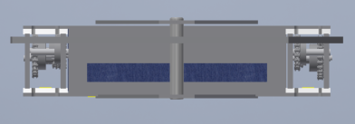

Top View

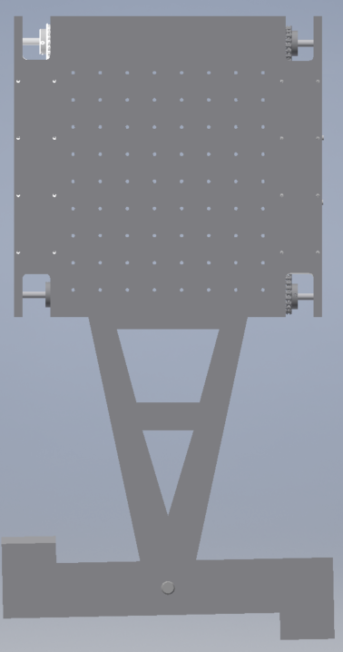

Side View

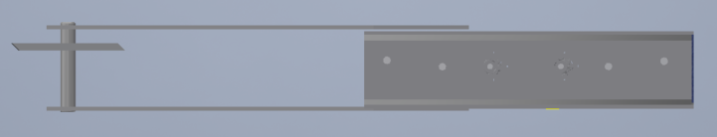

Description: The battle bot will have a 60.9 cm blade (2ft) made out of steel which will spin at a high rate. The motors and controllers will be housed inside the aluminum shell. The shell and supports of the battle bot will be made out of 6.35 mm thick aluminum 7075, which is rated at 61,000psi strength and 150 Brinell hardness. The drive train will be fabricated from 9.525mm thick aluminum 7075.

