Title

# Methods

We will explore portfolio construction based on asset centrality based on correlation MST where we try using different centrality measures and pick portfolios based on either upper or lower percentile of degree distribution.

We studied all stocks in S&P 100 in the time period ranging from 2005 to 2017 (3037 days). For each market day, we calculate the correlation between their daily log returns over the previous 250 days, and then use the correlation to define gower distance(d=sqrt(2*(1-correlation))) and construct the Minimum Spanning Tree. Here is an example of a MST for Jan 31st in 2007.

.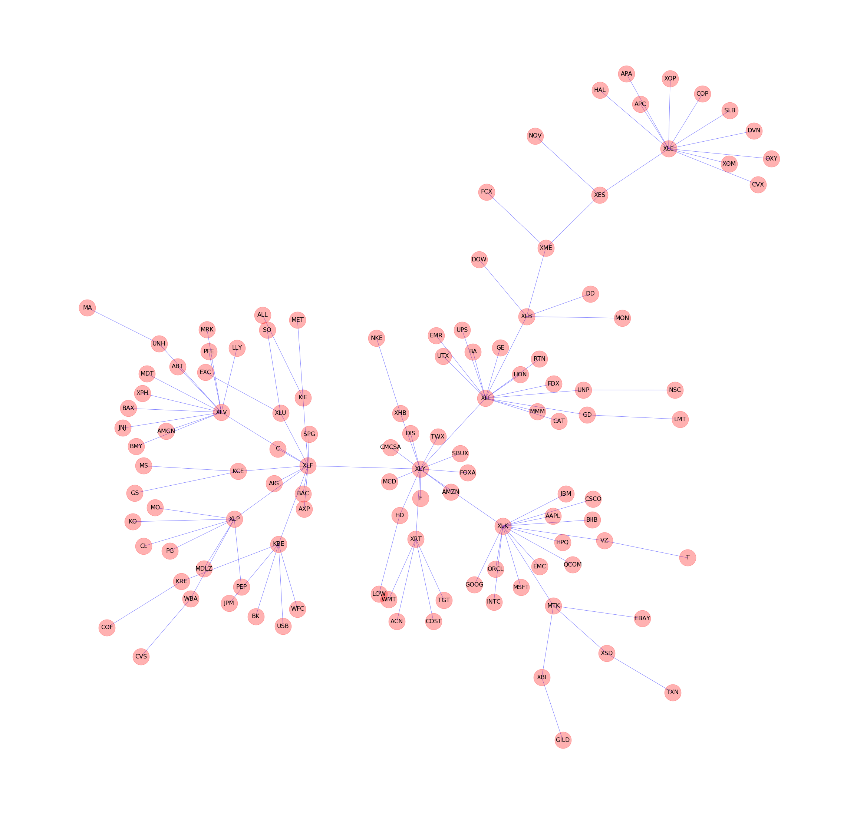

Figure: an example of MST, with all stocks in S&P100 in 01/31/2017 as nodes, and the gower distances as edges.

Then we used centrality measure to analyze the MST and to construct the portfolio.

We consider a few centrality measures for the nodes on MST: betweenness, closeness and degree, which are defined as follows[1]:

Betweenness centrality of a node v is the sum of the fraction of all-pairs shortest paths that pass through v.

Closeness centrality of a node u is the reciprocal of the sum of the shortest path distances from u to all n-1 other nodes. Since the sum of distances depends on the number of nodes in the graph, closeness is normalized by the sum of minimum possible distances n-1.

Degree centrality for a node v is the fraction of nodes it is connected to. But in our case we modified it as “weighted degree centrality”. We use (2-d) as weight, where d is the Gower distance described above. The weighted degree centrality of a node v is the fraction of weights of edges which v is connected to.

For each measure we pick the nodes in the lower and upper percentile (25%) of centrality measure distribution and pick assets in that percentile to make an investment portfolio.

# Results

## 1. Portfolio change

First question we study is how often we would have to rebalance our portfolios. We look at the percentage of stocks change first on bi-weekly rebalancing for the whole time period and then on daily rebalancing for some special periods.

### Bi-weekly portfolio change rate during the whole period

We first look at the percentage of stocks change on bi-weekly rebalancing for all data from Jan 2005- Jan 2017:

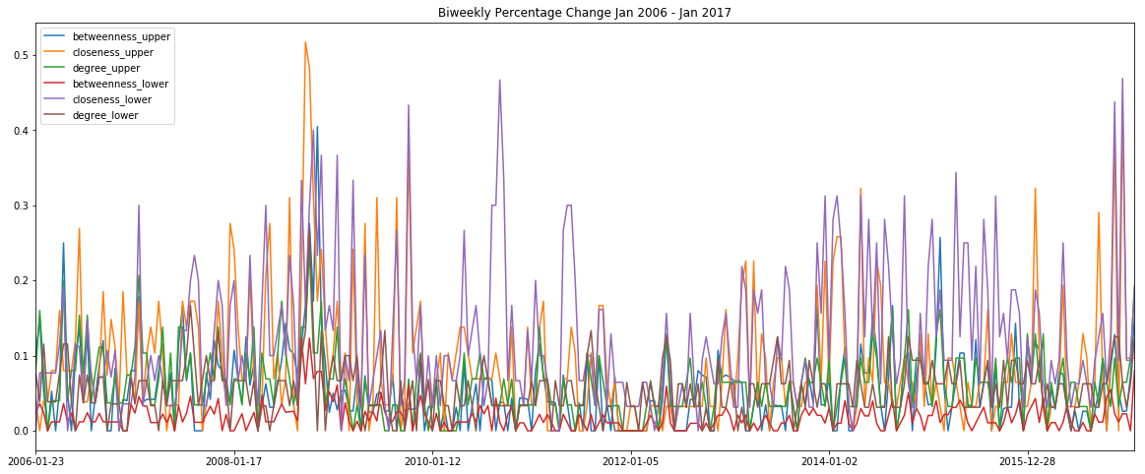

Figure: Bi-weekly Percentage Change From Jan 2006 - Jan 2017

we can see from the graph that closeness centrality has been producing much larger spikes meaning more portfolio rebalancing compared to betweenness and degree, while other portfolios remain a more steady and lower change rate. For clearness, we draw graphs separately for the central portfolio and for the peripheral portfolio.

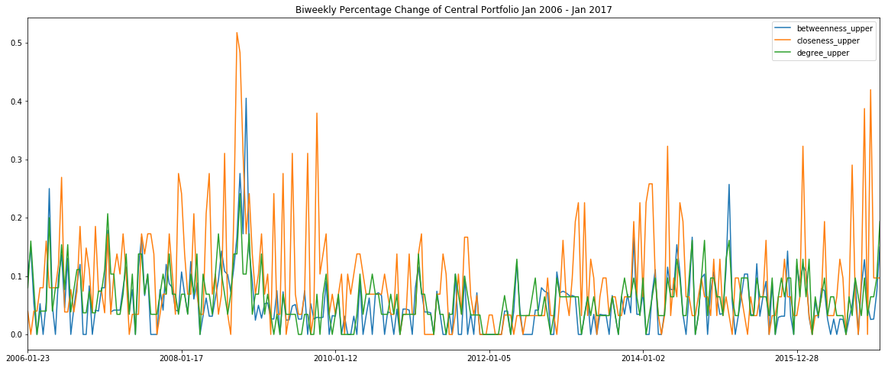

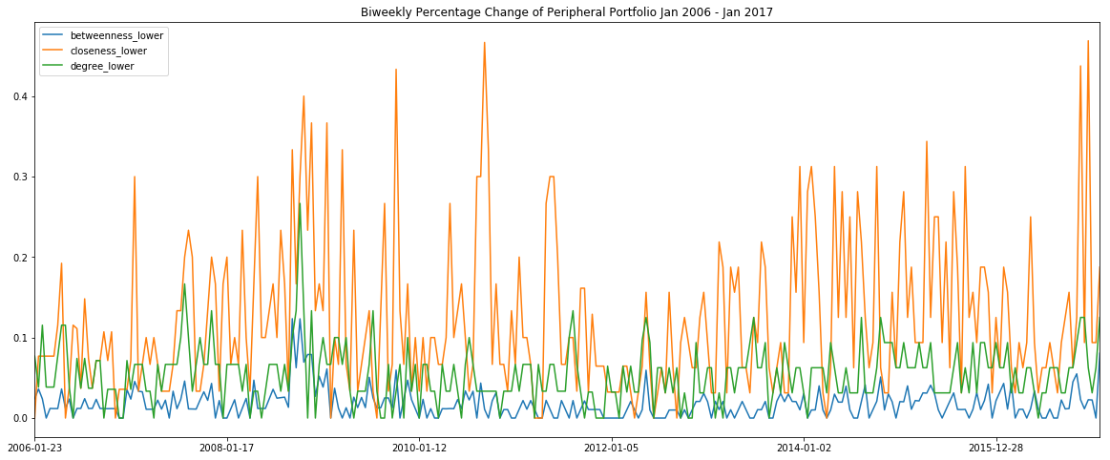

Figure: Bi-weekly Percentage Change From Jan 2006 - Jan 2017 for Central and Peripheral Portfolios respectively

We also calculate some descriptive statistics:

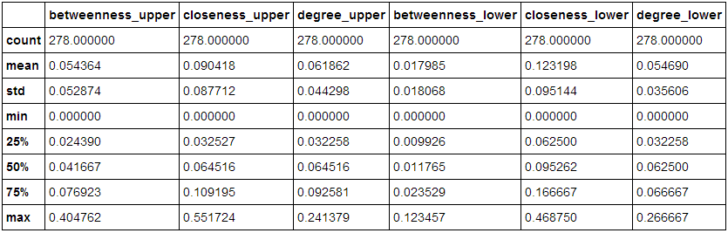

We find that except closeness centrality, other portfolios have change rates below 10% for 75% of the time period and about 5% for half of the time period. And degree centrality shows a stable and low change rate.

### Central vs. Peripheral Portfolios in 2016

We can have a closer look at the performance in 2016 to have a clearer idea about the result. During 2016, Daily rebalancing stays within a reasonable percentage: below 5% except for some spikes. We see a spike following election day in US on Nov.9th 2016. Other spikes occur in late April, early September and December. We can conduct a detailed study on what news have generated the corresponding spikes.

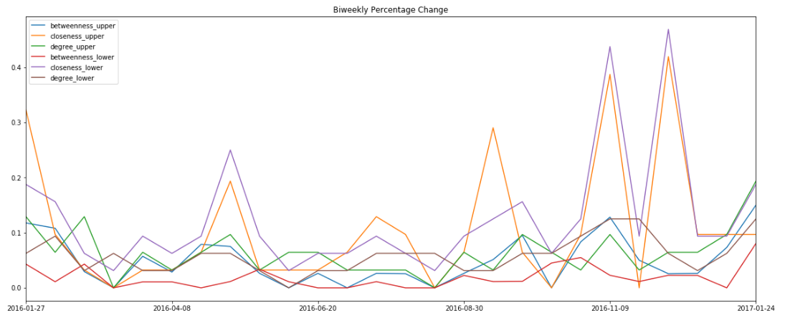

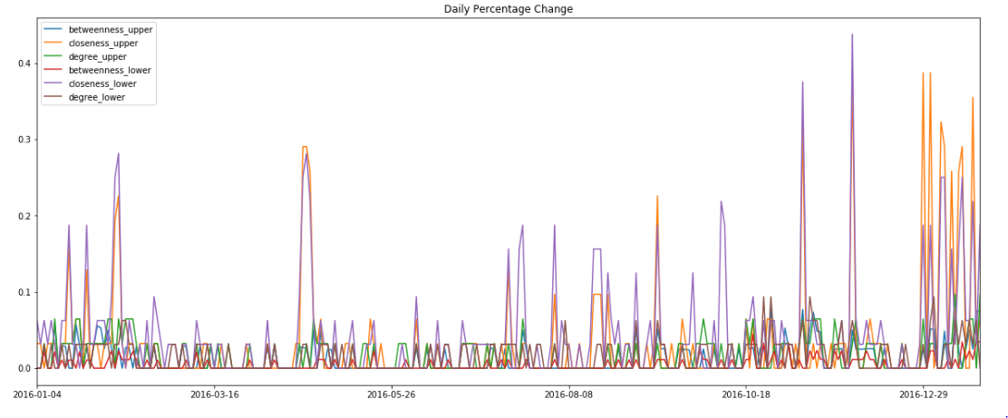

Figure: Bi-weekly and Daily Percentage Change From Jan 2016 - Jan 2017

Below we look at how much portfolio composition changes for Central Portfolios and Peripheral Portfolios respectively. For Central Portfolios, Bi-weekly changes seem to be within 10% outside of the events that generate spikes. Closeness centrality has been producing much larger spikes meaning more portfolio rebalancing compared to betweenness and degree.

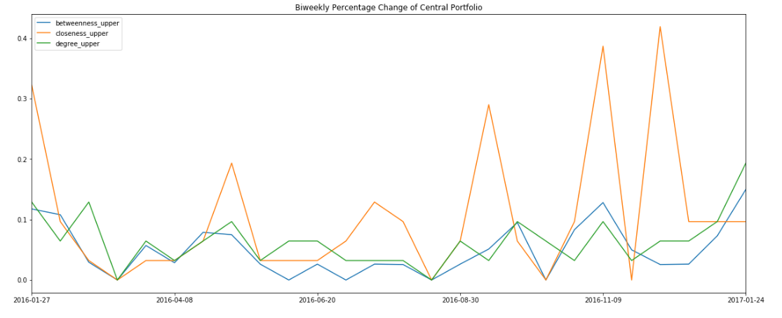

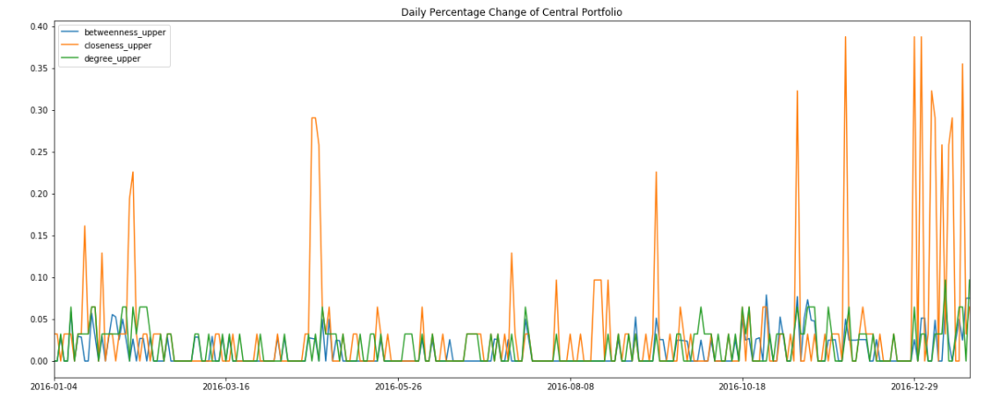

Figure: Bi-weekly and Daily Percentage Change From Jan 2016 - Jan 2017 For Central Portfolios

For peripheral portfolios closeness also shows a lot more spikes and seems more sensitive to market changes.

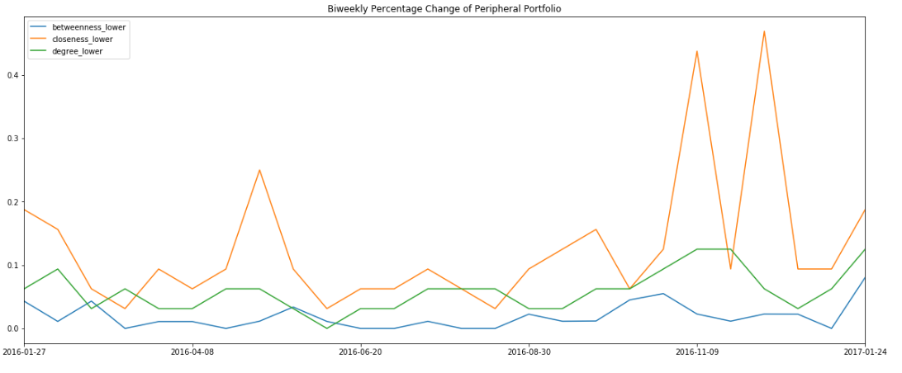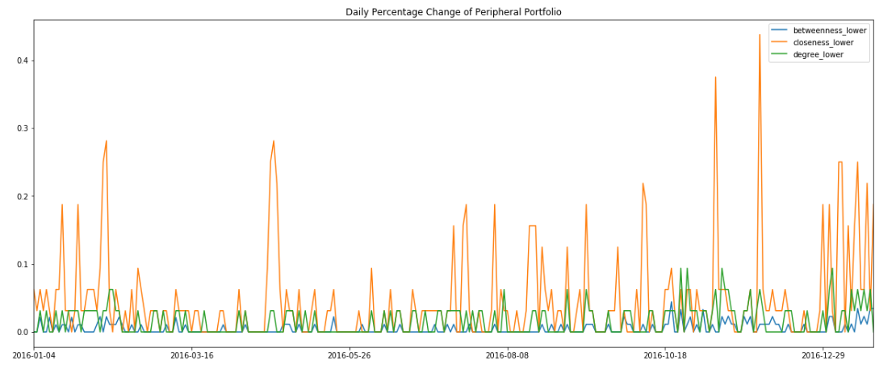

Figure: Bi-weekly and Daily Percentage Change From Jan 2016 - Jan 2017 For Peripheral Portfolios

### portfolio change during special periods

We then have a closer look at some special periods, the 2008 financial crisis and 2016 US election for example.

i. 2008 financial crisis

We can see from the graphs that high spikes happens at September and October in 2008, which is just the time when the stock market began to crash. And same as what we get before, closeness peripheral have more spikes than closeness central.

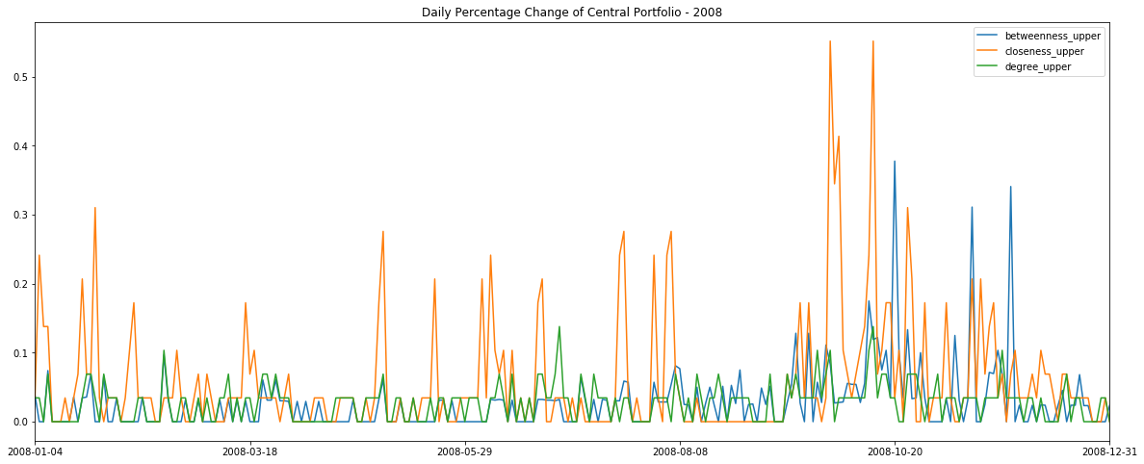

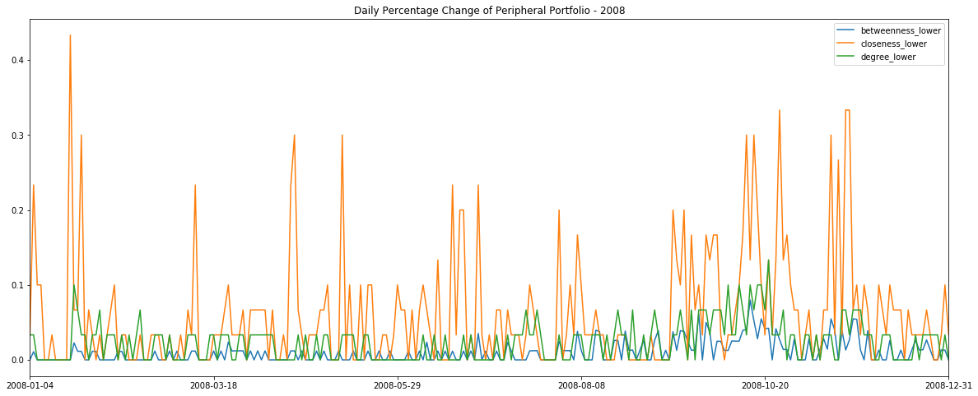

Figure: Daily Percentage Change From Jan 2008 - Dec 2008 For Central and Peripheral Portfolios respectively

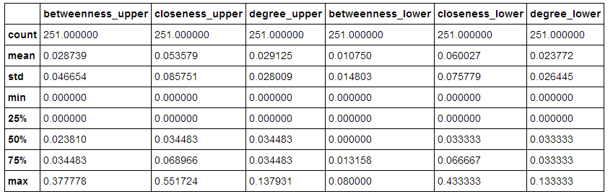

From statistics we can see that degree lower construct very stable portfolios.

ii. election

The 2016 US election was held on Nov 9th. We can see that a high spike happened at that day. There are also spikes at Nov 30th and early January in 2017.

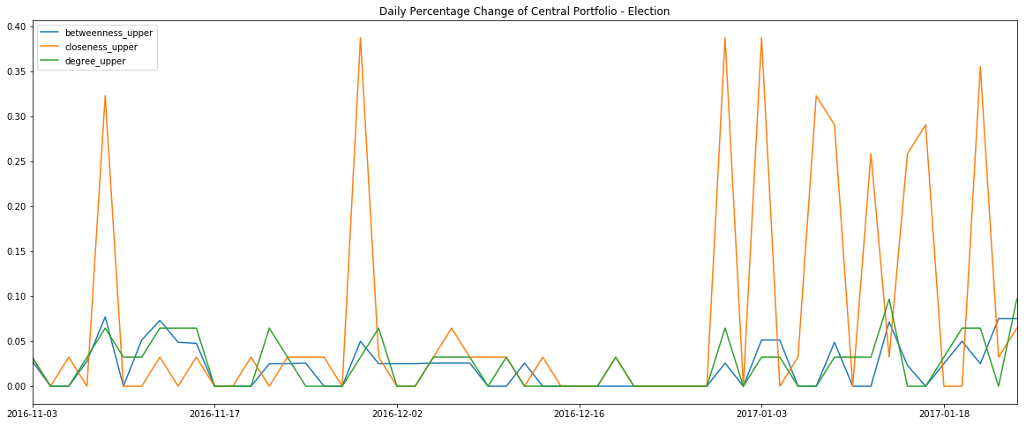

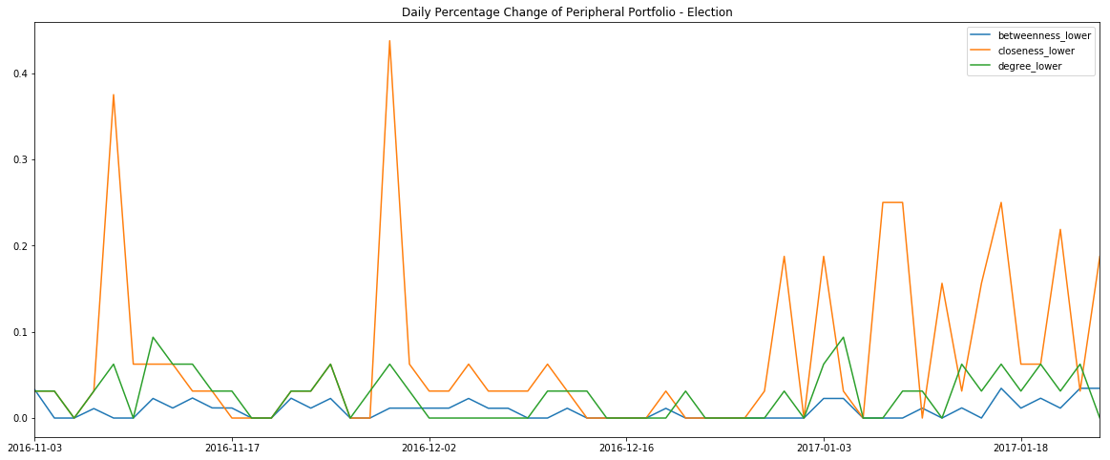

Figure: Daily Percentage Change From Nov 2016 - Jan 2017 For Central and Peripheral Portfolios respectively

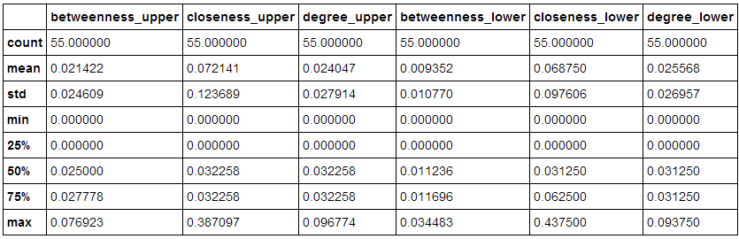

## 2. Returns

We measured the performance of portfolios for bi-weekly and daily rebalancing over different timeframes. We allocated equally among stocks in each portfolio, including central and peripheral portfolios constructed based on the three measures of centrality. ,Therefore, we compared cumulative performance of portfolios for bi-weekly and daily rebalancing and also compared central (upper percentile of centrality distribution) and peripheral (lower percentile of centrality distribution) portfolio performances. We calculated the cumulative performance of a portfolio made up of all stocks in S&P 100 with equal weights as a benchmark.

### Daily Rebalancing vs. Bi-weekly Rebalancing

Following figures report portfolio cumulative performance during 2016 for daily and bi-weekly rebalancing. The table shows the final returns for both rebalancing frequency. We note that during 2016, bi-weekly rebalancing portfolios outperform daily rebalancing ones.

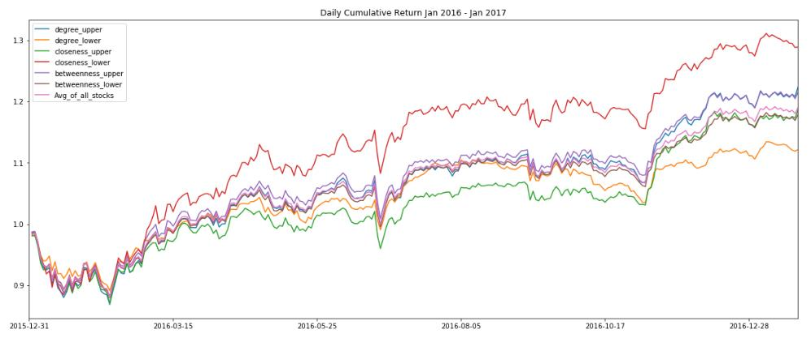

Figure: Cumulative returns for daily rebalancing (Jan 2016 – Jan 2017)

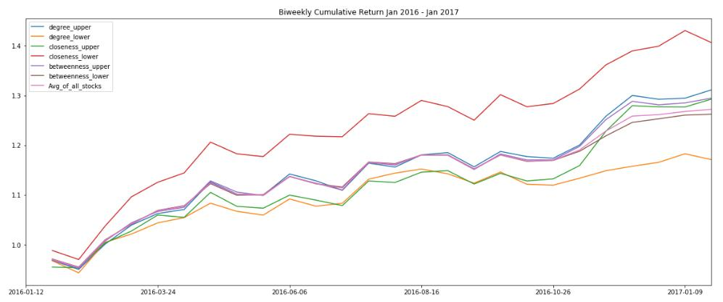

Figure: Cumulative returns for bi-weekly rebalancing (Jan 2016 – Jan 2017)

Table: Daily vs. bi-weekly rebalancing (Jan 2016 – Jan 2017)

|  |  |  |
| --- | --- | --- |
|  | Daily | Biweekly |
| Central & Degree Centrality | 22.37% | 31.12% |
| Peripheral & Degree Centrality | 12.17% | 17.12% |
| Central & Closeness Centrality | 18.62% | 29.25% |
| Peripheral & Closeness Centrality | 28.90% | 40.60% |
| Central & Betweenness Centrality | 21.53% | 29.45% |
| Peripheral & Betweenness Centrality | 17.89% | 26.22% |
| Benchmark | 19.03% | |

### Central vs. Peripheral Portfolios in Recent Years

The following figures show the bi-weekly cumulative returns over the past 10 and 5 years respectively, from which we can observe that peripheral portfolio of degree centrality outperforms on biweekly rebalancing for most of the time, followed by peripheral portfolio of closeness centrality. The three central portfolios, on the contrary, perform even worse than the benchmark portfolio.

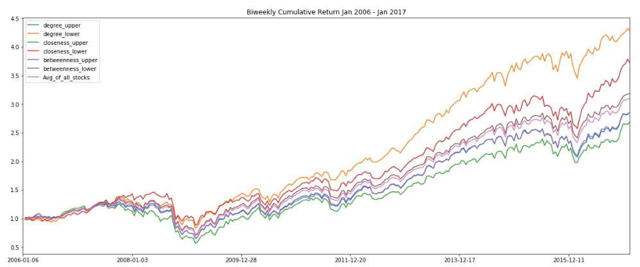

Figure: Cumulative returns for biweekly rebalancing (Jan 2006 – Jan 2017)

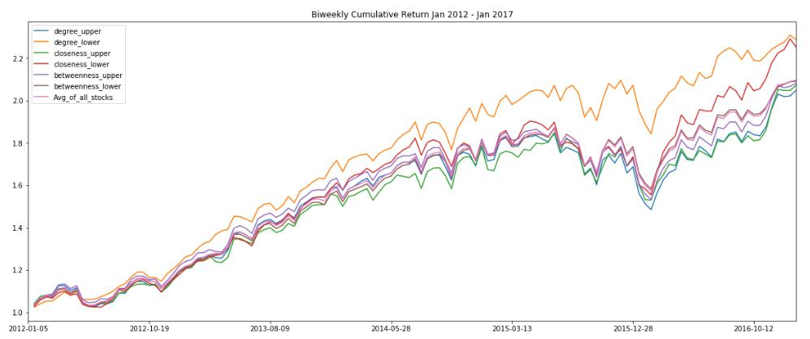

Figure: Cumulative returns for biweekly rebalancing (Jan 2012 – Jan 2017)

Next, we report the cumulative performances of daily rebalancing for each of the recent five years. Things seem quite different among different years. Usually peripheral portfolios of either degree centrality or closeness centrality perform best. Peripheral portfolio of degree centrality outperforms in each year from 2012 to 2015, but does not perform well in 2016. Peripheral portfolio of closeness centrality does a great job in 2016 and 2014, but not in other years.

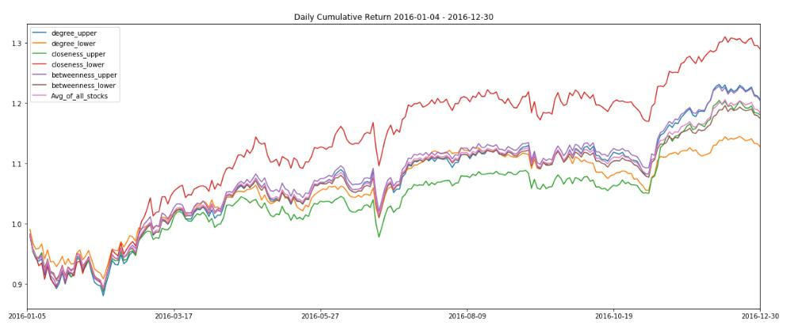

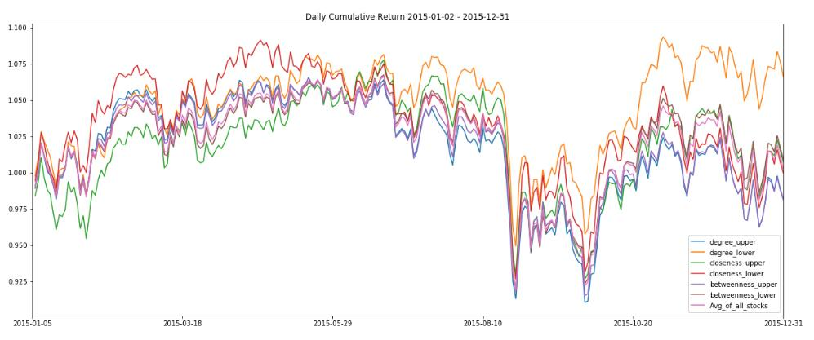

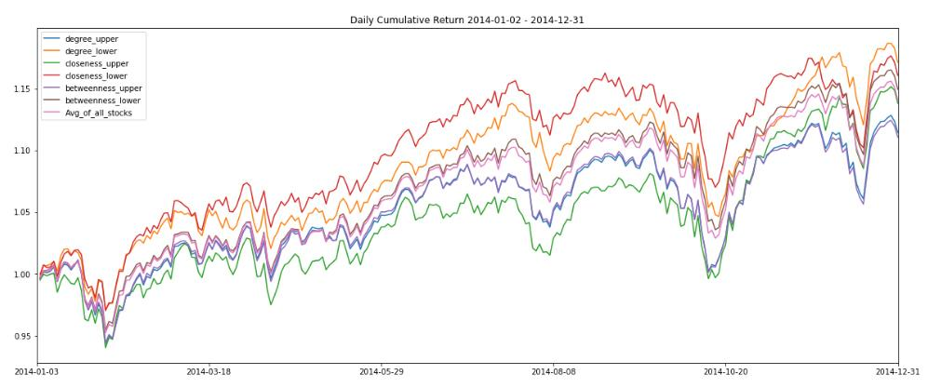

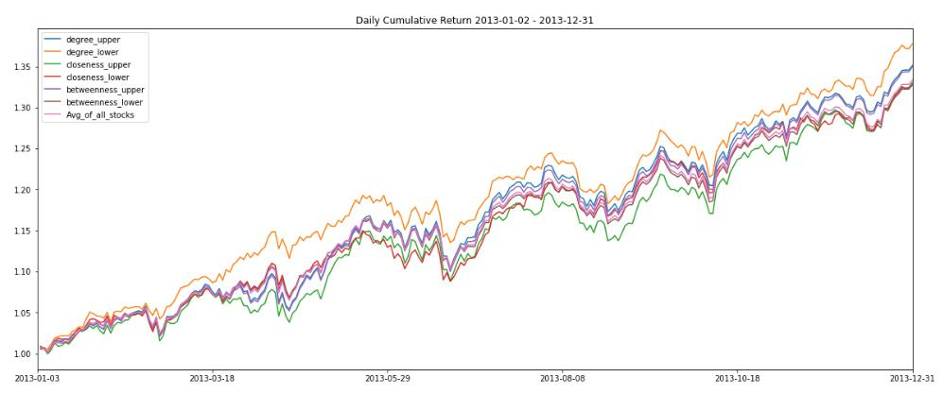

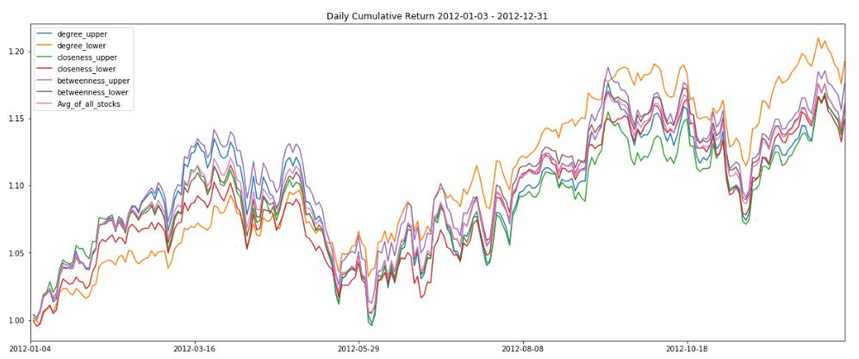

Figure: Cumulative returns for daily rebalancing (2016, 2015, 2014, 2013, 2012)

### Performance during Financial Crisis of 2007 - 2008

In this part, we focus on the portfolio performance during financial crisis of 2007 to 2008, for daily and biweekly rebalancing and also for the central and peripheral portfolios of different centrality measures.

Unlike the situation in 2016, the daily and bi-weekly rebalancing portfolios have similar performance in 2007 and 2008. In 2007, daily rebalancing portfolio outperforms the bi-weekly rebalancing one by a little amount, while the bi-weekly rebalancing portfolio loses less in 2008 than the daily one, except for the peripheral portfolio of closeness centrality.

In 2007, peripheral portfolio of closeness centrality outperforms on both daily and biweekly rebalancing, followed by peripheral portfolio of degree centrality, while they have similar performance in 2008 on daily rebalancing. For bi-weekly rebalancing, peripheral portfolio of degree centrality performs best in 2008. Besides, let us stress that in these two years, peripheral portfolios of both closeness and degree centrality outperform the benchmark on both daily and biweekly rebalancing.

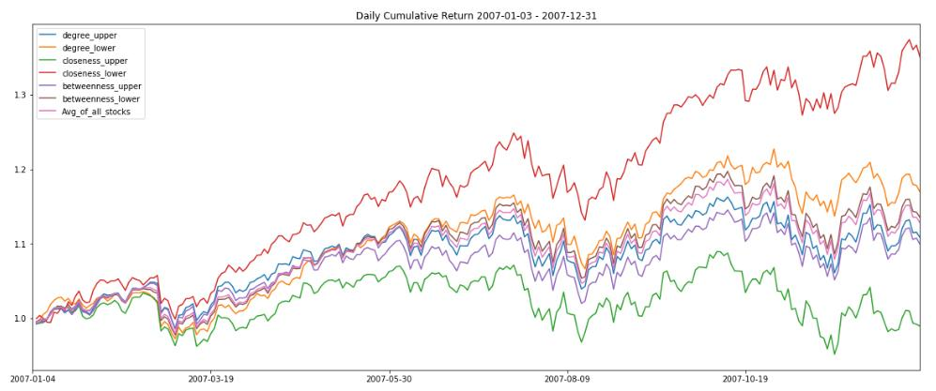

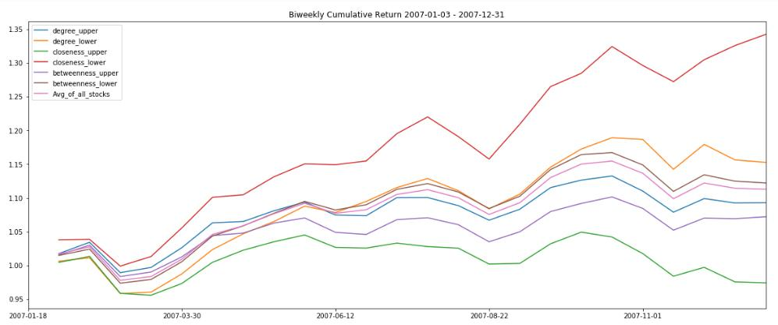

Figure: Cumulative returns for daily and bi-weekly rebalancing (2007)

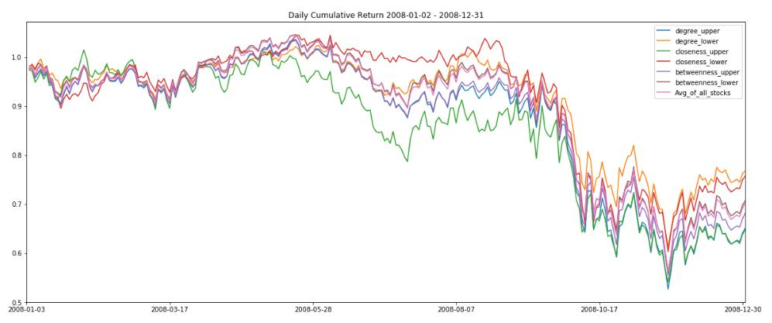

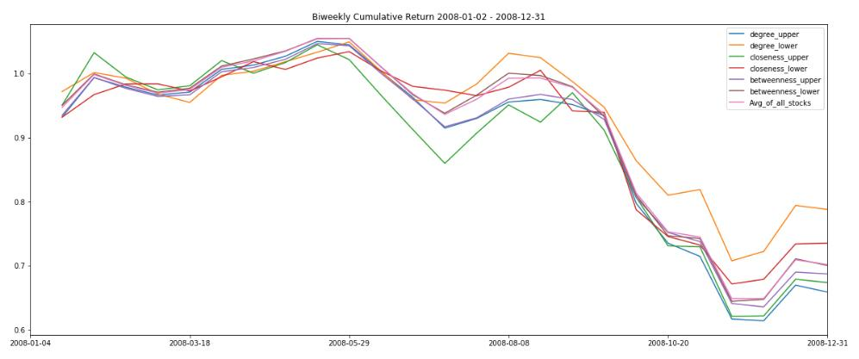

Figure: Cumulative returns for daily and biweekly rebalancing (2008)

Table: Daily vs. bi-weekly rebalancing (Jan 2016 – Jan 2017)

|  |  |  |  |  |
| --- | --- | --- | --- | --- |
|  | 2007 | | 2008 | |
|  | Daily | Biweekly | Daily | Biweekly |
| Central & Degree Centrality | 10.84% | 9.30% | -35.38% | -34.12% |
| Peripheral & Degree Centrality | 16.95% | 15.27% | -23.88% | -21.22% |
| Central & Closeness Centrality | -1.04% | -2.57% | -34.12% | -32.63% |
| Peripheral & Closeness Centrality | 35.05% | 34.23% | -22.12% | -26.49% |
| Central & Betweenness Centrality | 9.94% | 7.21% | -31.91% | -31.28% |
| Peripheral & Betweenness Centrality | 13.54% | 12.23% | -29.28% | -29.96% |

Next, we will further study the performance of unequally weighted portfolios.

1. https://networkx.github.io/documentation/development/reference/algorithms.centrality.html