Distributed Database Management

# Module Activity

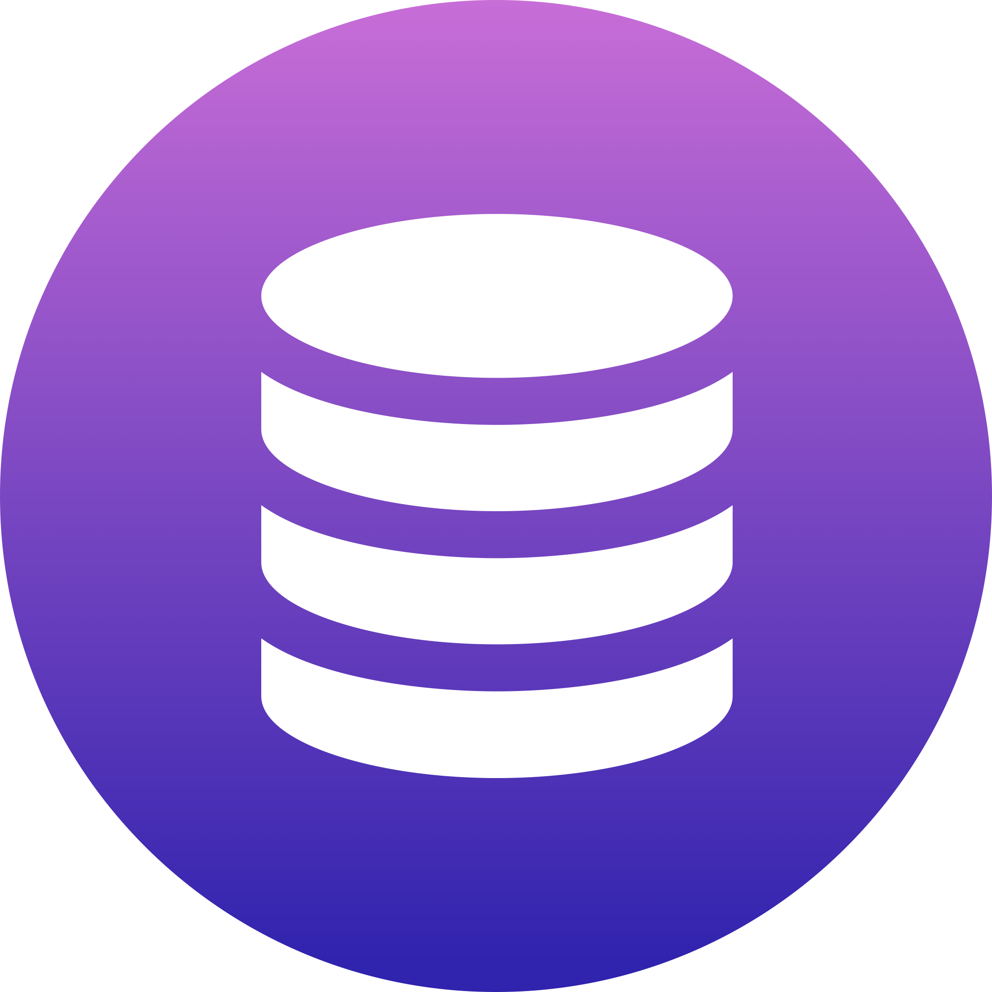

The world is rapidly changing and with it so is business. In today’s information age, the more data a business or company can leverage or maintain, the more profitable that company will become in the long run. With the advent of organized data kept in the database, business became able to make decisions regarding the people and products they serve. The database not only helped store information, but to supply it on demand. Doctors’ offices could completely eliminate or massively reduce the amount of space they needed to store patient files and records. Merchants and retail companies could save the details and data based on the transaction’s consumers were making with them. These databases helped in so many ways.

With the advent of distributed databases small companies could now leverage the types of technologies that only larger business could wield. Because data stored in the cloud did not require expensive server and computer technologies, these small companies could pay per usage, meaning the company only had to pay for the resources they used in a specific amount of time. When a company uses a distributed database in the cloud setting, they are able to make their database redundant geographically, meaning that the database is replicated and stored on VMs all over the United States or even the world. This gives the company leveraging the distributed database the power to ensure each user has the smallest connection time. This results in a faster user experience because as the further away data is from the user, the farther it travels, and the longer it takes to query and then make it back to the user. When the distributed database is replicated or redundant, each user in a different geographic region will have access to a specific distributed database that serves that region.

Technology is able to interlink these different databases so that when on interrelated database is updated, they are all updated. This helps to ensure that all the data a company stores is kept up to date and represents a single logical database. To ensure there is a connection, all the database located across all the geographic regions are connected with a network. This network is critical to the success of the database. If for some reason the network goes down, the entire data operation could collapse or become compromised. This could be catastrophic for a business or company that relies on that database.

A real-life example of how distributed databases can help business is in regard to those companies that operate in diverse geographic regions. These companies could implement distributed databases which serve the specific stores in a region during the day while at night, all information can be processed to the main headquarters database during non-peak hours. This type of situation would allow the business to keep network and database costs down during the day when there is more traffic and bandwidth is more expensive.

As more and more companies become able to leverage this type of technology, we are seeing the supporting framework for distributed databases grow at an exponential rate. This can be seen in cloud computing and cloud-based networking. The types of engineers and employees that are able to maintain this type of technology is rapidly changing. To keep up, courses like this are created to teach new generations about the technologies that are changing the world.

Resources:

2018 Retrieved from <https://www.atlantic.net/cloud-hosting/about-distributed-databases-and-distributed-data-systems/>

2019 Retrieved from <https://www.tutorialspoint.com/distributed_dbms/distributed_dbms_databases.htm>