Creating a Wireframe of a Home Page

Module 02 Activity

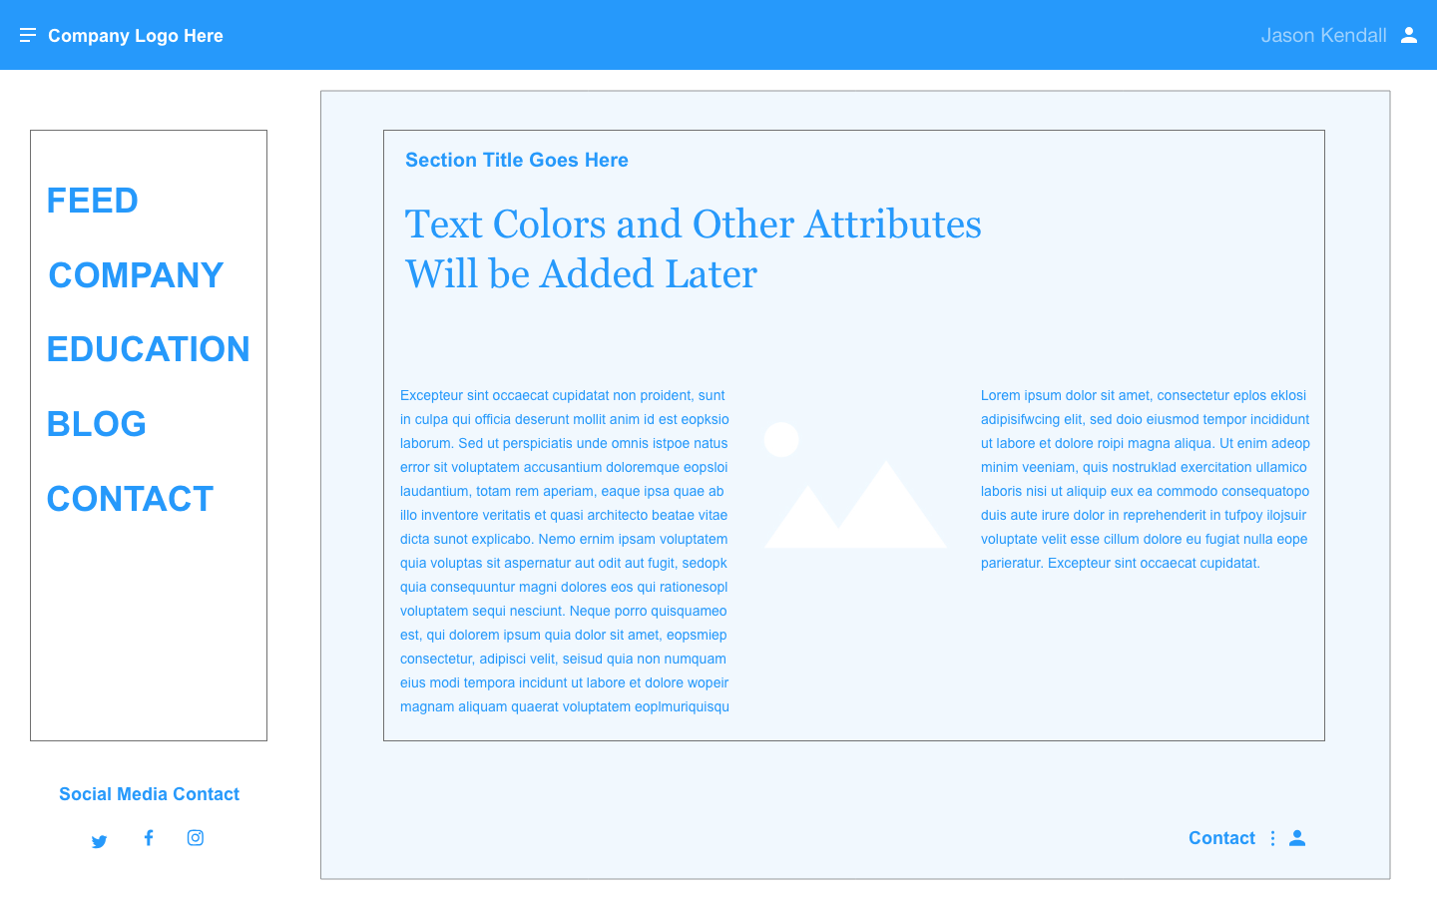

# Jason Kendall

# Fall 2018