Final Implementation Plan

Prepared for: Universal Widgets Inc

Prepared by: Jason Kendall, Developer Solutions Inc.

Solutions inc.

August 7, 2018

Proposal number: 7

# Final implementation plan

## Project Plan Objective

The objective of this report is to analyze, interpret, and formulate an implementation plan designed to advise Universal Widgets Inc. in the development of a cloud based production environment.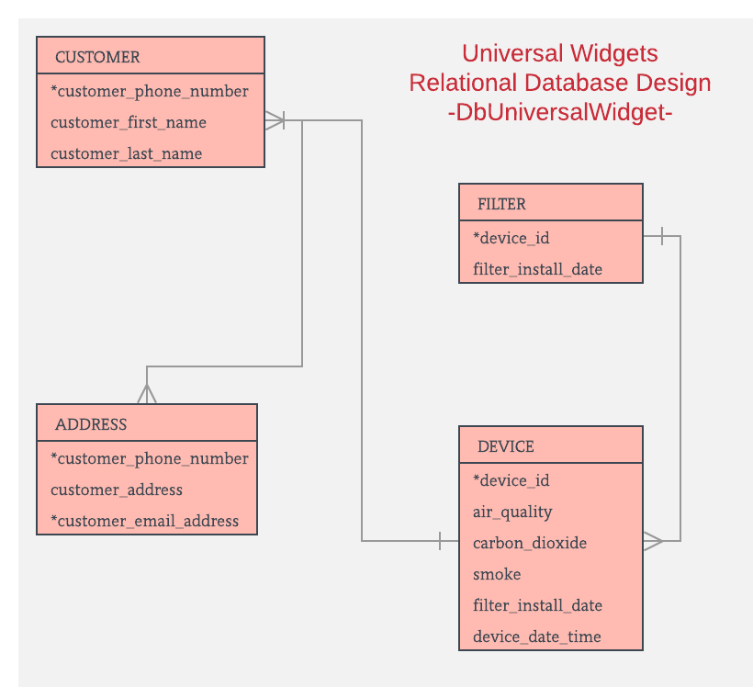

Solutions inc.

Universal Widgets Inc. will benefit from the cloud based production environment in many ways. The architecture of this database will be pre-planned and include an ER diagram for accuracy and clarity of data presentation.

## Two-Factor Authentication

For this database we will utilize two-factor authentication, which is becoming used more and more with the advent of cheaper and more highly sophisticated security measures which protect against the growing threat of hackers. Two-factor authentication will utilize a redundant system to authenticate the credentials of a user. What the user “knows” and what the user “has” which are the username and password respectively. Additionally a cypher will be used to store a security certificate on the individuals machine which is connecting to the cloud server.

Solutions inc.

This certificate is encrypted and used to identify the same user and pass that get registered during the sign up process. When the user attempts to login, the server checks the identity of the users certificate and if they match, the user will be allowed to enter their credentials (the second layer of security).

## UML Diagram

The UML diagram is completed in an effort to provide clarity as to the system architecture for everyone involved in the project. This will be used as a general guideline during the implementation of the database, servers, applications, and security protocols. This diagram can be updated and should remain flexible during the life of the project. A single instance of the UW UML will prevent conflicting information and will help to ensure everyone and every team is on the same page when it comes to the architecture of the project through its implementation life cycle.

## Task List & Critical Path

The task list is another critical element of the implementation plan and like the UML diagram, should remain flexible through the life cycle of the project. The task list will provide everyone involved in the project with a general idea of what needs to be done and also how long it will take to complete, which is discussed in the critical path.

The critical path is a general guideline used to keep the team on target, provide management an accurate timeline of tasks that must still be completed, and give everyone else not directly involved in the project and idea of who will be doing what and when it will get done.

## Critical Path

## Establish secure cloud based network

Time estimate: 2 week

## Setup security protocols

Time estimate: 1 week

## Install production toolkit and versioning process

Time estimate: 5 days

## Validate production environment

Time estimate: 2 week

## Backup critical elements

Time estimate: 2 days

## Push product software to production environment

Time estimate: 3 weeks

## Project completion

Time estimate: 3 weeks

## Create DB

SQL Code

CREATE DATABASE `dbuniversalwidget`;

CREATE DATABASE `jasonkendall`;

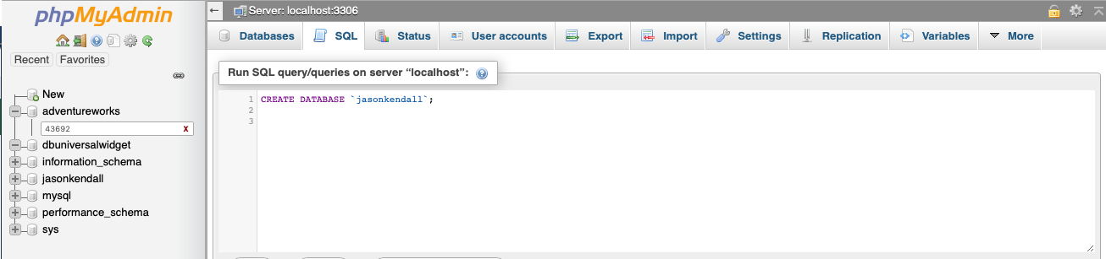

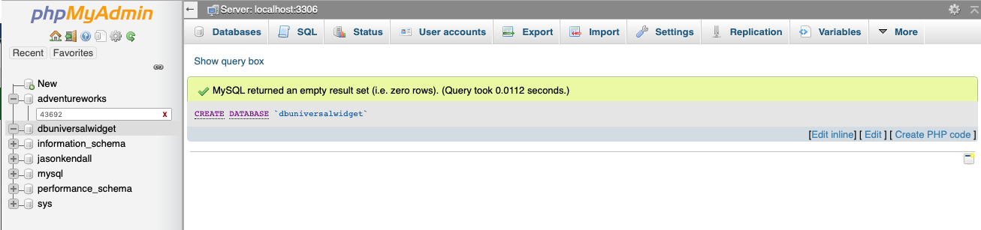

This process was completed for the entire database DbuniversalWidget and ends up with the tables specified in the word document attached to the module 07 activity.

Each column is assigned a data type so that information can be accurately passed to the database according to its input.

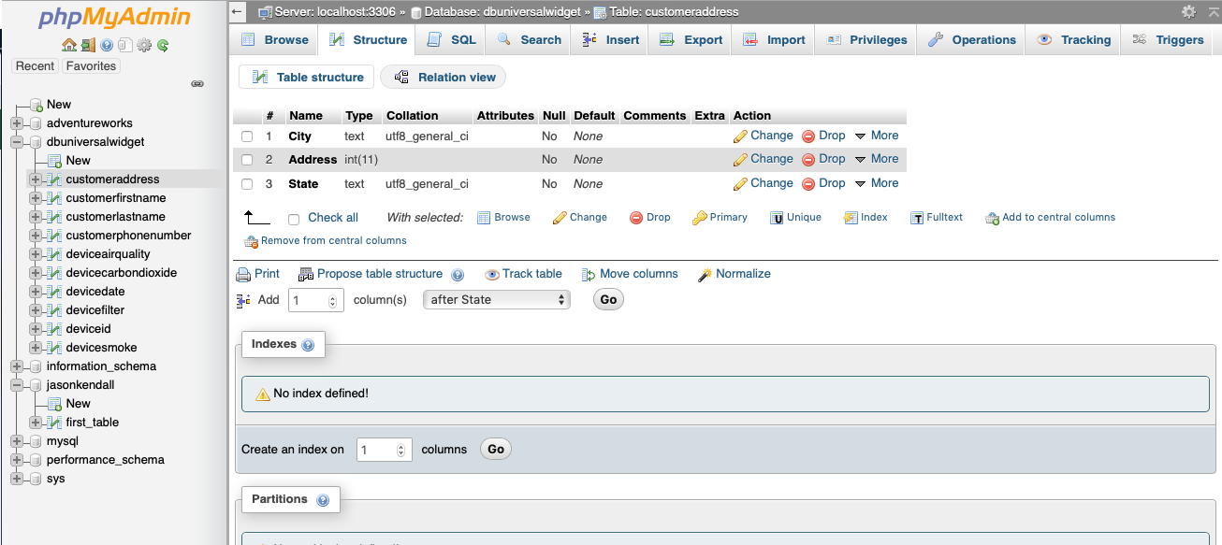

## Insert Records

INSERT INTO records (recordOne, recordTwo, recordThree)

VALUES (10, 20, 30);

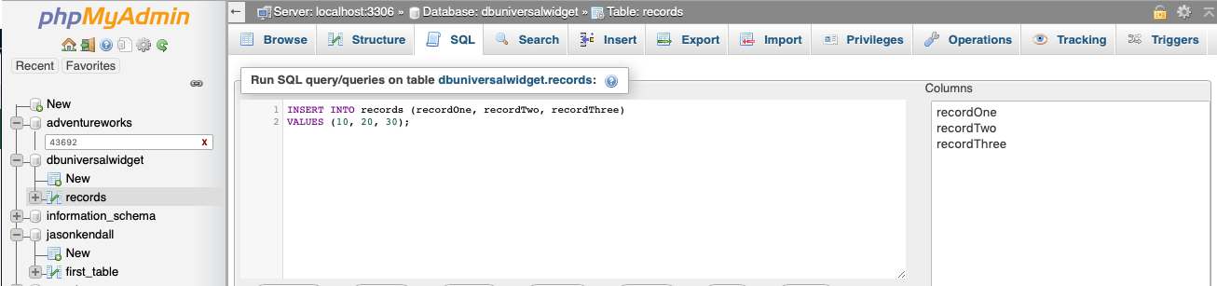

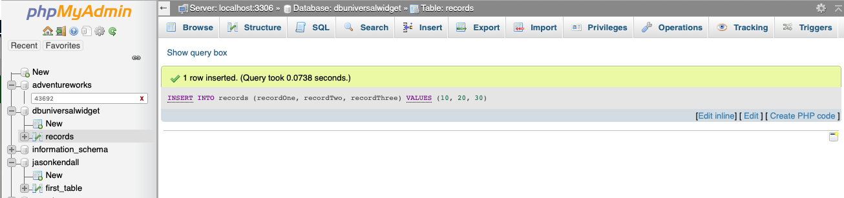

Examples of code used: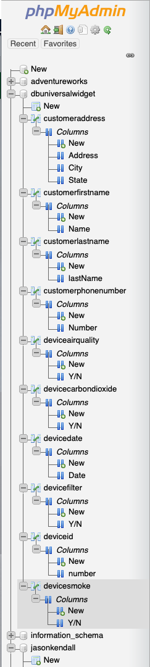

[INSERT](http://localhost:8888/phpmyadmin/url.php?url=https://dev.mysql.com/doc/refman/5.5/en/insert.html) INTO `customeraddress` (`City`, `Address`, `State`) [VALUES](http://localhost:8888/phpmyadmin/url.php?url=https://dev.mysql.com/doc/refman/5.5/en/miscellaneous-functions.html#function_values) ('Washington', '58394', ‘WS');

[INSERT](http://localhost:8888/phpmyadmin/url.php?url=https://dev.mysql.com/doc/refman/5.5/en/insert.html) INTO `customeraddress` (`City`, `Address`, `State`) [VALUES](http://localhost:8888/phpmyadmin/url.php?url=https://dev.mysql.com/doc/refman/5.5/en/miscellaneous-functions.html#function_values) ('Atlanta', '43947', 'GA');

INSERT INTO `devicesmoke` (`Y/N`) VALUES (‘no’);

## Select - View Records

SELECT * FROM `records` WHERE 1

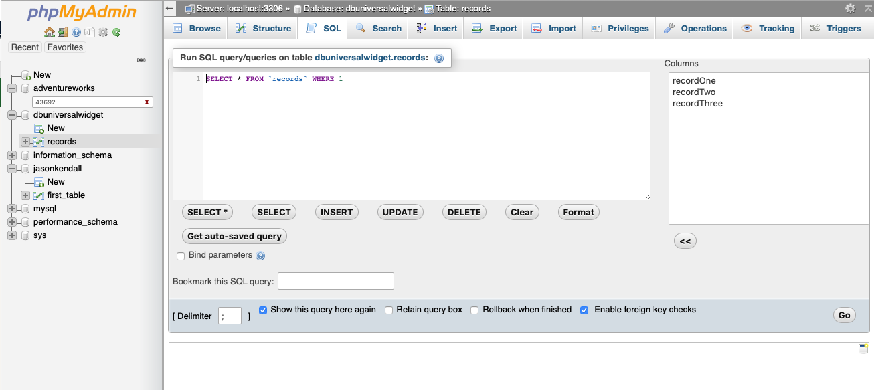

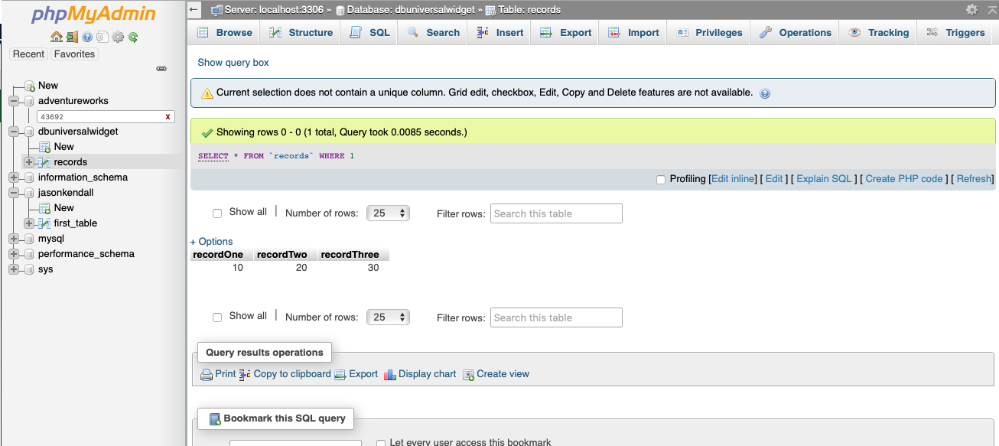

## Combined Report

## [SELECT](http://localhost:8888/phpmyadmin/url.php?url=https://dev.mysql.com/doc/refman/5.5/en/select.html) * FROM `customerfirstname`, `deviceid`, `deviceairquality` WHERE 1

I understand this conceptually, however, I am out of time. This is what I have. Thank you!!

