**Editing CSS Using Chrome Dev Tools**

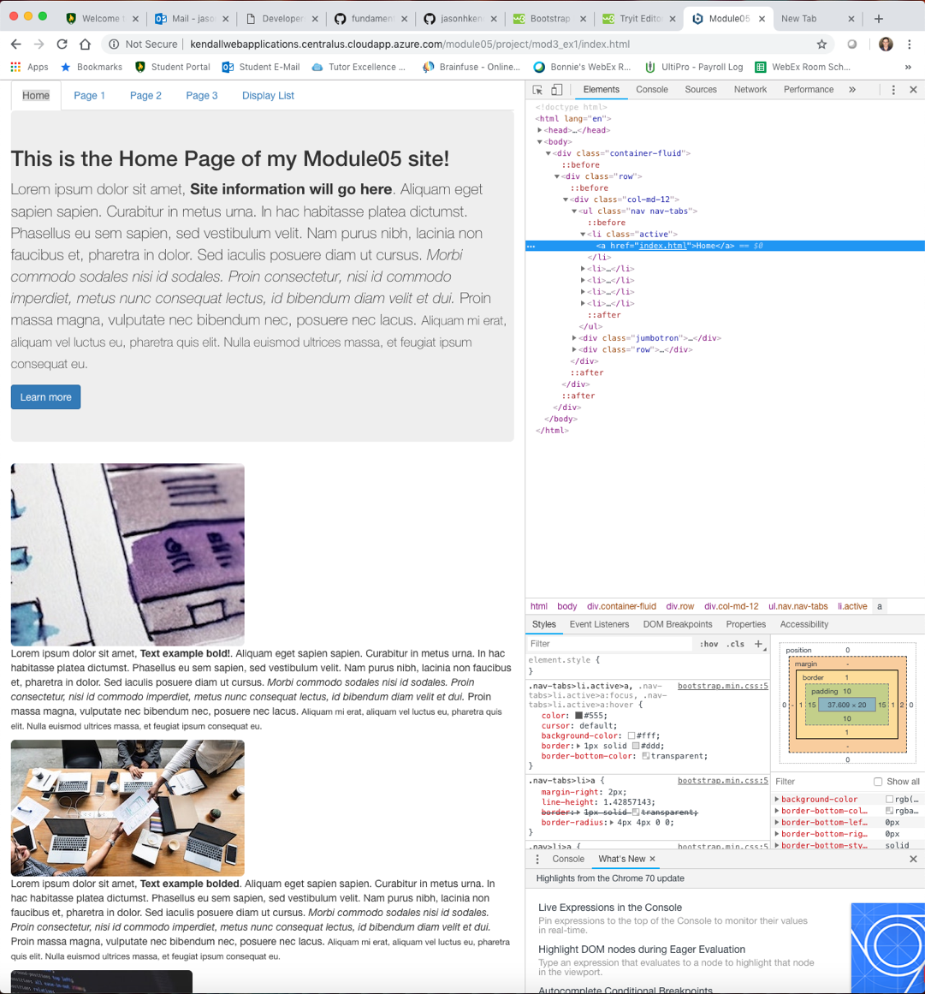

*Module 05 Project*

Jason Kendall

Fall 2018

Before Any CSS Changes

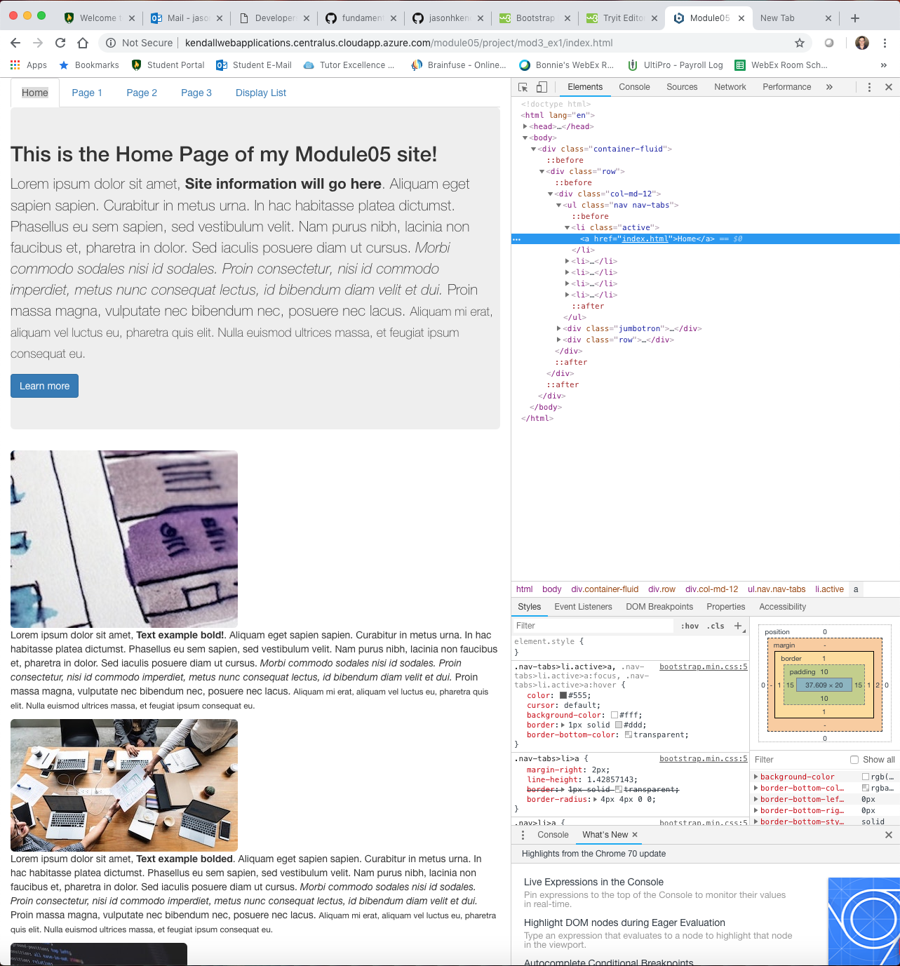

Updating the Nav Bar’s Color

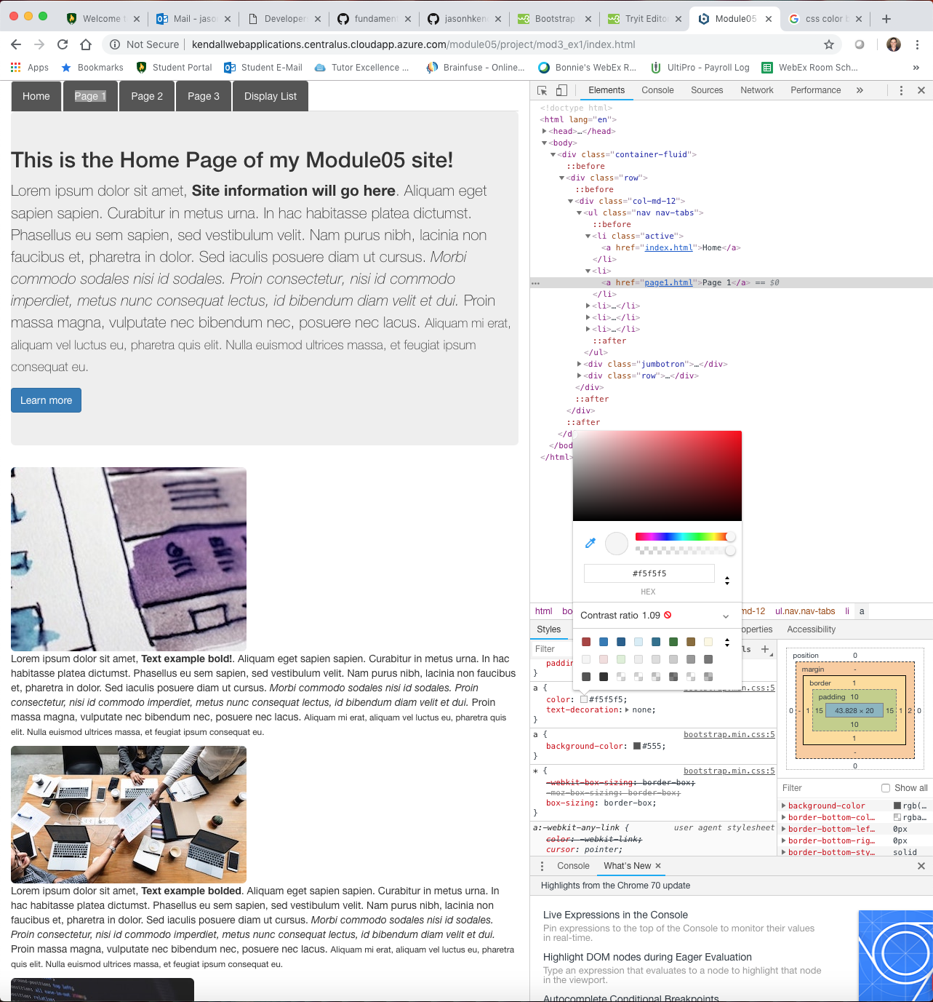

The CSS developer tools built into Google Chrome are amazing. This provides an “on the fly” type of experience which allows the developer to quickly and accurately make changes to the site’s CSS.

It only took me a few minutes to update the color of the nav bar, as you can see the color has changed from an off white to a darker color.

Matching the Theme

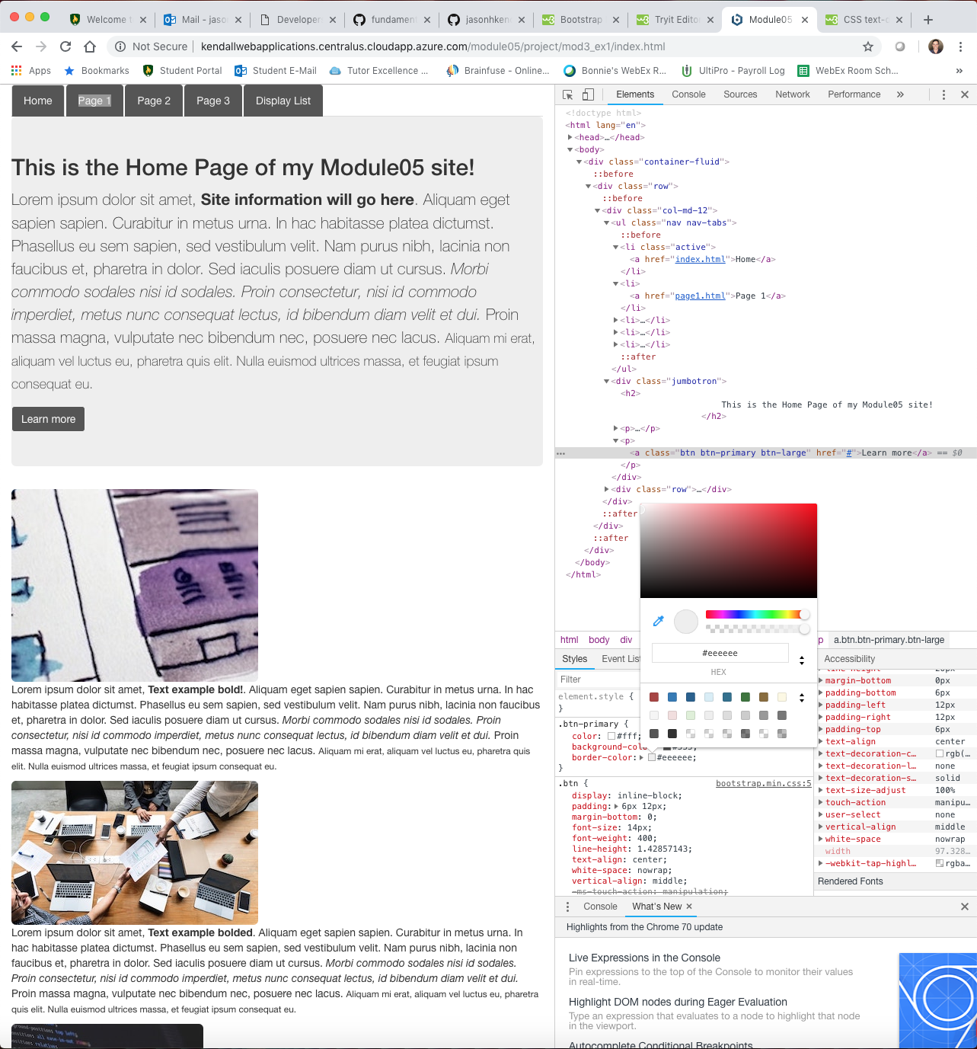

The next change was also a color modification to the learn more button which was quickly updated to match the new nav bar.

This goes to show how easy it is to match the theme if you decide to make changes down the road.

Updating Text and Background

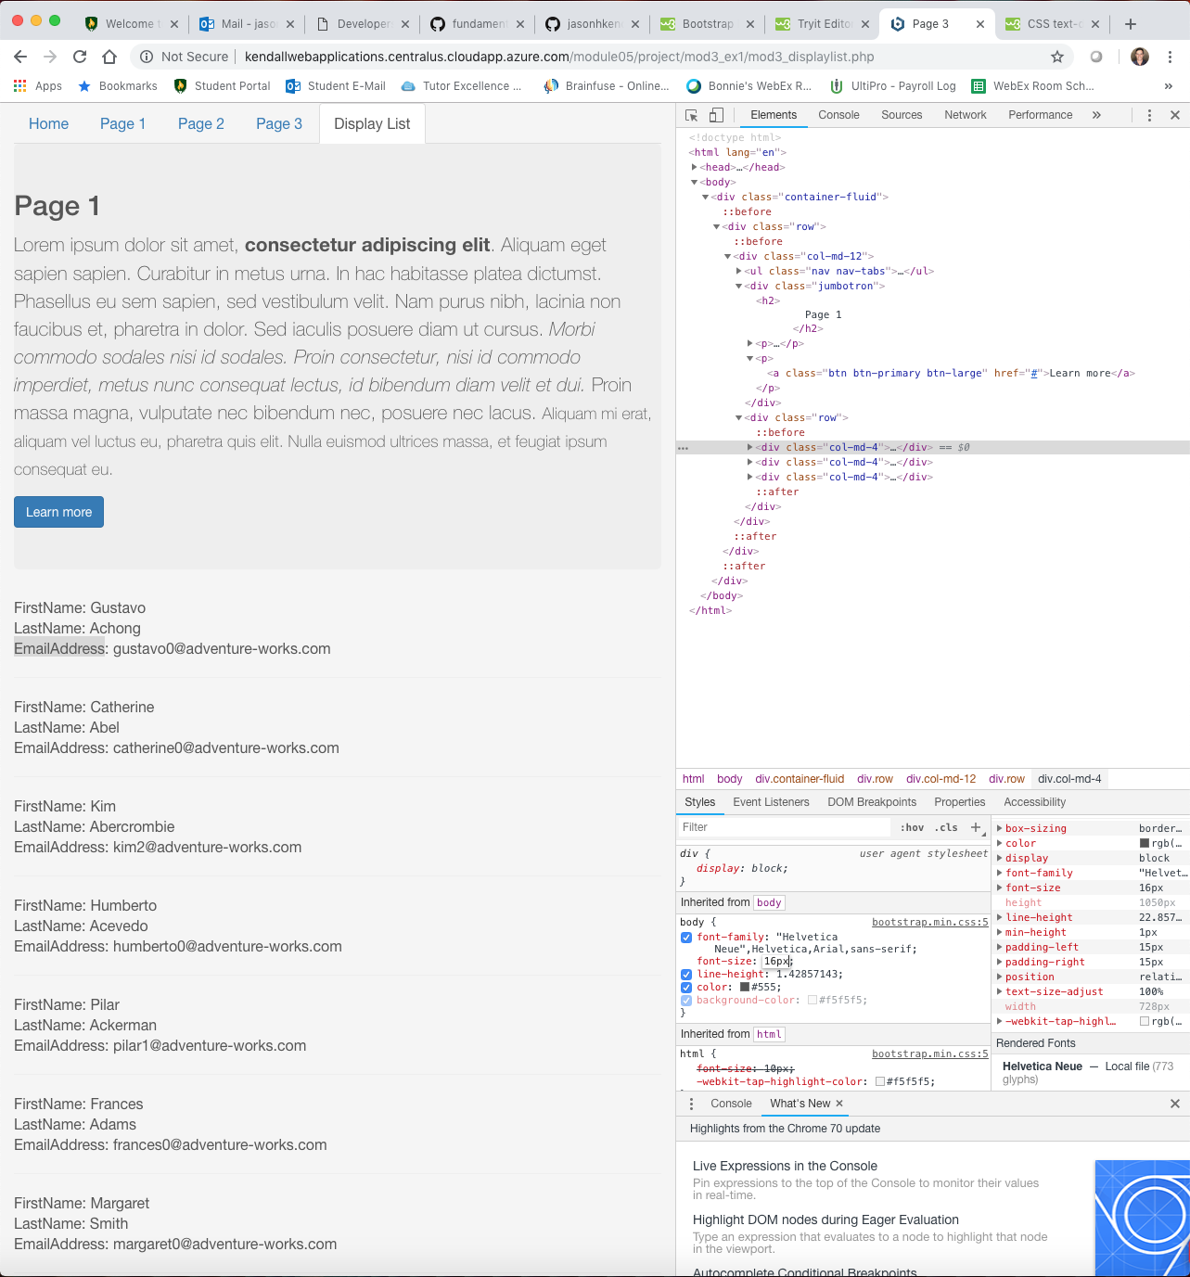

For the database text boxes, we can easily make CSS updates through the developer tools. Under the “Style” box drop down options such as color, font, behavior. When we edit these styles, they are either local or site wide, this is another reason why CSS is so flexible.

Site URL/FQDN:

<http://kendallwebapplications.centralus.cloudapp.azure.com/module05/project/mod3_ex1/mod3_displaylist.php>

GitHub URL:

https://github.com/jasonhkendall/fundamentalwebapps/module05