**Final Documentation**

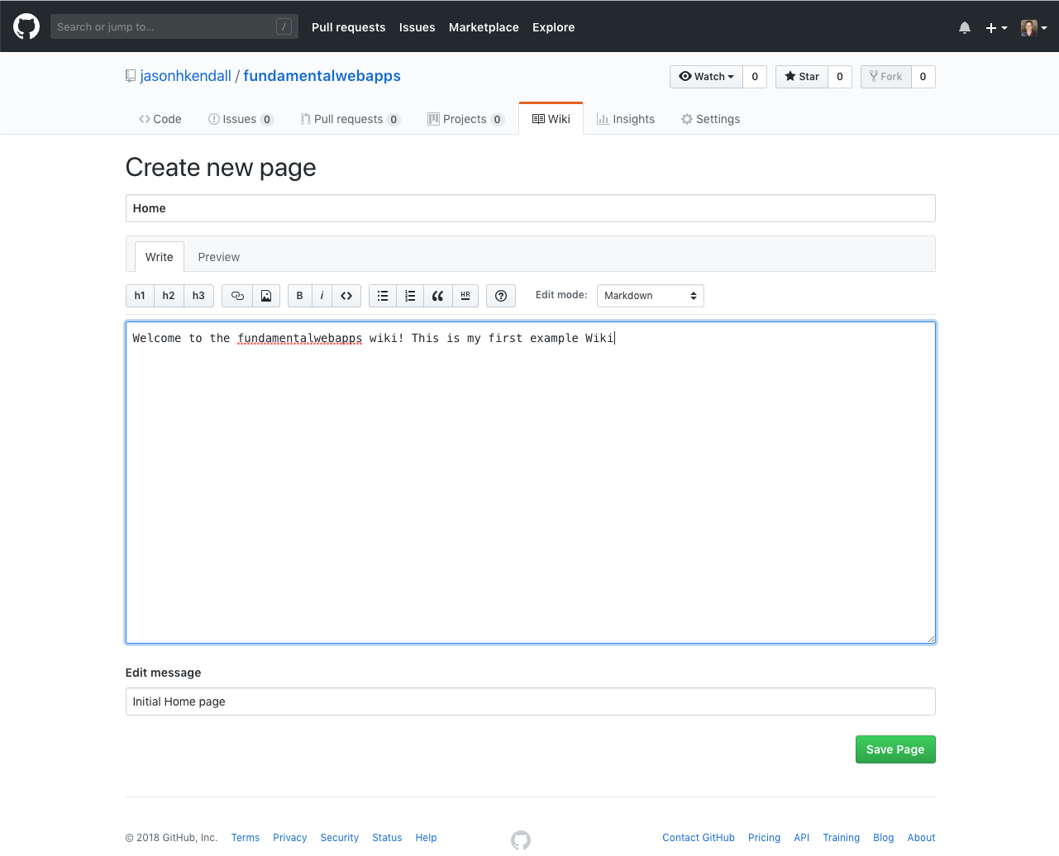

*Module 06 Activity*

Jason Kendall

Fall 2018

The ReadMe File

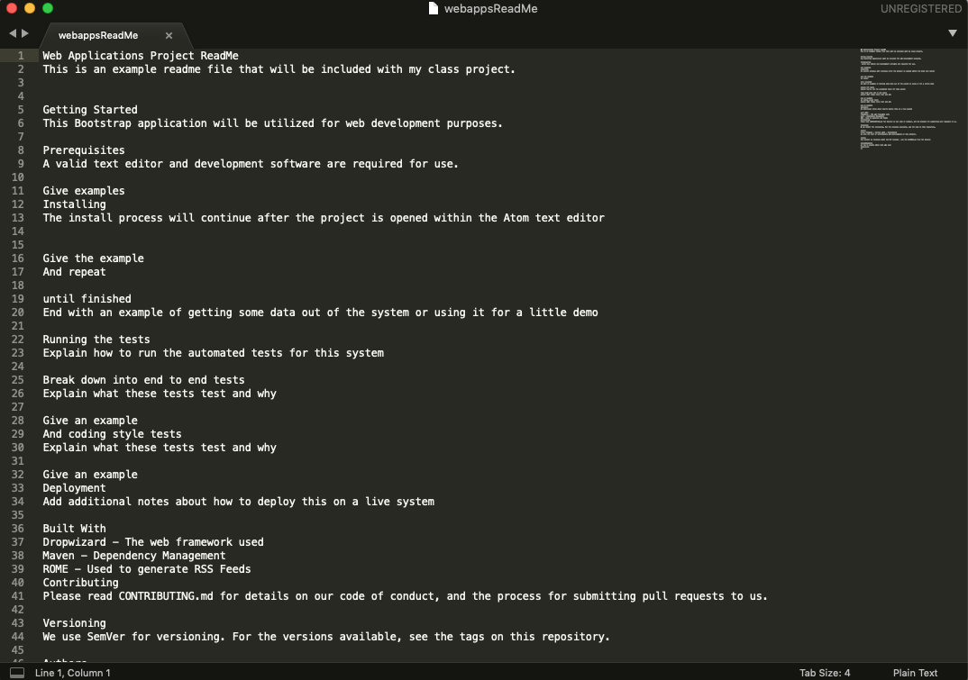

The GitHub Wiki



The GitHub Repo Page

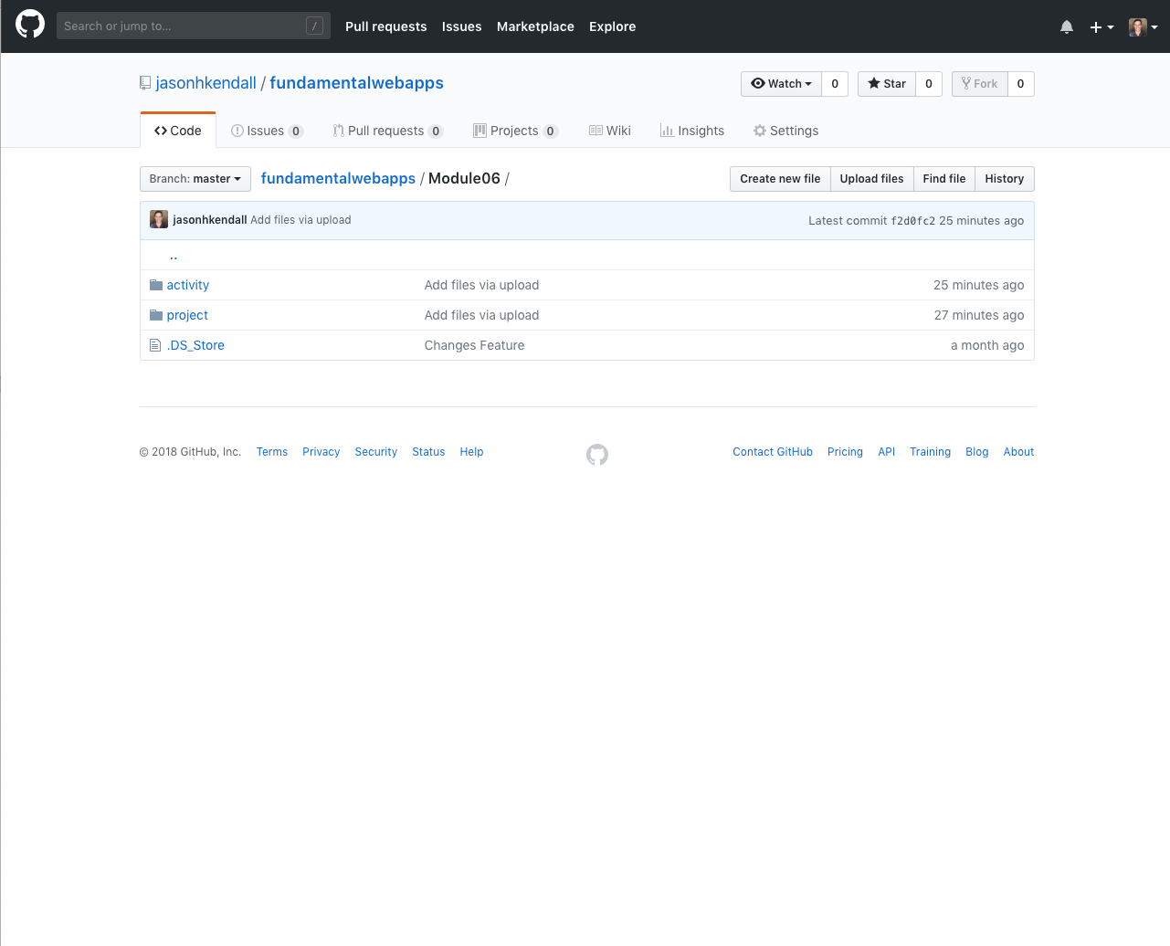

GitHub Wiki:

https://github.com/jasonhkendall/fundamentalwebapps.wiki.git

GitHub URL:

https://github.com/jasonhkendall/fundamentalwebapps/module06