project #1: High Dynamic Range Imaging

B07902129 何政勳

1. MTB Alignment
   1. MTB Alignment was implemented using OpenCV threshold, inRange, bitwise_xor and bitwise_and.
   2. 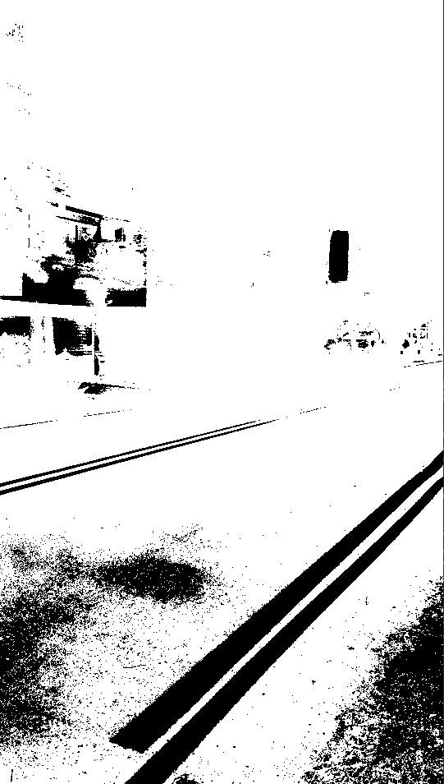Threshold image and exclusive mask were generated to align the images.

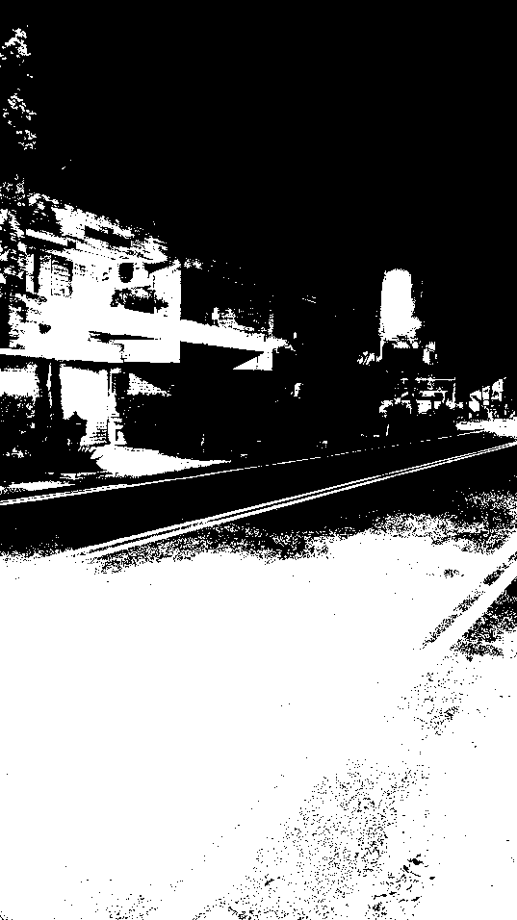

Exclusive mask

Threshold image

1. HDR
   1. HDR was implemented based on the MATLAB code.
   2. SDV least squares solution was calculated using numpy.linalg.lstsq.
   3. CRF of the 3 channels were calculated separately.
   4. Radiance map was saved as a .hdr file.

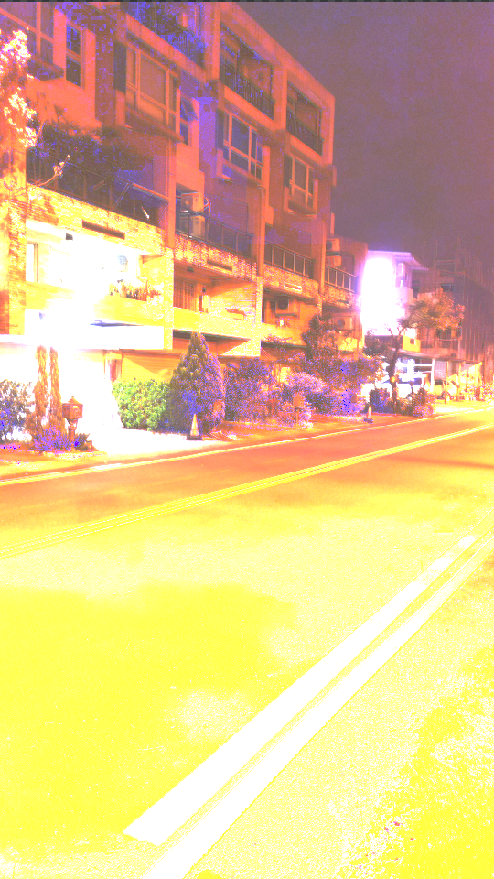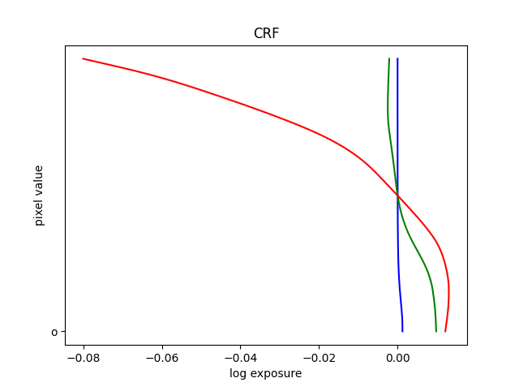

CRF for 3 channels

HDR image

1. Tone Mapping Result
   1. 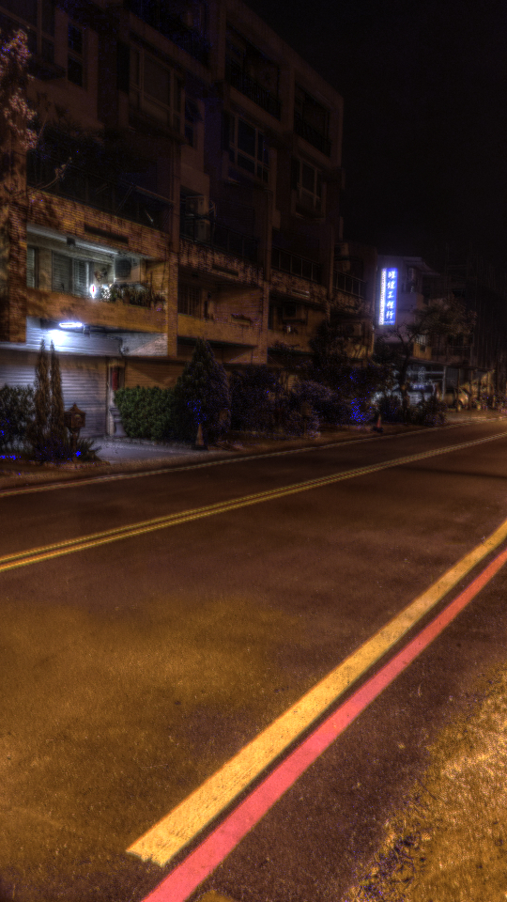Tone mapping utilized the program Luminance HDR v.2.6.0 <http://qtpfsgui.sourceforge.net/>
2. Original Images

|  |  |  |
| --- | --- | --- |
|  |  |  |
| 4s | 2s | 1s |
|  |  |  |
| 1/2s | 1/4s | 1/8s |

|  |  |  |
| --- | --- | --- |
|  |  |  |
| 1/16s | 1/32s | 1/64s |
|  |  |  |
| 1/128s | 1/256s | 1/512s |