Using Oracle’s SQL*Plus Editor in the DeVry iLab

This document will step you through how to find, log into, and utilize the basic feature of the standard SQL*Plus editor in Oracle. This editor will be your main iLab tool for most all of the labs within the series of courses that utilize the Oracle Database.

- After your have logged into a Citrix session, you will want to locate the SQL Plus icon in the group of icons you have in your Applications window. This will be a stand alone application icon like the one picture in figure 1 below. Double click the icon to start the application.


Figure 1

Logging into SQL*Plus

- Once the SQL*Plus editor has started you will be presented with a Log On window like the one you see below in Figure 2.

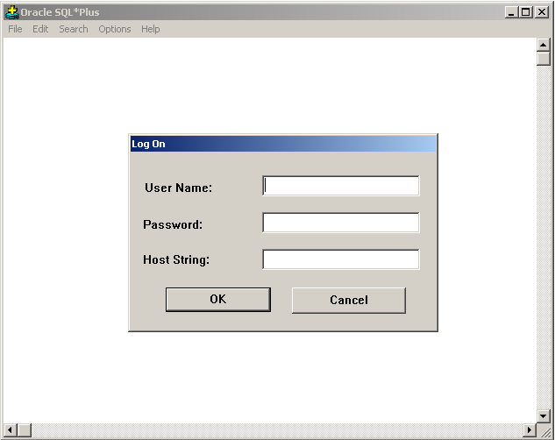

Figure 2

- Your login credential will consist of your DSI# for a user name, the word “password” as your initial password, and DVOLUSER for the host string. You must enter all three credentials in order to be able to access Oracle. Once entered your Log On window should look like the one in Figure 3 below (be sure you are using YOUR DSI# and not the one in the example below).

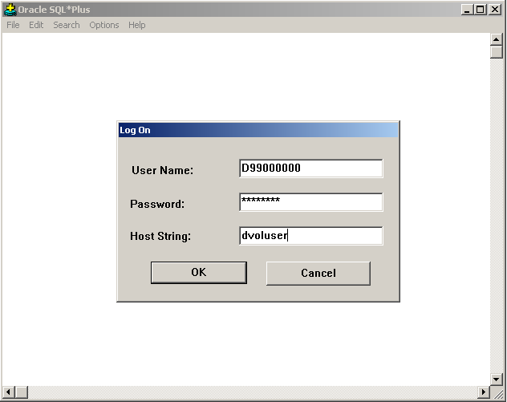

Figure 3

- The password you currently have (the word password) is a temporary default password. The first time you log into Oracle you will be prompted to change your default password to a new password that will be unique to you. Be sure that you use a password that you can remember, and be sure to write it down. If you forget your password and try to log in more than three times unsuccessfully then your account will be locked and you will need to submit a helpdesk ticket to get the account reset. The change password window will appear like the one in Figure 4 below.

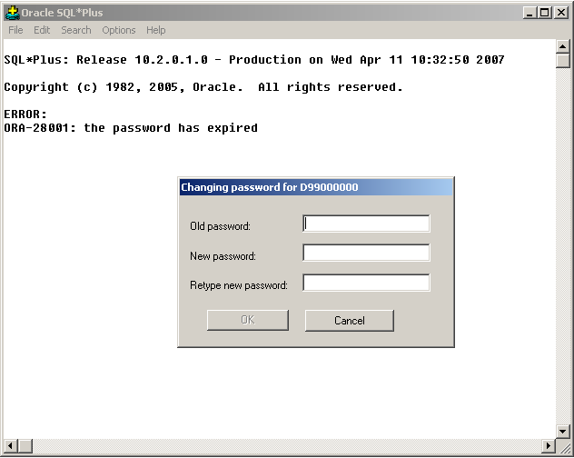

Figure 4

- To change your password you will need to enter the default password in the box labeled Old password (this will be the word password). Next, in the box labeled New password enter your new unique password that will distinguish you from the other users in the database. Finally, reenter the new password for confirmation. When you have all of the data entered your session window should look like the one below in Figure 5. Do not be concerned about the error message stating that the password has expired. This is related to the original default password and is why you are having to change it at this time. At this time you can select OK to complete this process.

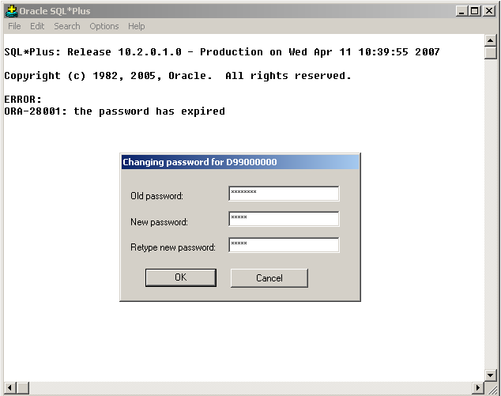

Figure 5

- You should now see a message stating that the password has been changed and that you are connected to the Oracle Database 10g Enterprise Edition. The editor screen should look like the one below in Figure 6. The SQL> is the starting point that you will use when entering any commands or statements into the SQL*Plus editor window. You are now ready to start using the editor.

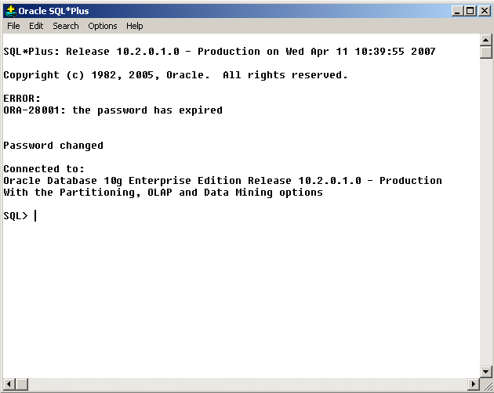

Figure 6

- The iLab environment offers several different ways for you to access the files and utilities you will need to successfully perform the tasks you will be asked to do in your Oracle related labs. You will need access to not only the SQL*Plus editor, but Microsoft notepad and Windows Explorer as well. Within iLab you can access both of these applications from within iLab as they are included in your applications window, or you can use the applications on your own personal computer that you are using to access Citrix with. For the purposes of this tutorial we will be using the Windows Explorer application on the Citrix server so that some specific situations can be pointed out.

The depiction of Windows Explorer in Figure 7 below is representative of what you might see if you opened it within iLab. Notice that there is drive labeled D99004085 on ‘Obt-w-olad001p’(F:). This is a mapped drive that each student will have based upon DSI# and setup within Citrix. It is your work area and you are the only one that can see it and use it. You can add directory folders to it, write files to it and basically use it as you would any other drive area. Also notice that there is a hard drive labeled C$ on ‘Client’(V:). This is actually the “C” drive on the computer that is being used to access Citrix and is also accessible from within the iLab environment. We will look at how you can do all of your work using this local hard drive.

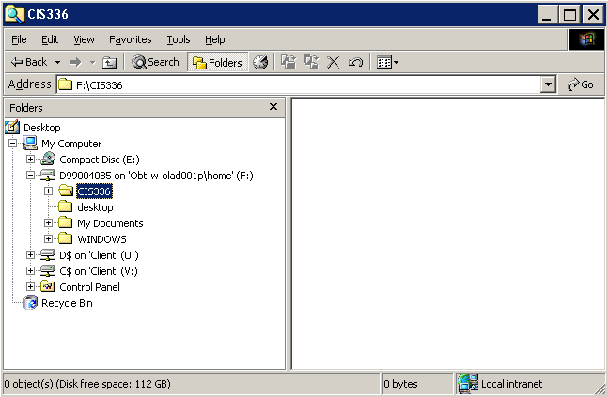

Figure 7

- As mentioned above, the “V” drive in iLab is actually the “C” on the local computer. In Figure 8 below notice that there is a file in the CIS336 folder on the “V” drive named LeeBooks.SQL. We are going to execute this SQL script file in the SQL*Plus editor by pointing to the “V” drive.

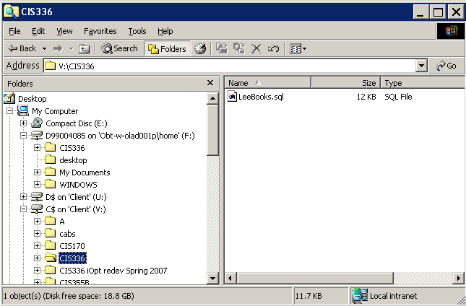

Figure 8

The CIS336 directory folder that is seen on the “F” drive in Citrix is not a standard folder but was created for this tutorial. Remember that you can create any directory on this drive that you wish and utilize it just as you would one on your own computer. The contents in this folder will not go away and anything saved there will be there the next time you log into iLab.

- Now we are going to run our SQL script file within the SQL*Plus editor. In Figure 9 below notice that the command line @V:\CIS336\leebooks.sql has been typed into the editor at the SQL> prompt. By pressing the Enter key at this time then the SQL script in the file will be executed.

The first time you access any file from the editor you will be presented with the Client File Security window that you see below. This is an extremely important window and you must take special care to select the right access on this window. If the wrong radio button is selected then access to the drives on your personal computer will be denied and you will have no option but to use the “F” drive within Citrix.

It is suggested that you only select the Full Access radio button in the “What access do you want to grant?” section of the window and leave the rest alone. This will mean that you will be prompted at the beginning of each Citrix session to make this selection. Although somewhat redundant it is one way to guarantee that your access is going to work.

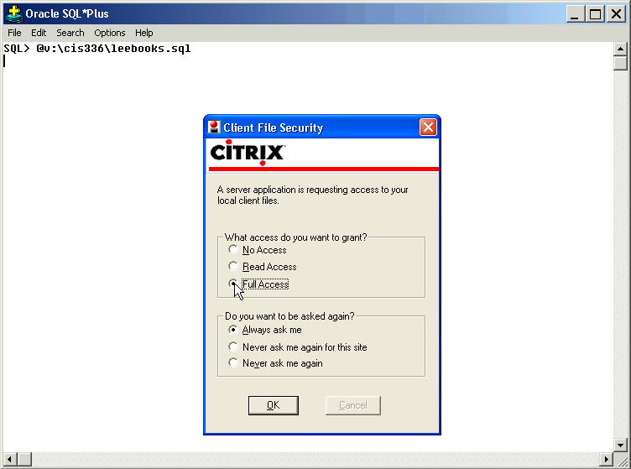

Figure 9

- Once we have set the access settings then the script file will start to run. Figure 10 below shows what you might see when running a script of this nature. You will learn more about running script files in SQL*Plus as you progress through your labs.

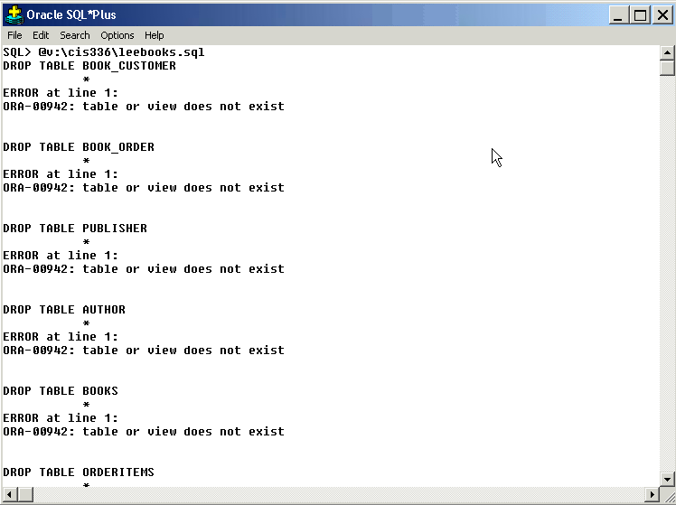

Figure 10

- Now we can select from one of the tables that was created through our SQL script file to verify that everything is where it should be. In Figure 11 we type in two commands. This first command of SET LINESIZE 132 is a formatting command that will allow 132 characters or bytes to display across the editor page. The second command, SELECT * FROM BOOK_CUSTOMER is an SQL query and will display the contents from all of the table columns in the BOOK_CUSTOMER table. Notice the output that is created when we press the enter key.

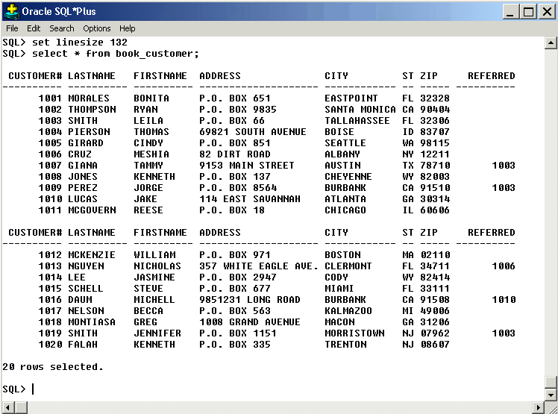

Figure 11

- Sometimes you will want to work from a clear editor screen and not have a bunch of stuff in the editor window. This can be done very easily by pressing the Shift key with the Del key on your keyboard. You will be presented with a message box asking if you really want to clear the screen and the screen buffer like the one you see below in Figure 12. Selecting yes will give you a clear editor window to work with.

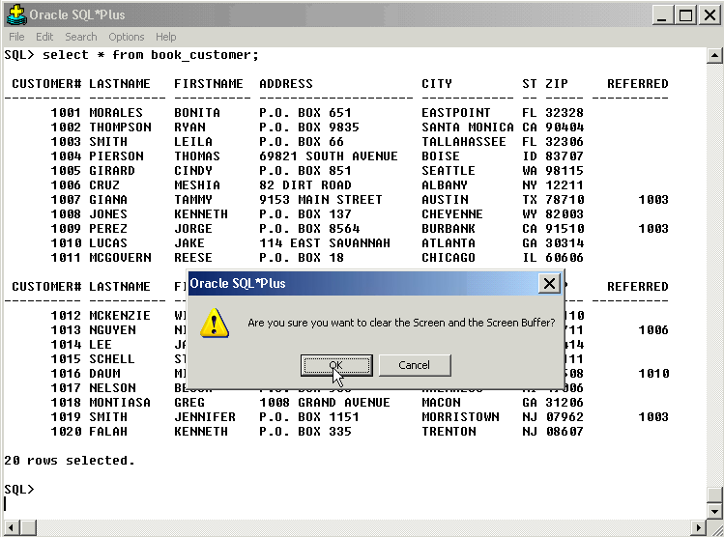

Figure 12

- Unlike Windows Notepad, the Oracle SQL*Plus editor does not have a save feature for saving script files that you type into the editor, or for saving the resulting output when you run a script file within the editor. For most all of your labs you will be asked to use Notepad to write the SQL commands for the lab and save them in a file that can then be run within the editor.

For saving the results from the SQL script file that you run in SQL*Plus you will need to use the SPOOL command to create an external file that will contain what is happening in the editor window. The SPOOL command actually starts a process that captures every key stroke and resulting action in the editor while the SPOOL session is running.

The command in Figure 13 below will create a file named TUTORIAL_OUTPUT.TXT on the “V” (remember this is the “C” on the computer being used to access Citrix).

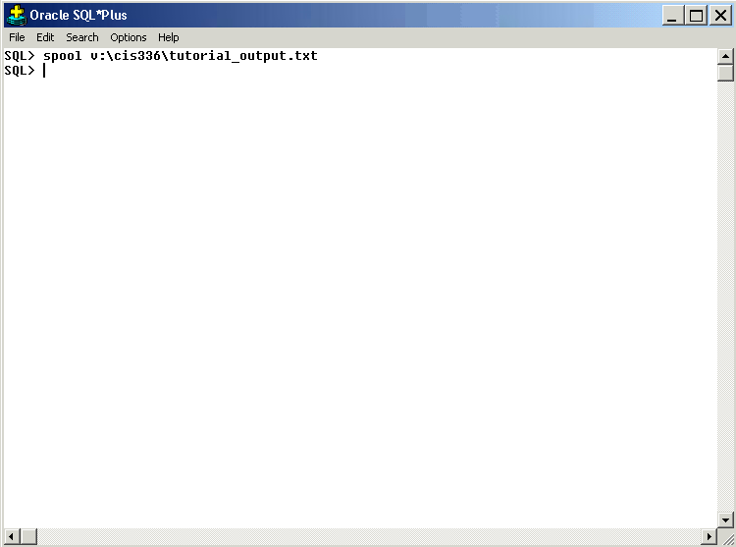

Figure 13
- Now we will run the LeeBooks.SQL script again in Figure 14 as we did before. This time we should be able to go to Windows Explorer and see the new file created on the hard drive.

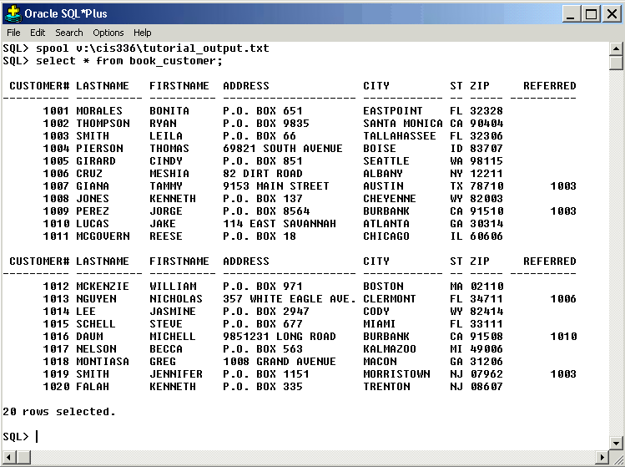
Figure 14

Now let’s look at the “V” drive in Explorer.

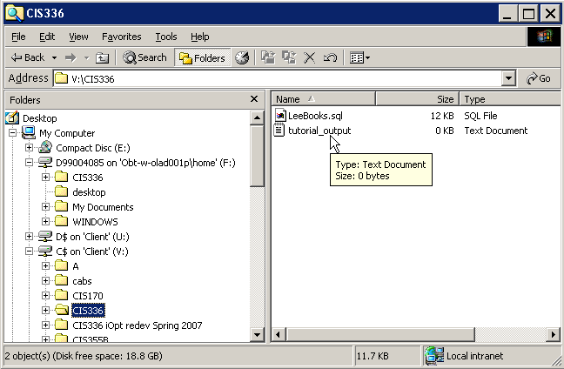
Figure 15
- In Figure 15 above you can see that a new file named tutorial_output.txt has been created. Based on this it appears that we have been able to capture the output from the LeeBooks.sql file using the SPOOL command. But wait, when we open the file as shown in Figure 16 below the file is empty. What happened?

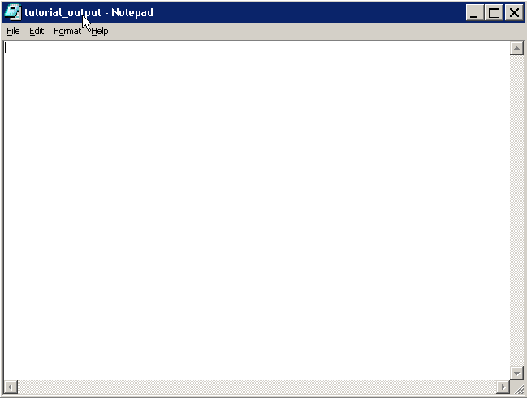

Figure 16

The problem is one that has to do with the editor buffer. The SQL*Plus editor has a buffer that will hold up to 2000 bytes (the default size) of output data from a script that is run in the editor. Once this buffer files then it will dump the contents and begin to file up again. If this happens in a SPOOL session then the contents of the buffer are dumped to the target file of the SPOOL session. In our example here we did not have near enough data to file up the buffer and cause it to dump the contents to the file. Thus we need a way to cause this to happen manually.

- In Figure 17 below we issue the SPOOL OFF command to stop the SPOOL session. This command also will cause the editor to dump the contents of the buffer to the target file of the SPOOL session and thus we will be able to capture our output.

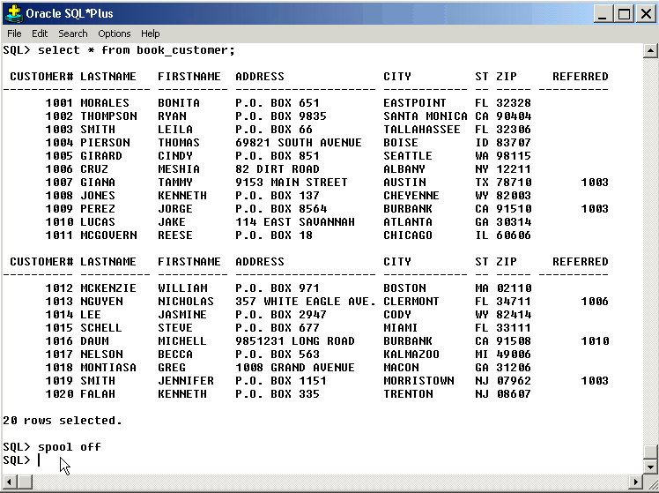
Figure 17

Notice now that the size of the file from the spool session is 4KB where before it was zero.

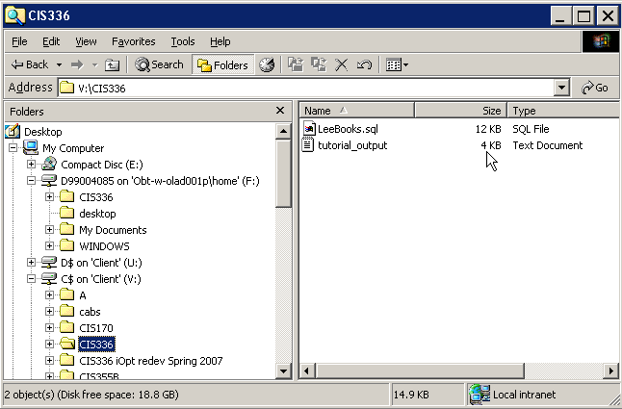
Figure 18
- Now let’s look at the contents of the file and see if we actually did get the output from running the script file. Notice that in Figure 19 below we now see that the file contains our output.

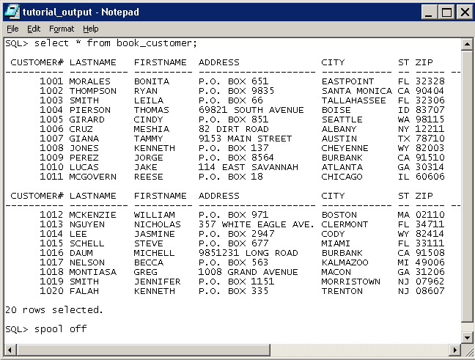

Figure 19

In Conclusion

You will learn much more about the functionality of the SQL*Plus editor and how you can use it to access the Oracle Database. SQL*Plus allows you to create objects, access existing objects, change objects and manipulate the Oracle Database using session commands as well as SQL commands and scripts. SQL*Plus is in essence your window to the Oracle Database.

