FROM USAspending Website,

1. From Advanced Search, filter “SUICIDE” in the Keyword and selected “Department of Veteran Affairs” from Agency.
2. Click Submit Search

**Discovery**

1. There is a big increase in award from 2017.

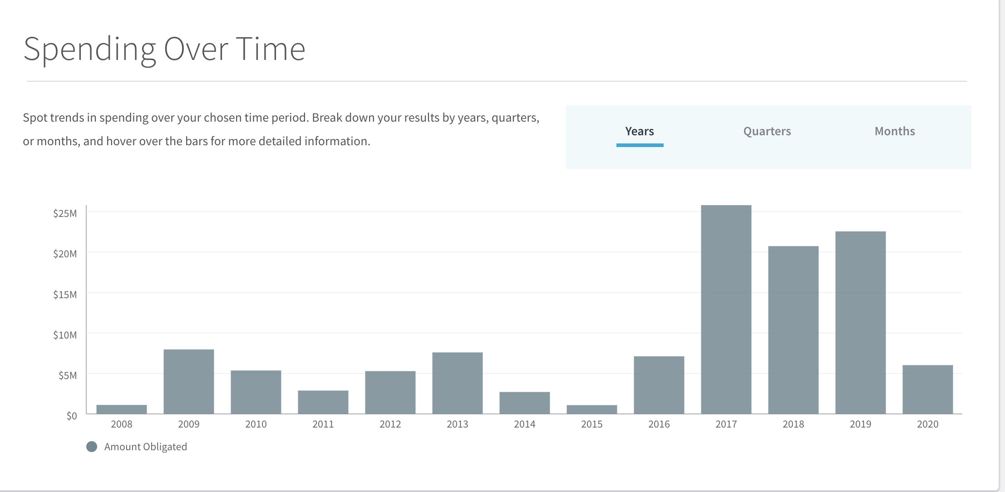

1. Top 2 Recipients are J.R. REINGOLD & ASSOCIATES, INC. ($39 million) and DISTRICT COMMUNICATIONS GROUP, LLC. ($24 million)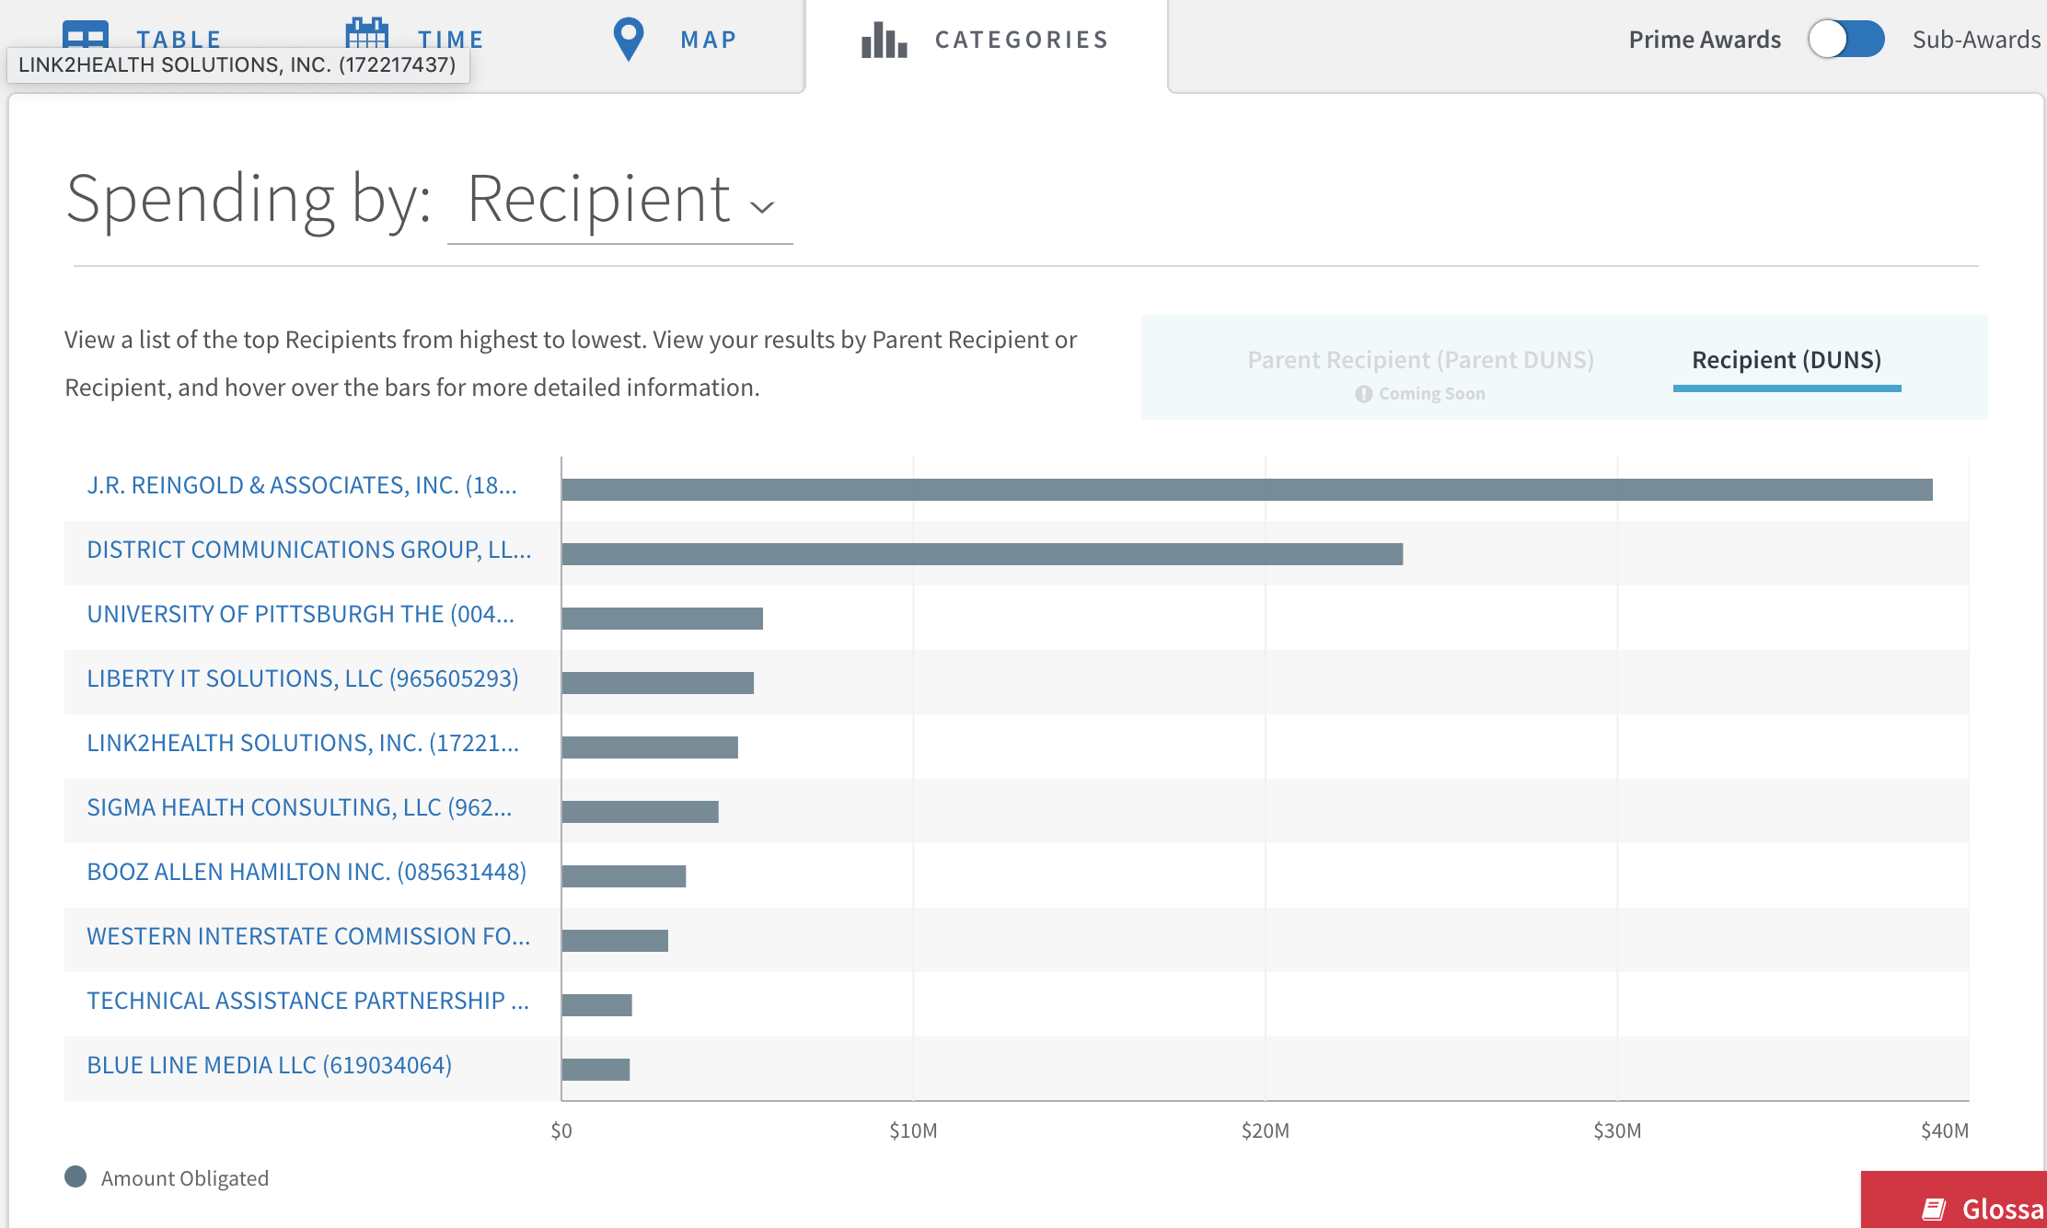
2. Virginia has the highest Obligation - ($ 40 million)

