1. **Navigate to GSEP IT Software Request** [**https://boeing.service-now.com/sp?id=index**](https://boeing.service-now.com/sp?id=index)

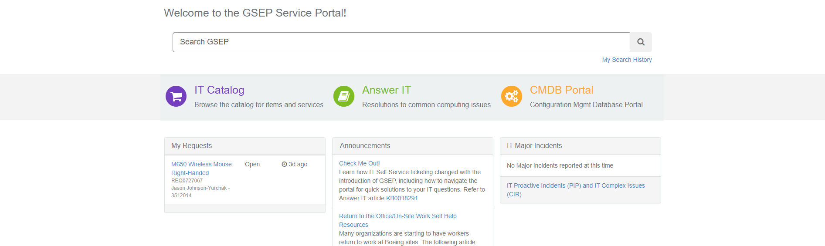

1. **Search Adobe Acrobat Professional in the GSEP Search Bar** 
   1. **My Requests on the top right allows you to track your requests after submission**

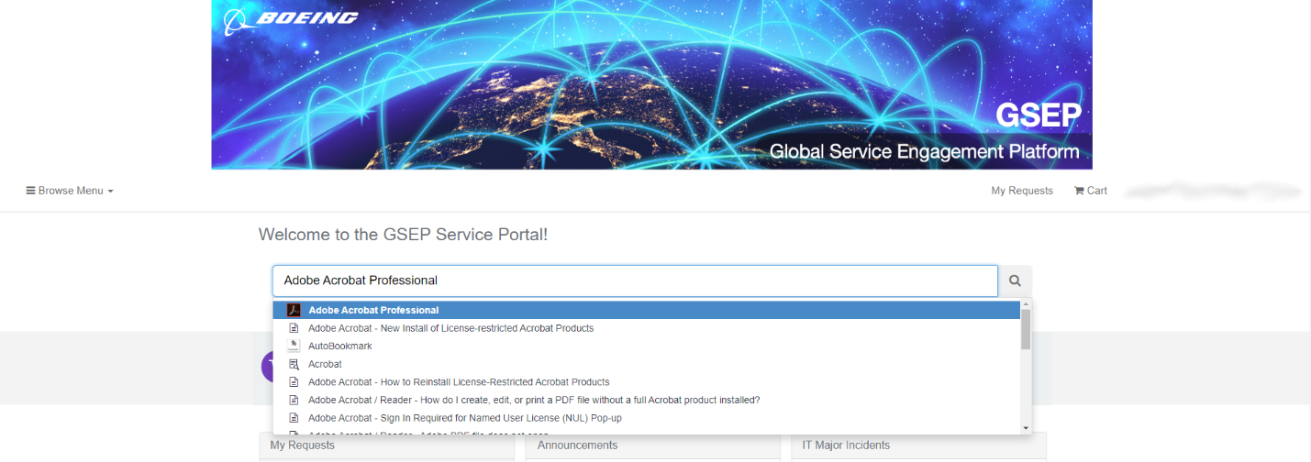

1. **Fill out the required information and select Order Now**

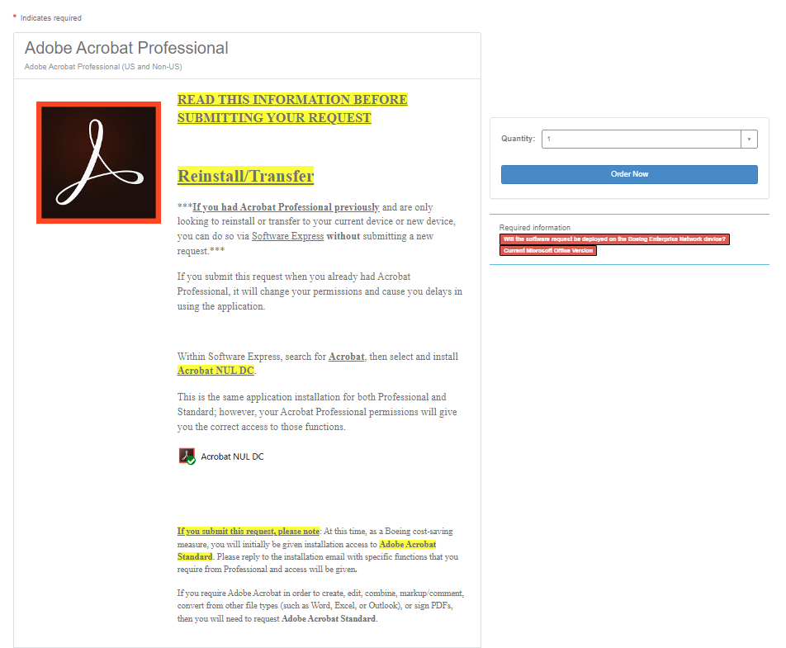

1. **After receiving the following approval email, follow these steps through Software Express**

