1. **Navigate to SAP Ariba under the tab “Tools” on the webpage**
2. **Select “Request/Change Ariba Access”**



1. **Select “Business User Role Access”**

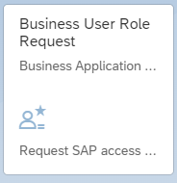

1. **Search “Webi Business Intelligence Reporting” in the keyword search before selecting “Submit Access Request”**







1. **The following email will indicate that your request has been routed to your manager:**

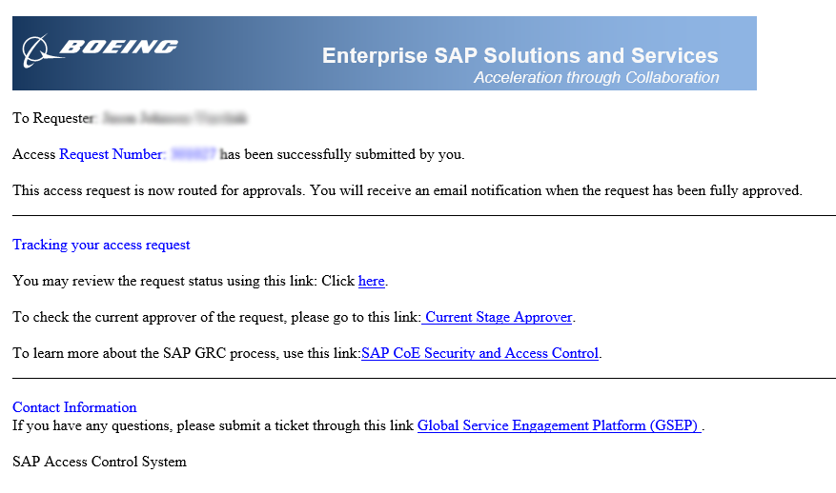

1. **Forward the above email to your manager with the following link to approve your query:** [**https://sapgrc.web.boeing.com/sap/bc/webdynpro/sap/grfn_powl_inbox?sap-client=100#**](https://sapgrc.web.boeing.com/sap/bc/webdynpro/sap/grfn_powl_inbox?sap-client=100)**.**
2. **In the above email for your request number, select “here”**



1. **Select “Audit Log” in order to track the progress of the request**

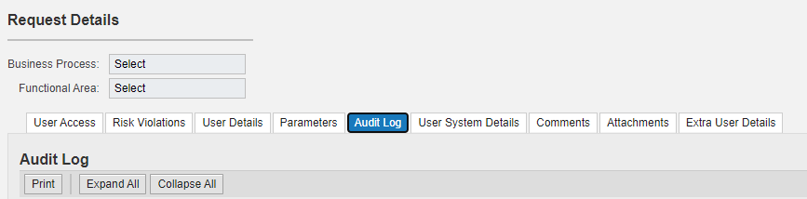

1. **Once completed, the following email will appear in your inbox, confirming approval:**

