1. **Search for DEEM in your Windows search bar**

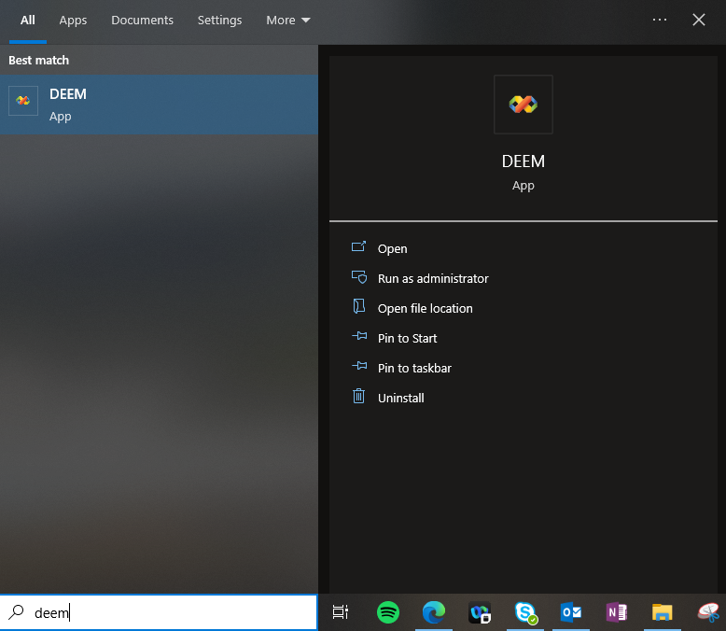

1. **DEEM will be slow but will look like the below when running**



1. **Select Boeing Commercial Airplanes**

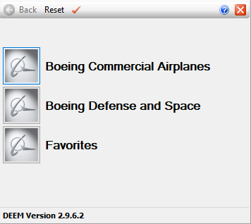

1. **Select any of the following options, but I chose 777**

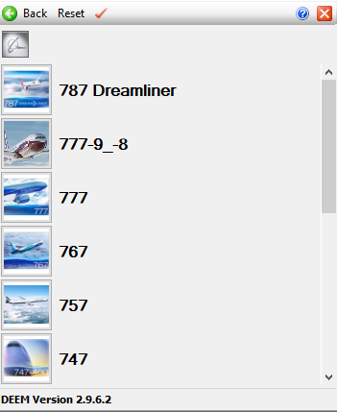

1. **Select Catia**

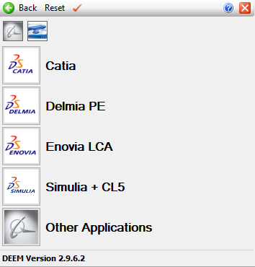

1. **Right click on the yellow icon, and select Create Favorite to This Button**

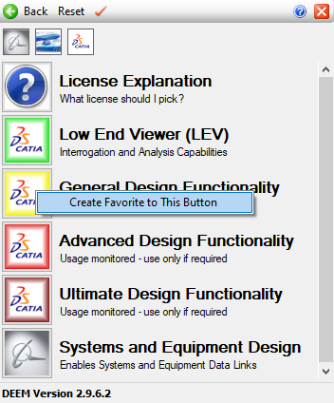

1. **Select General Design Functionality**

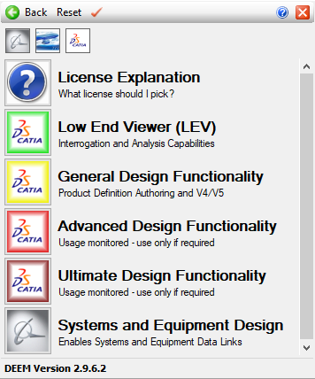

1. **The program will run and look like the below when ready to use**

