1. **Search Software Express Puget Sound in your Windows Search Bar**

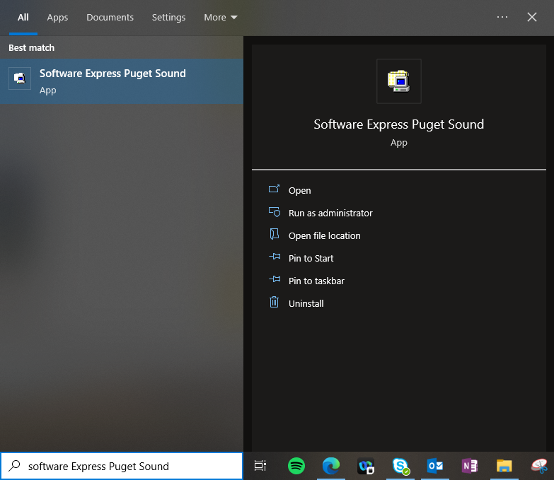

1. **Search EDCOMS in the top right Software Express Search Bar**

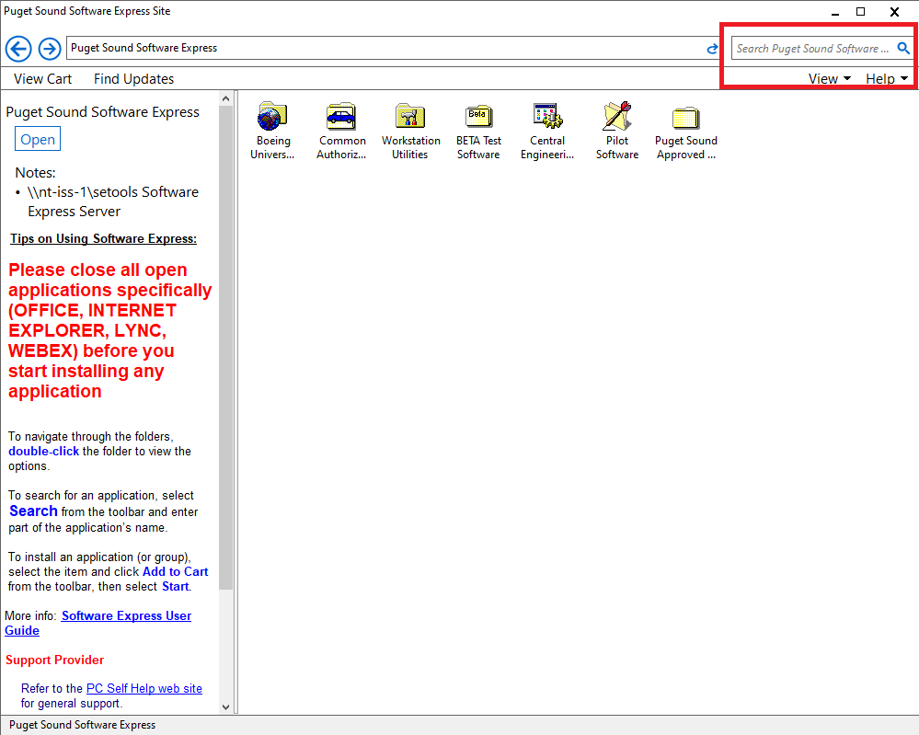

1. **Install EDCOMS**

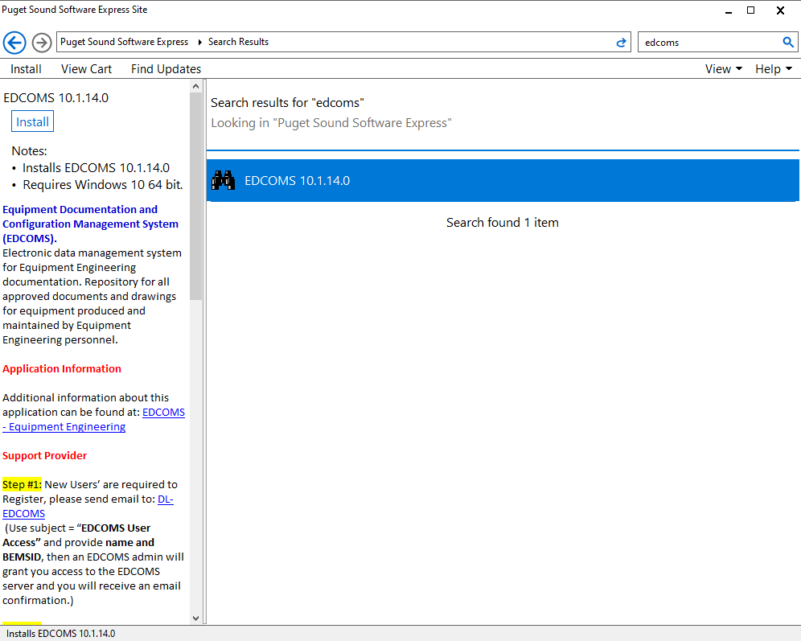

1. **Use the following instructions for operating EDCOMS.**

<http://equipmenttool-engineering.web.boeing.com/EquipEngr/EDCOMS/EDCOMS_Trainer.pdf>

**Beware: the downloading steps in this link are outdated. Please follow above steps.**