**Requesting an EID Account:**

* Start MARS <https://infosec.web.boeing.com/Search/ISFindit.aspx?aId=1>
* In the upper-left corner select My Accounts.
* Click Request Accounts underneath your name.
* Select Request Application Access.
* Select EID.
* The following message will appear if you are not approved for access yet:

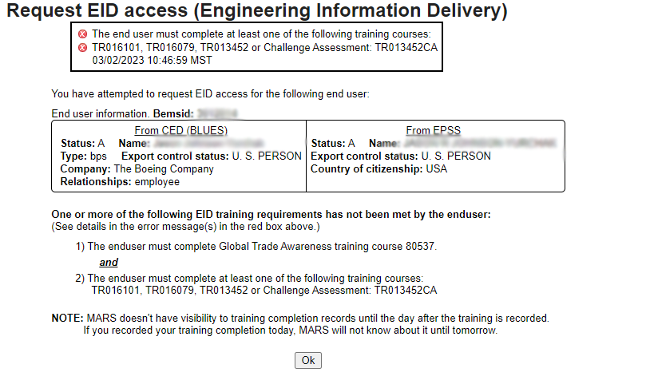

* If you see this message, follow the instructions below. If you already have access, skip to “Gaining Access to EID”.

**Requirements to view Model-Based Definition (MBD) Data in REDARS:**

* Navigate to “Learning Plan Required Trainings” under “RESPONSIBILITIES” on the homepage:

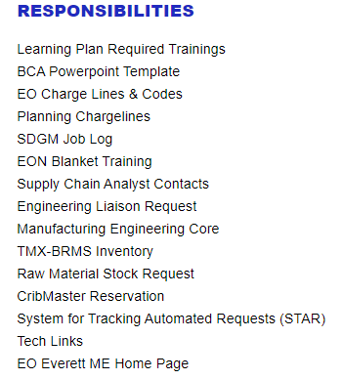

* Complete Global Trade Awareness under Program Code 80537, as mentioned in the MARS message. The organization should look like the following:

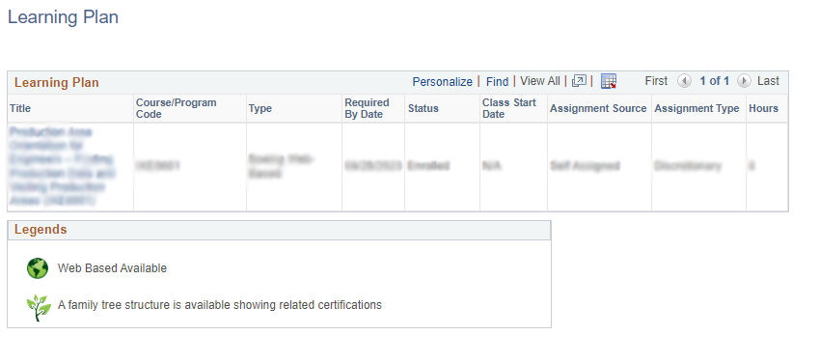

* Once completed, navigate to “Find Learning” under “CAREER DEVELOPMENT” on the homepage:

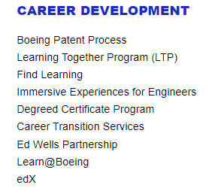

* In the displayed search box, launch one of the required courses that was mentioned in the MARS message (TR016101, TR016079, TR013452, or TR013452CA).



* Upon completion, navigate back to MARS and follow the instructions below.

**Gaining access to EID:**

* In the MARS request for EID (steps detailed at the top of this document), input the appropriate data and submit the request. Once approved, your access will be updated automatically.
* Once you have obtained access, the Model Based Definition Searches will appear on your REDARS page:

